**Expression of Interest (EOI) for Enhancement, Maintenance and Support of e-Mutation System**

|  |  |
| --- | --- |
| Submitted To: | **Ministry of Education, Government of Bangladesh** Ministry of Education, Floor No 18, Bhavan No 6, Bangladesh Secretariat, 16 Abdul Gani Rd, Dhaka 1205 |
| Submitted by the Joint Venture of: | |
| Lead Bidder | **Sheba Technologies Limited**  8th Floor, Khawja Tower, 95, Mohakhali C/A, Dhaka-1212 |
| Associate Bidder | **WINGS Learning Center.** Dhanmondi R/A, Dhaka-1209  House # 55, Road # 4/A |

|  |
| --- |
|  |
|  |

**Memo No.: 31.00.0000.057.07.008.20-27**

October 5, 2020

*Date: March 23 2022*

**Pradip Kumar Das**

Additional Secretary (Field Administration)

Ministry of Land

Ministry of Lad Building-04:

Floor- 3rd, Bangladesh Secretariat

Dhaka

**Subject: Submission of Expression of “Hiring a Firm for Enhancement & Maintenance Service of E-Mutation System** *[EOI Ref. No.: 31.00.0000.057.07.008.20-27; Date: 16/09/2020]*

Dear Sir,

With reference to your invitation on the subject mentioned project we are pleased to submit herewith our Expression of Interest for your kind consideration.

We are Submitting the Expression of Interest in following description

**Sheba Technologies Ltd.**

House 55, Road 4/A, Dhanmondi R/A,

Dhaka 1209, Bangladesh

In Association (as a sub-consultant) with

**Wings Learning Center (WLC)**

Dhanmondi R/A, Dhaka-1209

House # 55, Road # 4/A

**Sheba Technologies Ltd. (STL)** is a subsidiary of Sheba Group which has over 20+ years of management experience with proven track record in rendering technologically advanced products and services. STL assists you to develop tailor-made software from scratch. A team of system analysts work on the solution architecture in a way that is designed to solve our client’s business/technological problems. STL brings business and application developer skillsets together to formulate necessary technical requirements and develop the best possible solution. Since its inception, STL has had the privilege to work with top Private, Non-Government and Public organizations where it ensures delivery of world class services and enterprise solutions. Within this short span of period, it also successfully produced and launched a robust in-house developed product.

We are always keen on listening to our customers and are constantly learning from their experiences while rendering Telecom and IT services. This has made us recognize the importance of evolving into the new ‘normal’ which is ‘Data is everything’. With this aspiration, STL is fully committed to bring world class technologically advanced Business Process Automation by delivering architecturally superior Software solution, Off-the-Shelf customizable Software, Digital Identity platform for Citizens, Smart City initiatives, Artificial Intelligence and Machine Learning to our esteemed clients who are also our long-term strategic partners.

**WINGS Learning Center. (WLC)** has been in operation as a leading education provider since 2000 and previously known as Victoria University, Australia in Bangladesh. It has been committed to provide with extraordinary language learning and Business executive development programs since its inception. WINGS Learning Center has become a trusted professional and career development partner for visionary and careerist learners in the competitive era of globalization. It is a full-service, year-round language training and testing services organization. One of the oldest language training institutions of Bangladesh, WLC is also British Council's test center for IELTS, O'Levels and all types of professional exams. Since its establishment, WINGS has helped students to learn English and to continue their studies at so many universities globally. WINGS provided MBA education with partnership of Victoria University, Melbourne, Australia till 2009. And, WLC also supports and runs a range of CPD courses on modern and contemporary Business Management and Development Economics matters in place. It has a research department developed and aimed to lead Economic Development Agenda and to train, to make routine research to aid Policy Makers in Bangladesh towards success of Economic Development in Bangladesh ahead.

To be the premier educational institution in providing high-quality, affordable and accessible educational programme’s serving the needs of business, industry and the diverse campus communities and facilitating the personal and professional development of its students, faculty and staff.

WINGS' vision is to become the ‘provider of choice’ of learning and development solutions in the market it serves. It designs and delivers high quality, original learning and development solutions that meet client’s organizational needs. It is devoted to inspiring people to realize their full potential through a wealth of learning solutions that is engaging, innovative and challenging.

To be a student-centered, dynamic and innovative, unique class campus of WLC-Wings learning Center, promoting excellence in teaching and learning, serving diverse communities and producing lifelong learners who can compete globally.

The EOI has been prepared on the basis of information provided in the invitation, Consultant’s knowledge and experience of similar works. The EOI also reflects our past experience obtained during the last decades in similar assignments at home and abroad.

Now, to substantiate our standing, we enclose herewith the EoI document which is reflective of the adequacy of our professionalism, capabilities and relevant experience. We believe that with the delineated experience, skill and expertise, you will find our EoI document adequate to shortlist us for the stated assignment.

We assure you that we will be available to respond any of your queries should you require any clarification from us.

We would expect to hear from you soon.

Thanking you,

Yours sincerely,



**Farhan Islam**Chief Operating Officer  
Sheba Technologies Limited  
Phone: +8801711547804  
Email: [farhan.islam@shebatech.com.bd](mailto:farhan.islam@shebatech.com.bd)

*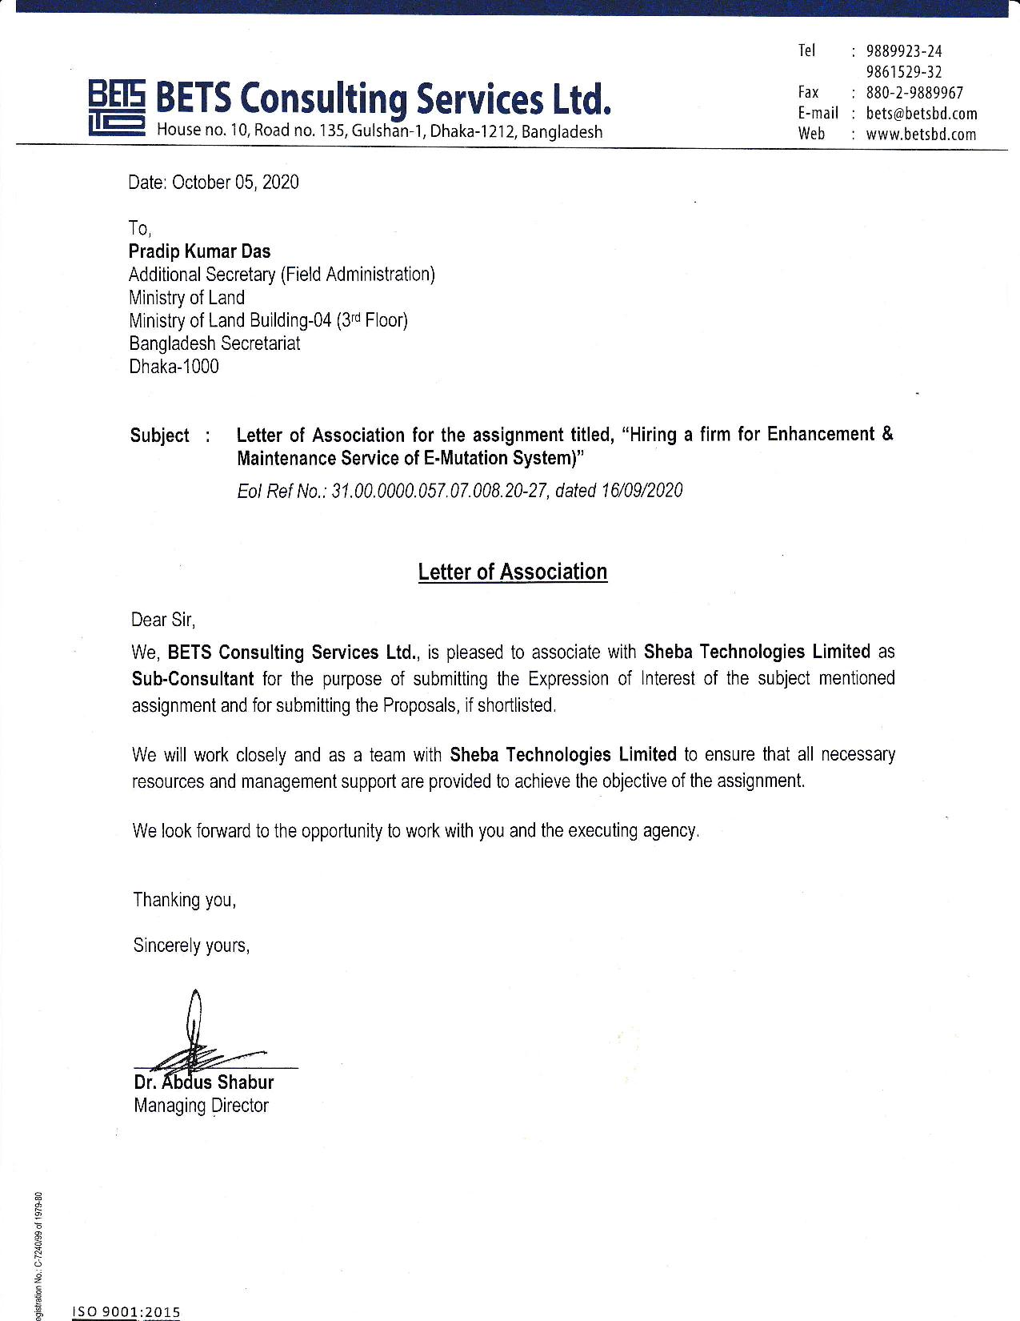*

**Table of Content**

[Section-1: Background and General Information of the Firms 5](#_Toc52790554)

[1.1. Sheba Technologies Ltd (STL). 5](#_Toc52790555)

[1.1.1-1.1.2 Registration and General Profile of the Firms & Updated Trade license, Updated TIN certificate, VAT registration certificate, latest BASIS Membership certificate 5](#_Toc52790556)

[1.2.3 Brochure of STL 18](#_Toc52790557)

[1.2. BETS Consulting Services Ltd. 32](#_Toc52790558)

[1.2.1-1.2.2 Registration and General Profile of the Firms & Updated Trade license, Updated TIN certificate, VAT registration certificate, latest BASIS Membership certificate 32](#_Toc52790559)

[1.2.3 Brochure of BETS 47](#_Toc52790560)

[Section-2: Similar Service Experience Records of the Firms 115](#_Toc52790561)

[2.1. Sheba Technologies Ltd. 115](#_Toc52790562)

[2.2. BETS Consulting Services Ltd. 116](#_Toc52790563)

[Section-3: Experiences of the Firm in Key Operating Areas 146](#_Toc52790564)

[3.1. Sheba Technologies Ltd. 146](#_Toc52790565)

[3.2. BETS Consulting Services Ltd. 148](#_Toc52790566)

[Section-4: Financial Capacity of the Firm 203](#_Toc52790567)

[4.1. Sheba Technologies Ltd. 203](#_Toc52790568)

[4.2. BETS Consulting Services Ltd. 229](#_Toc52790569)

[Section-5: Organizational Capability of the Firms 263](#_Toc52790570)

[5.1. Sheba Technologies Ltd. 263](#_Toc52790571)

[5.2. BETS Consulting Services Ltd. 270](#_Toc52790572)

[Section-6: Logistics Resources of the Firm 272](#_Toc52790573)

[6.1. Sheba Technologies Ltd. 272](#_Toc52790574)

[6.2. BETS Consulting Services Ltd. 273](#_Toc52790575)

[Section-7: Availability of Technical Experts for Performing the Assignment 279](#_Toc52790576)

[Annex-1: Copy of the Advertisement 351](#_Toc52790577)

# Section-1: Background and General Information of the Firms

## 1.1. Sheba Technologies Ltd (STL).

### 1.1.1-1.1.2 Registration and General Profile of the Firms & Updated Trade license, Updated TIN certificate, VAT registration certificate, latest BASIS Membership certificate

|  |  |  |
| --- | --- | --- |
| **Name of the Company** | Sheba Technologies Limited | |
| **Contact Person:** | Farhan Islam Senior Manager, Business Operations Phone: 01711547804 Email: farhan.islam@shebatech.com.bd | |
| **Constitution & Year of Establishment:** | Incorporation Year: 2015 | |
| **Registered Office/Corporate office/Mailing Address:** | Registered Office: H # 55, R # 4/A, Dhanmondi, Dhaka-1209, Bangladesh  Corporate Office: 8th floor, 95, Khaja Tower, Bir Uttam AK Khandakar Road, Mohakhali CA, Dhaka 1212 | |
| **Trade License** | F:\Trade License STL_2020-1.jpg  F:\Trade License STL_2020-2.jpg | |
| **TIN Certificate** | F:\TIN Certificate of STL-1.jpg | |
| **Income Tax certificate** | F:\Income Tax Certificate of STL for FY 2018-2019-1.jpg | |
| **VAT registration certificate** | F:\VAT Certificate of STL-1.jpg | |
| **BASIS Membership Certificate** | **Note:** We are yet to receive our BASIS 2020 certification hardcopy due to the current close down. | |
| **CMMI Level 3 Certification** |  | |
| **ISO 27001:2013 Certification** | E:\Tahsin STL\Legal Documents\STL Legal Documents\ISO 27001-2013.jpg | |
| **ISO 9001:2015 Certification** | E:\Tahsin STL\Legal Documents\STL Legal Documents\ISO 9001-2015.jpg | |
| **Tax Clearance Certificate for last 3 years** |  | |
|  |  | |
|  |  | |
| **Bank Solvency Certificate** | C:\Users\User\Downloads\Bank Solvency certificate_latest-page-001.jpg |

### 1.2.3 Brochure of STL

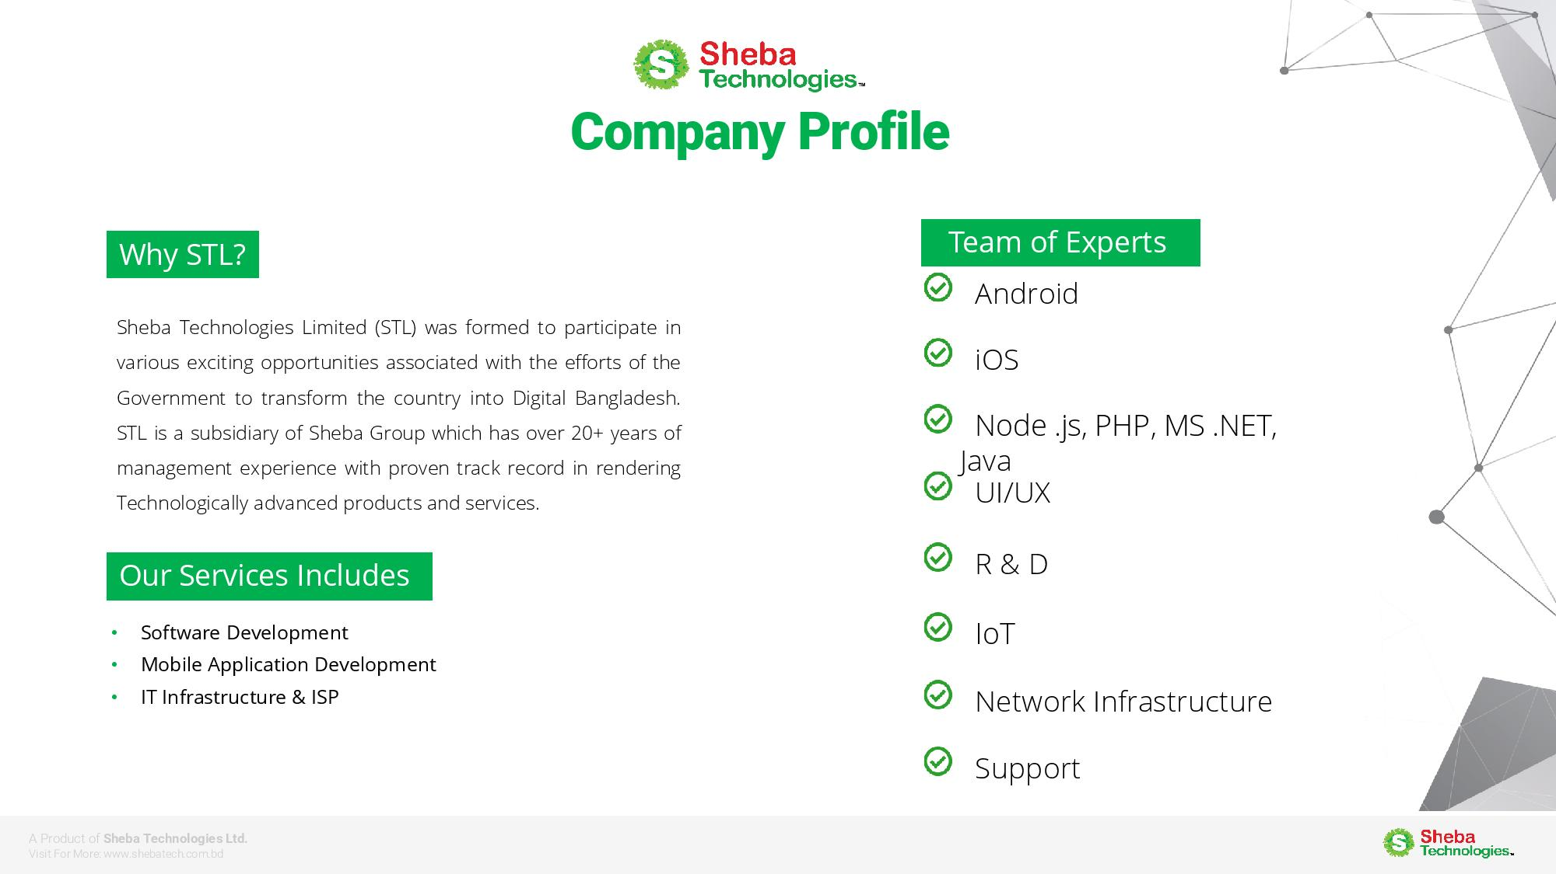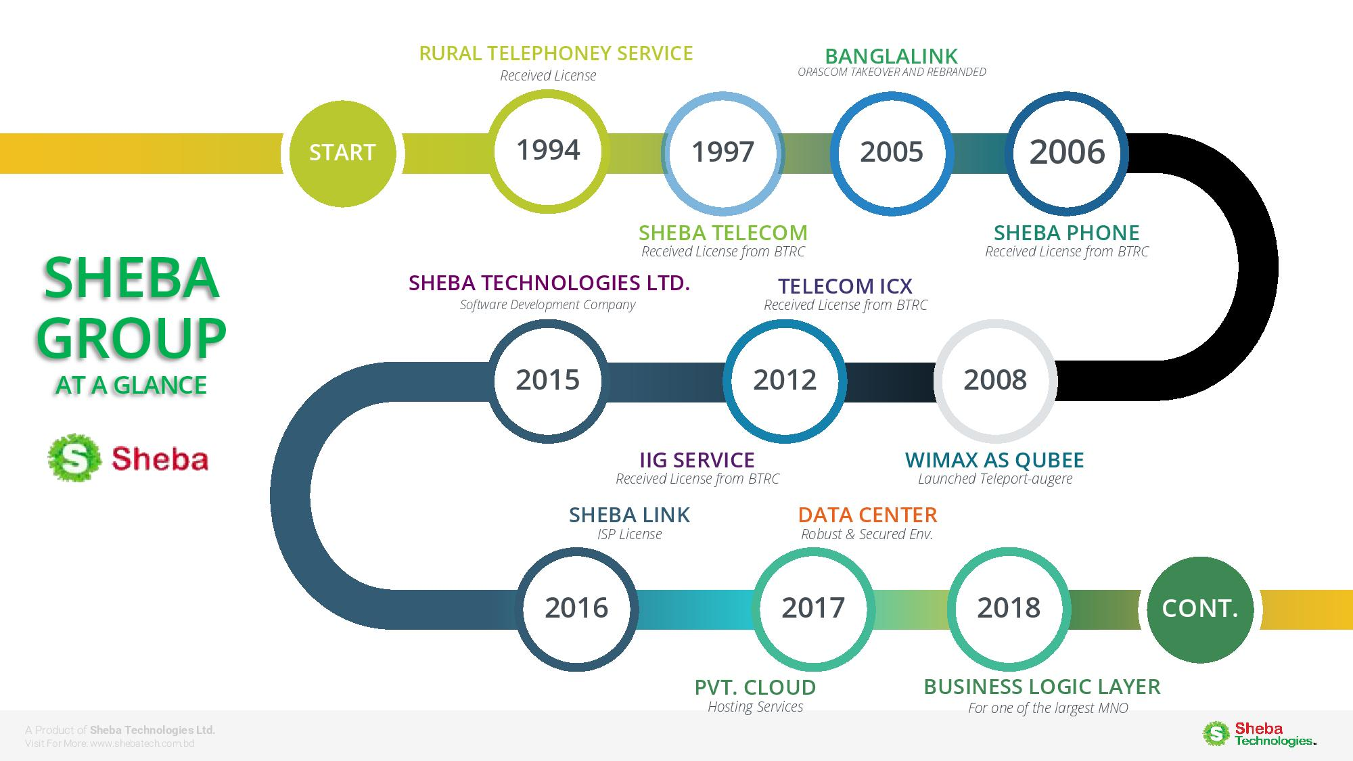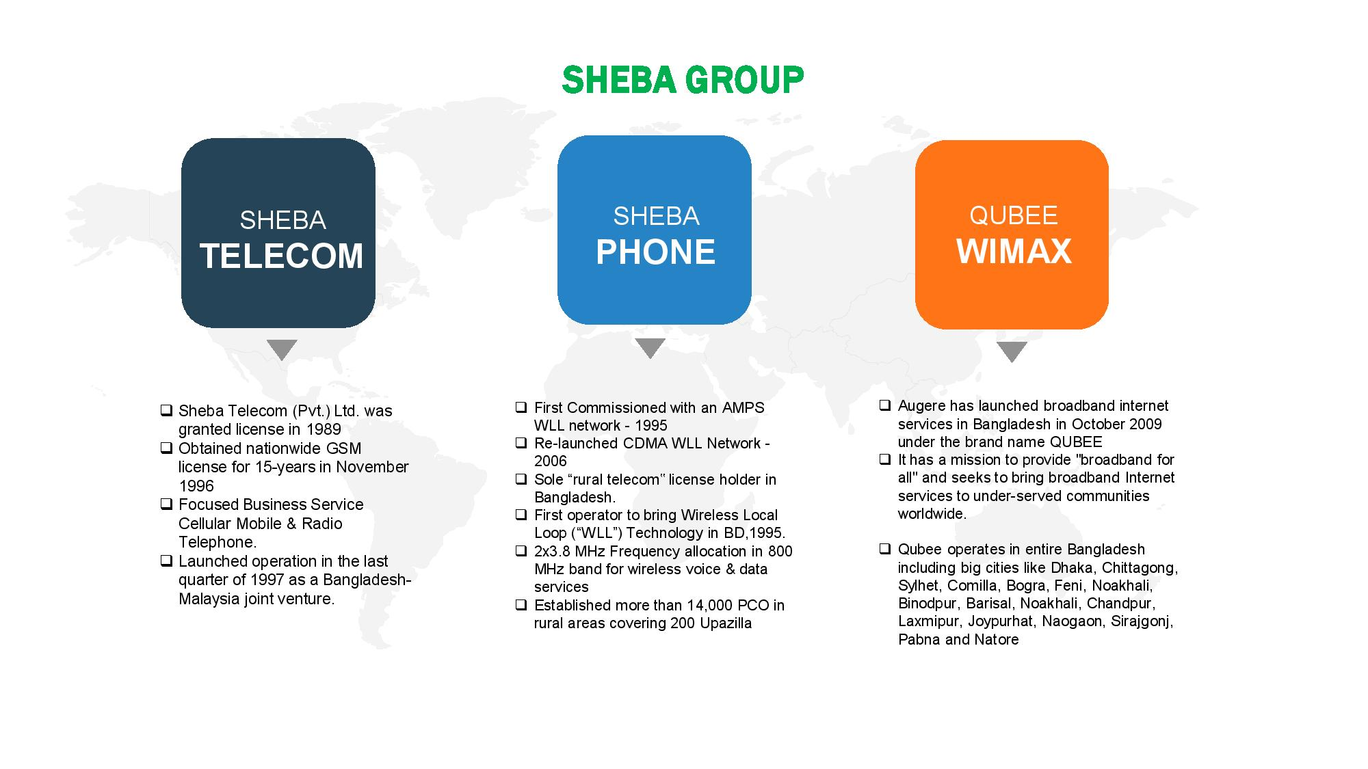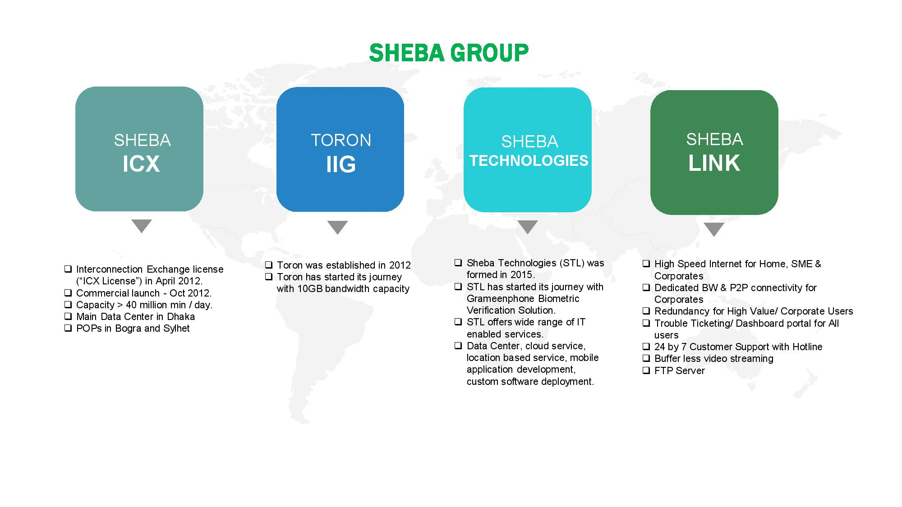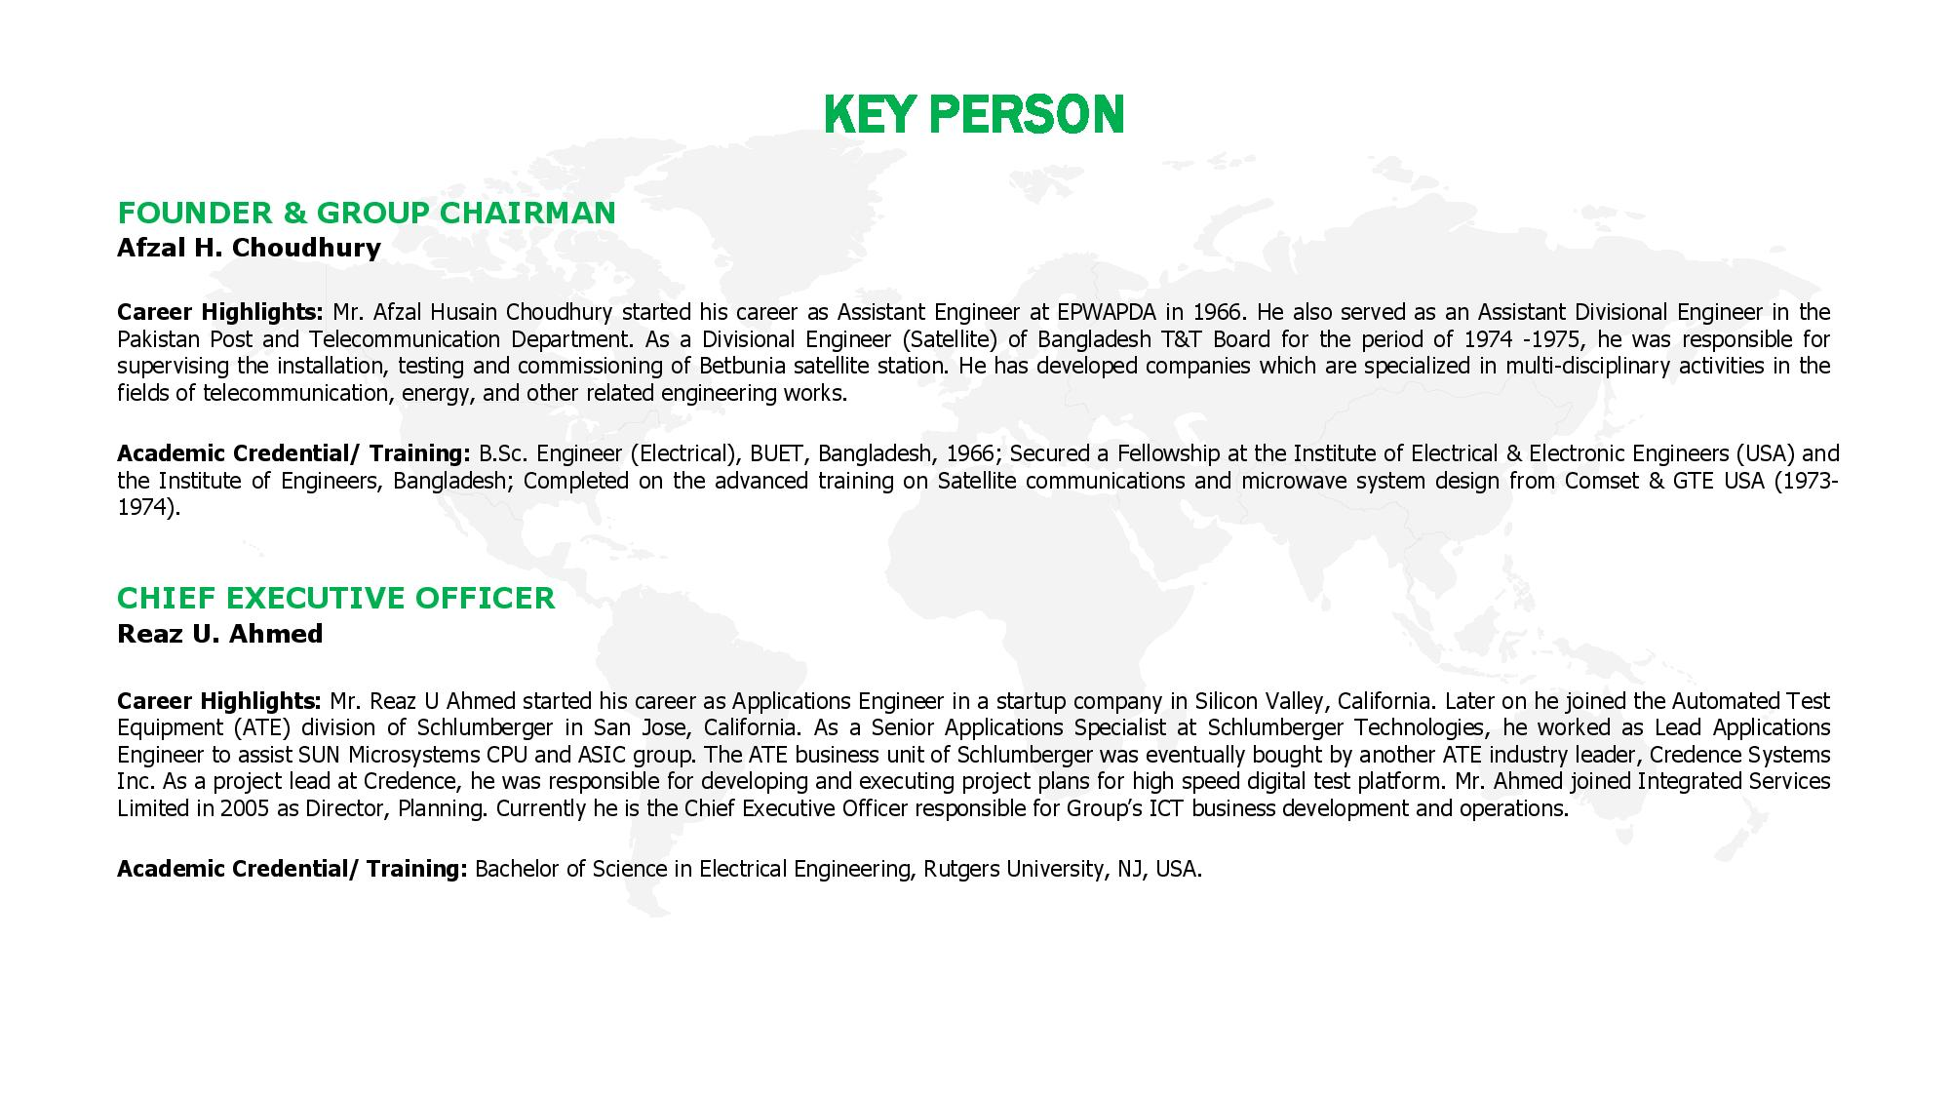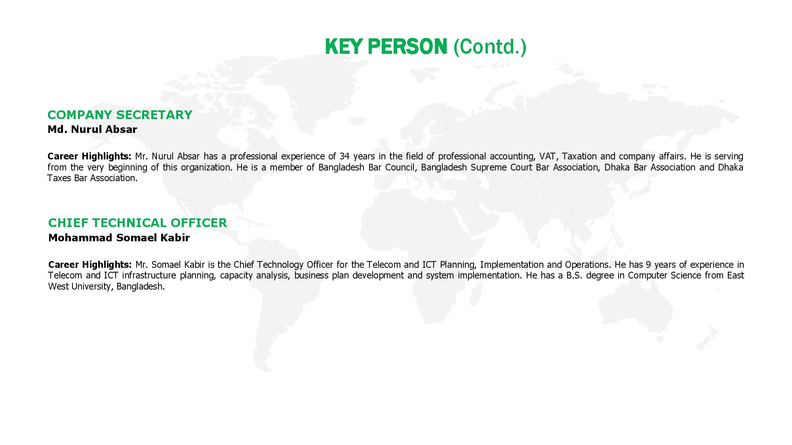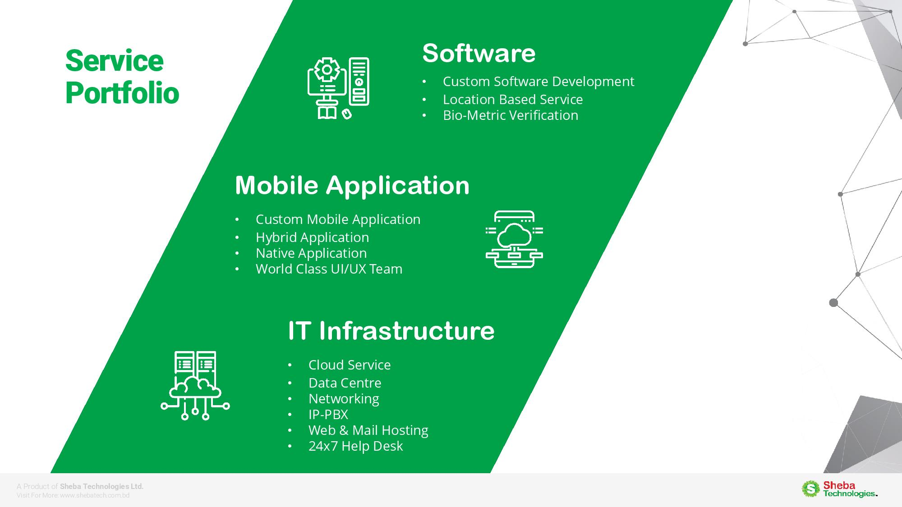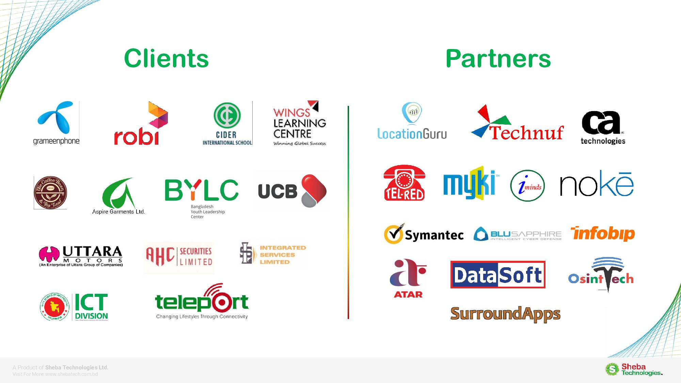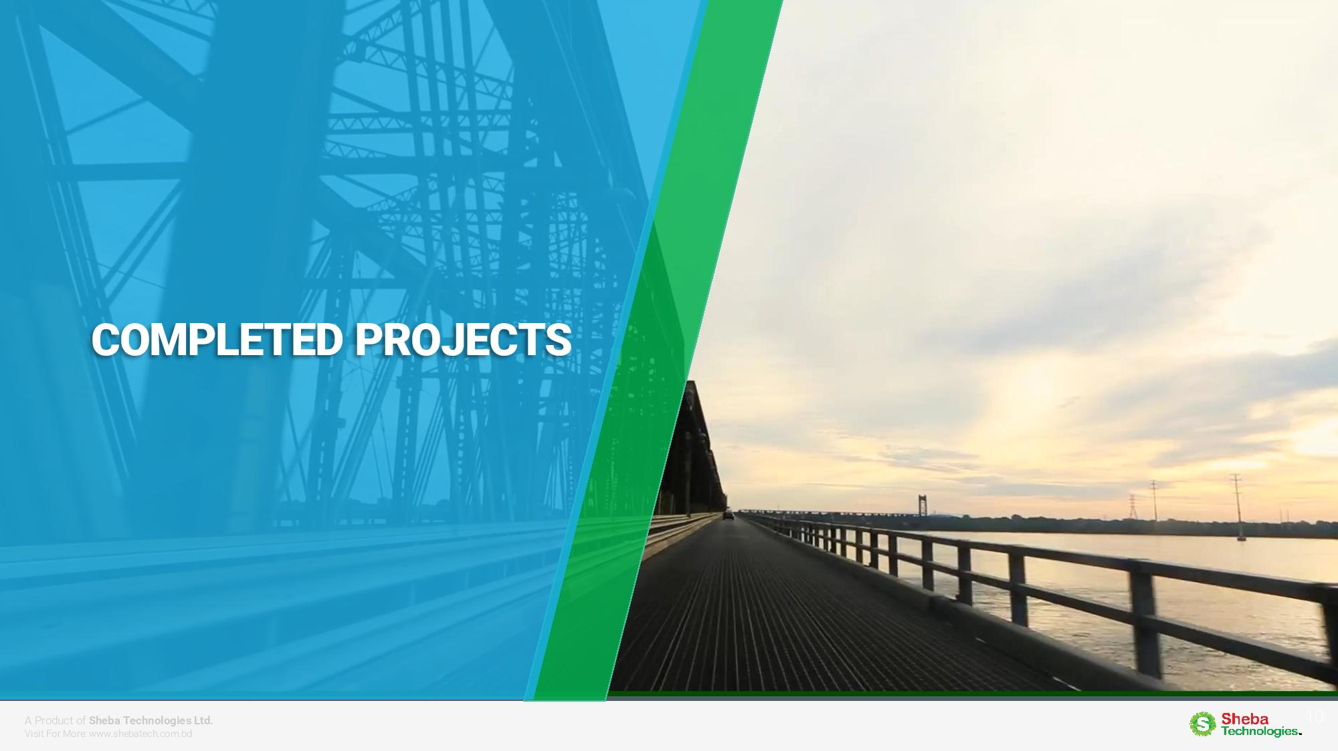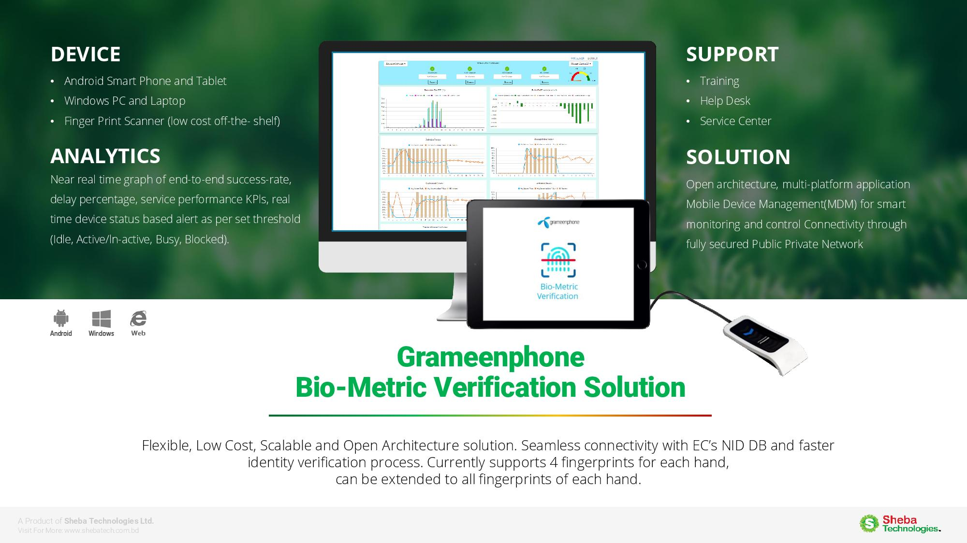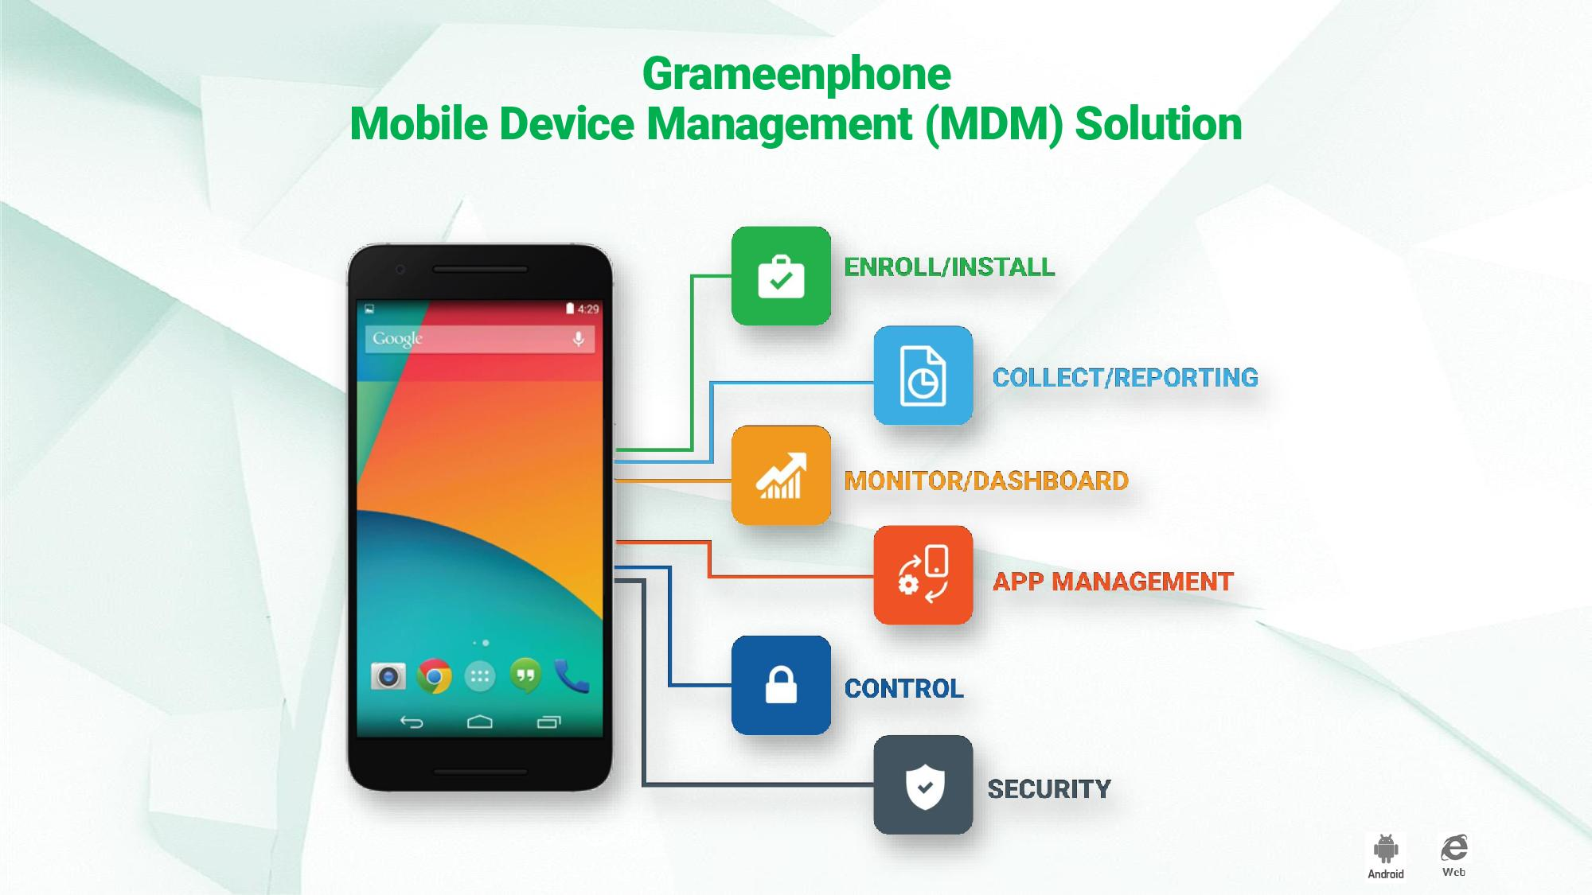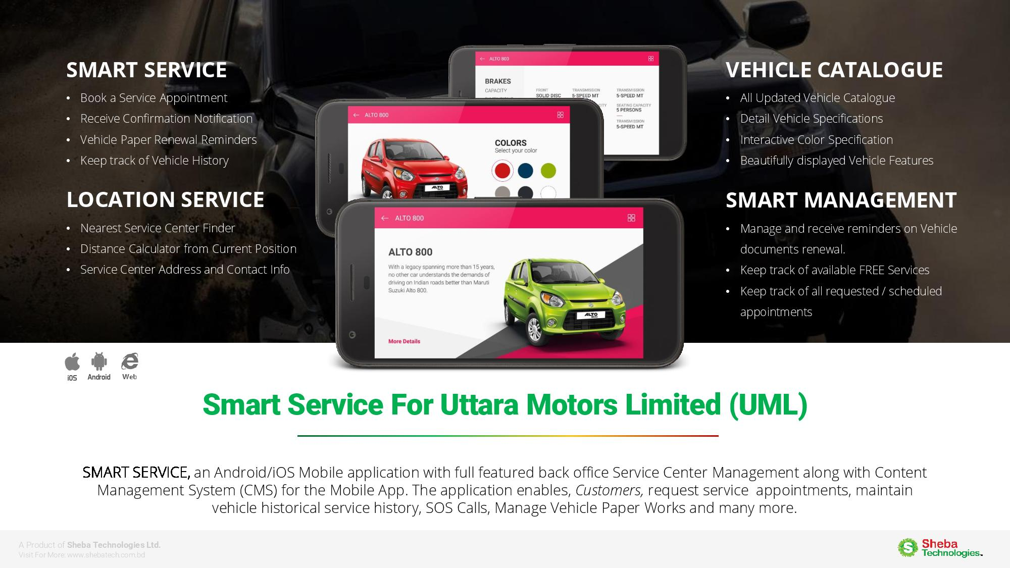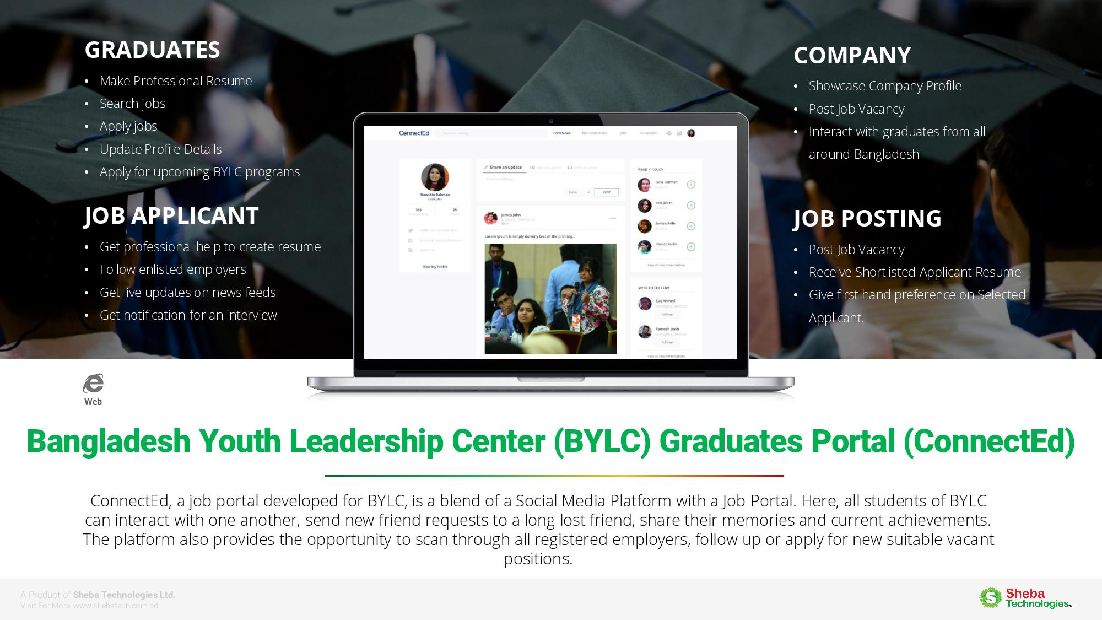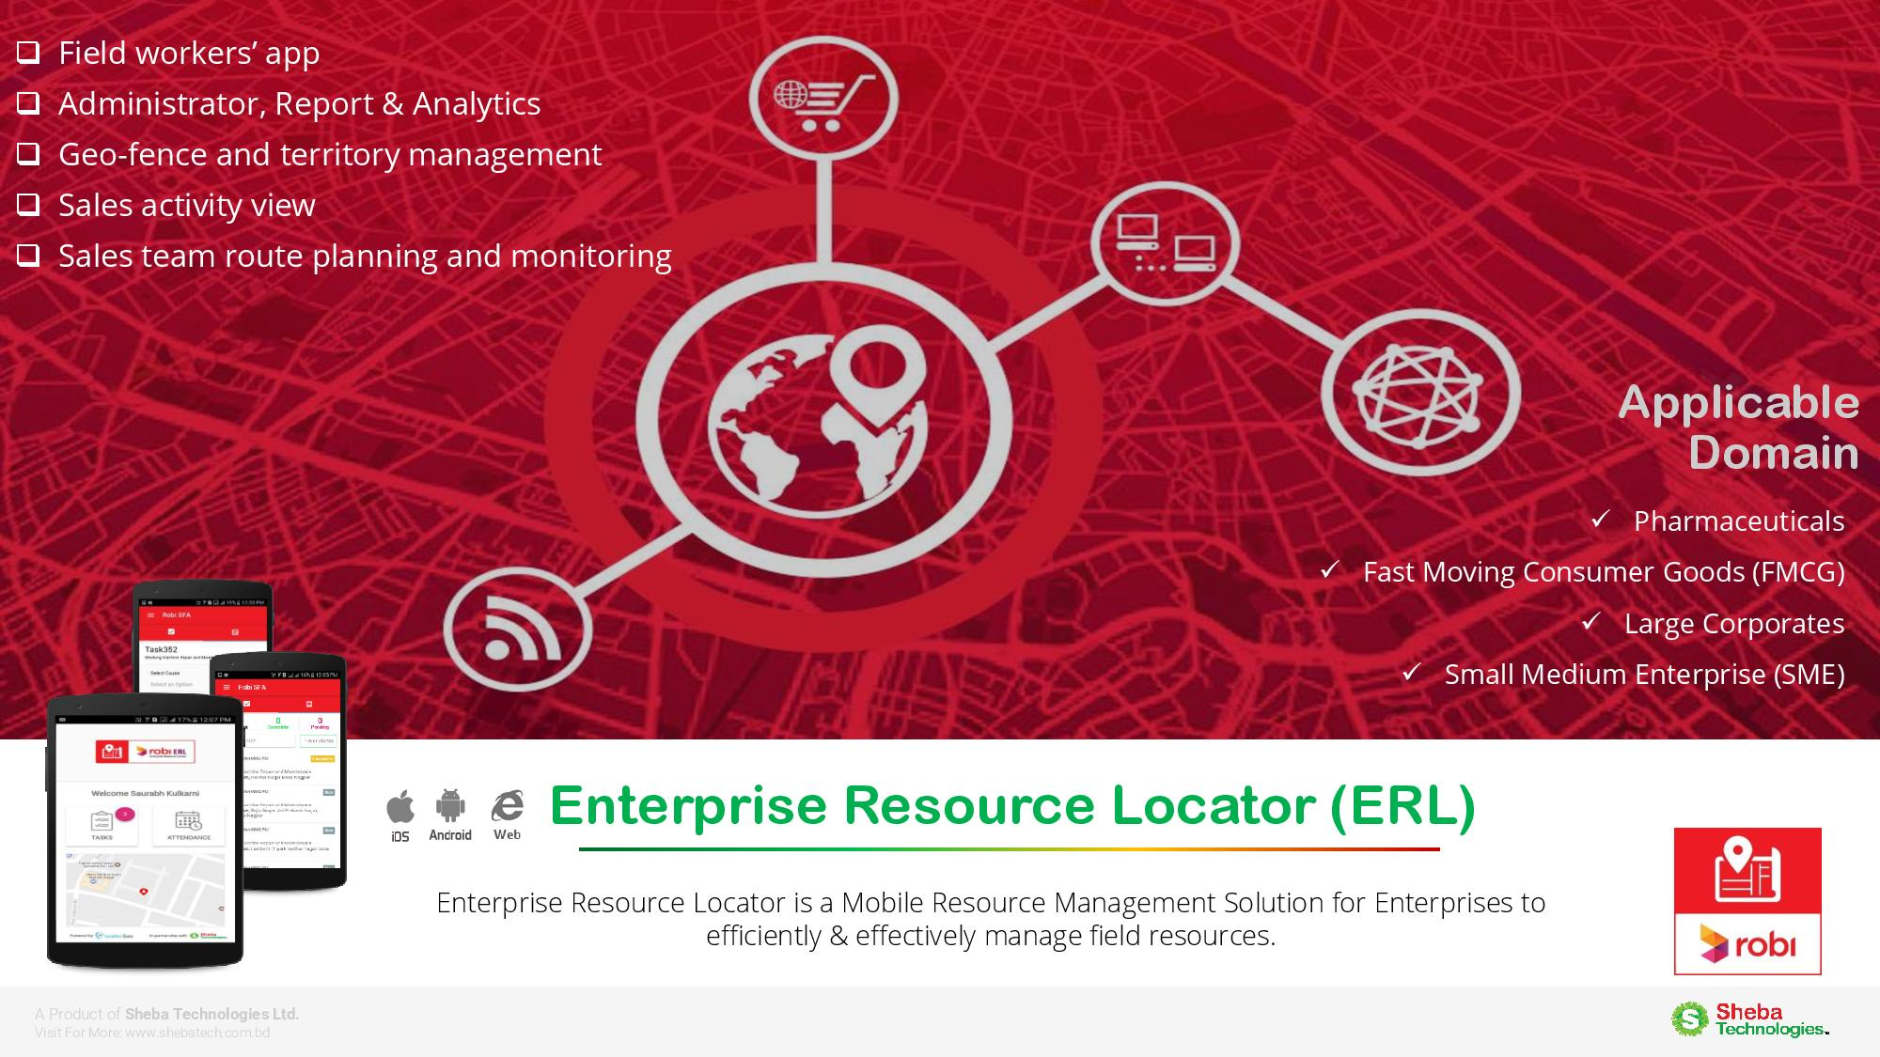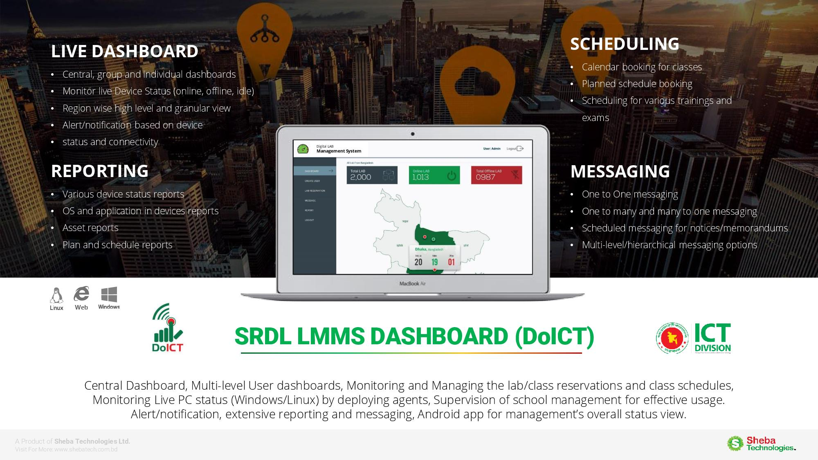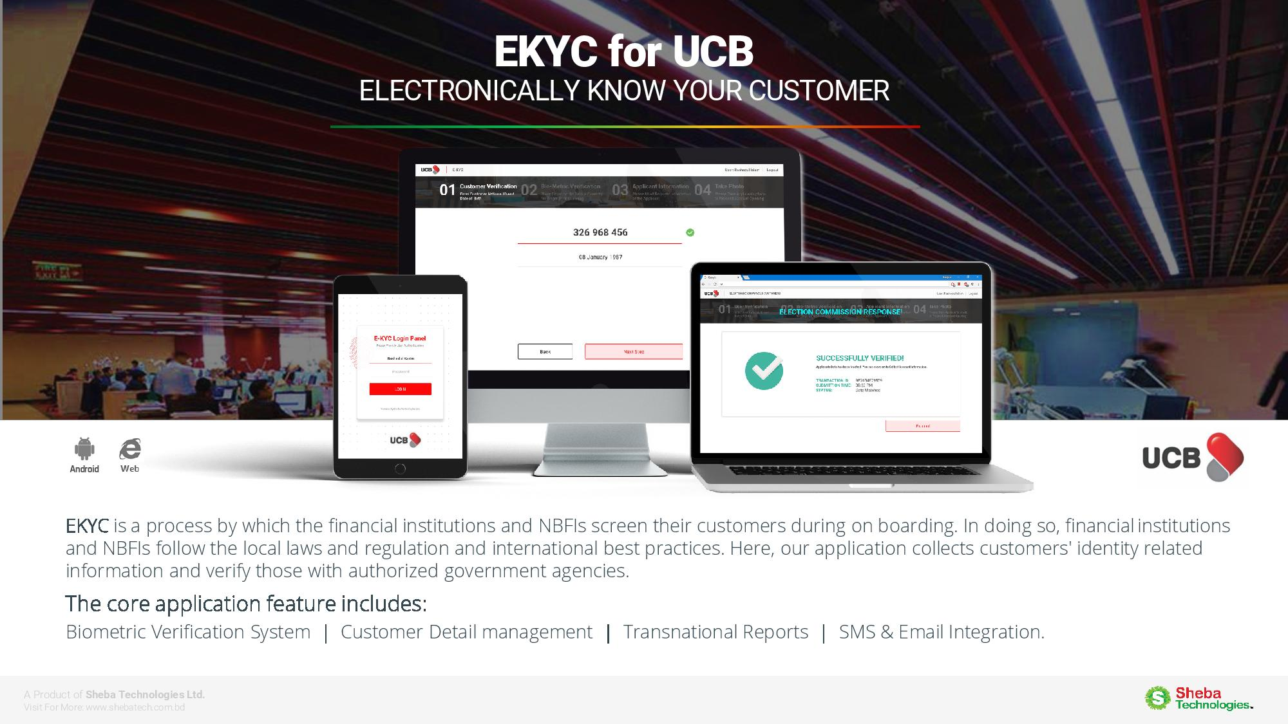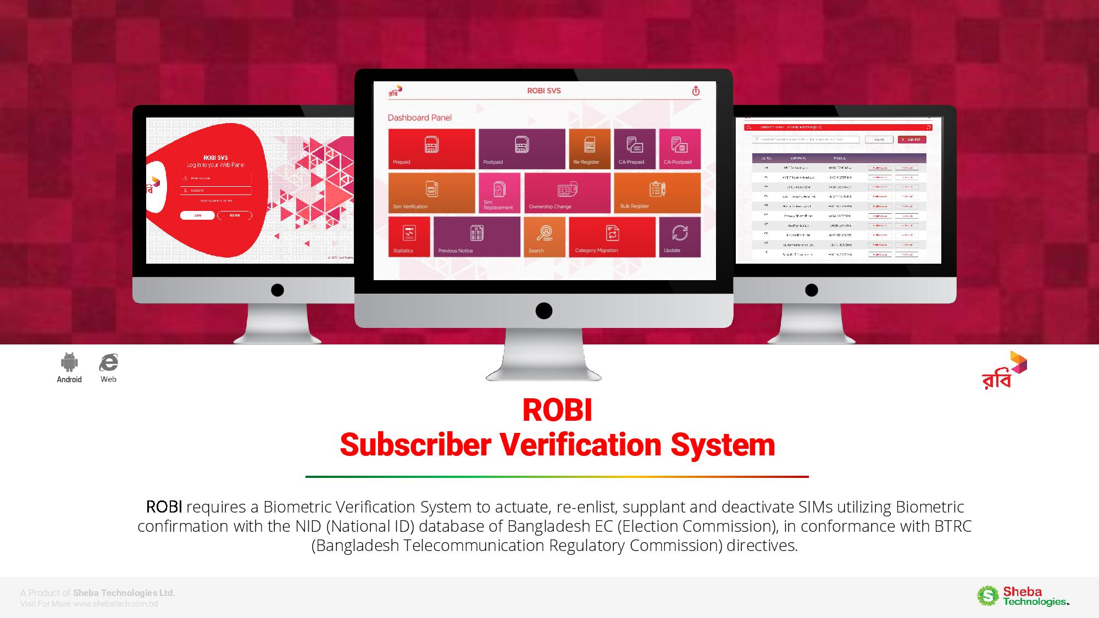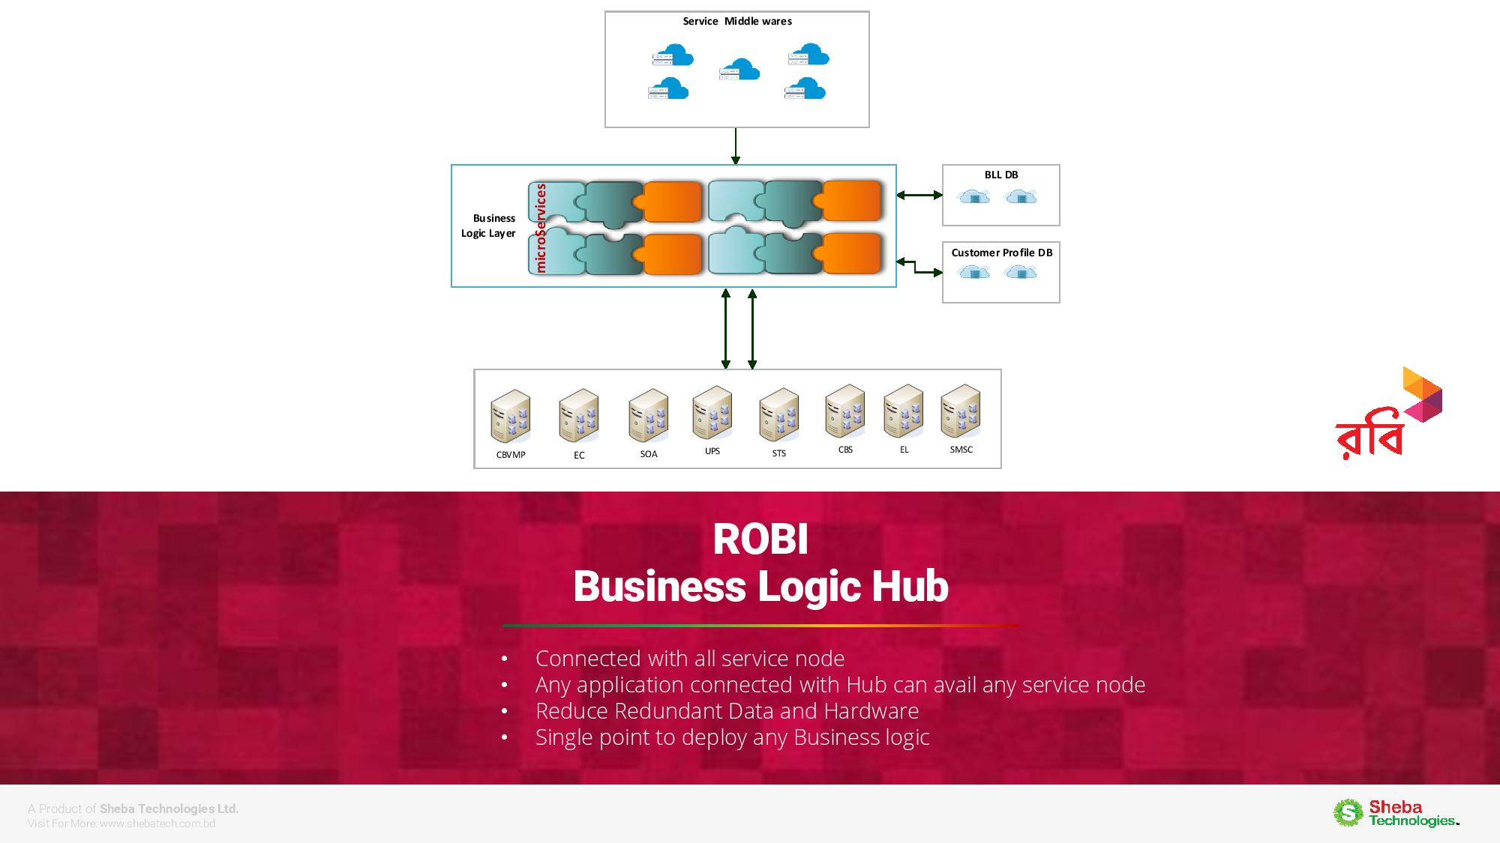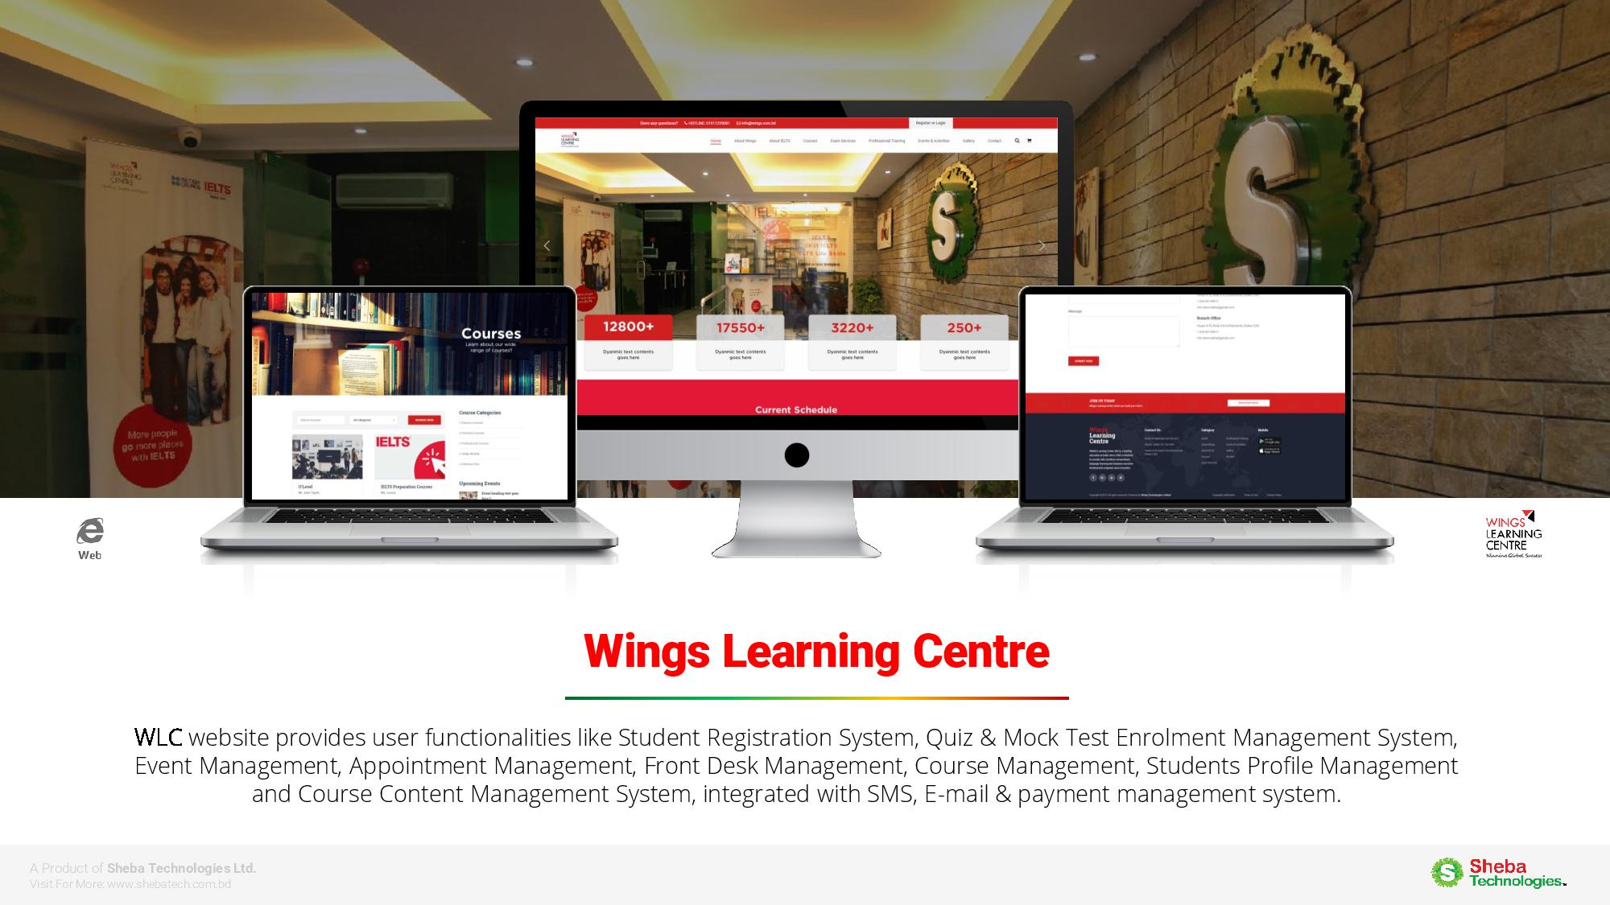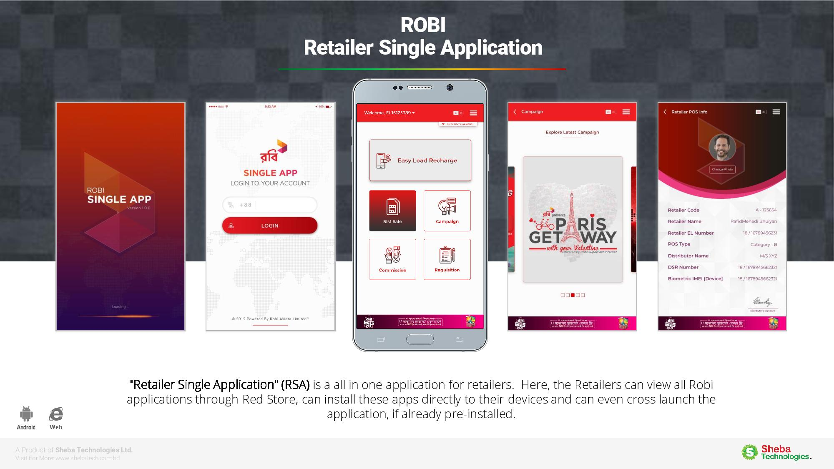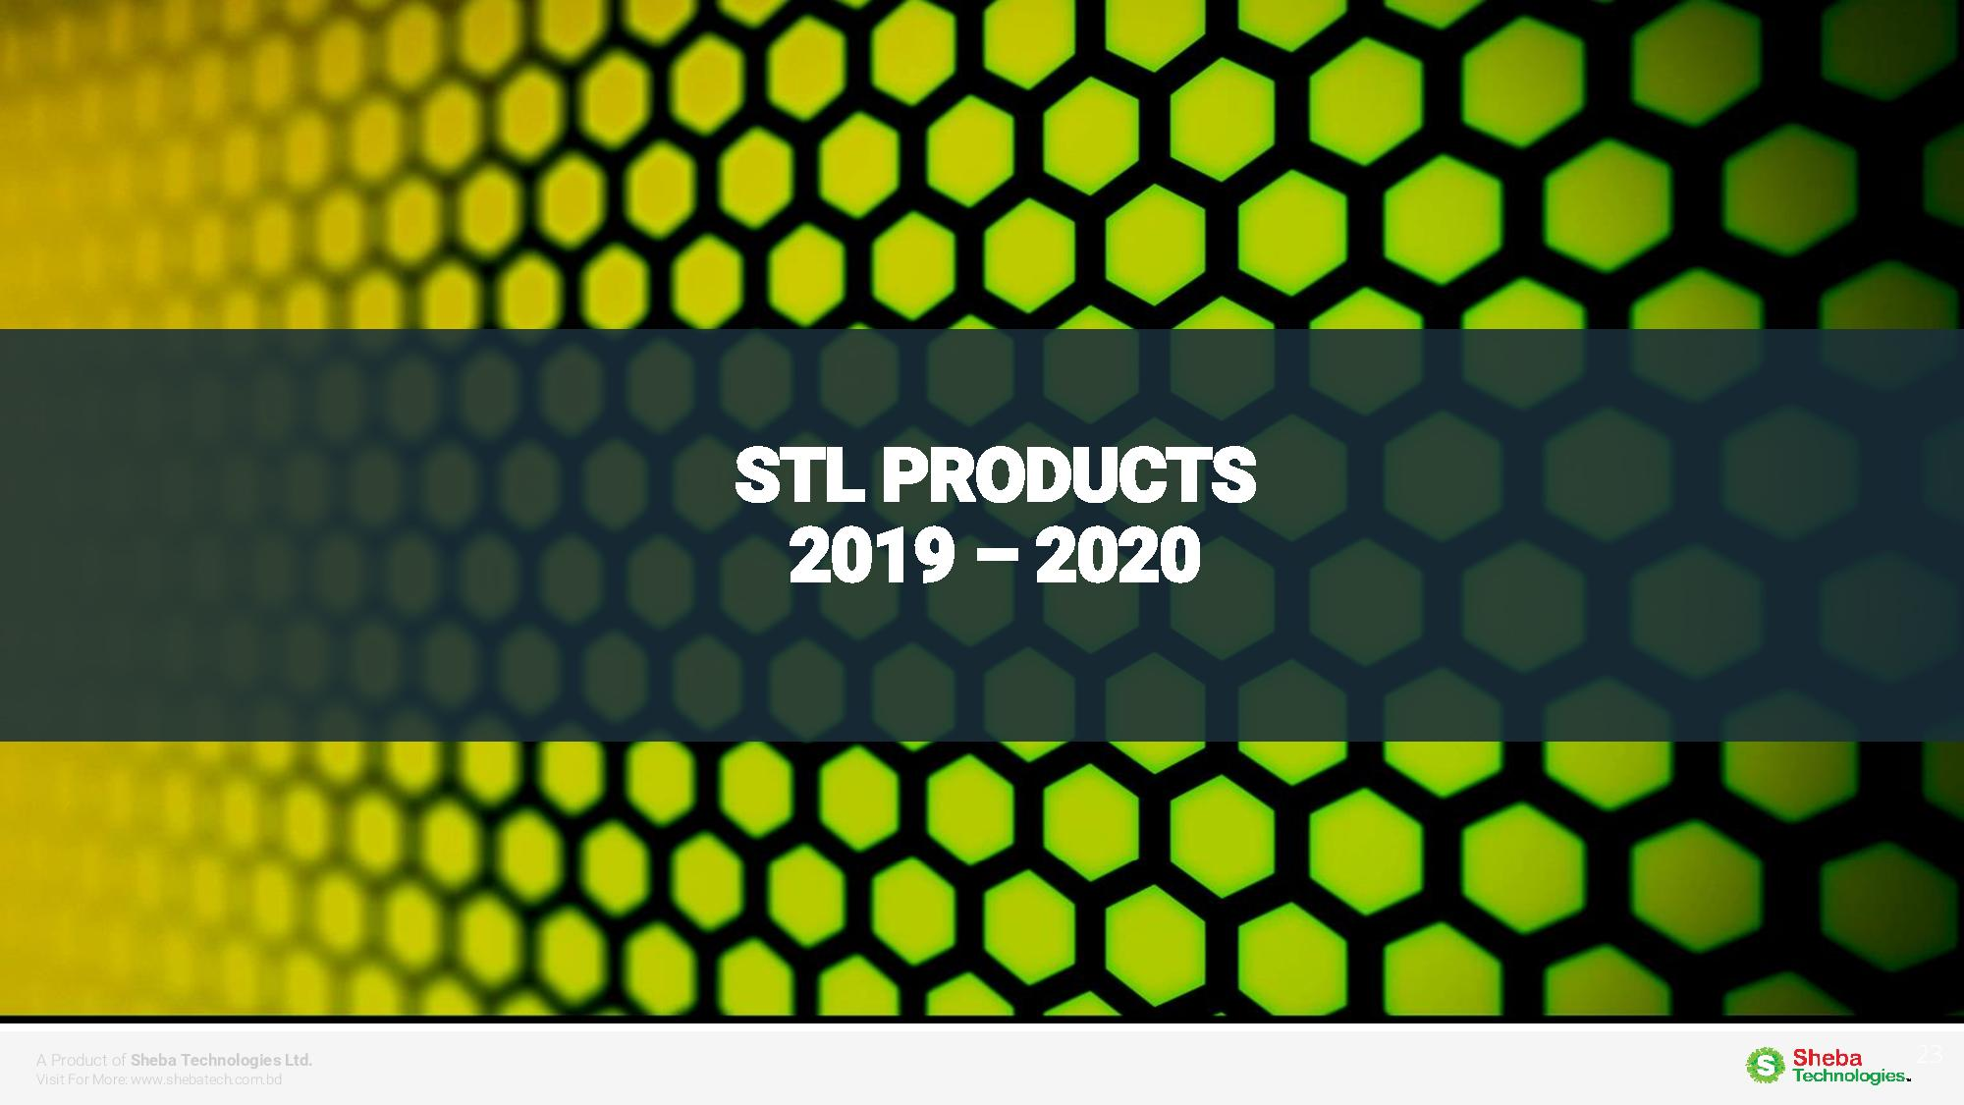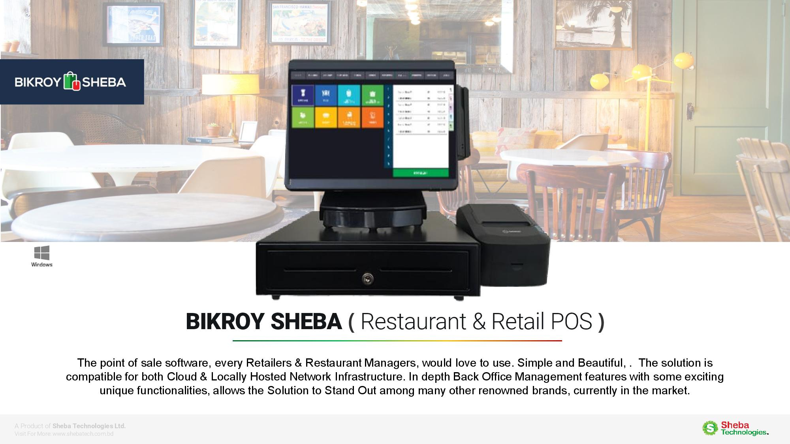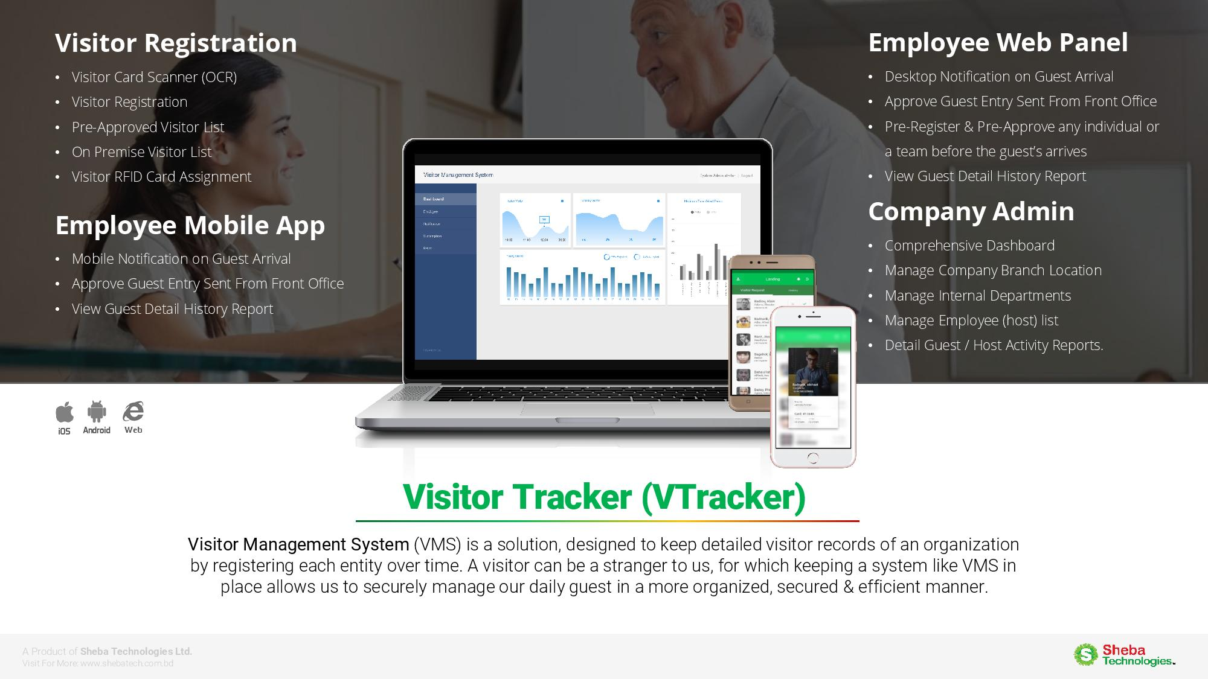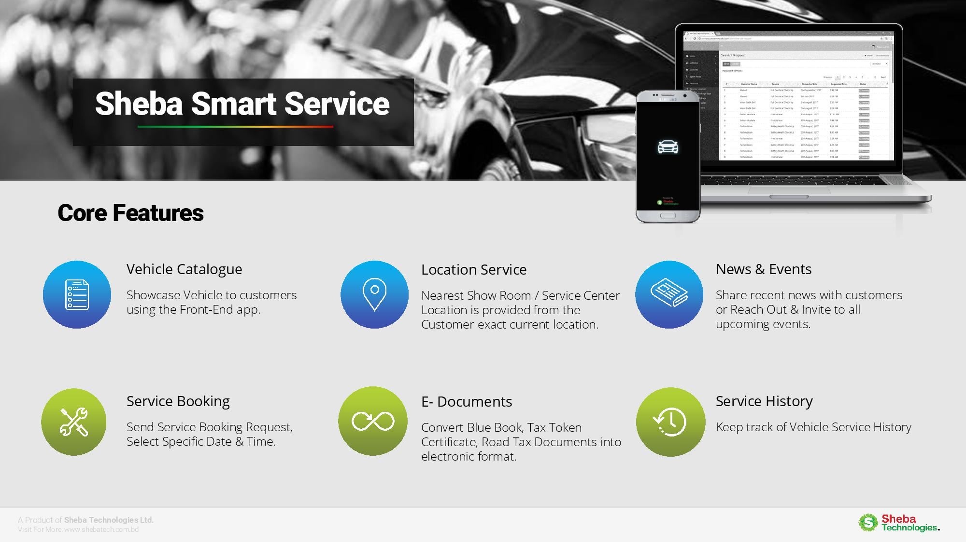

## 1.2. BETS Consulting Services Ltd.

### 1.2.1-1.2.2 Registration and General Profile of the Firms & Updated Trade license, Updated TIN certificate, VAT registration certificate, latest BASIS Membership certificate

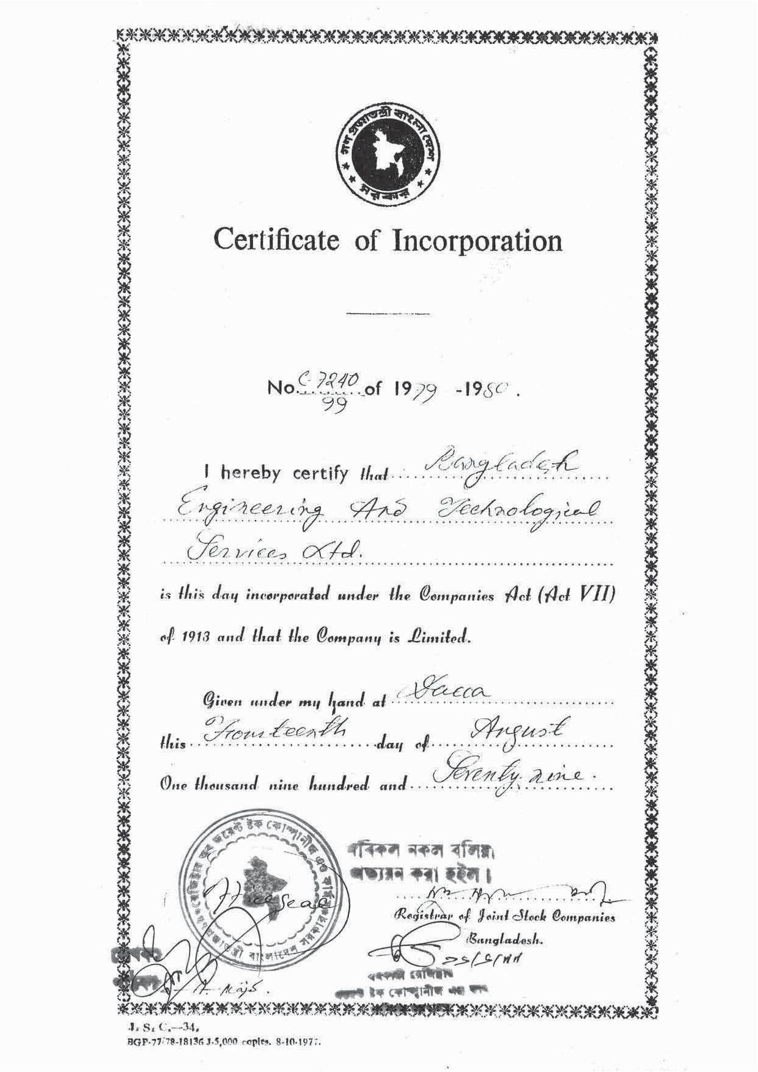

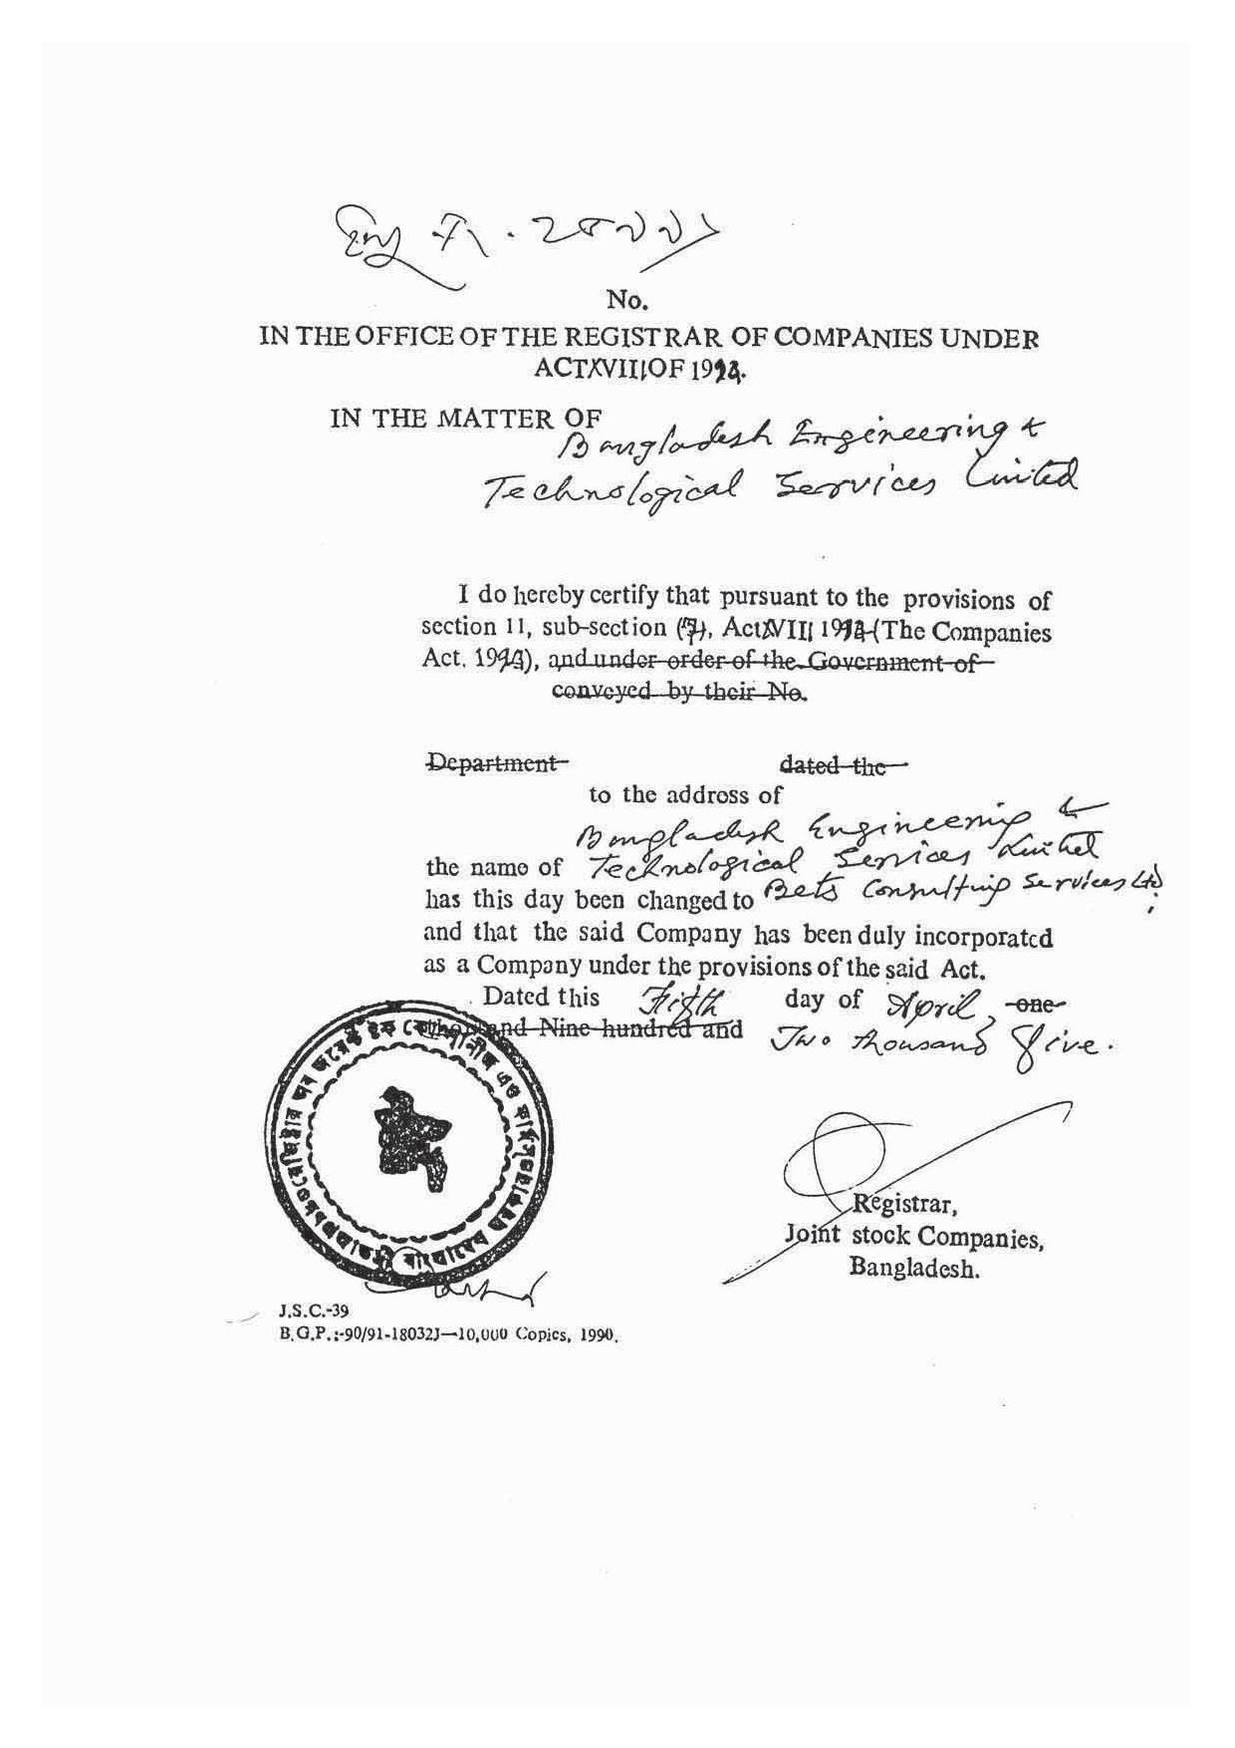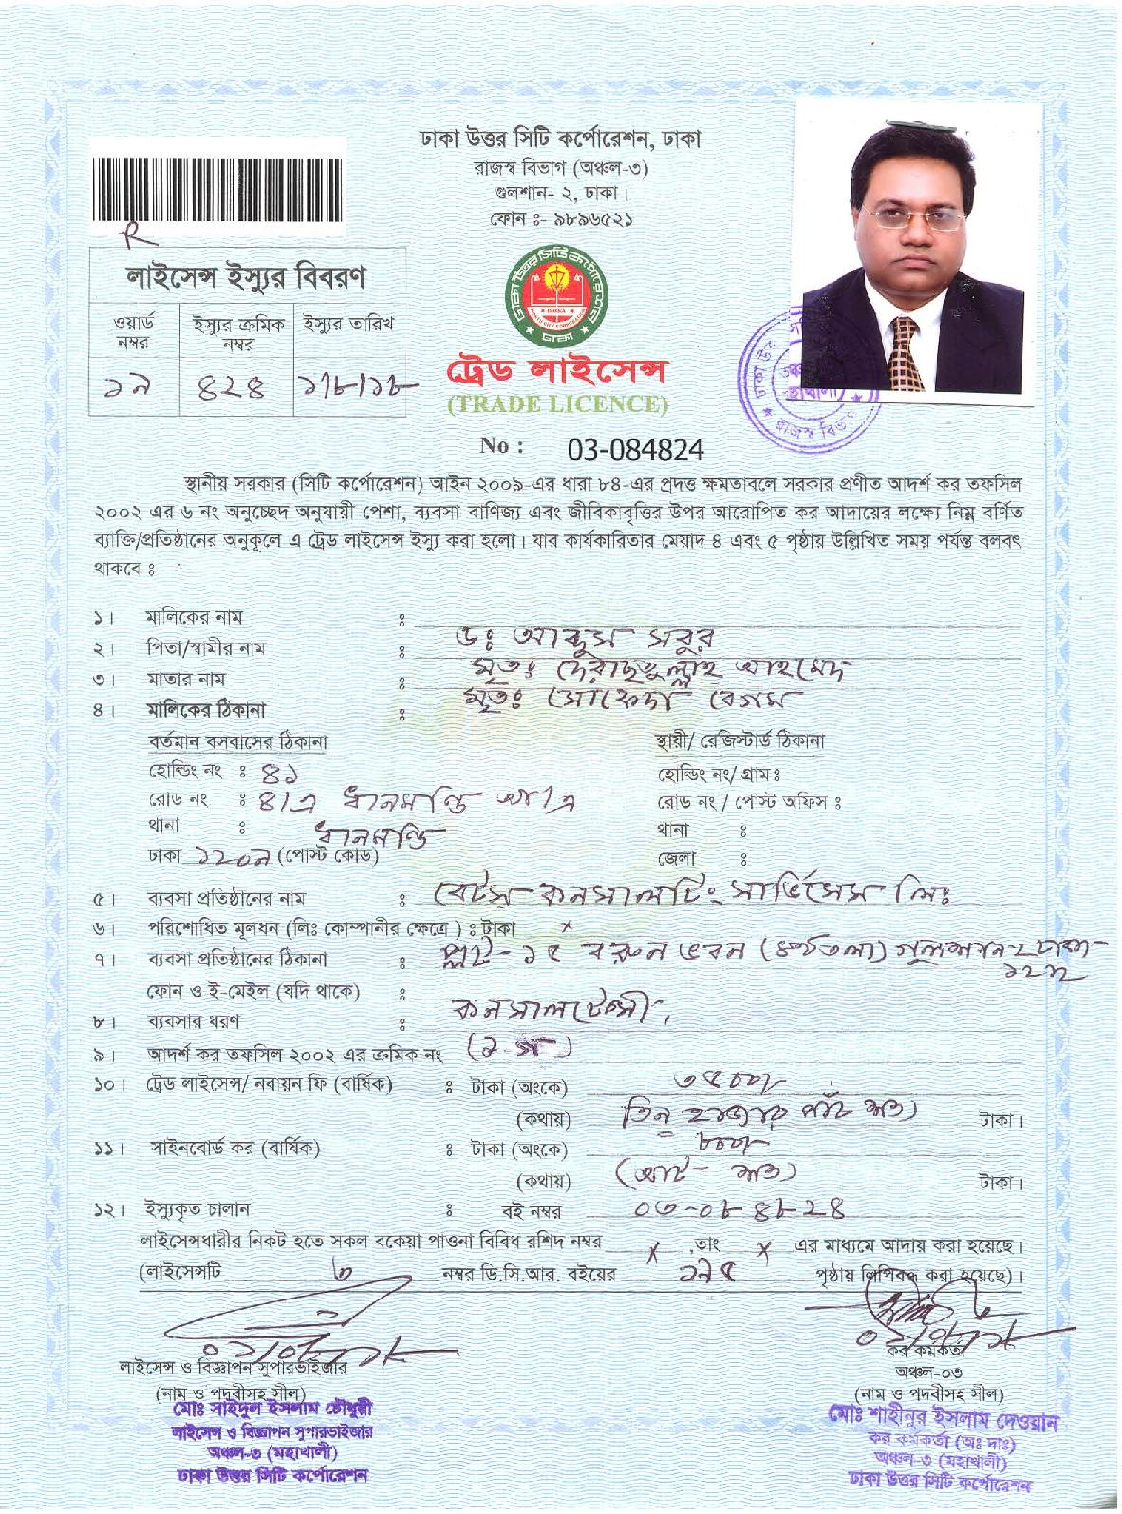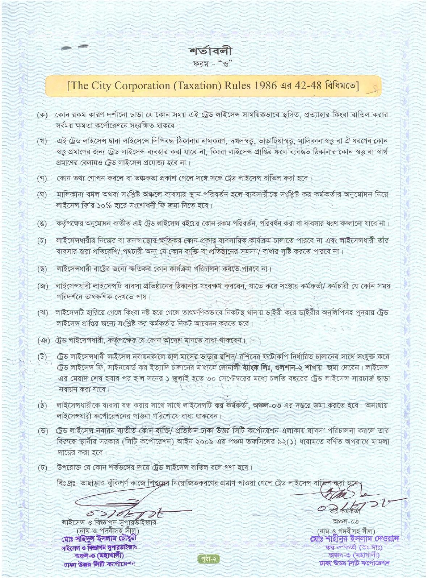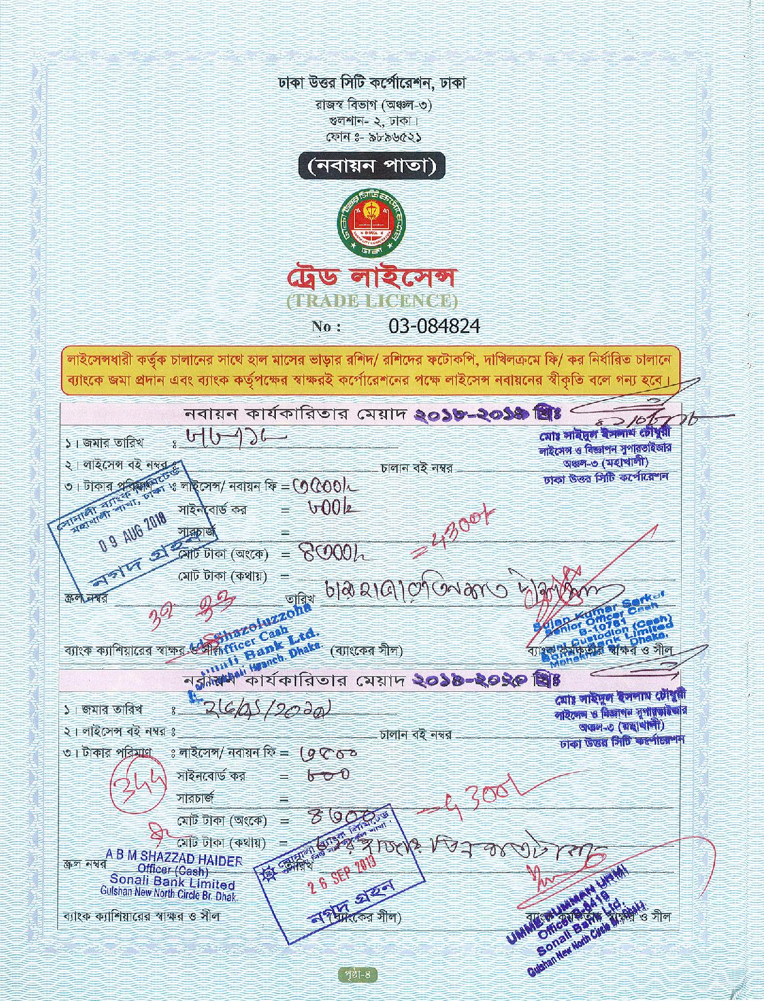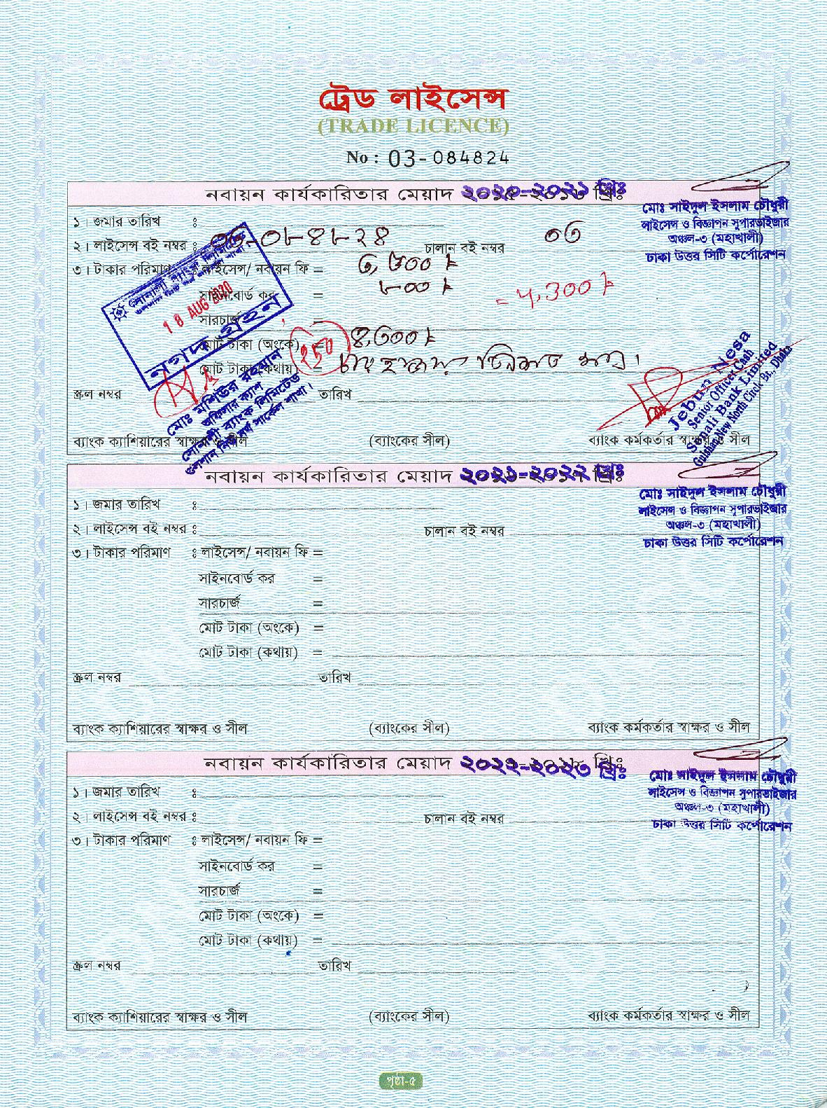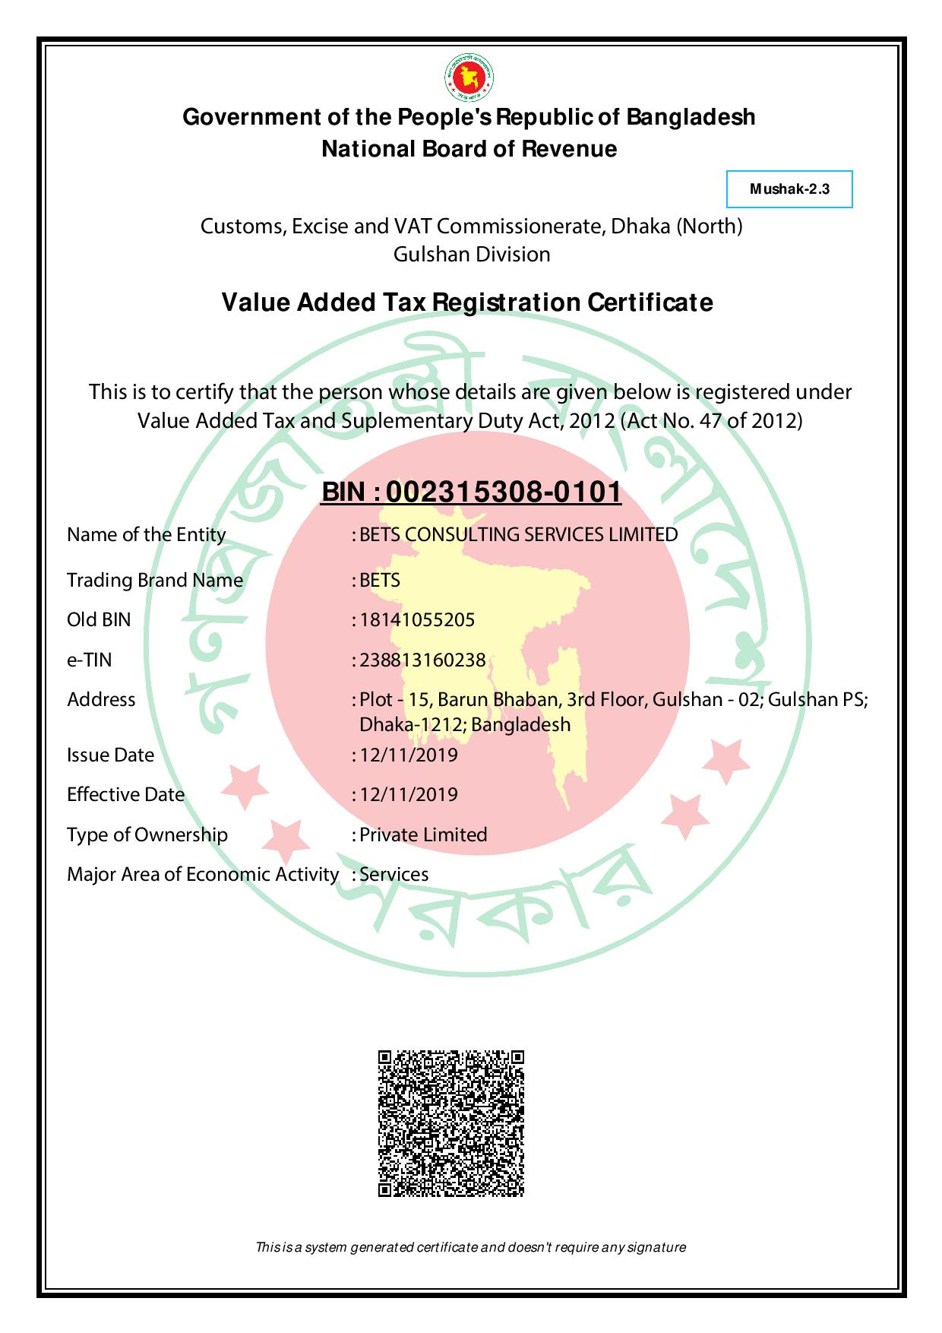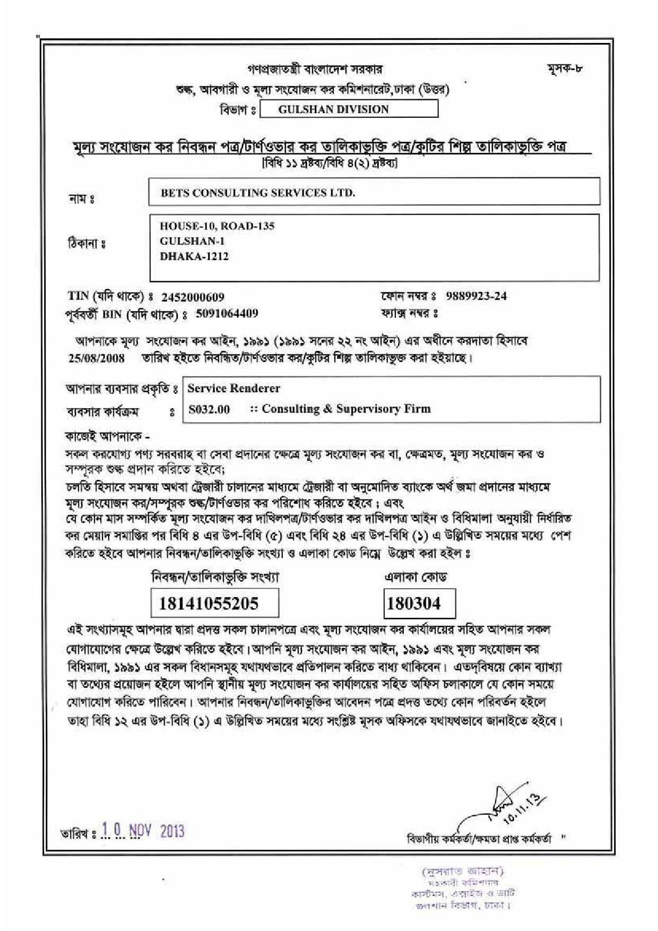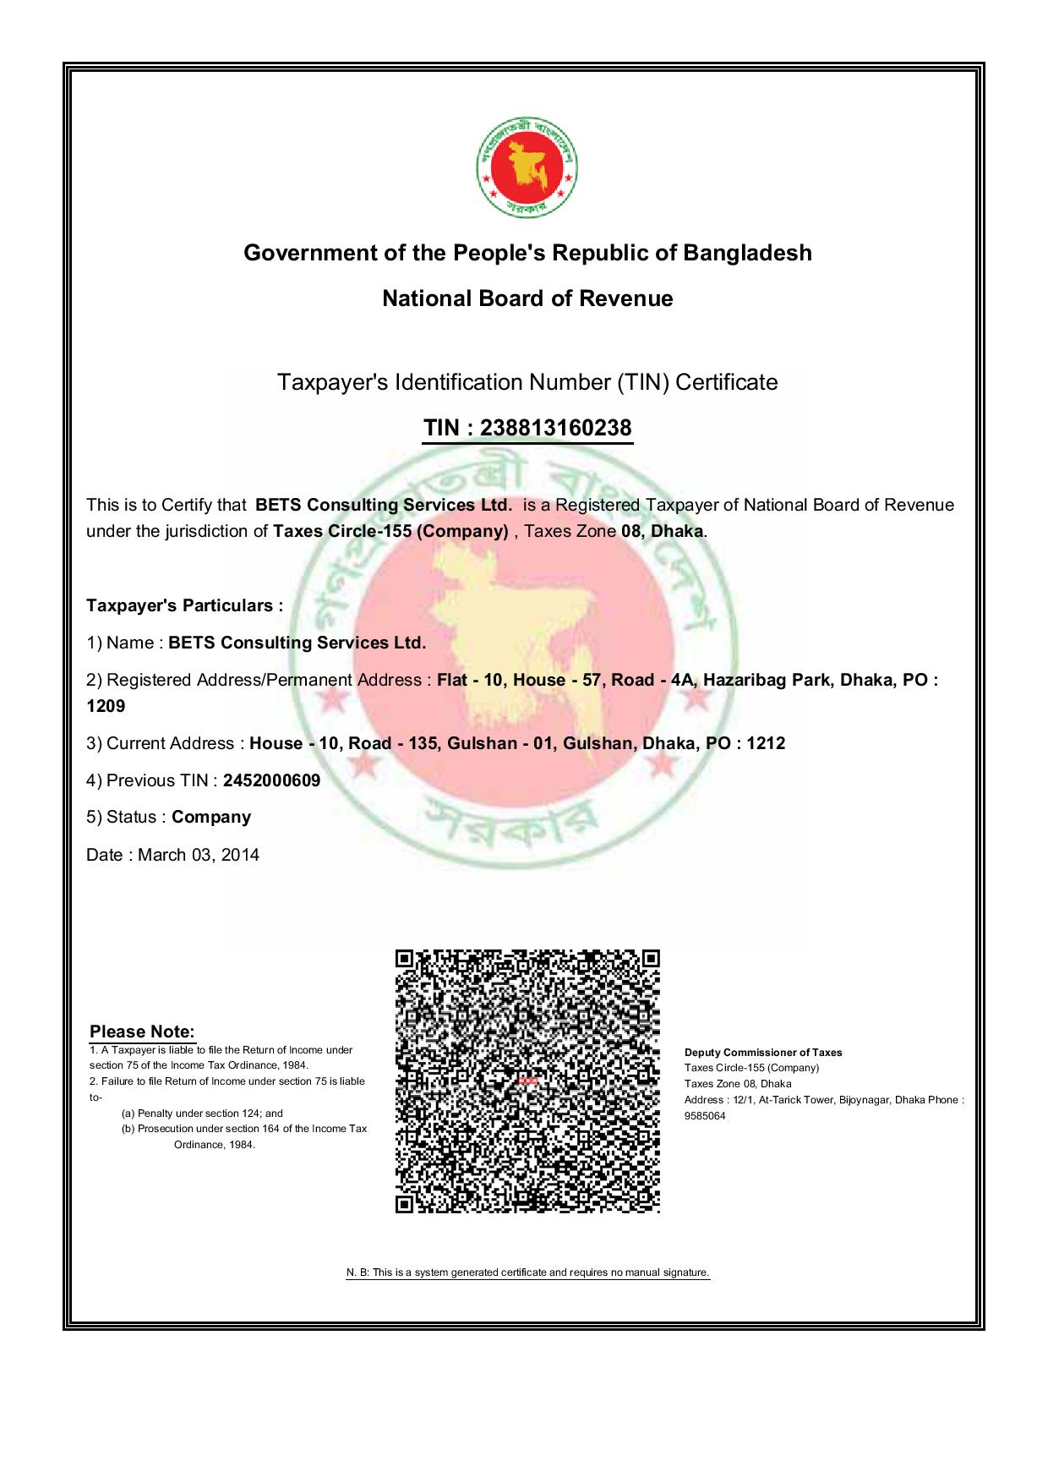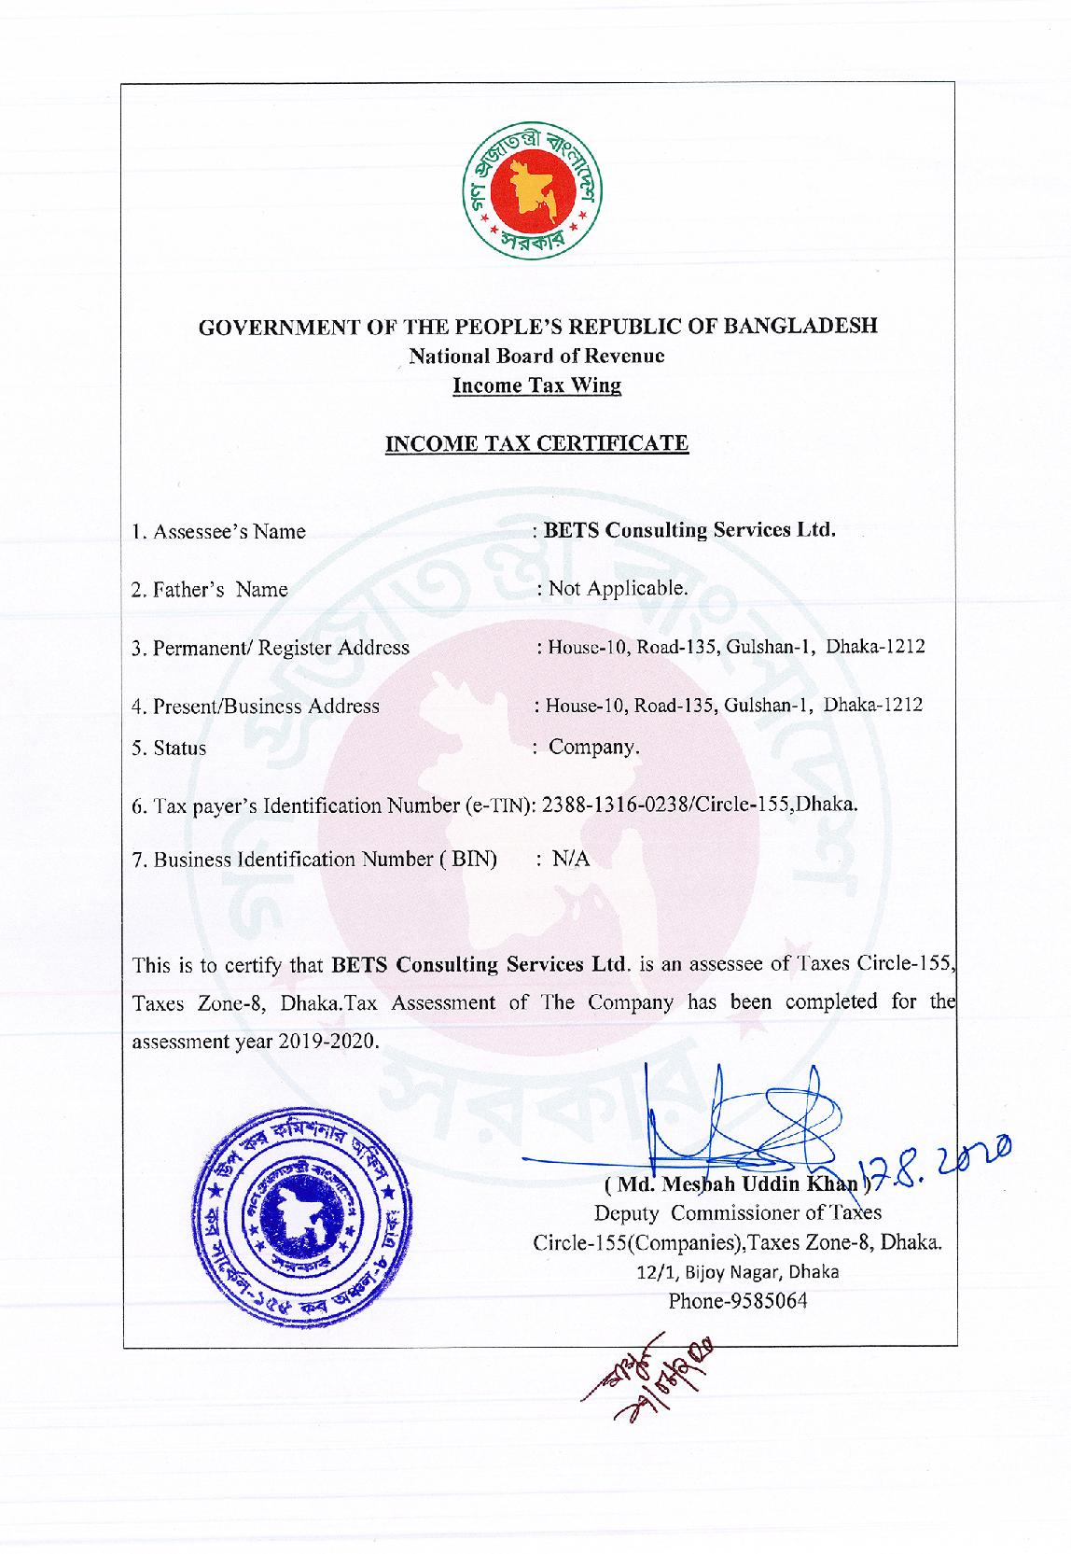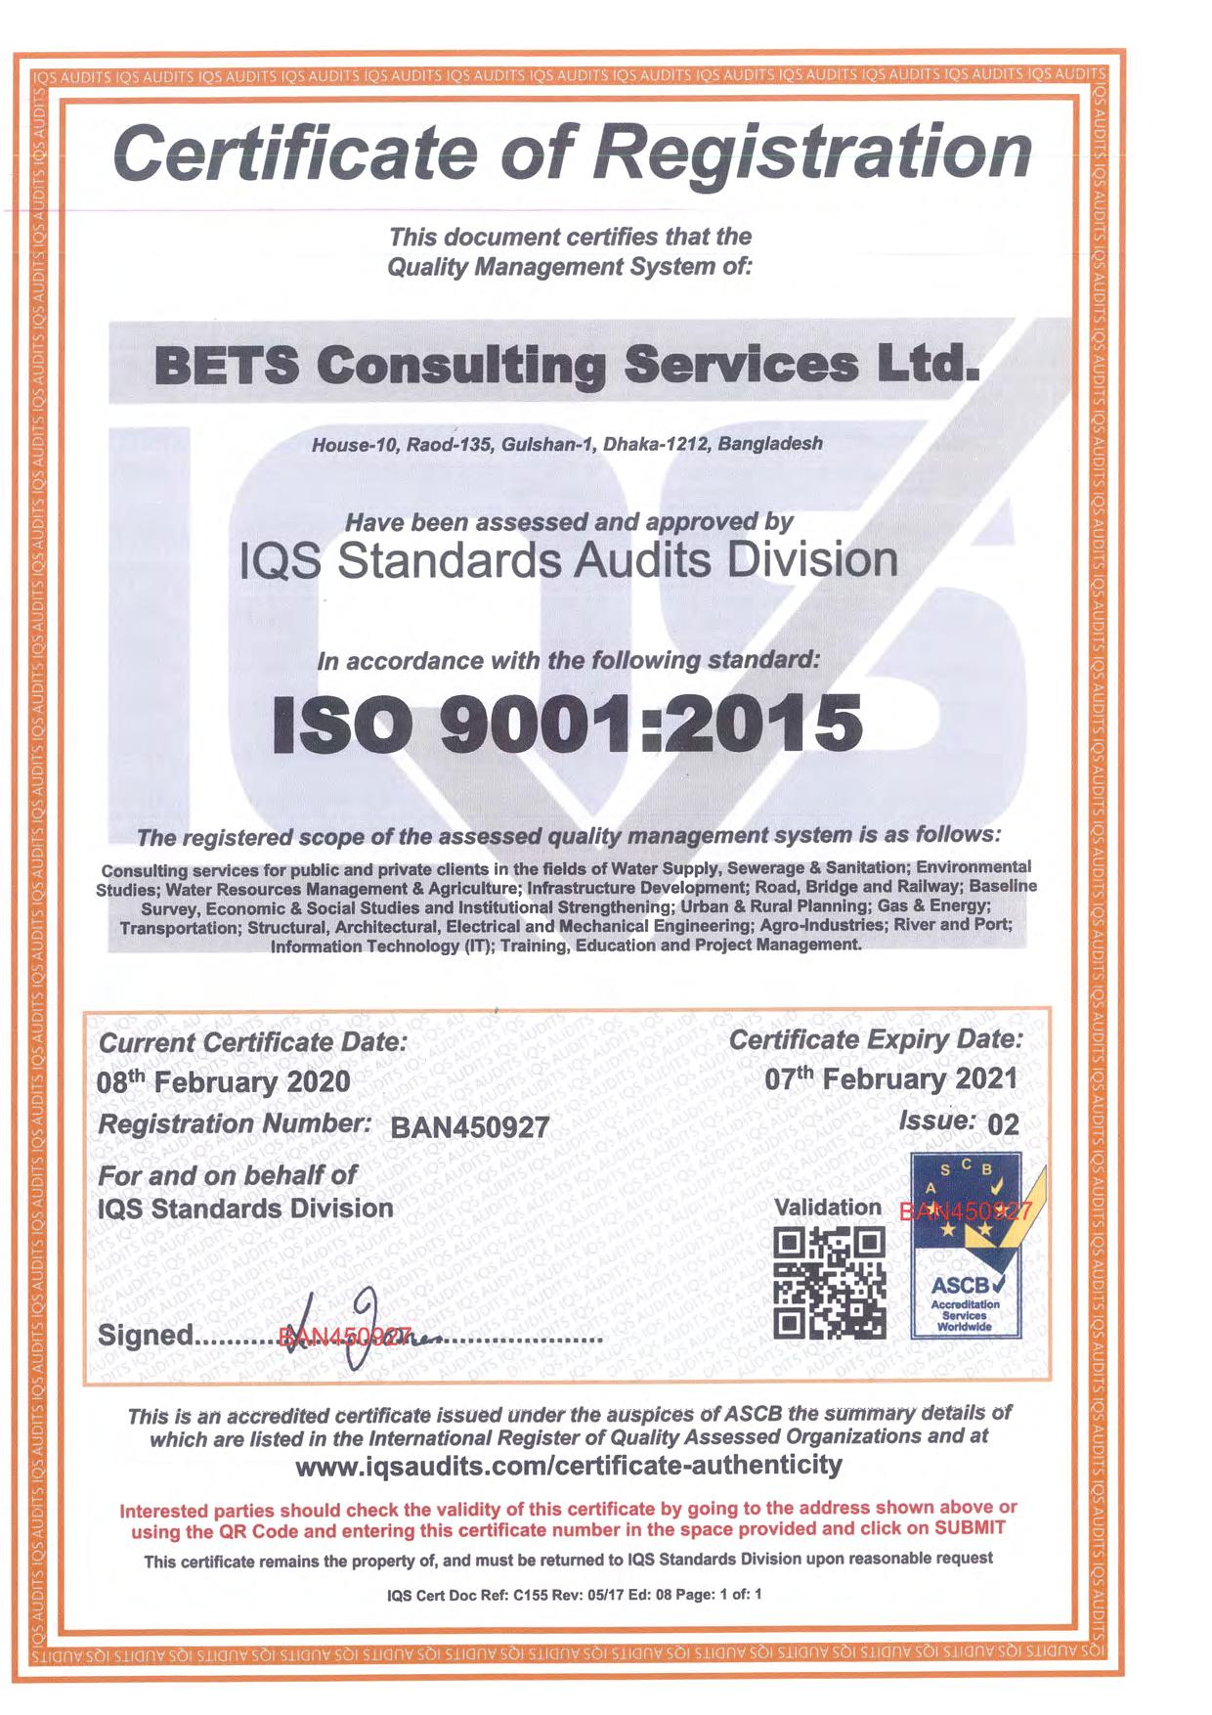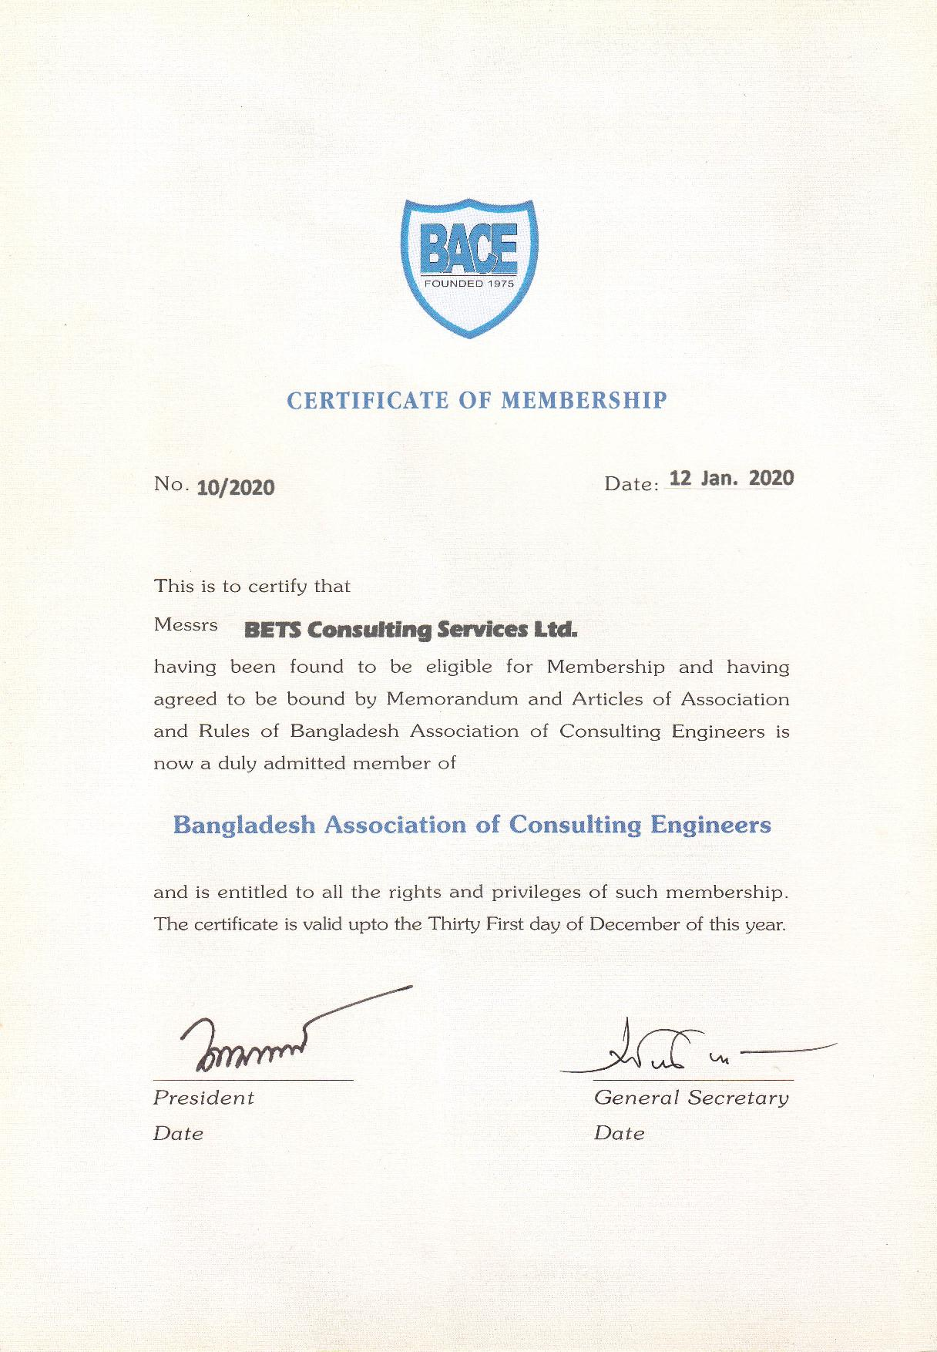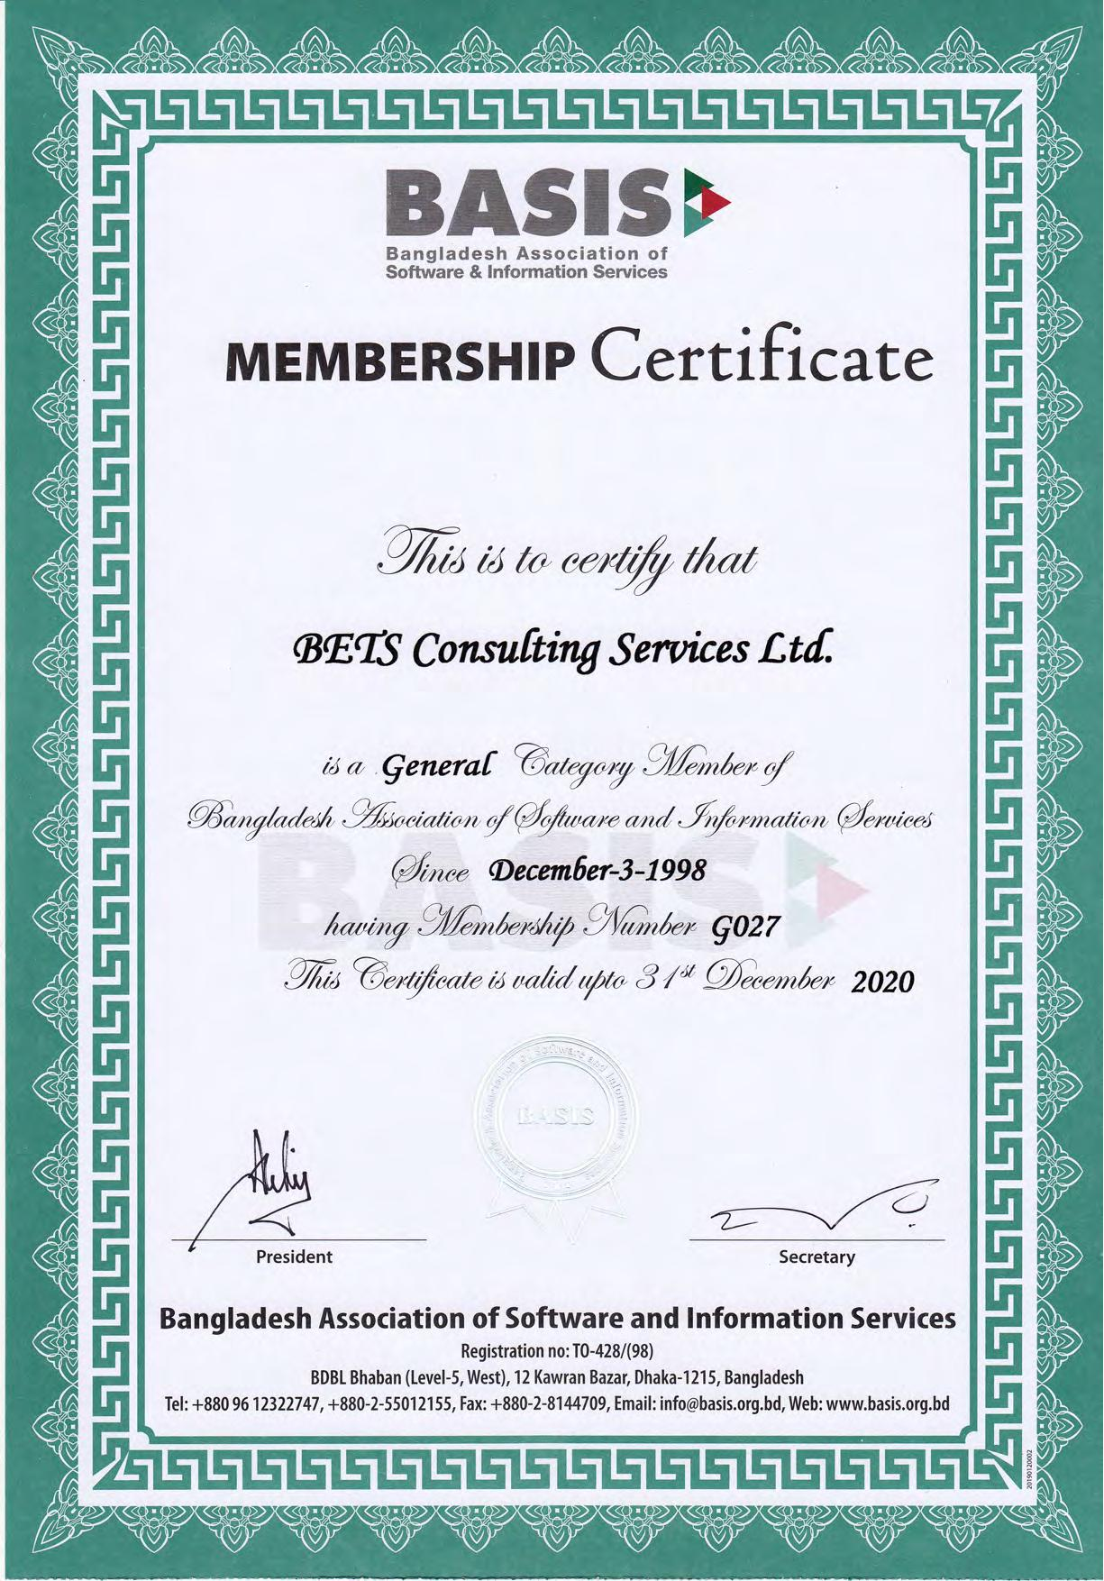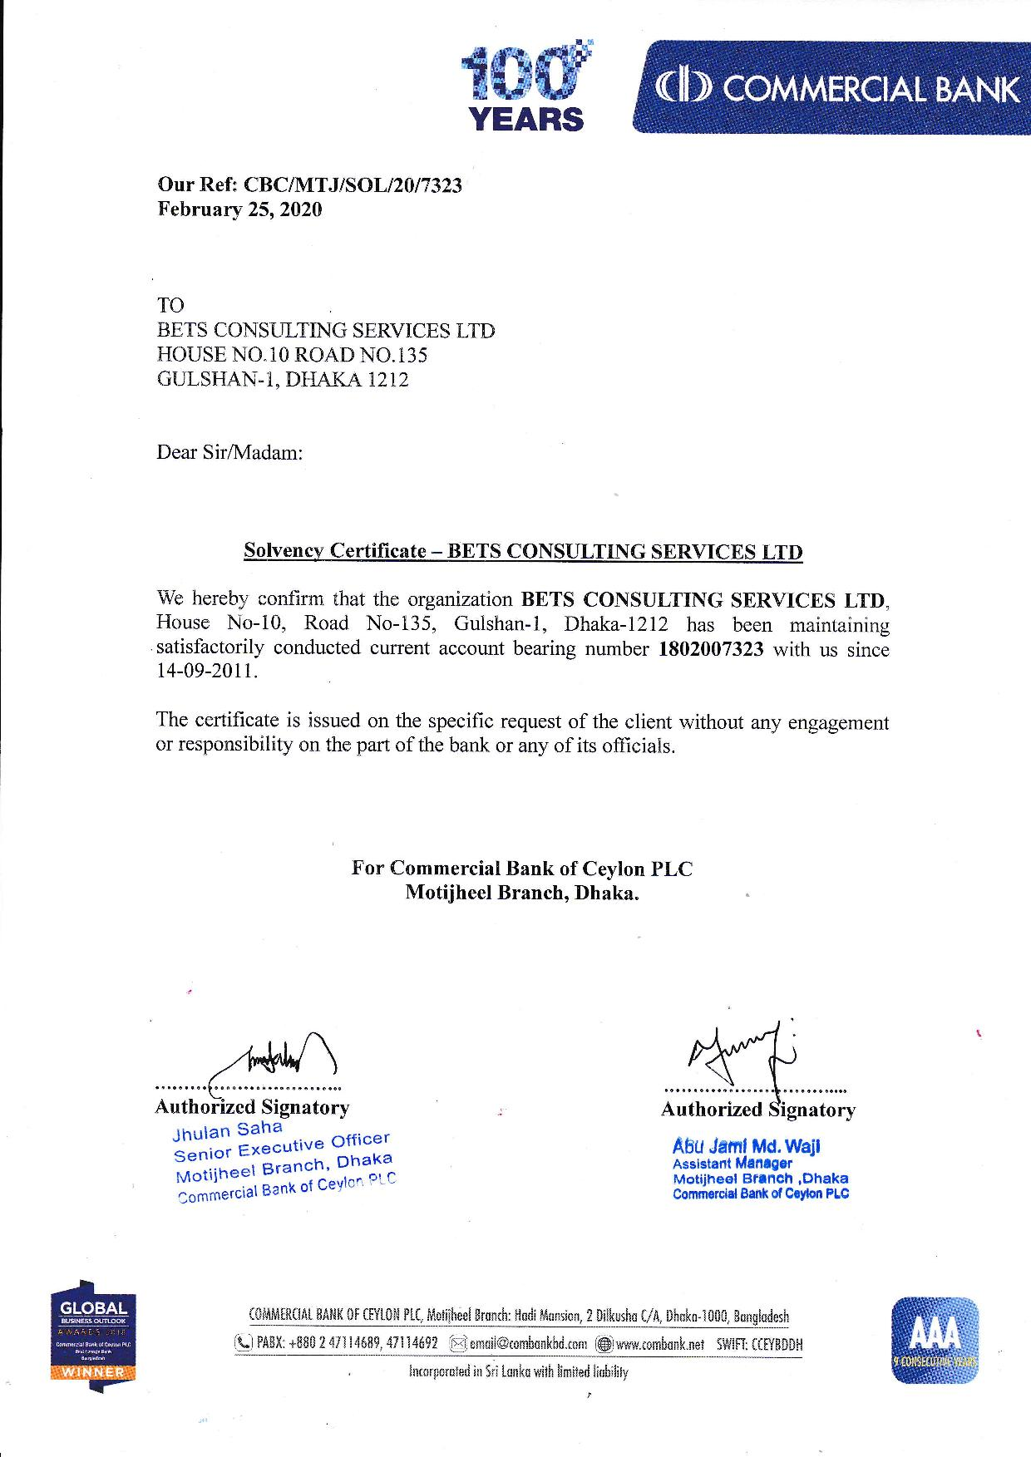

### 1.2.3 Brochure of BETS

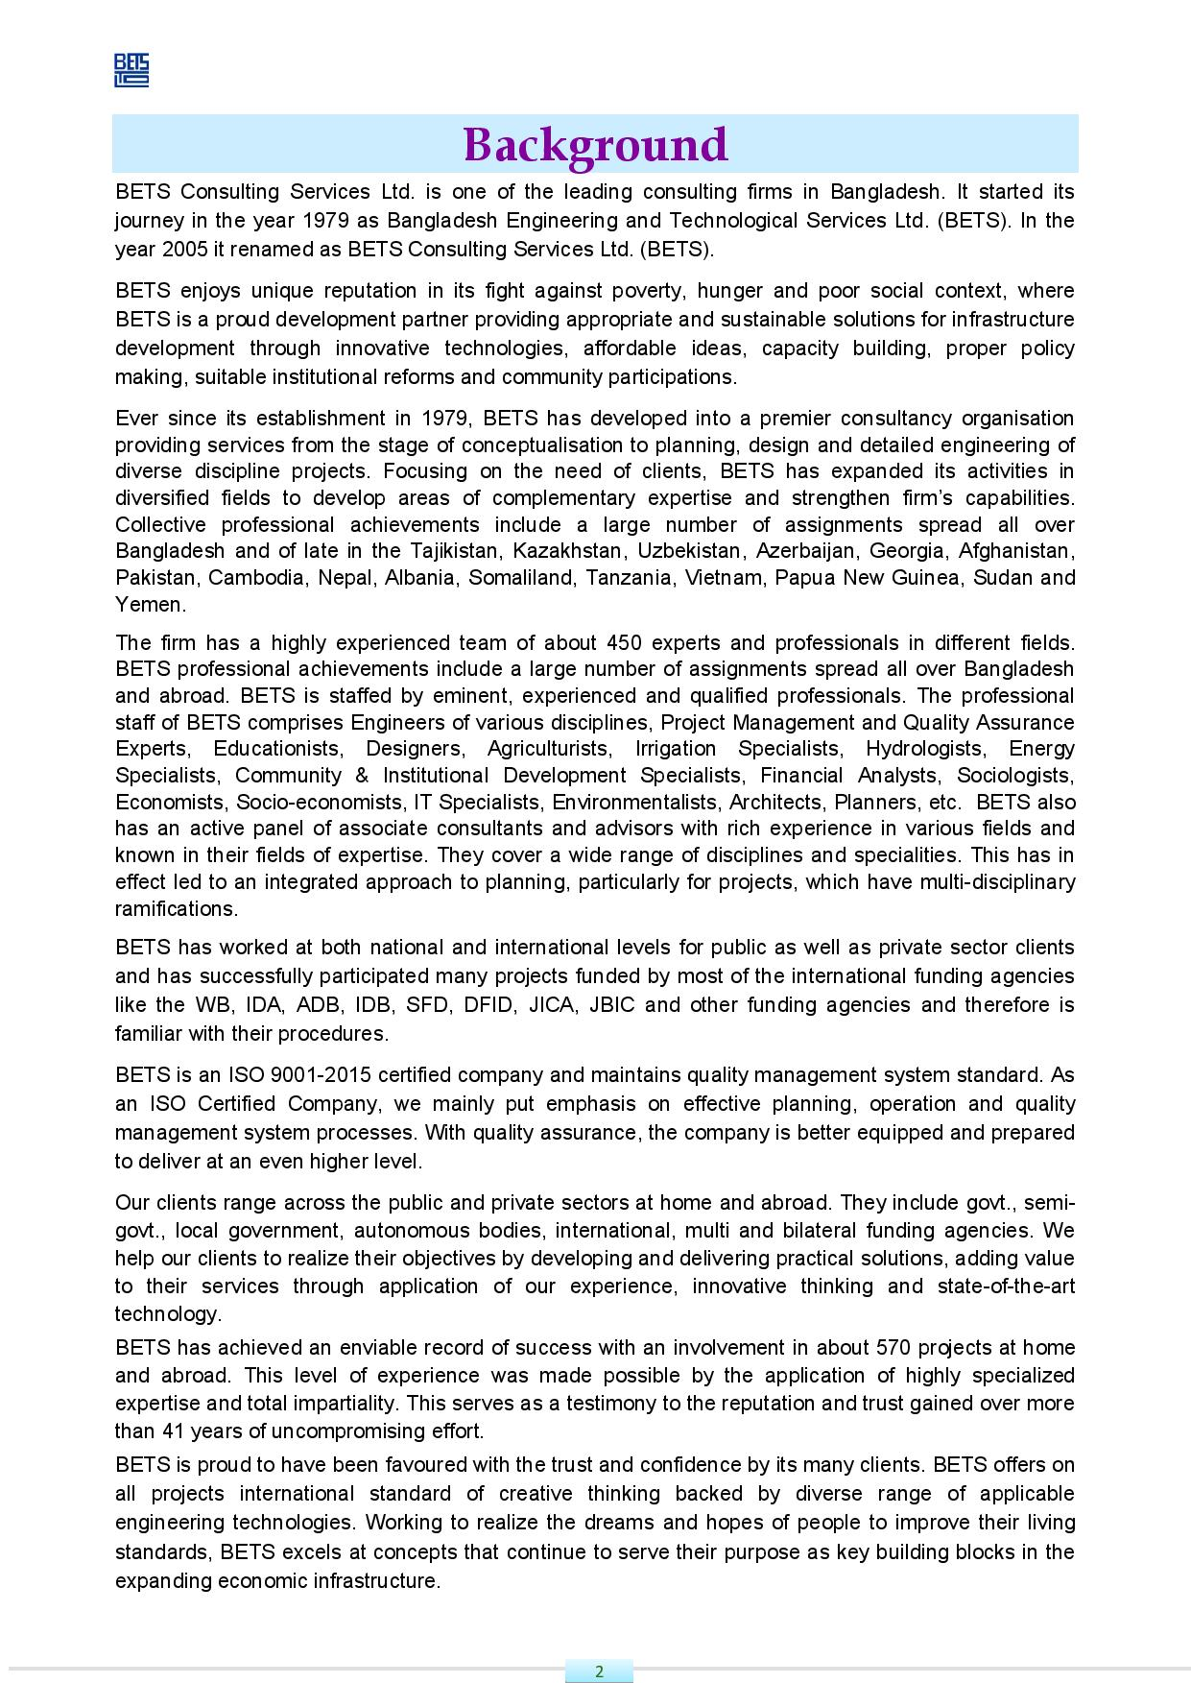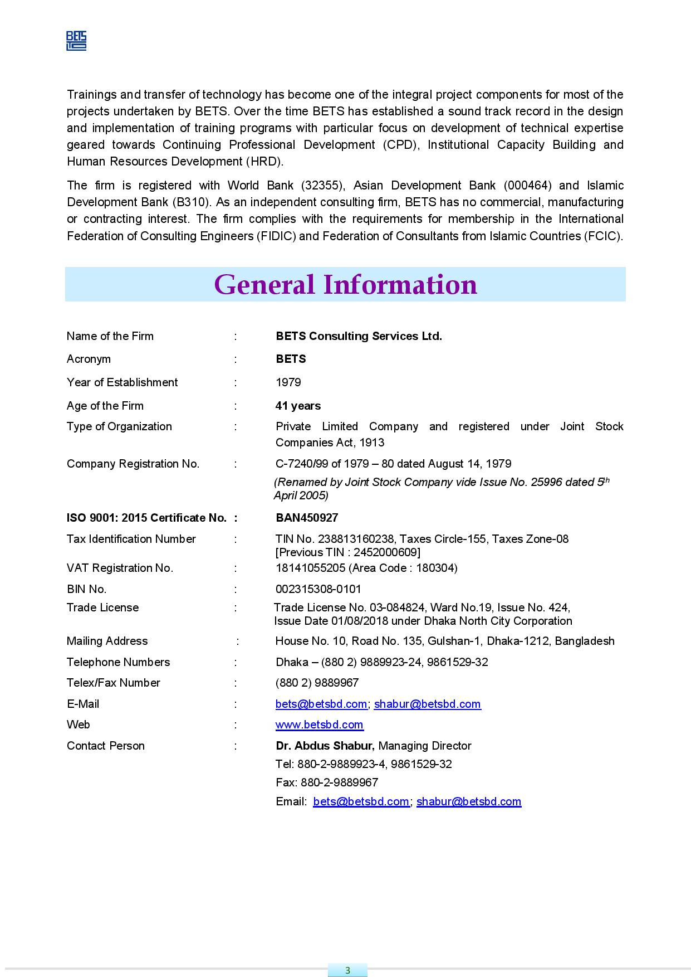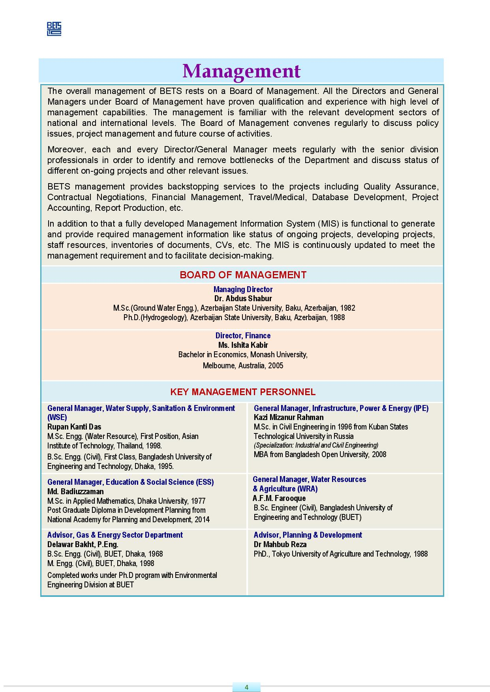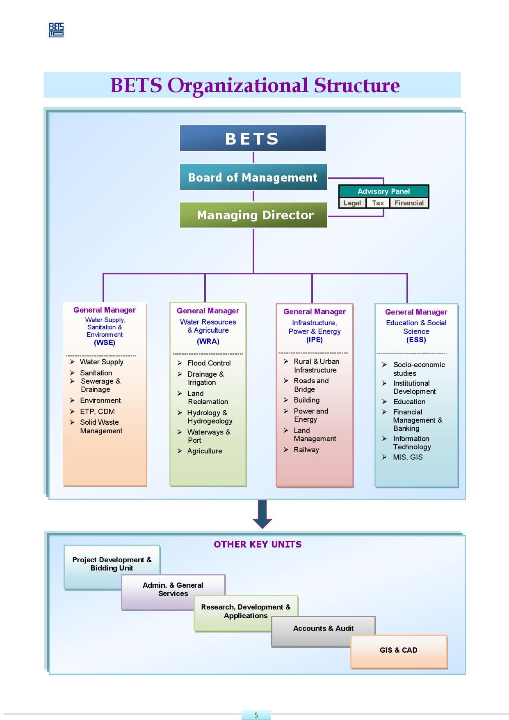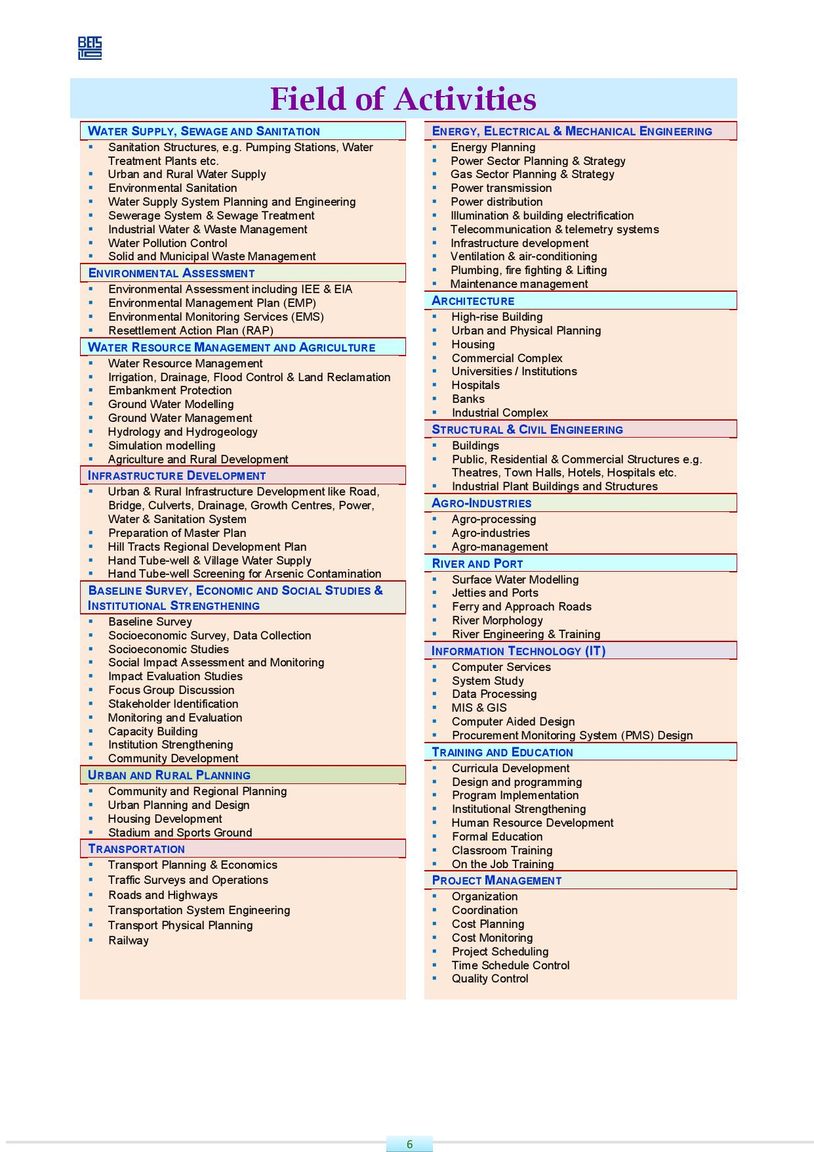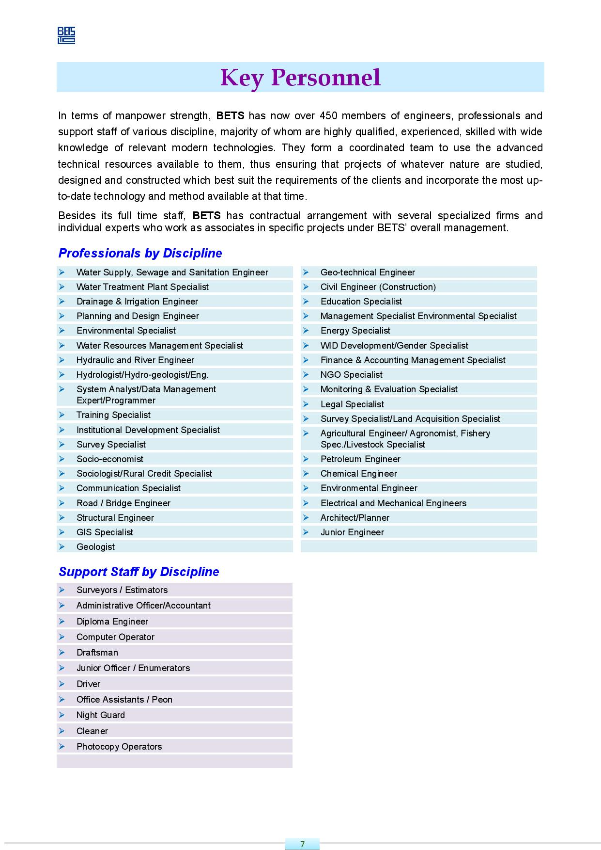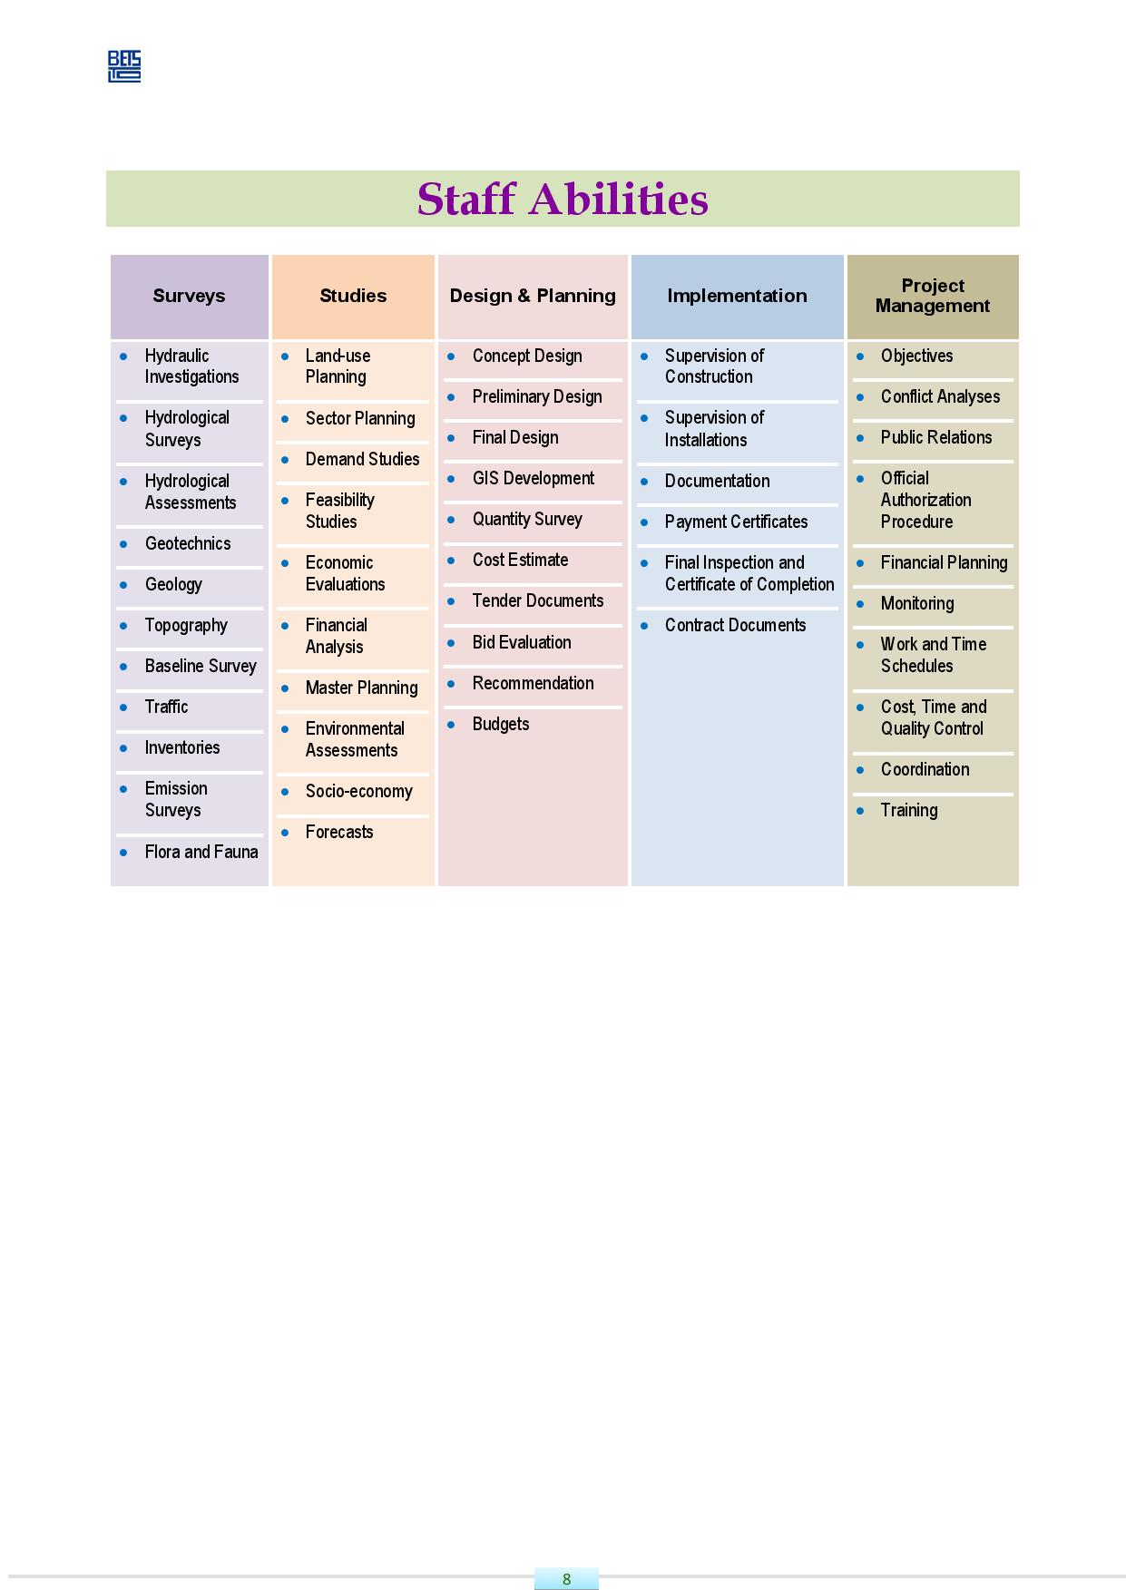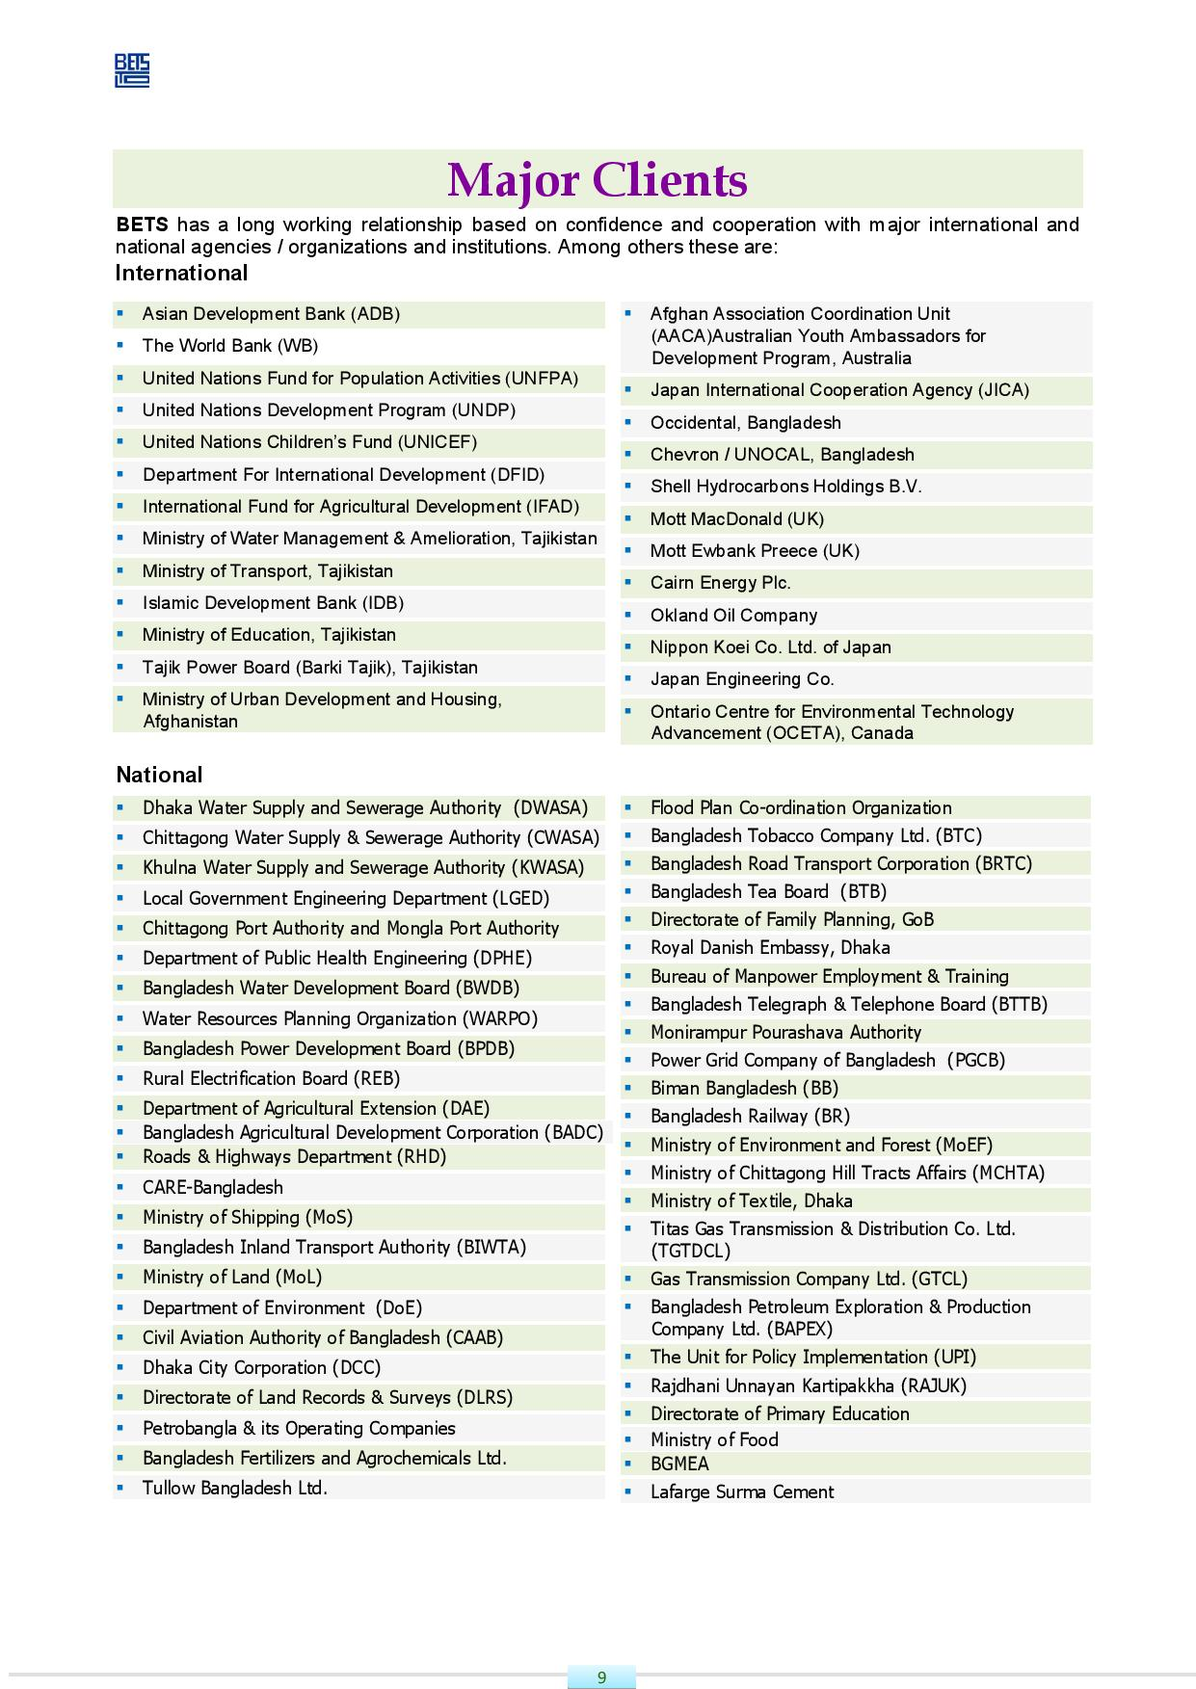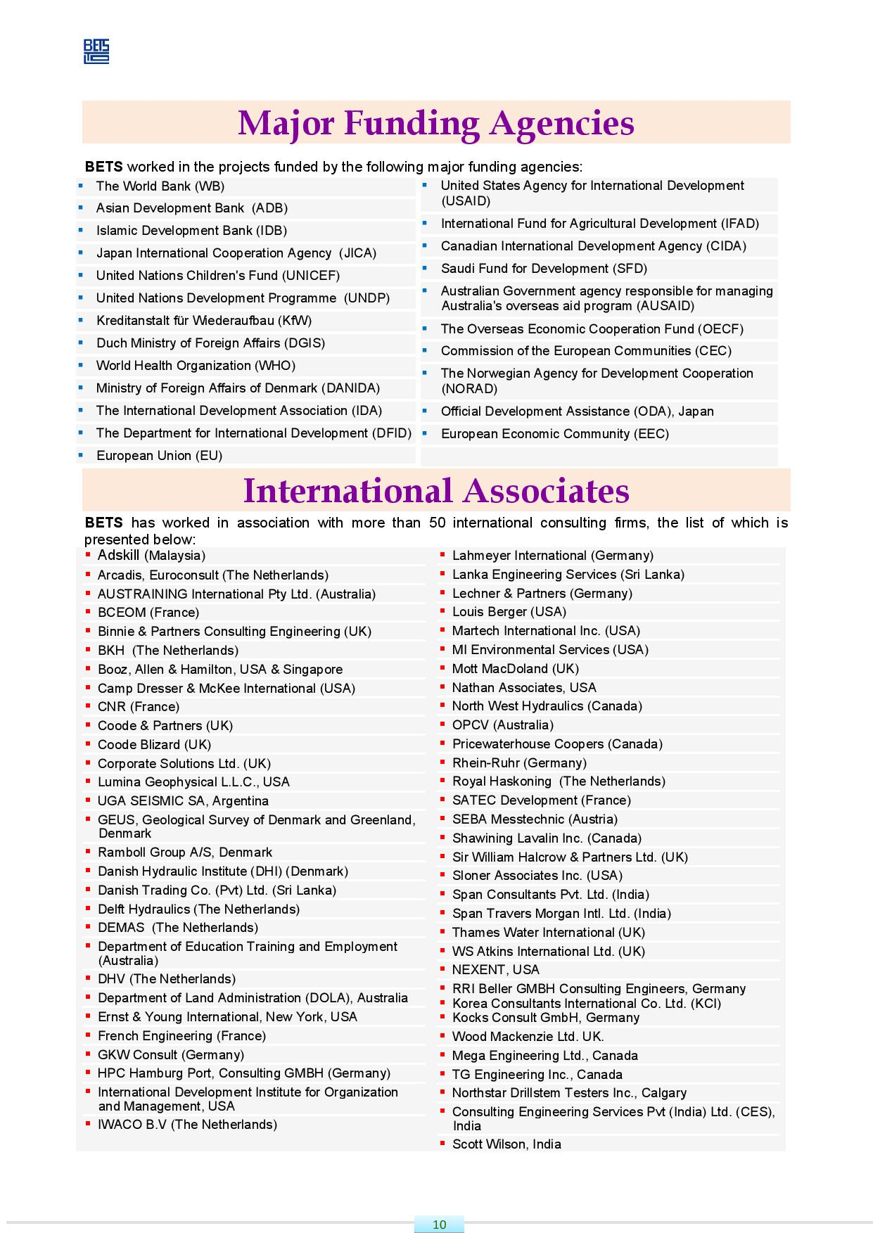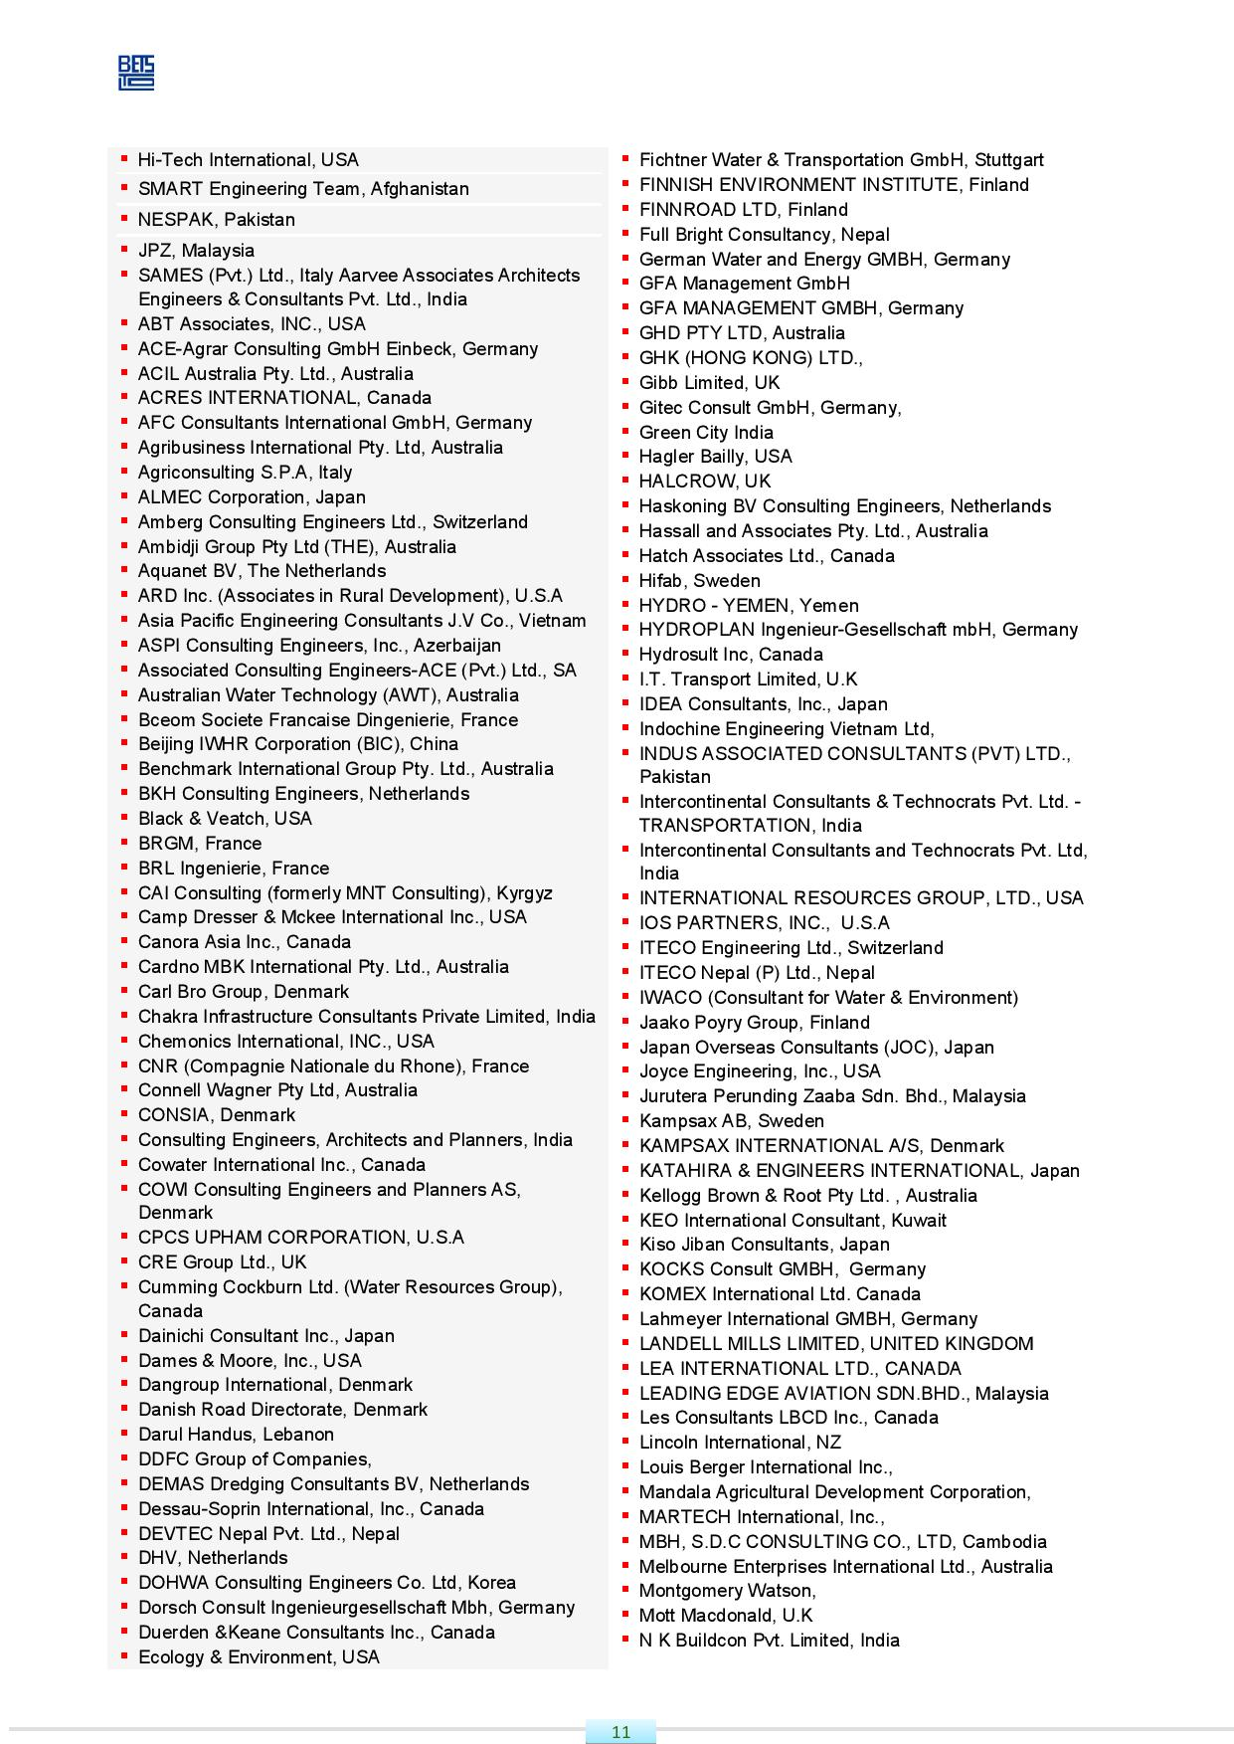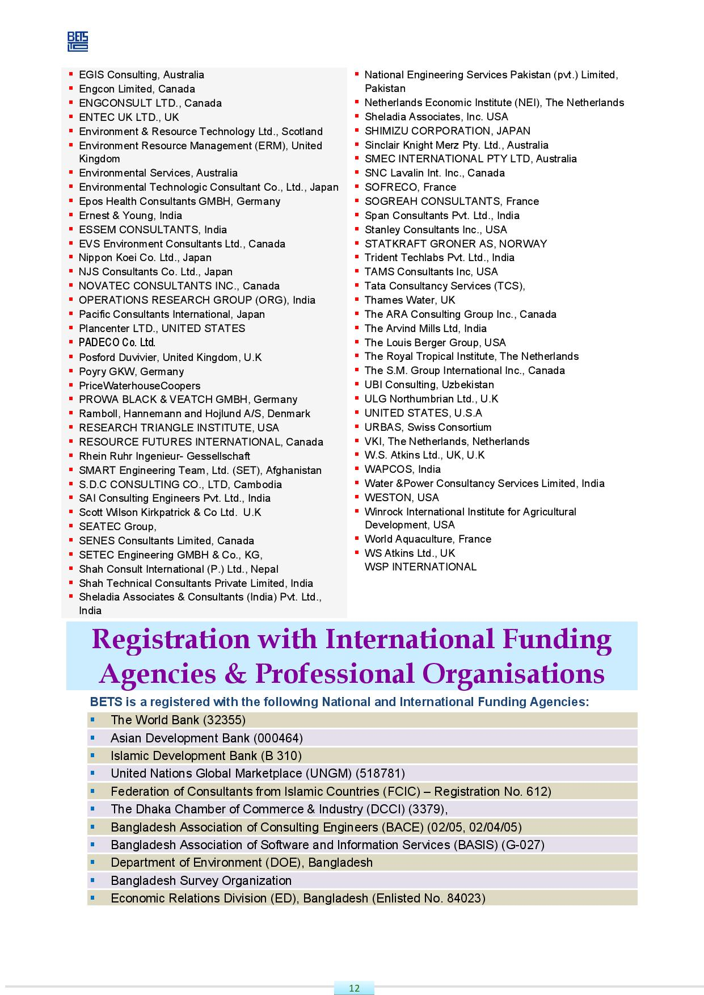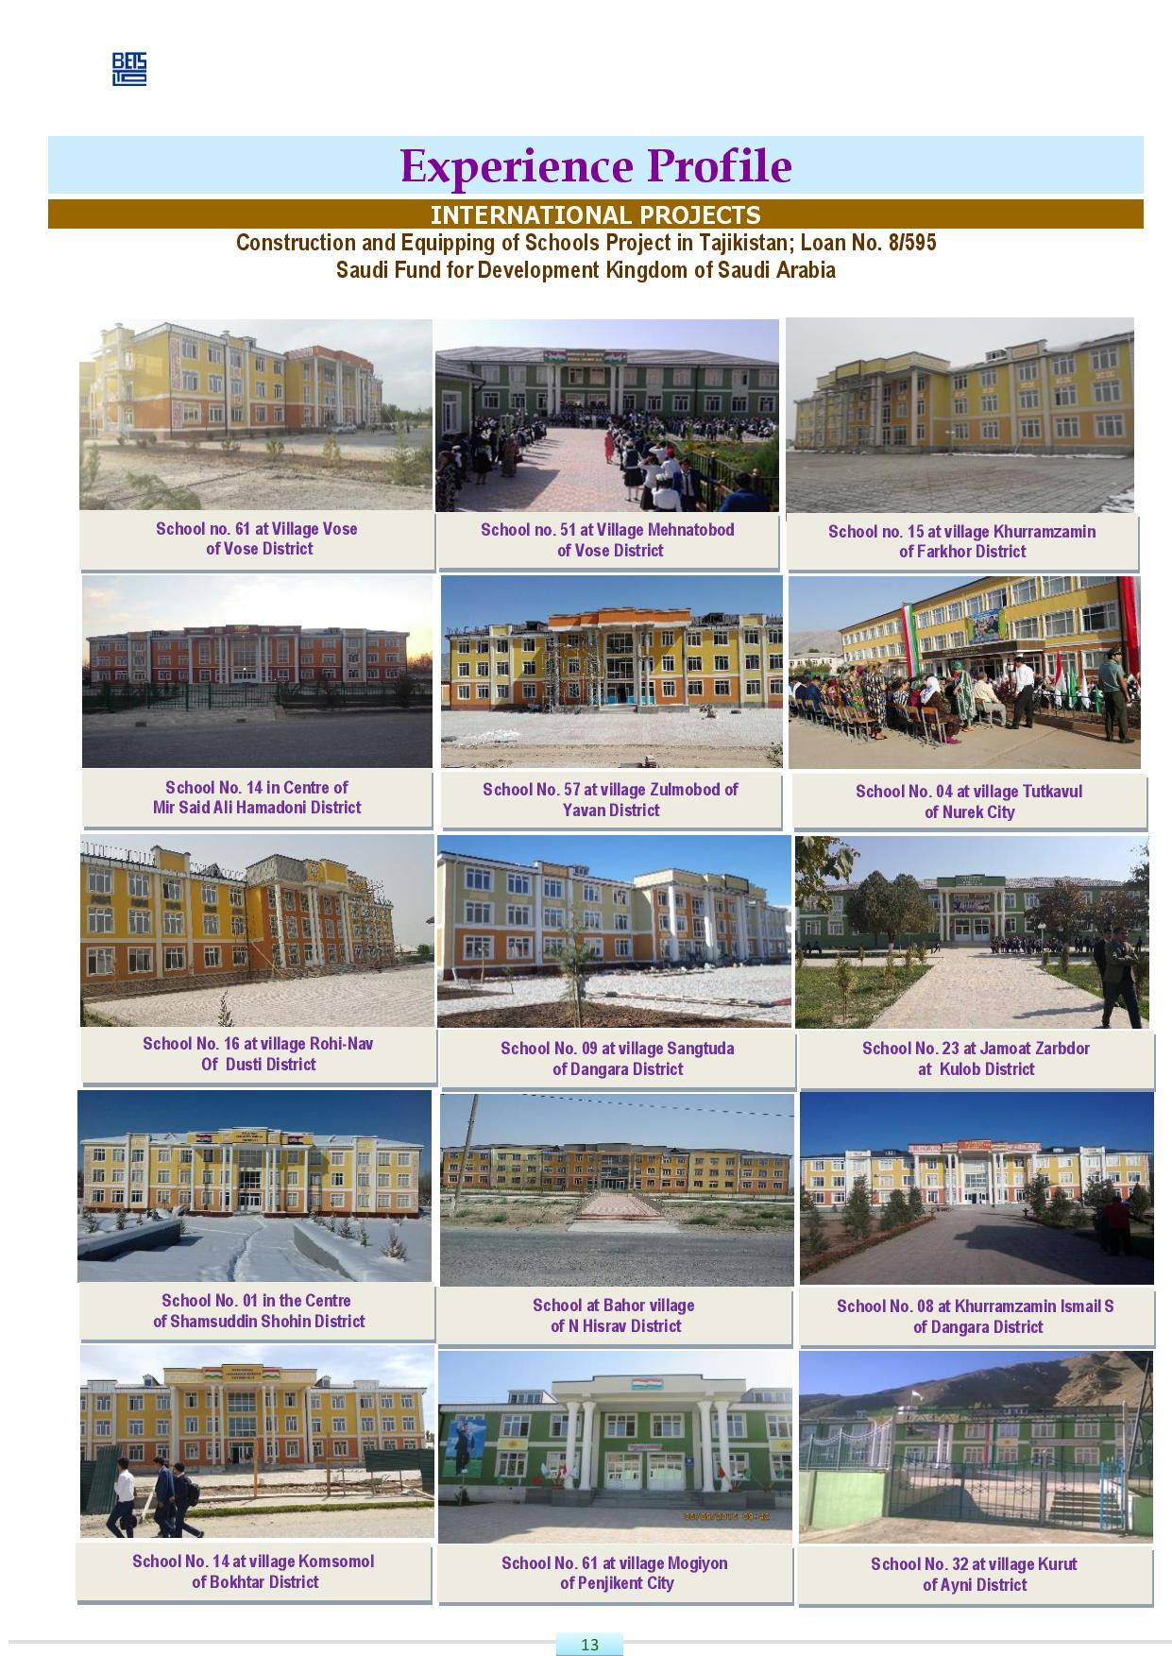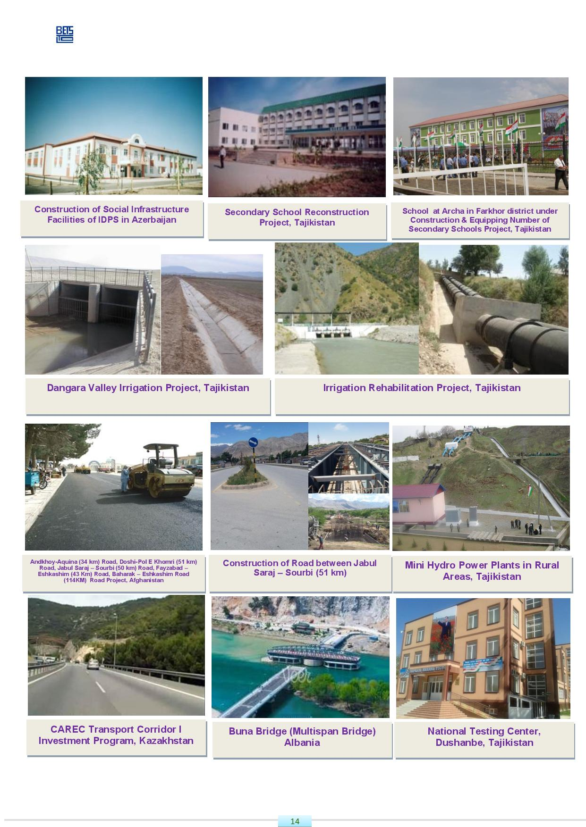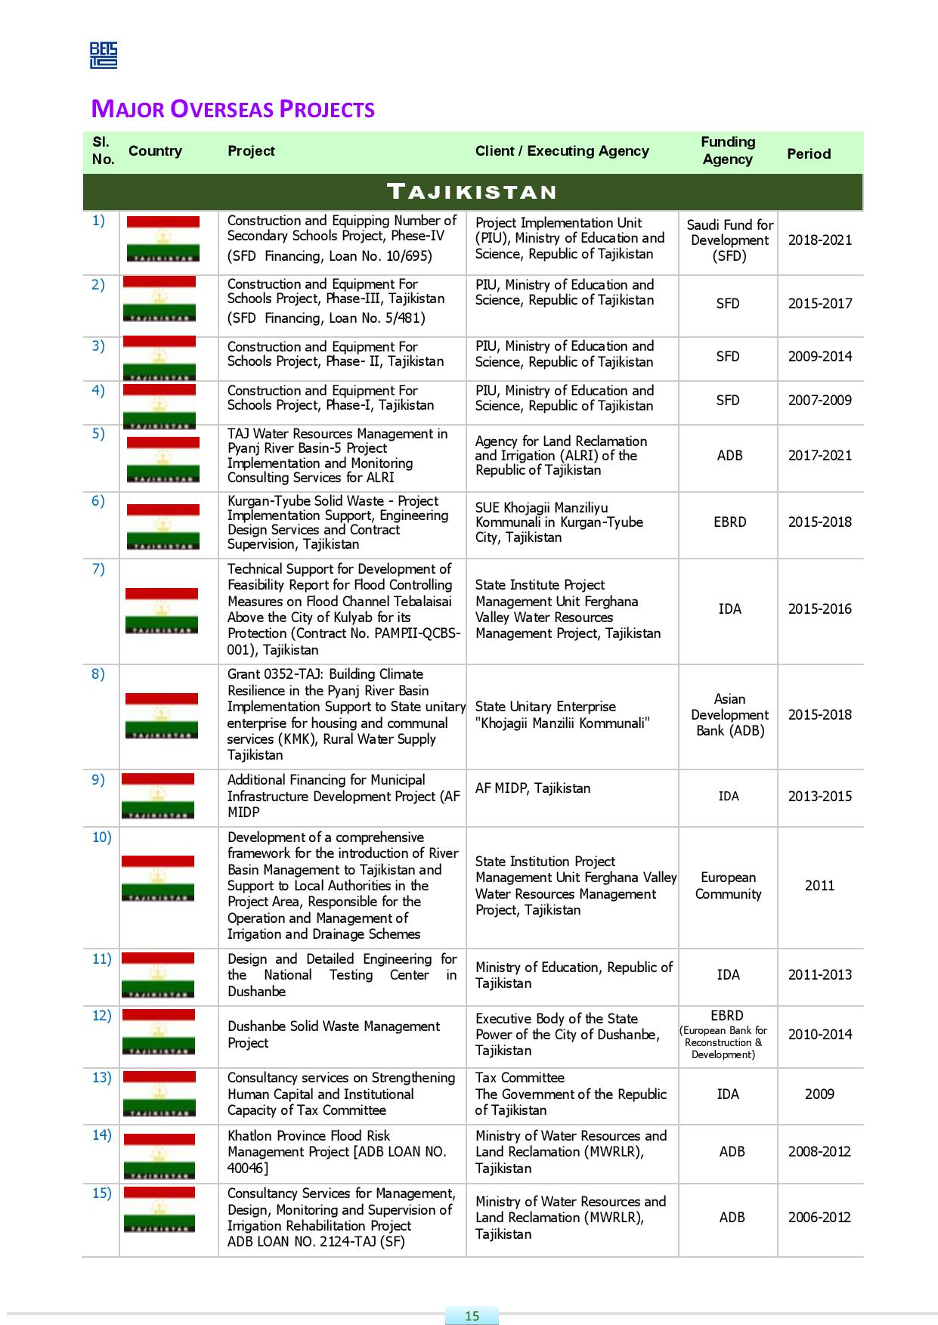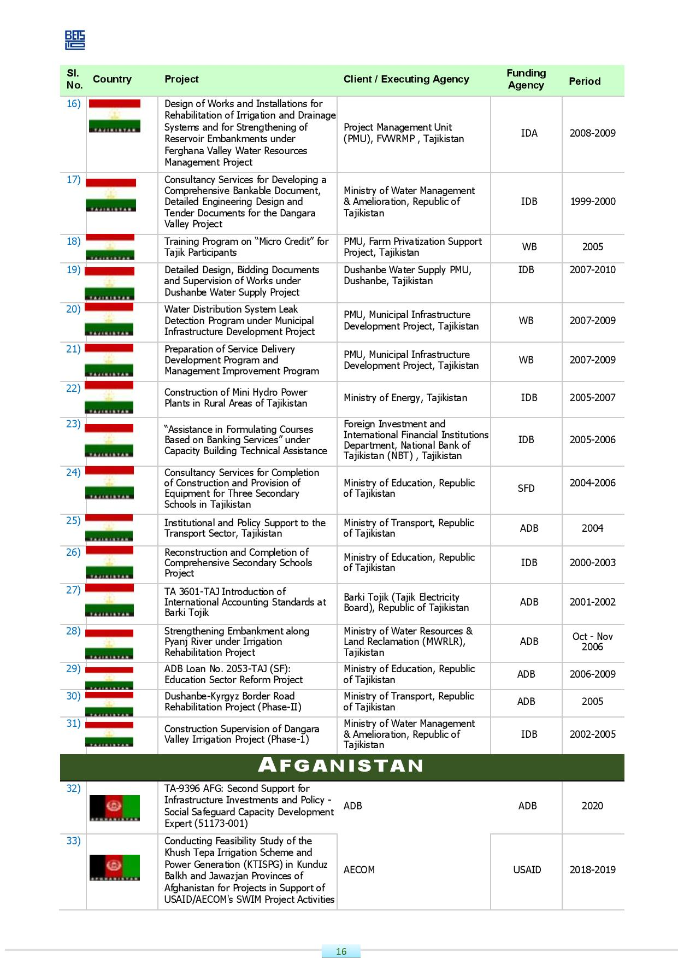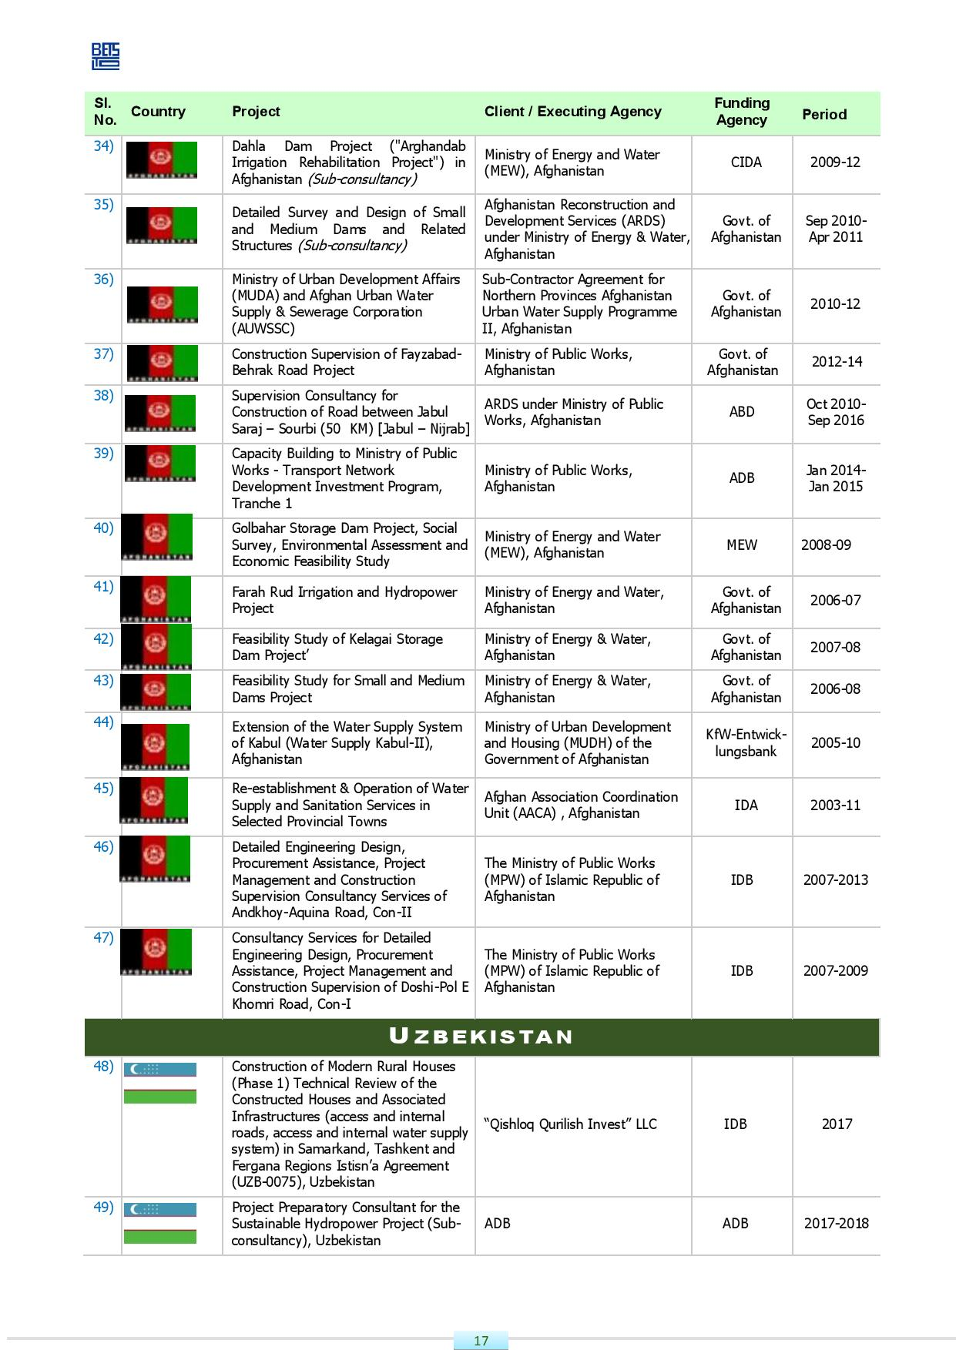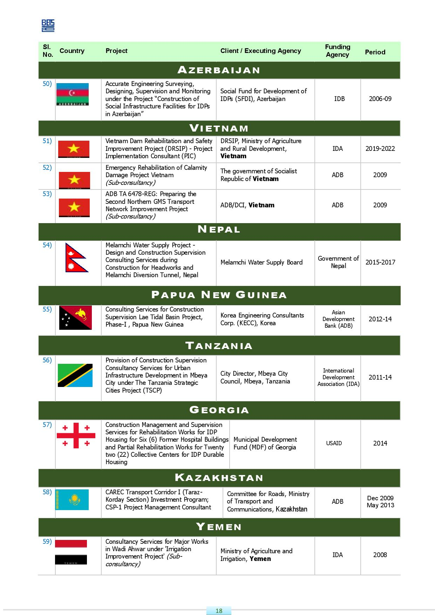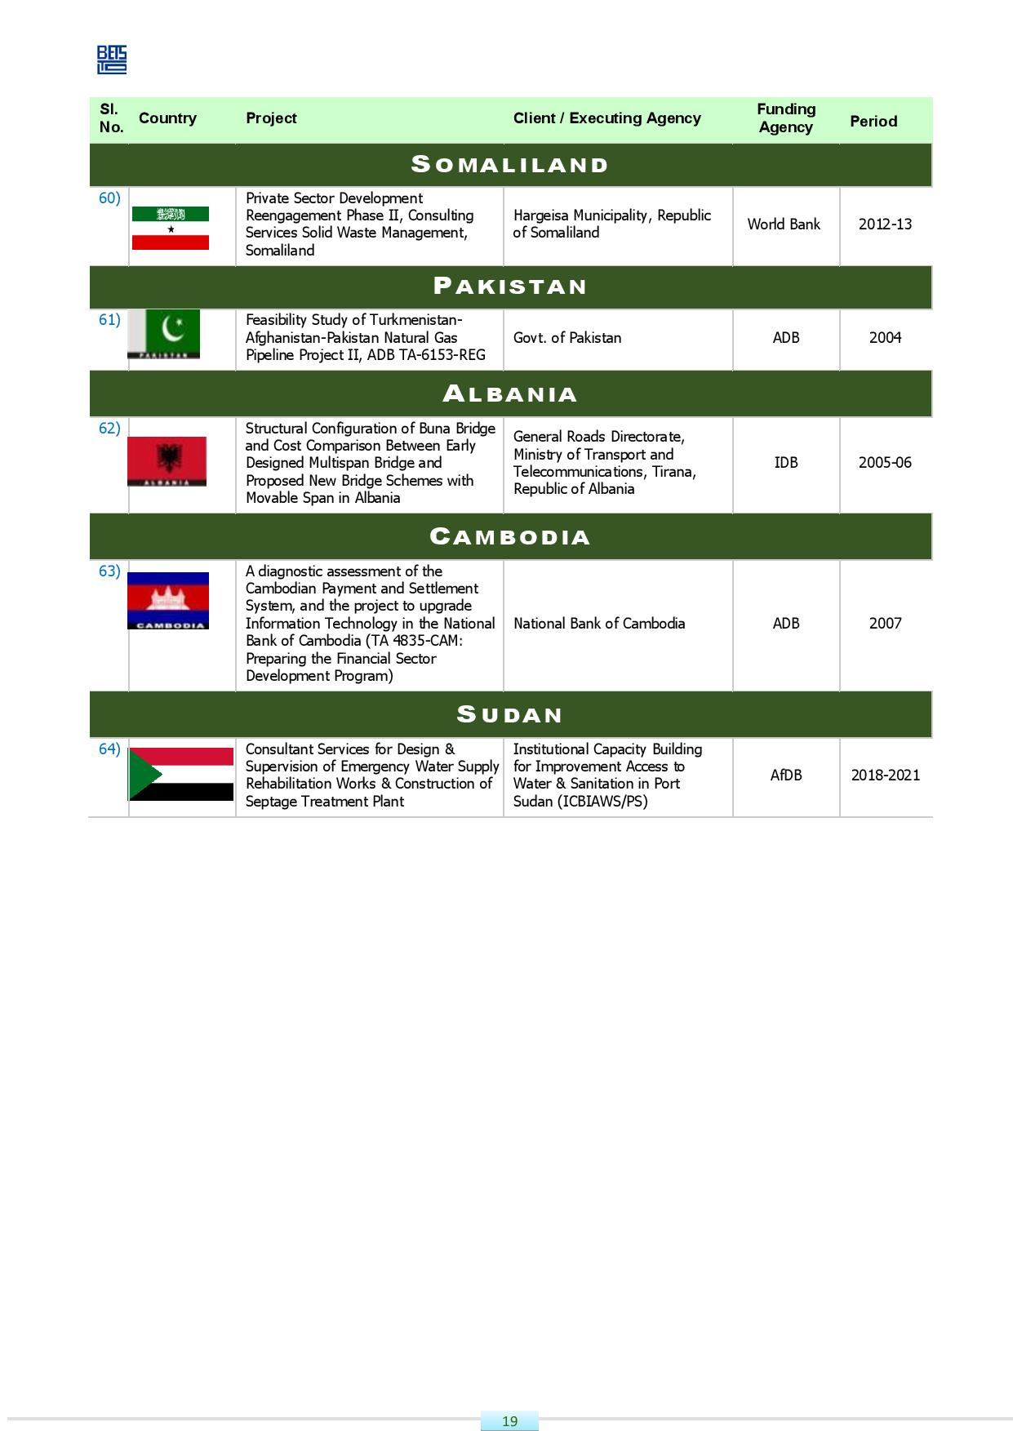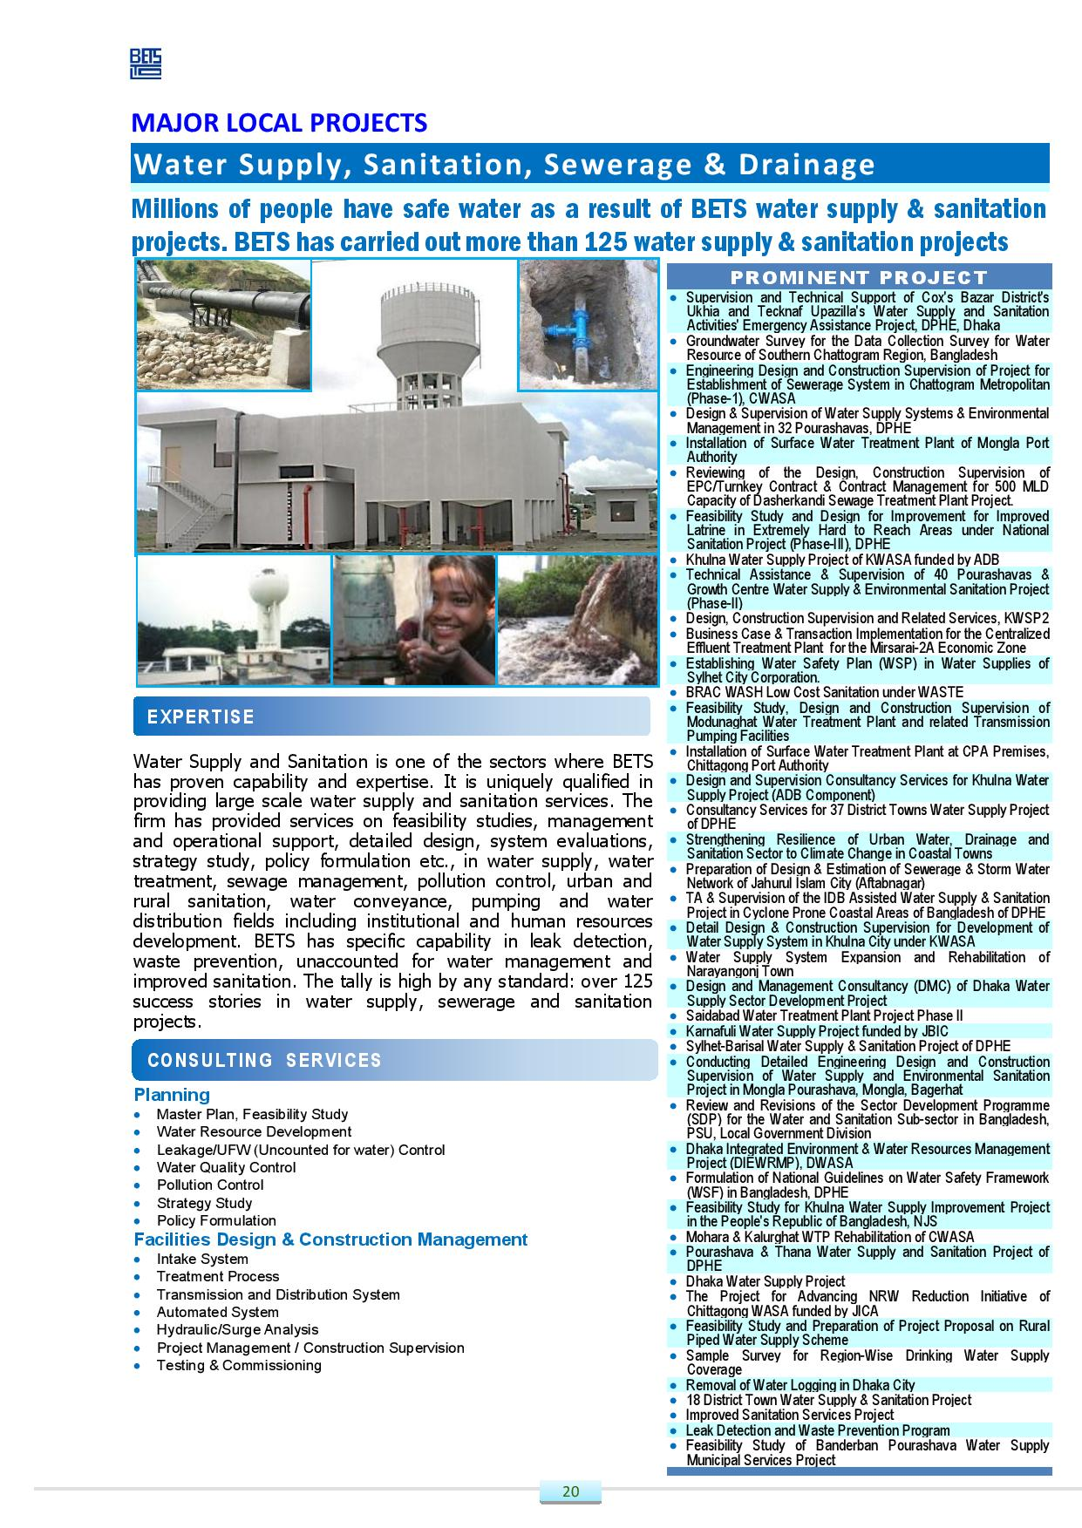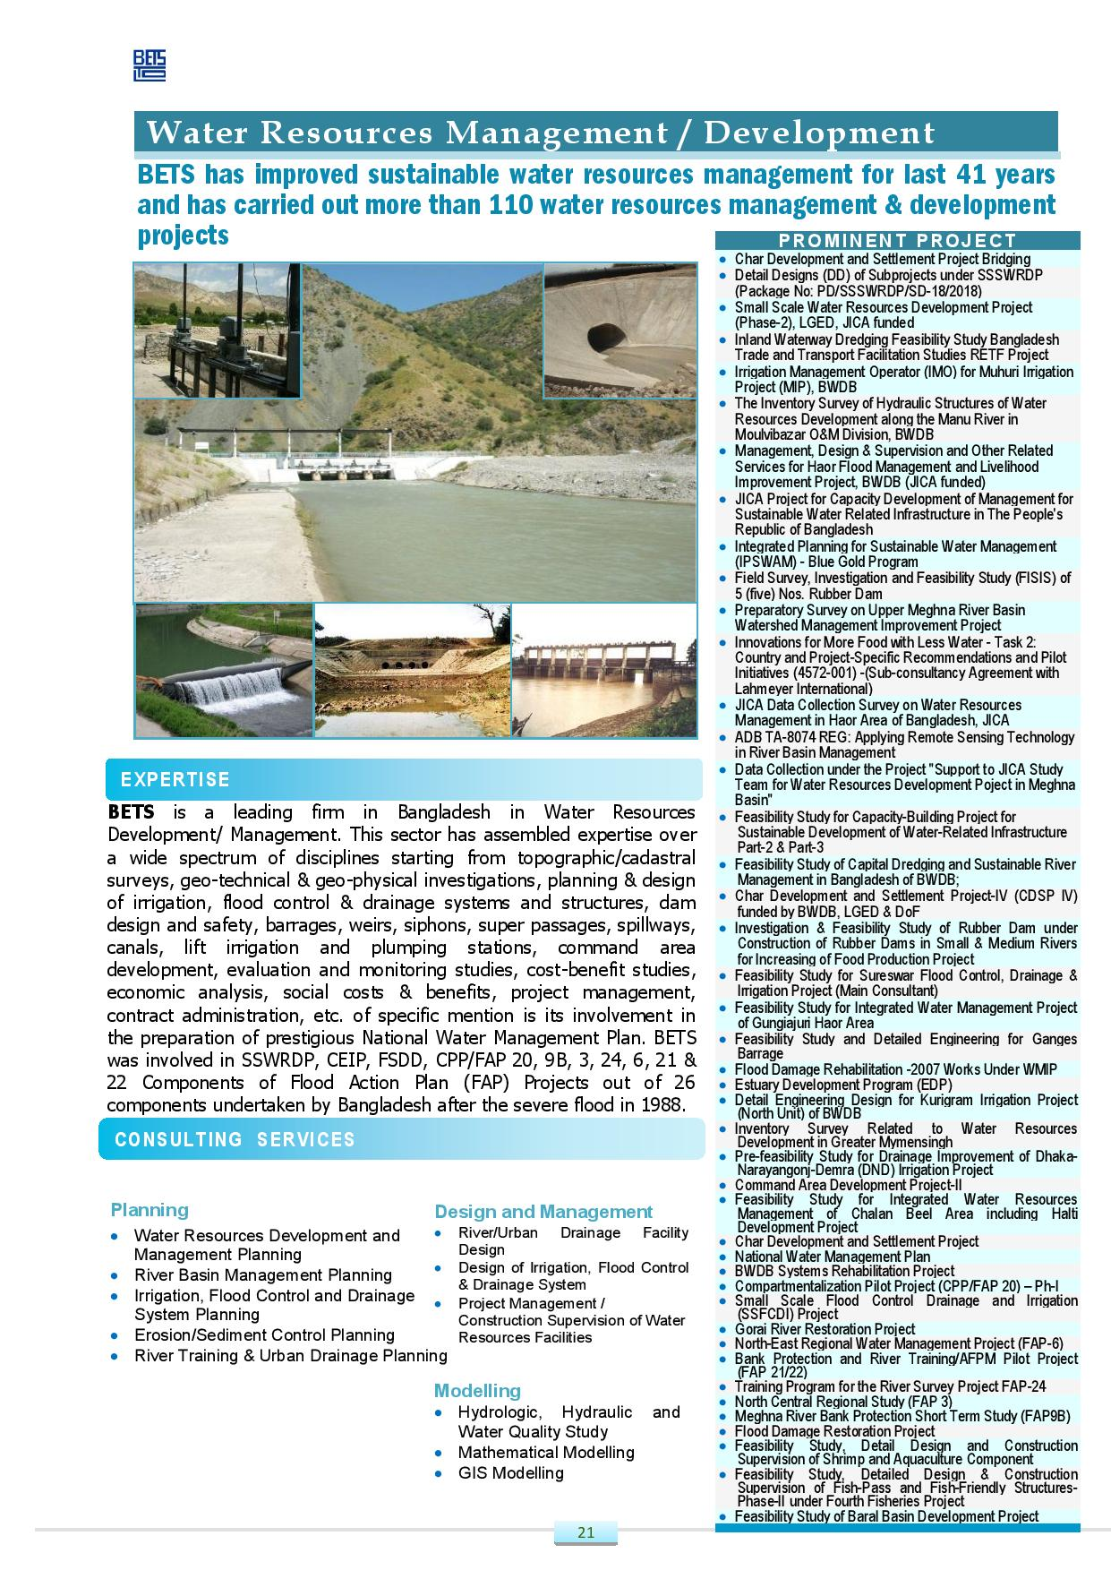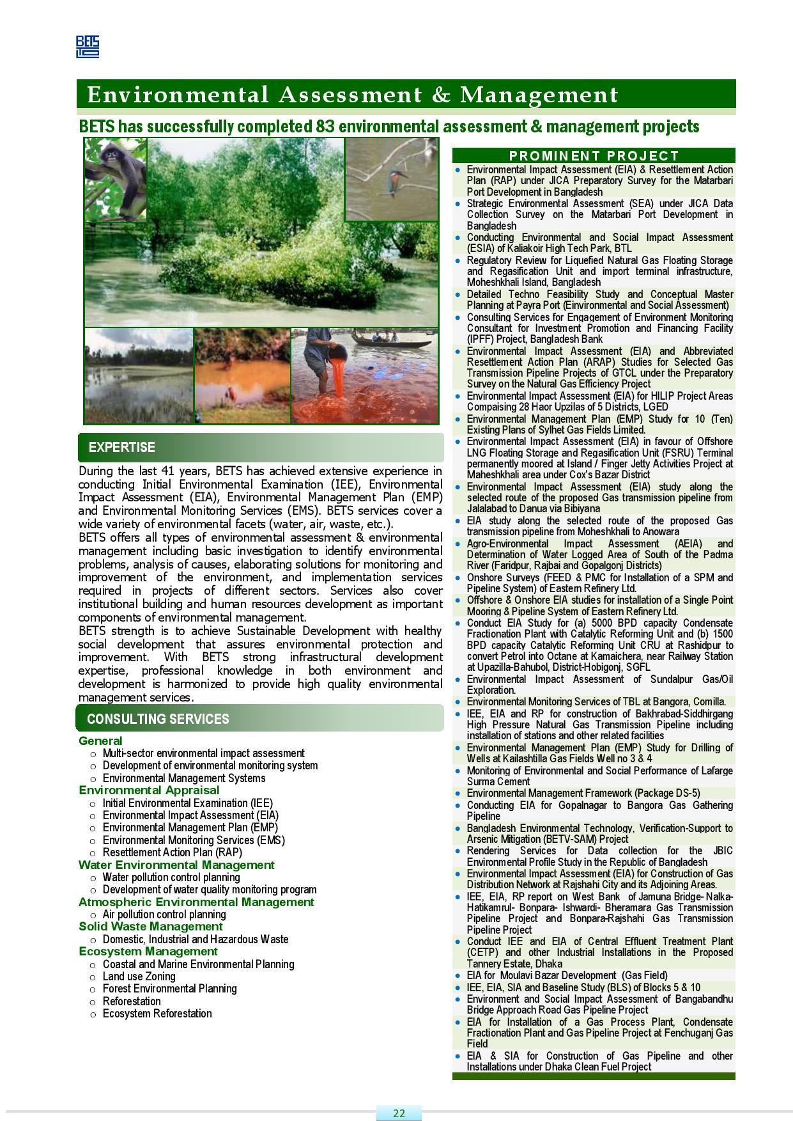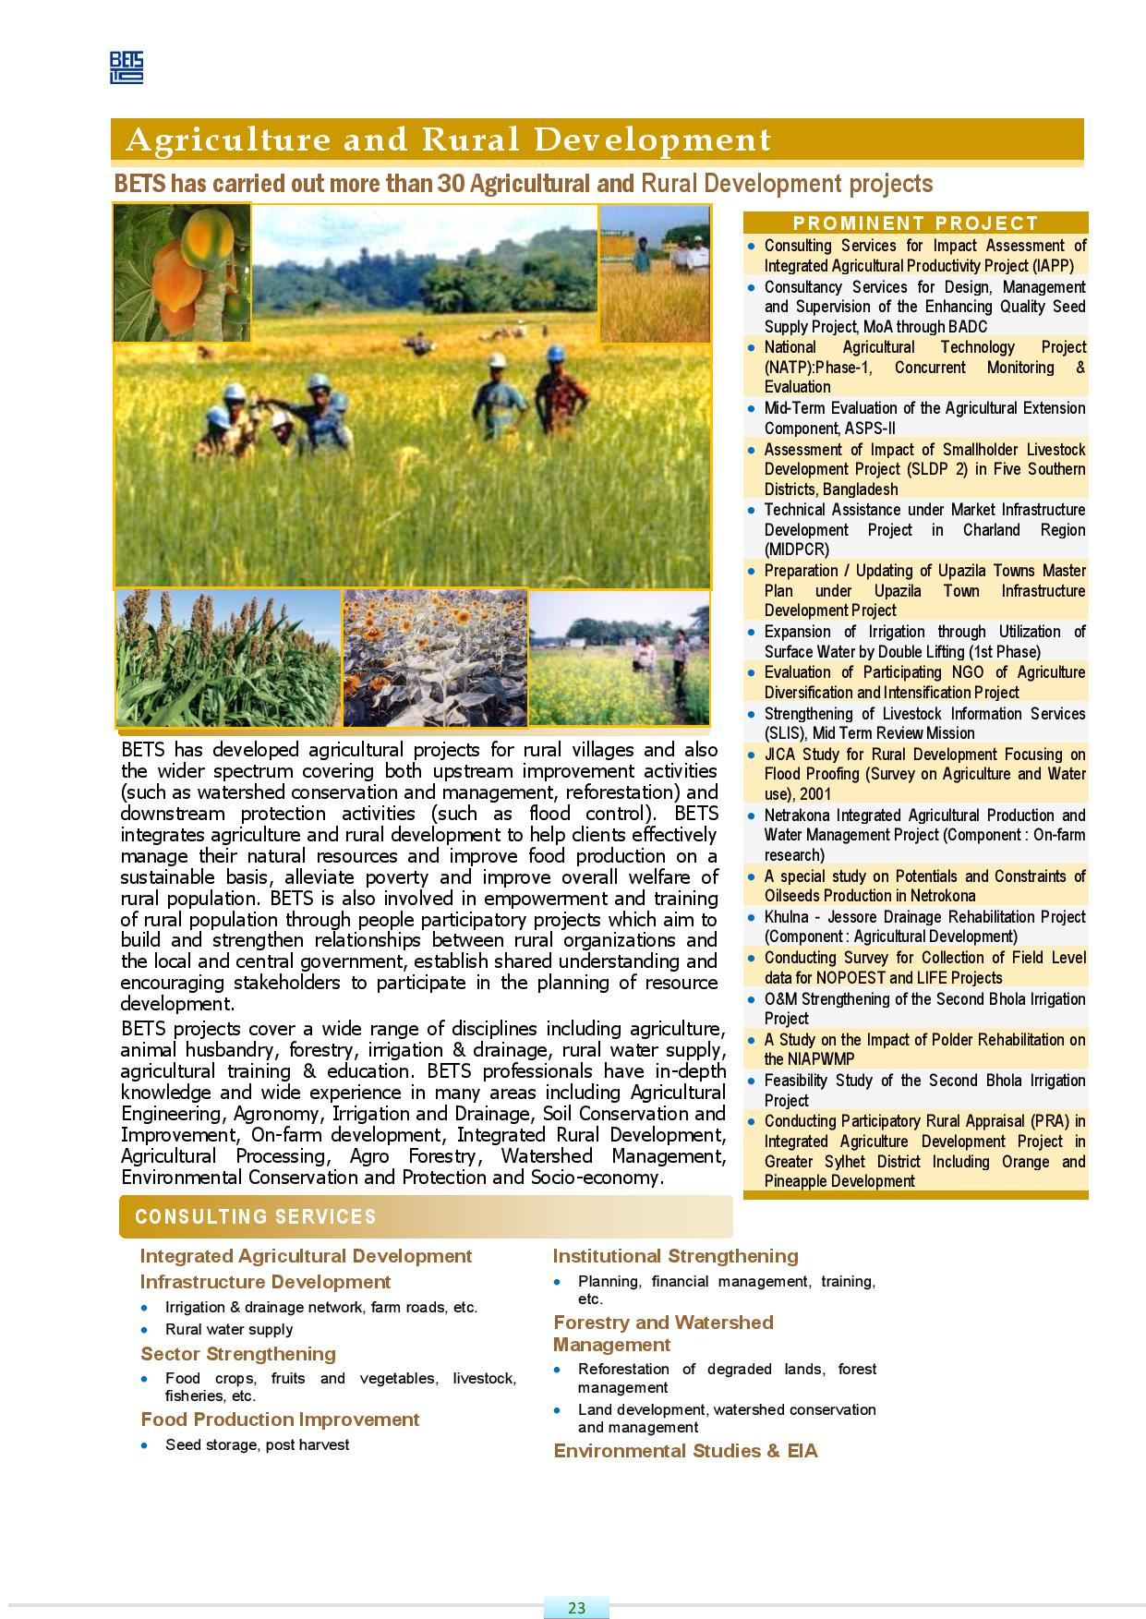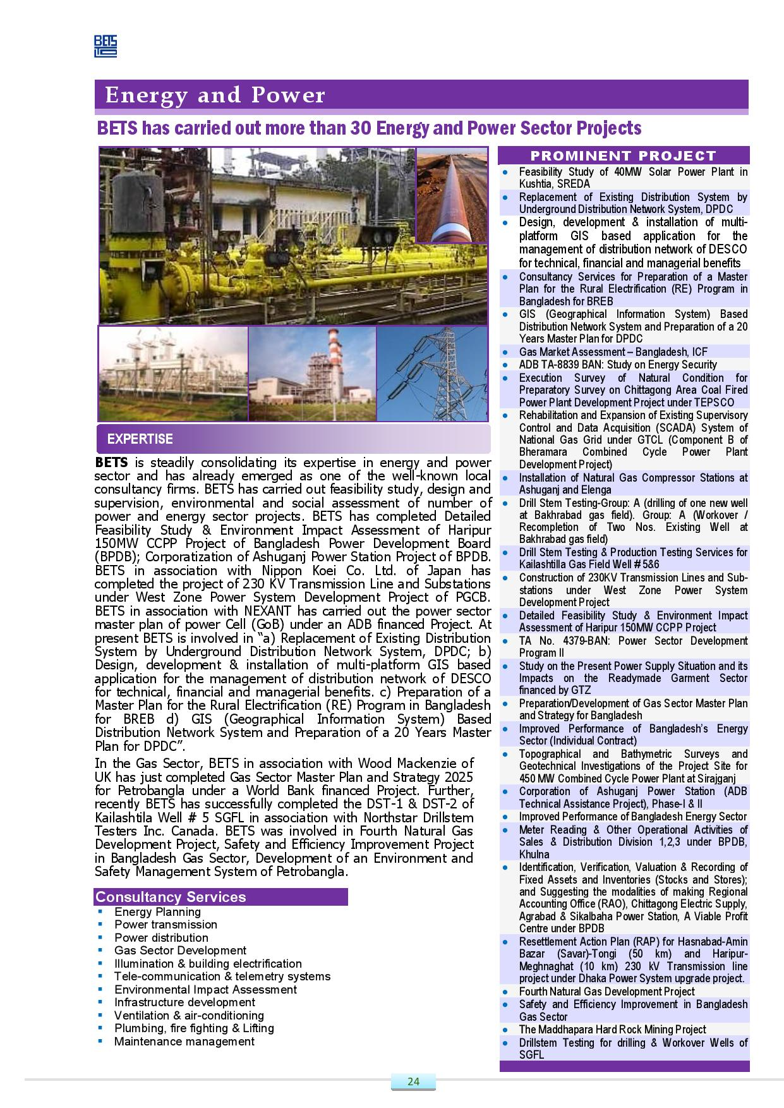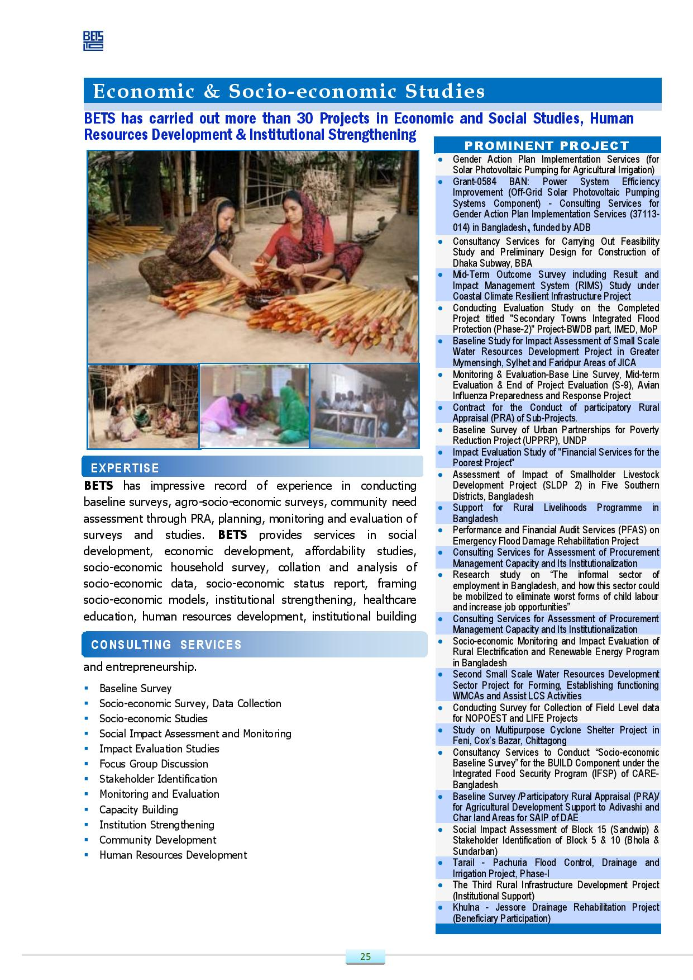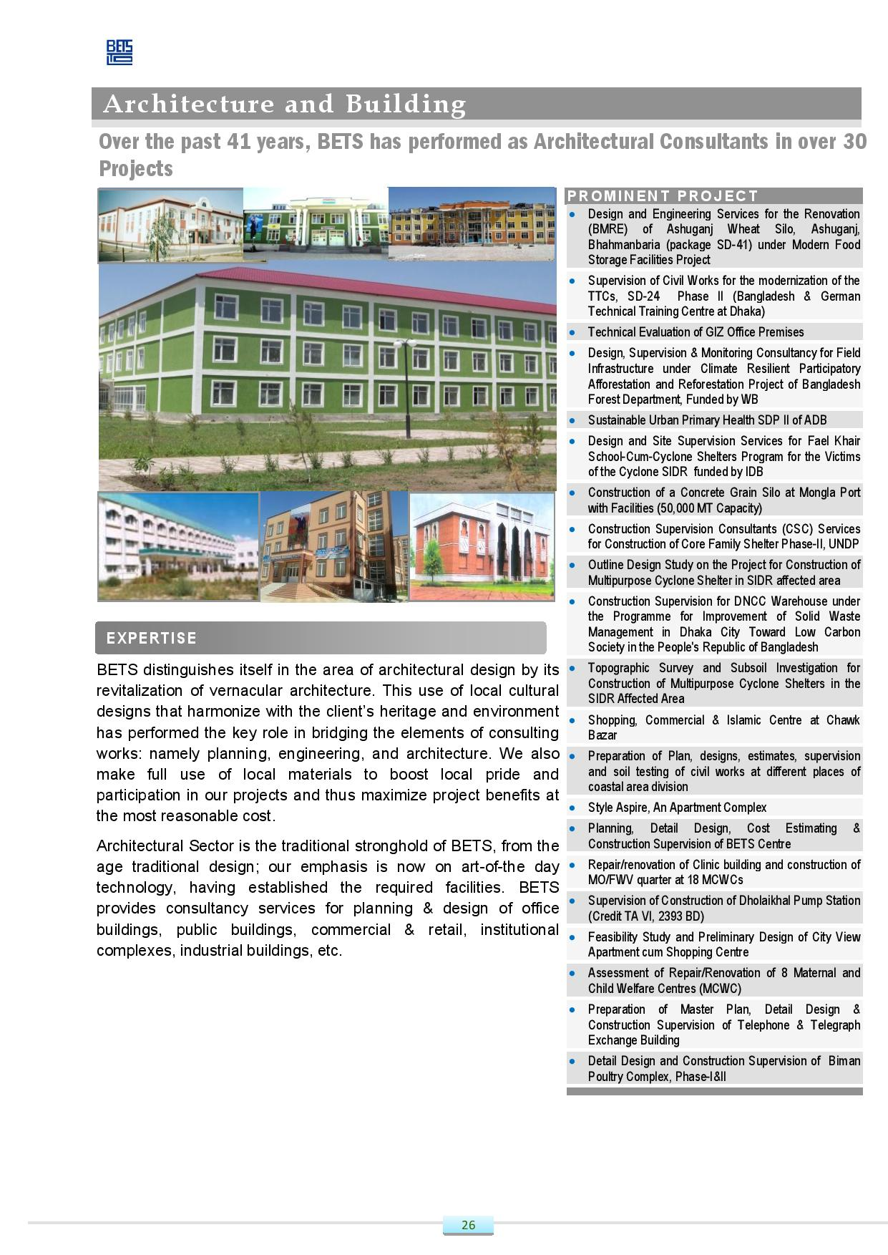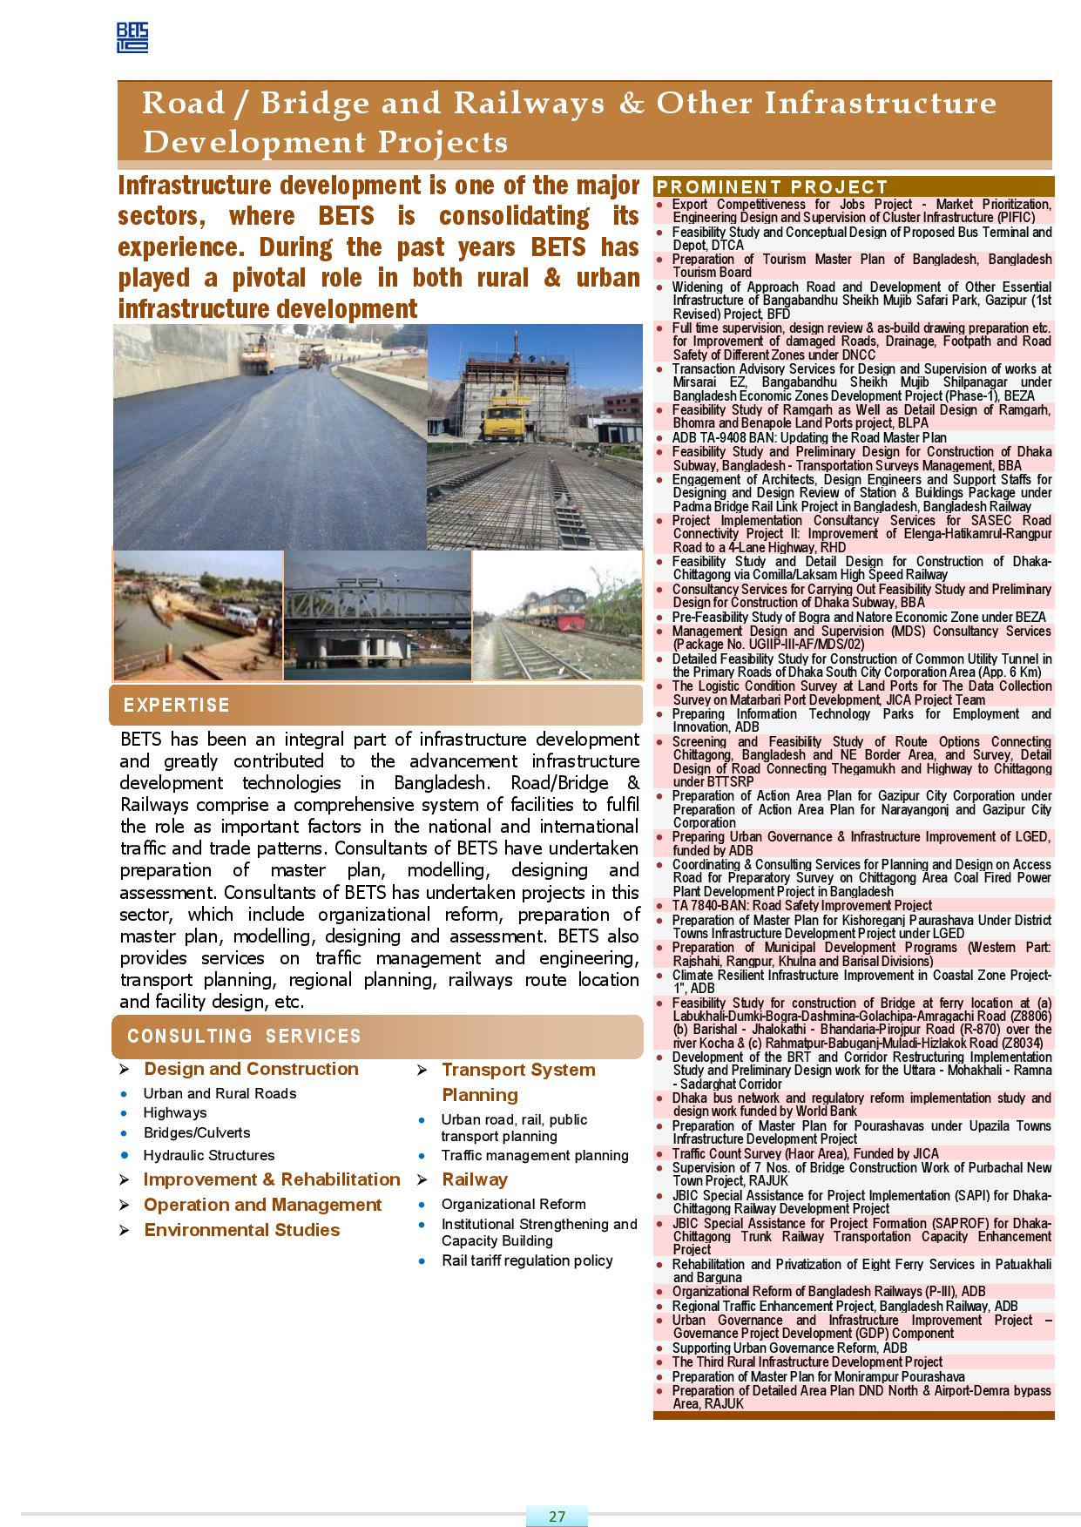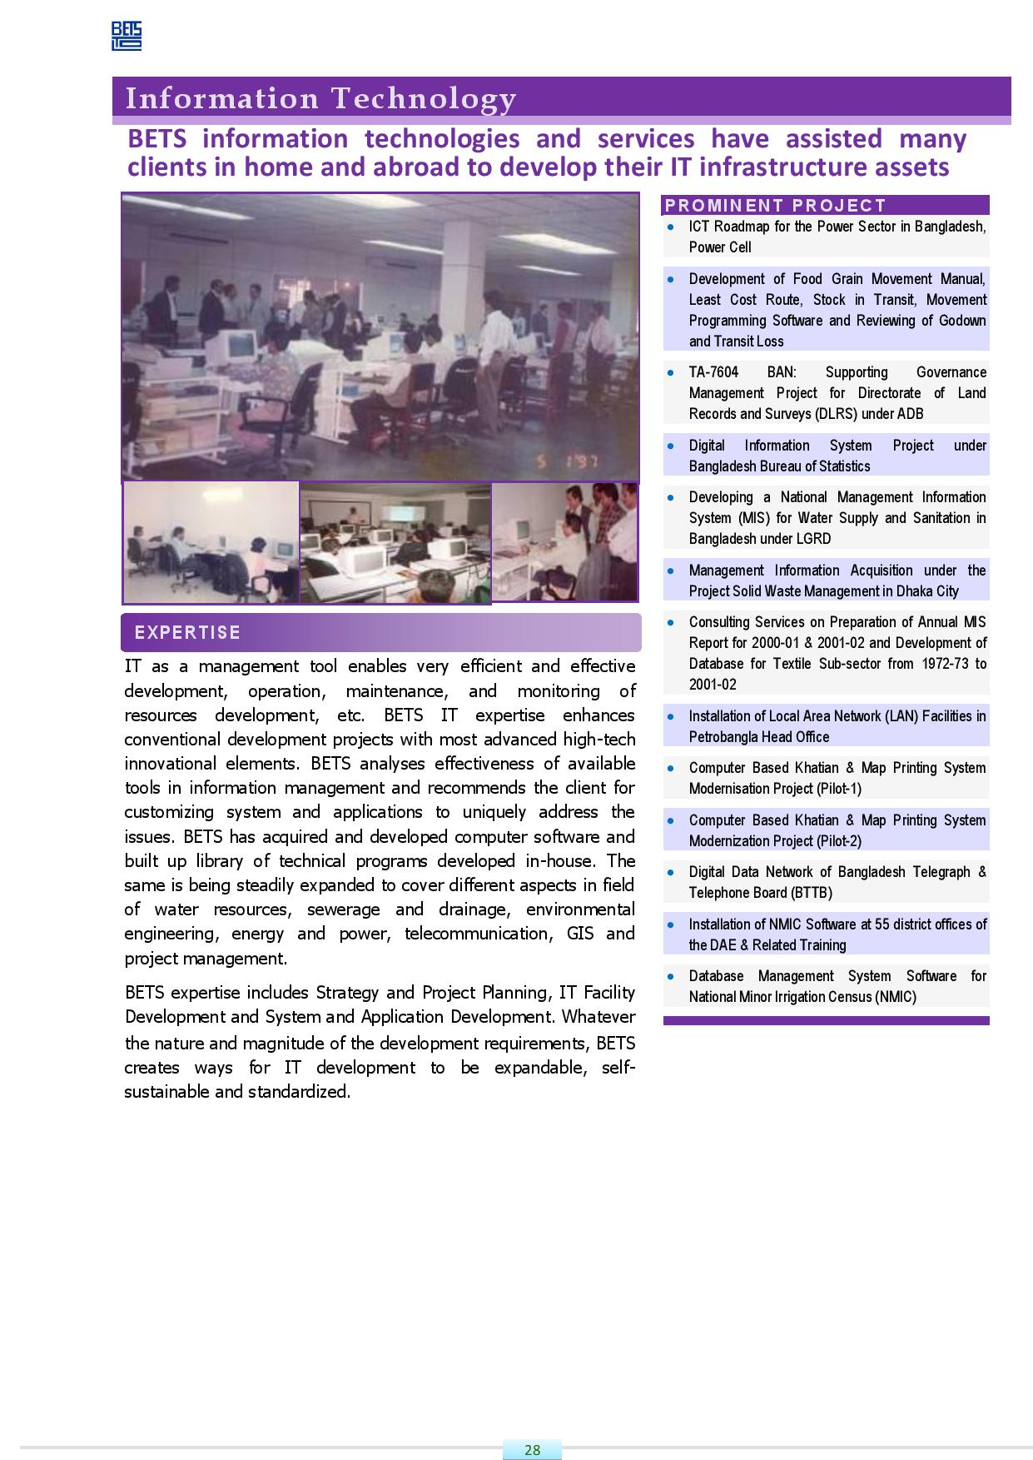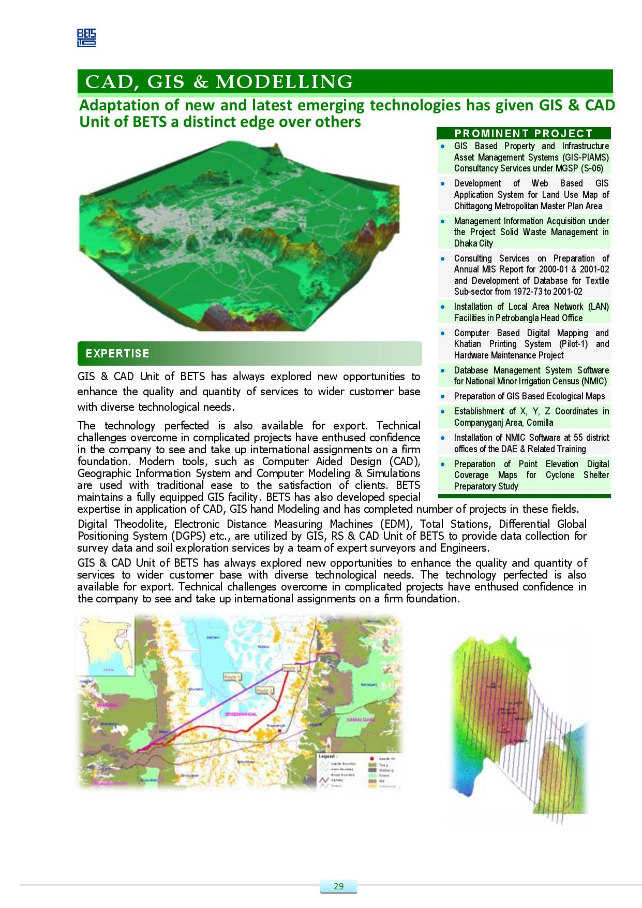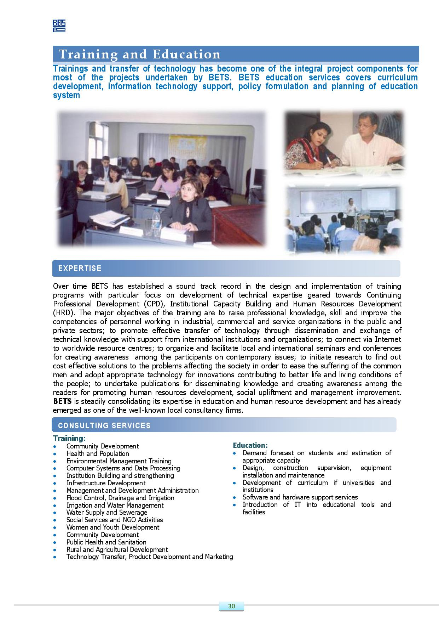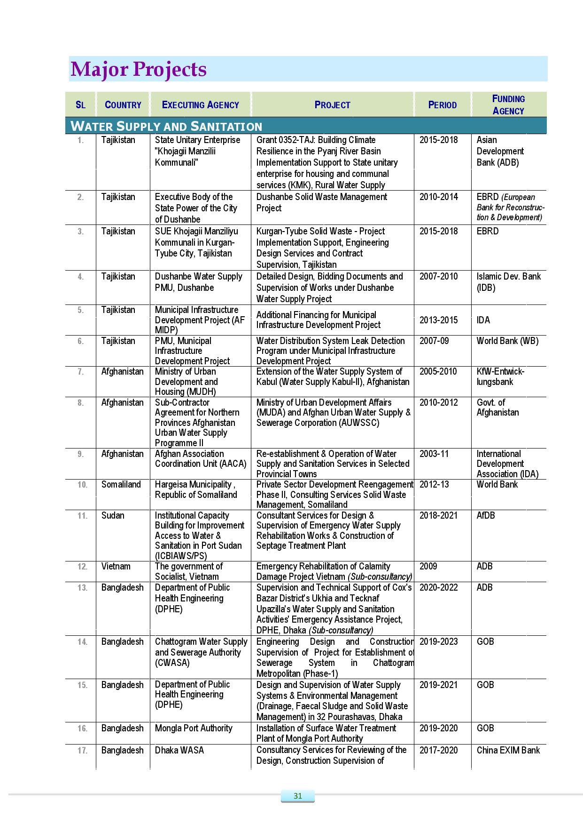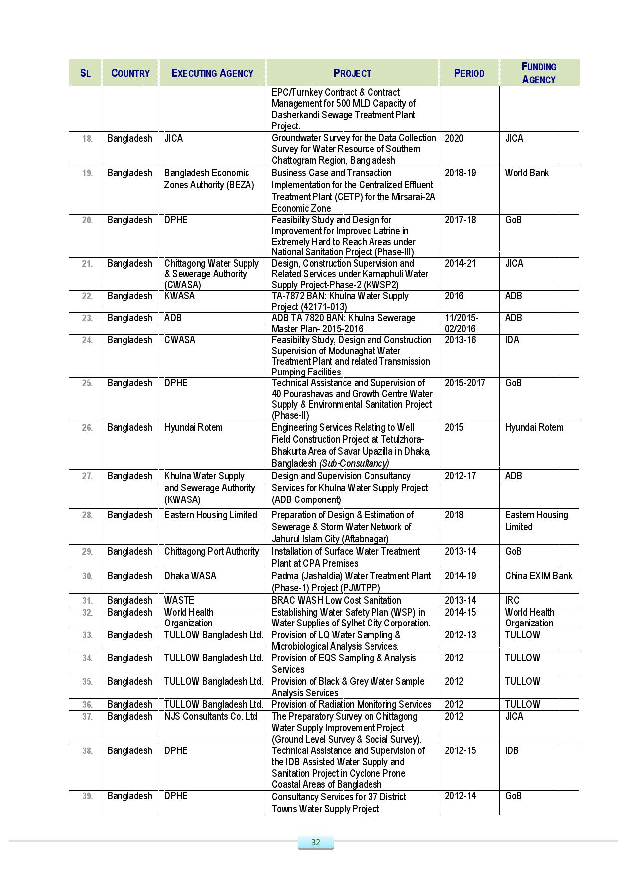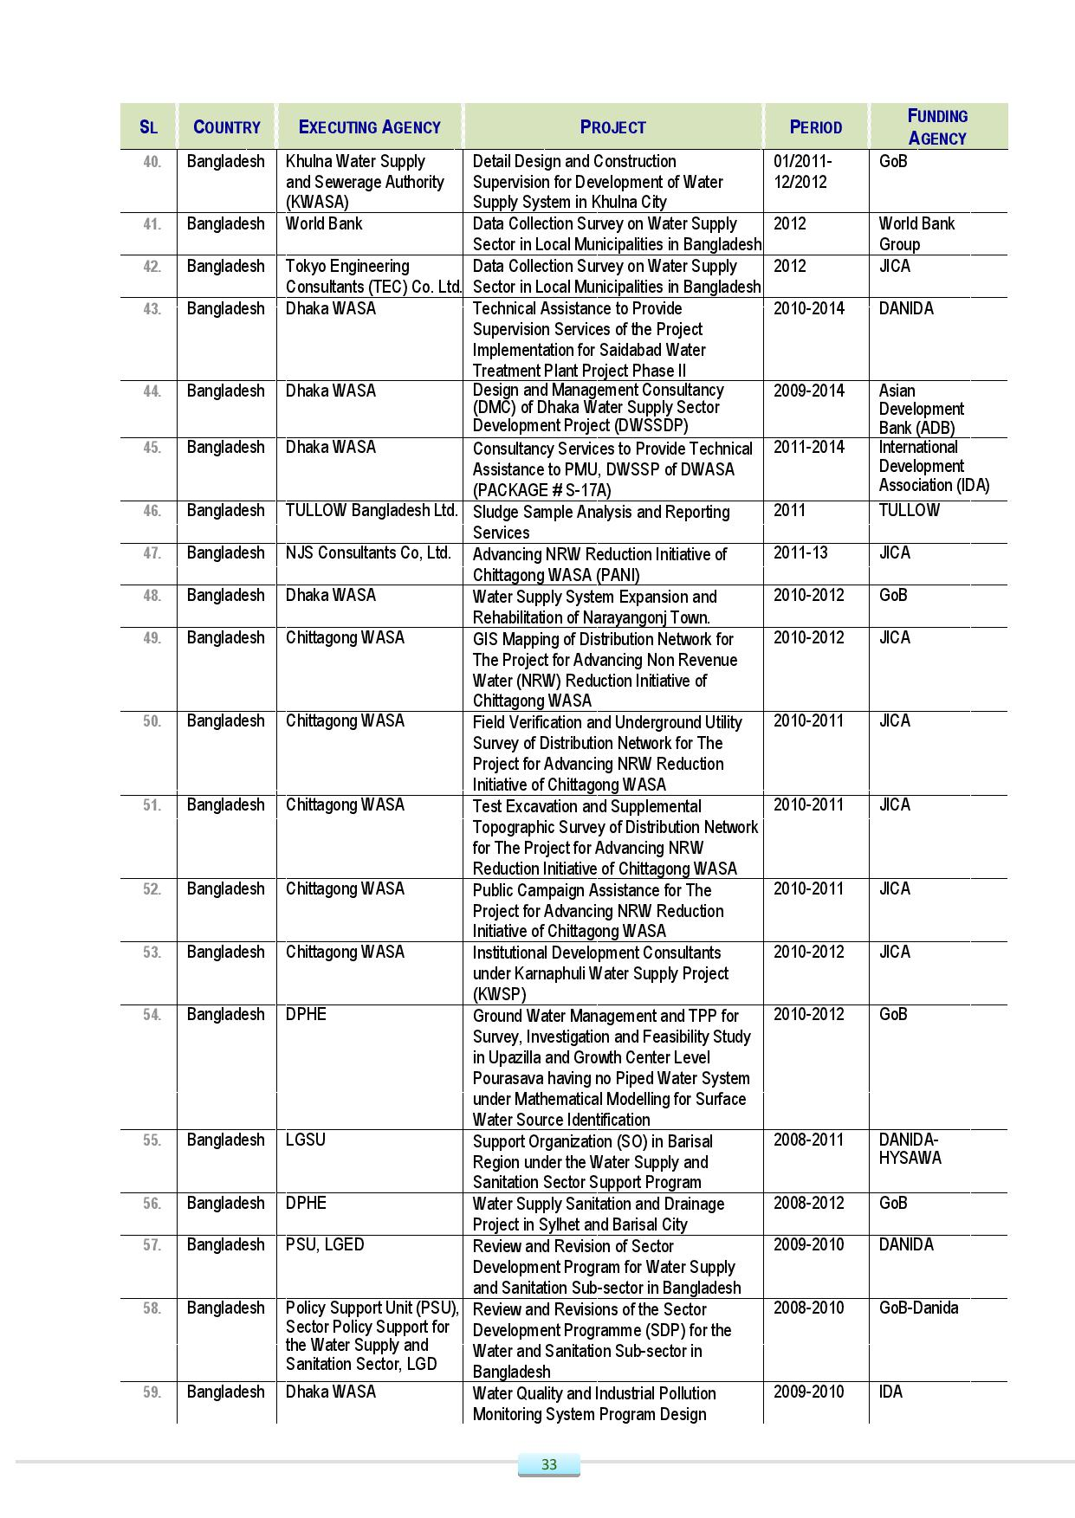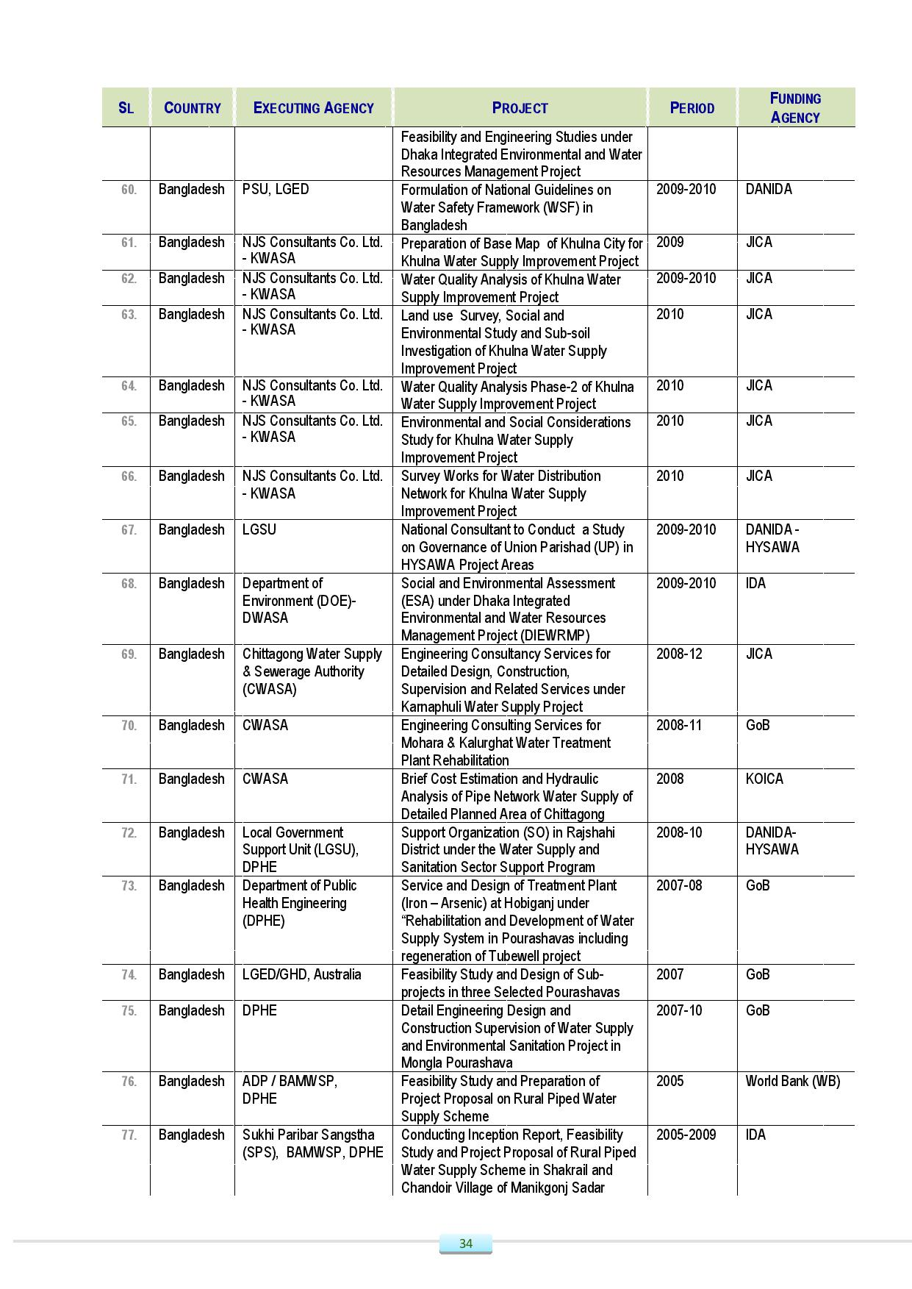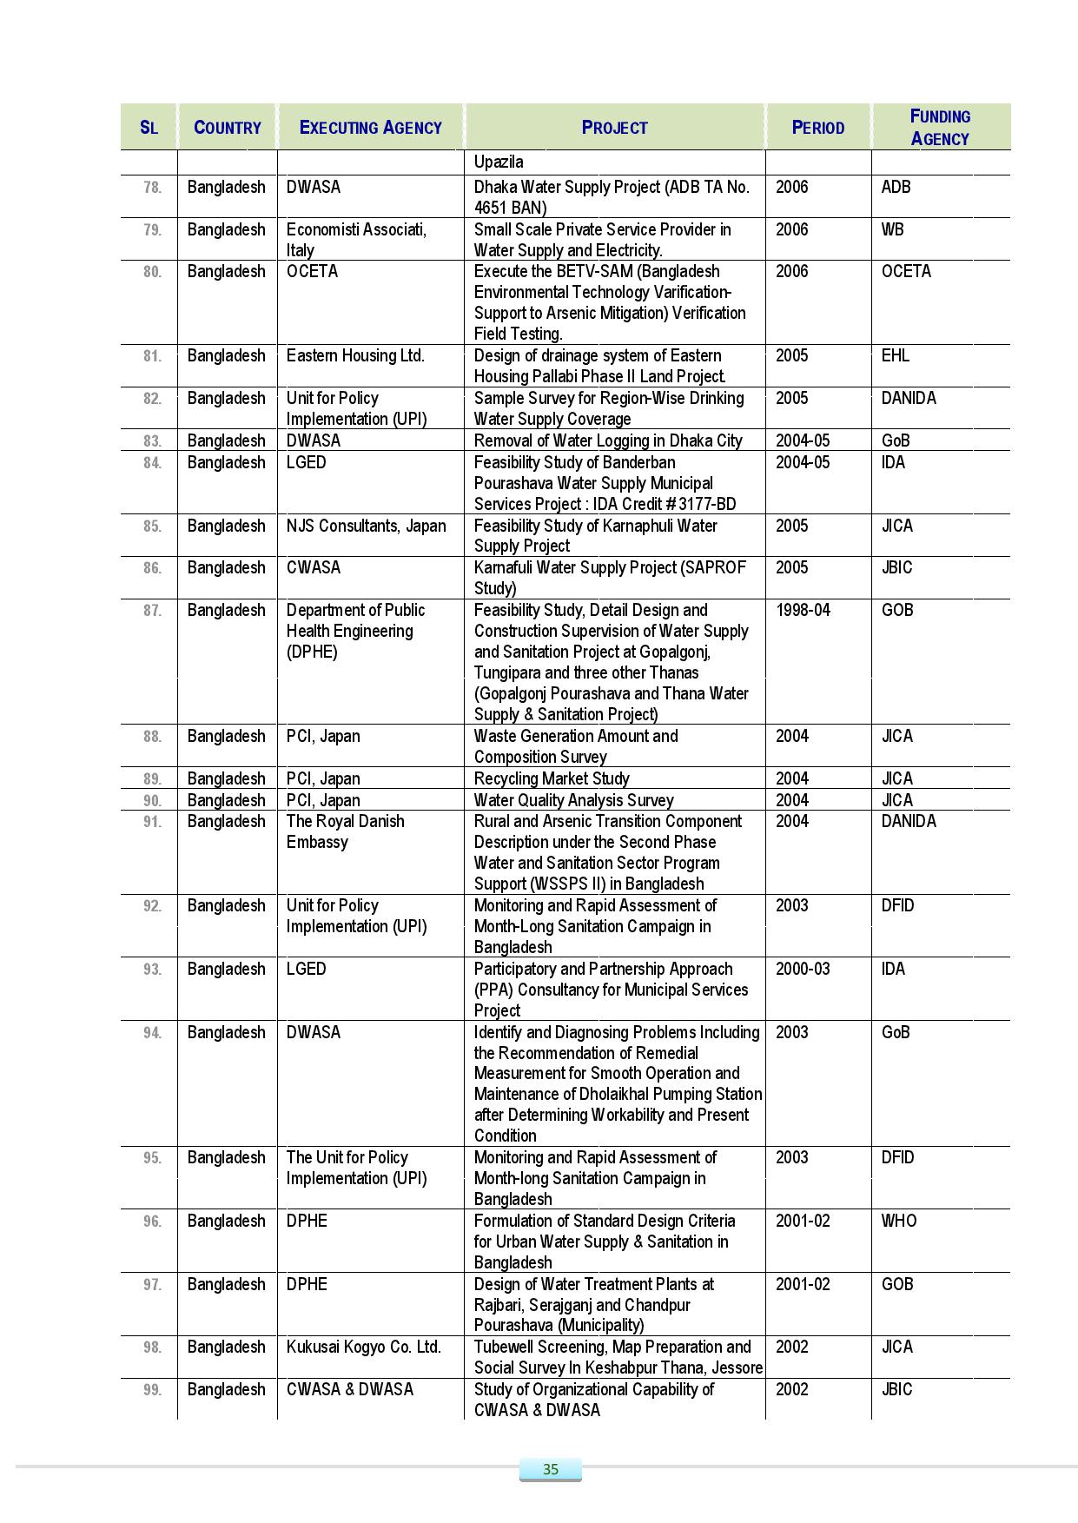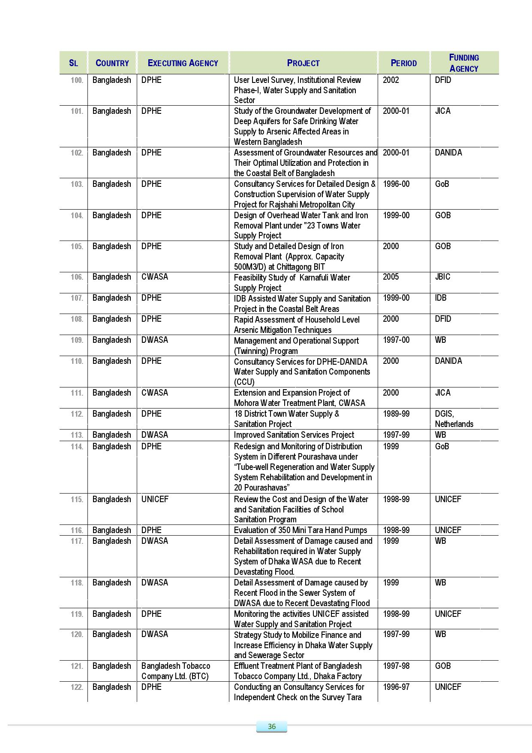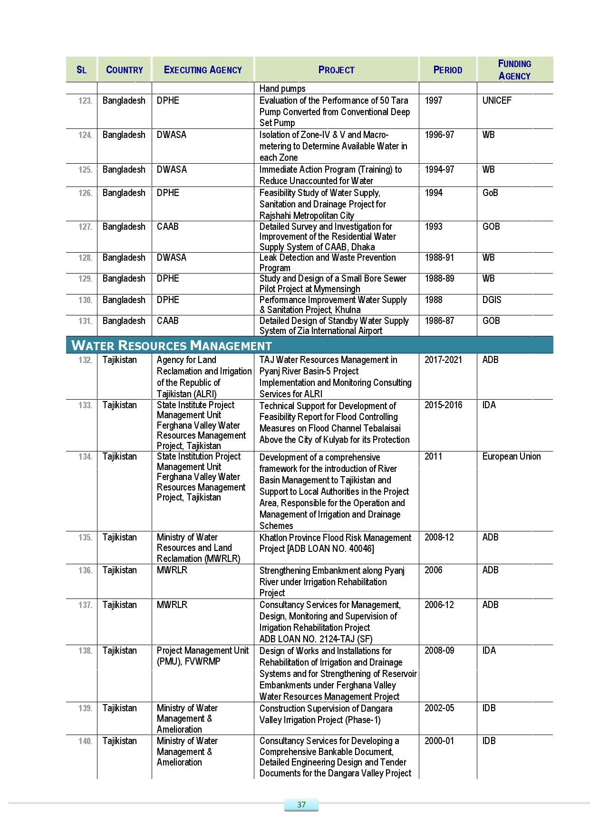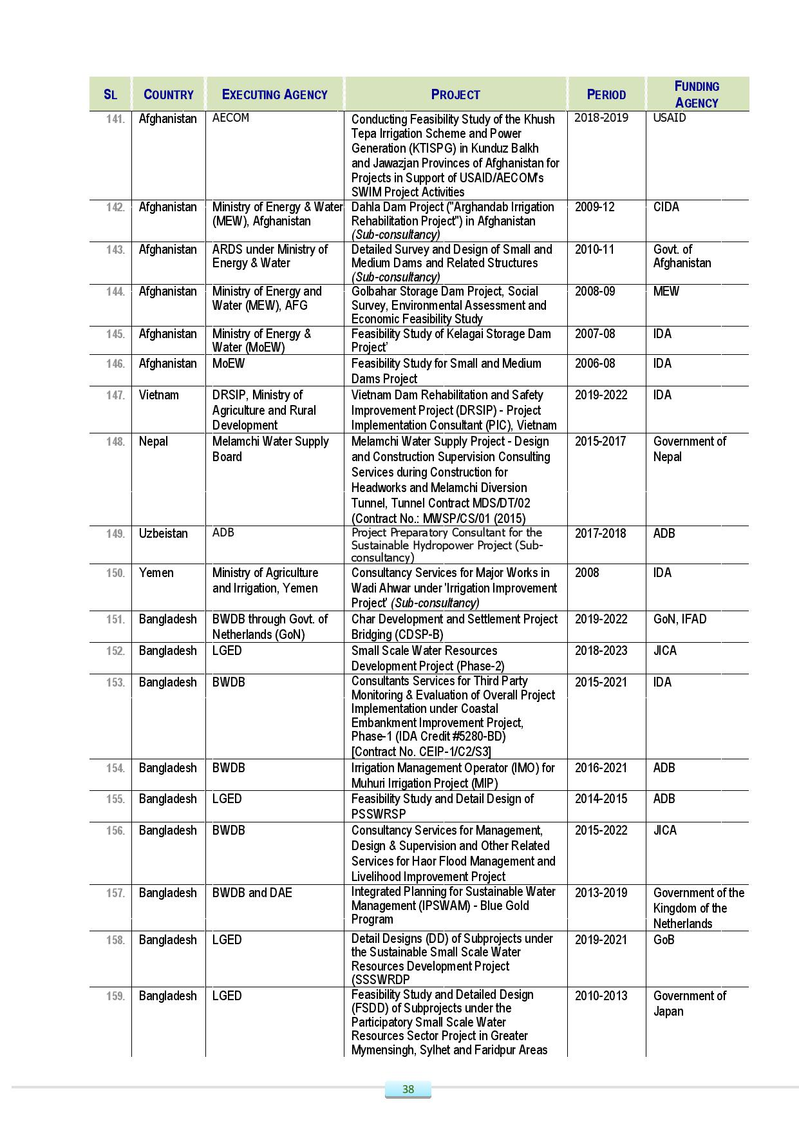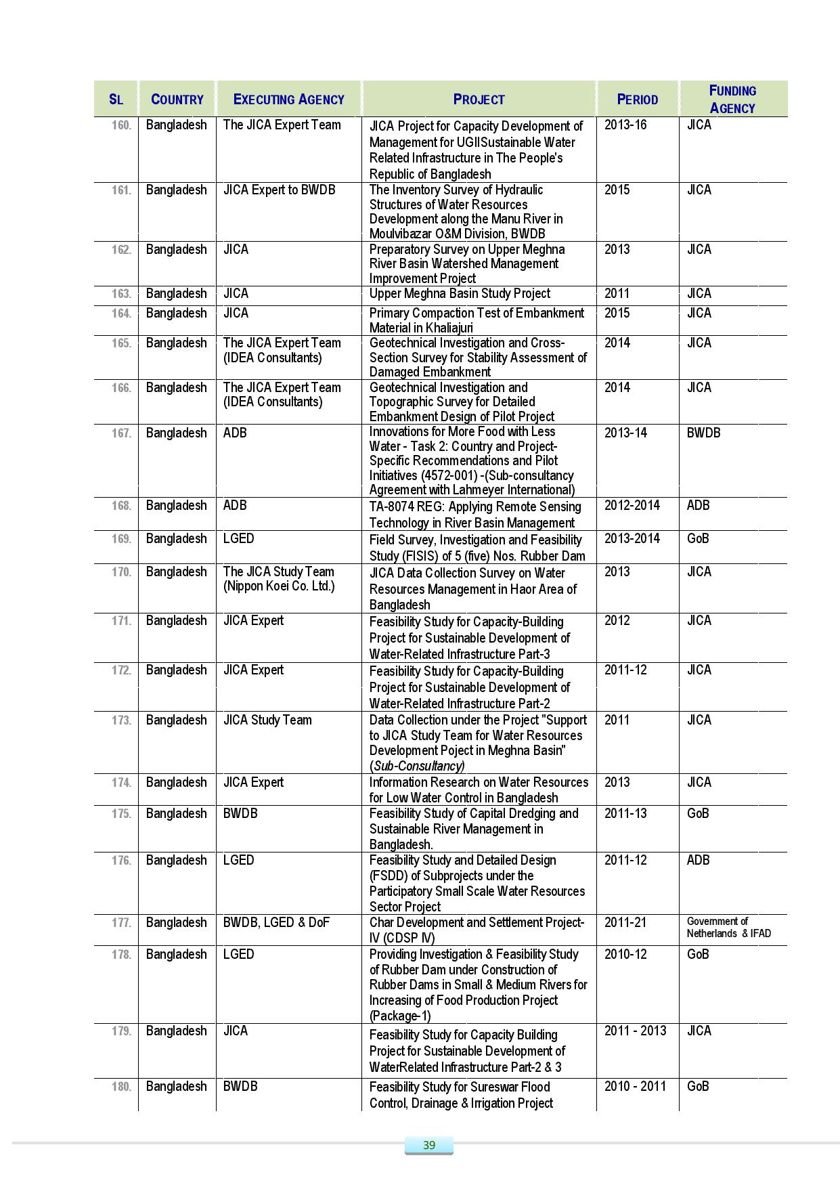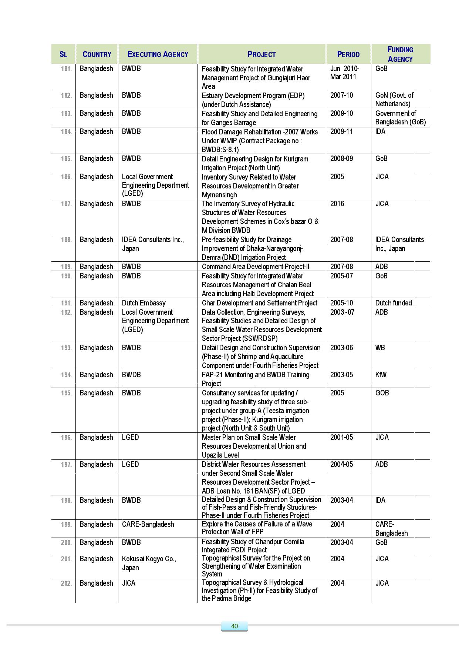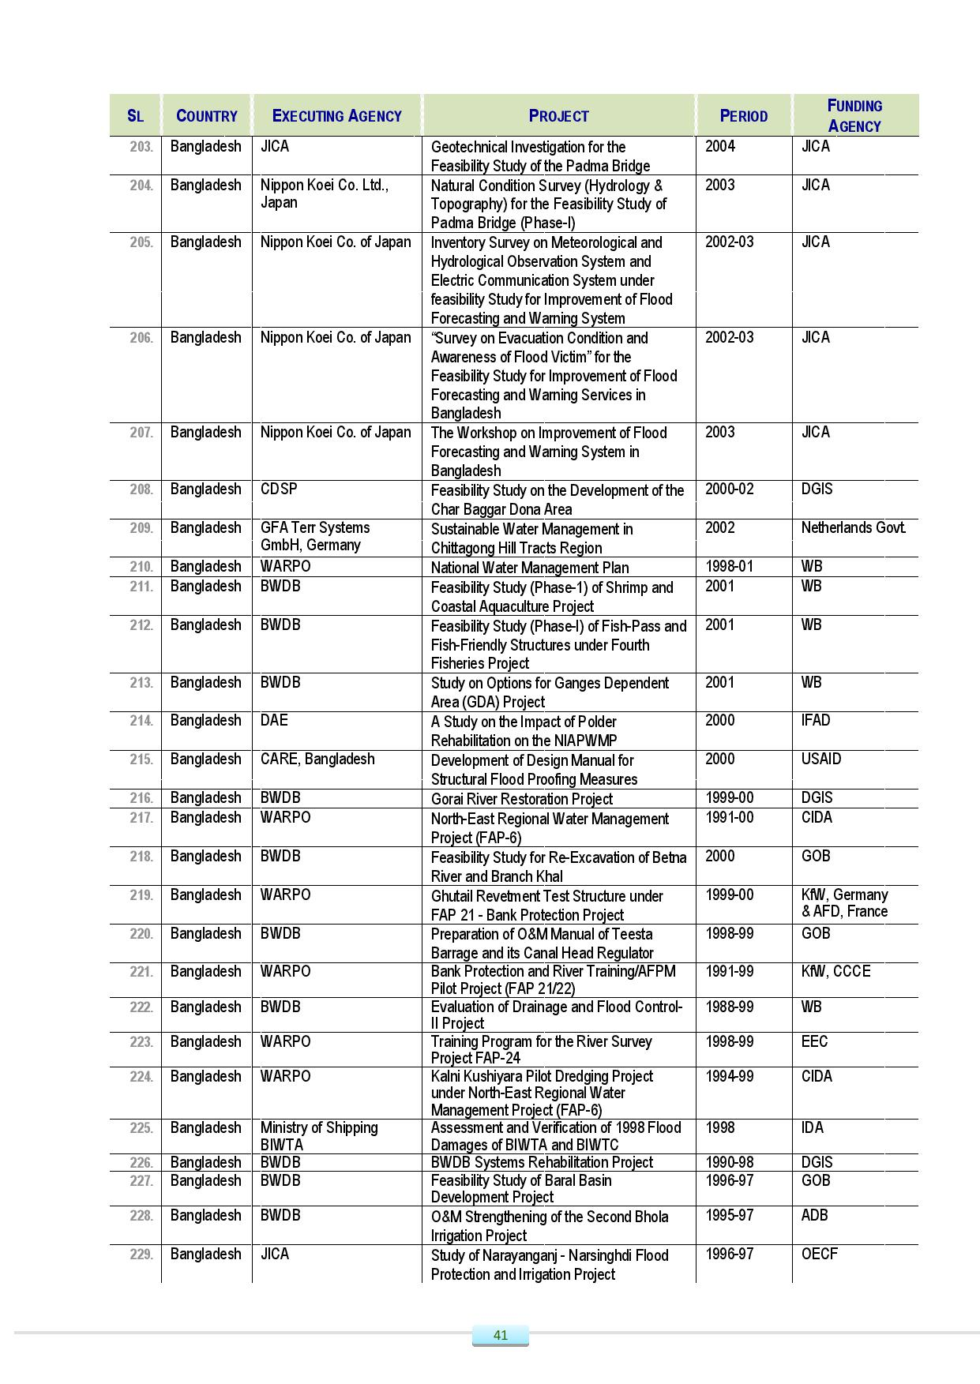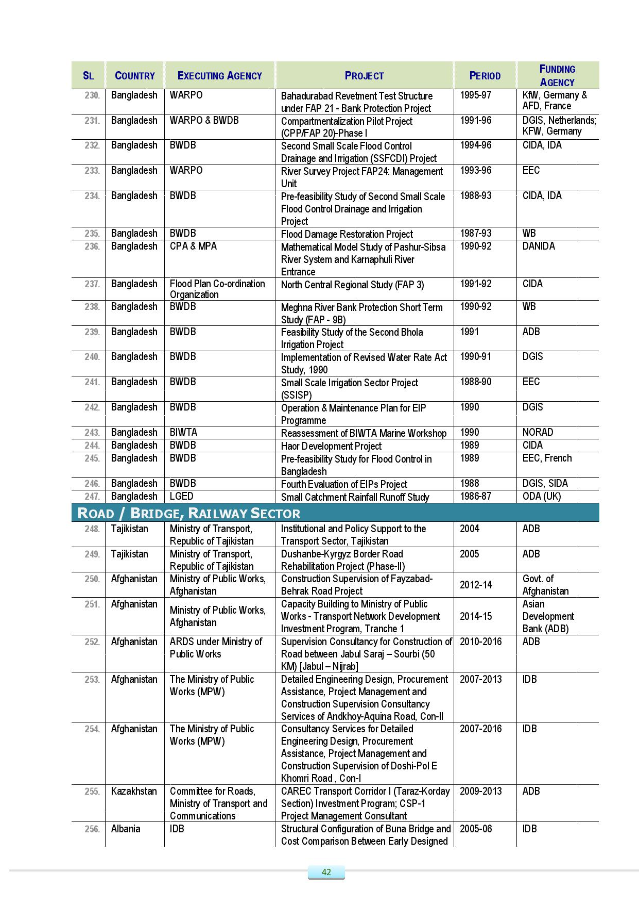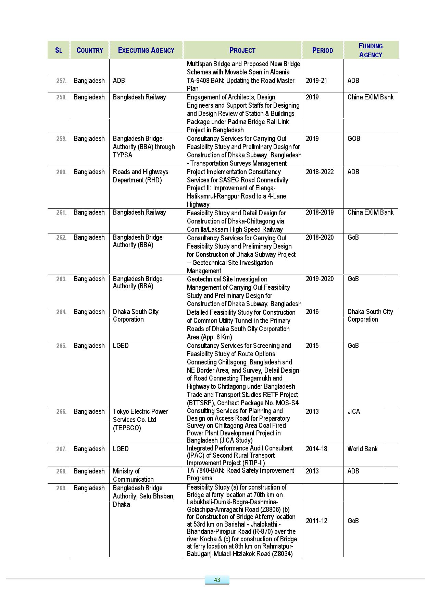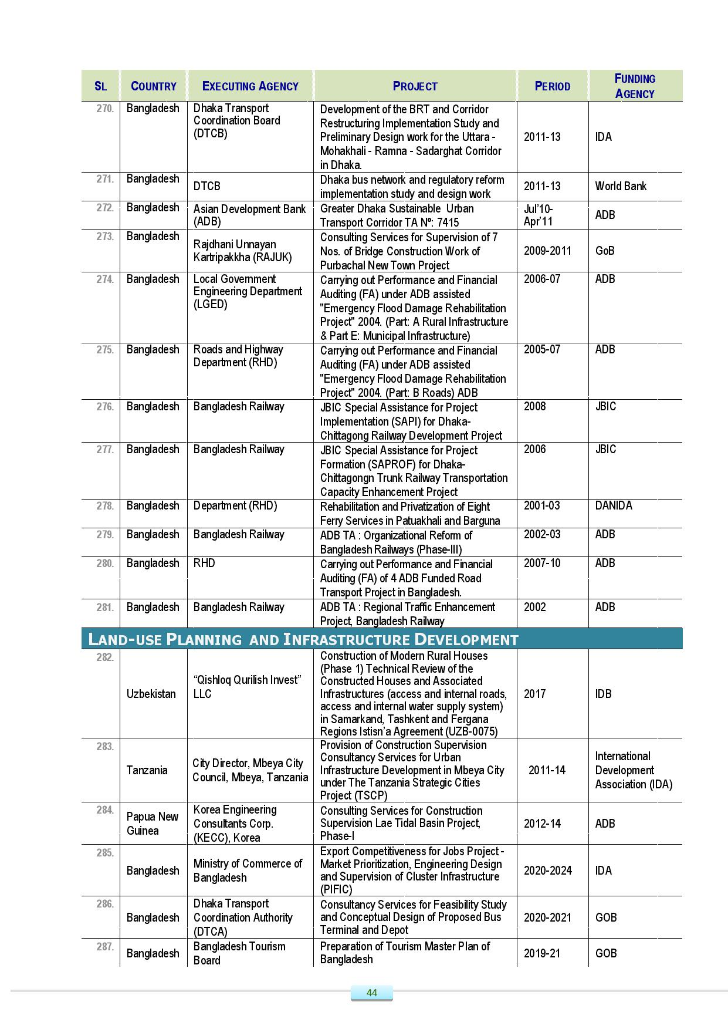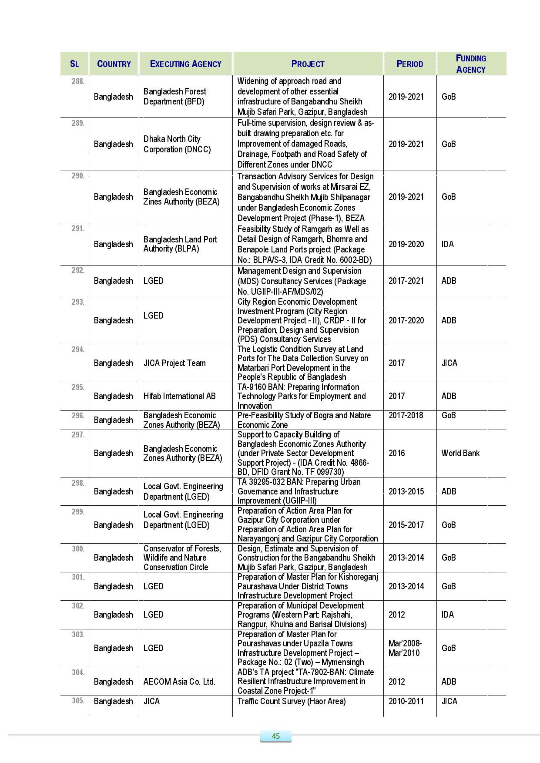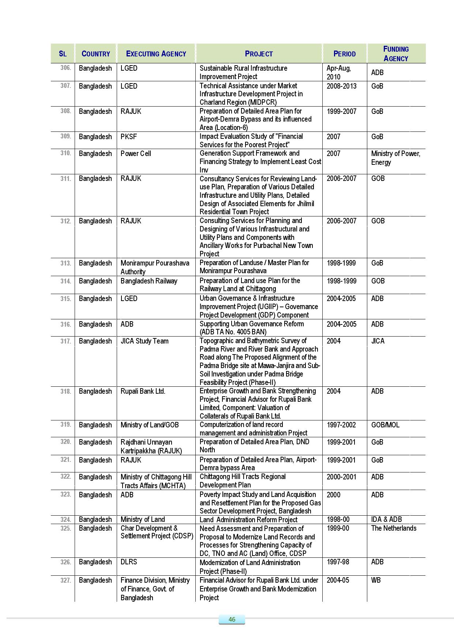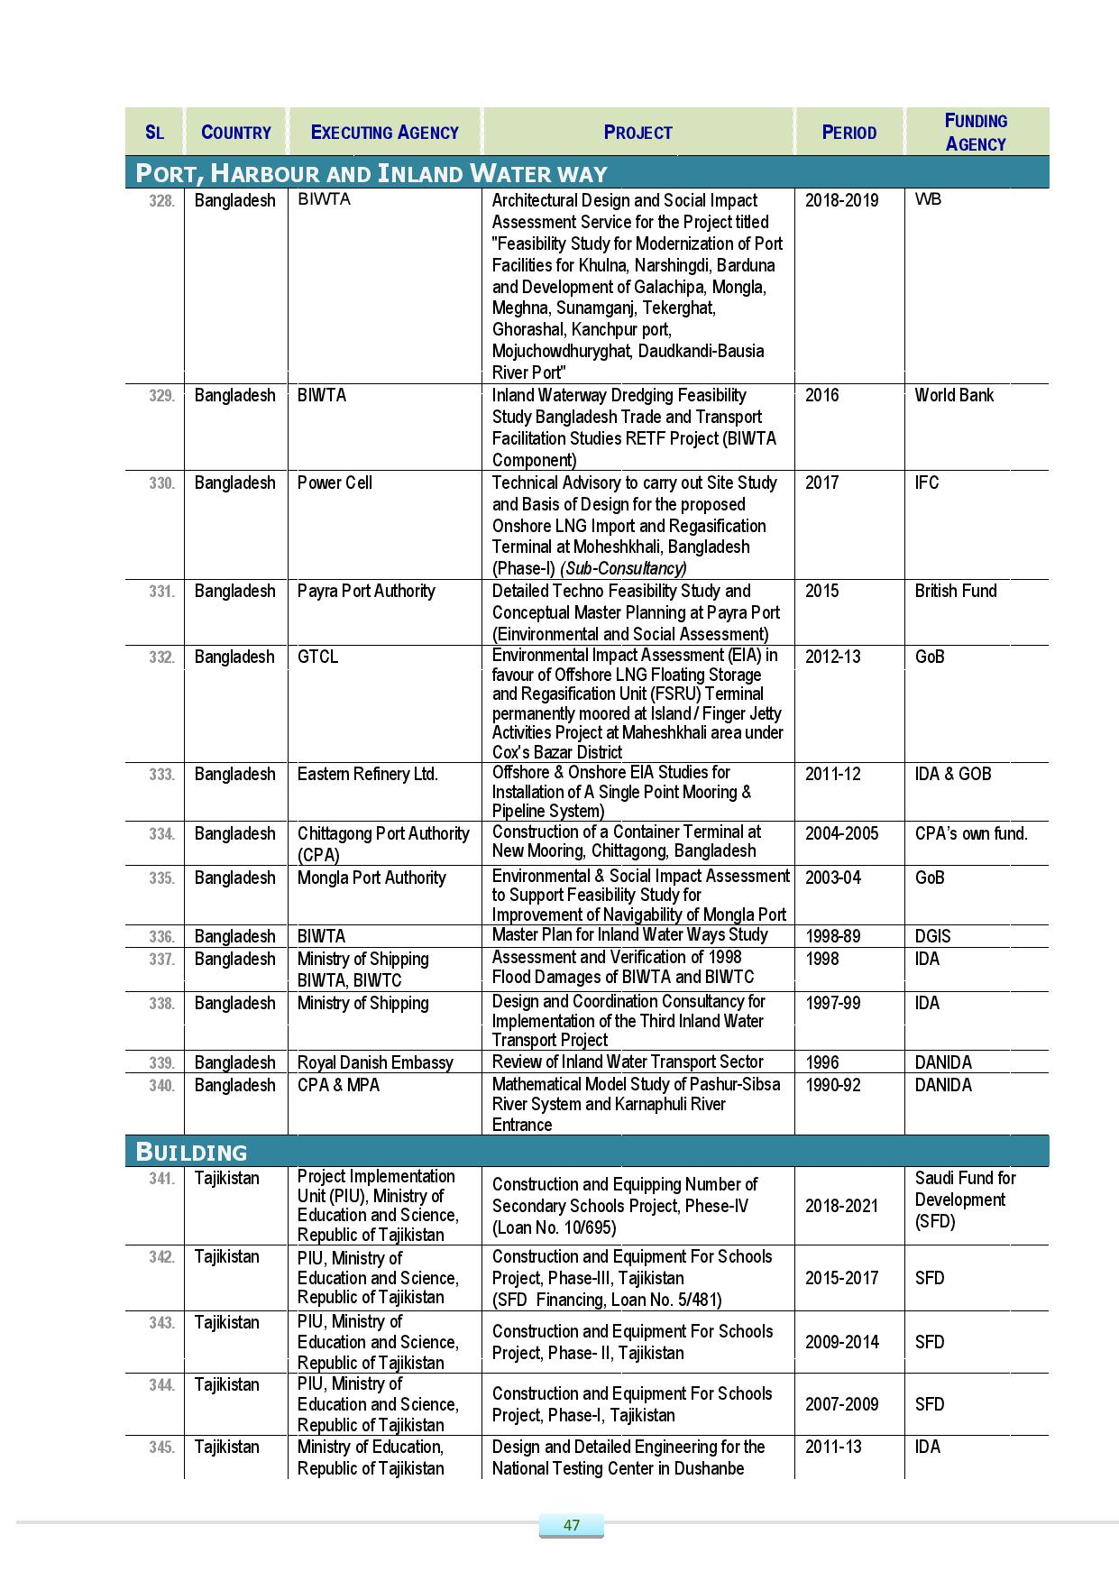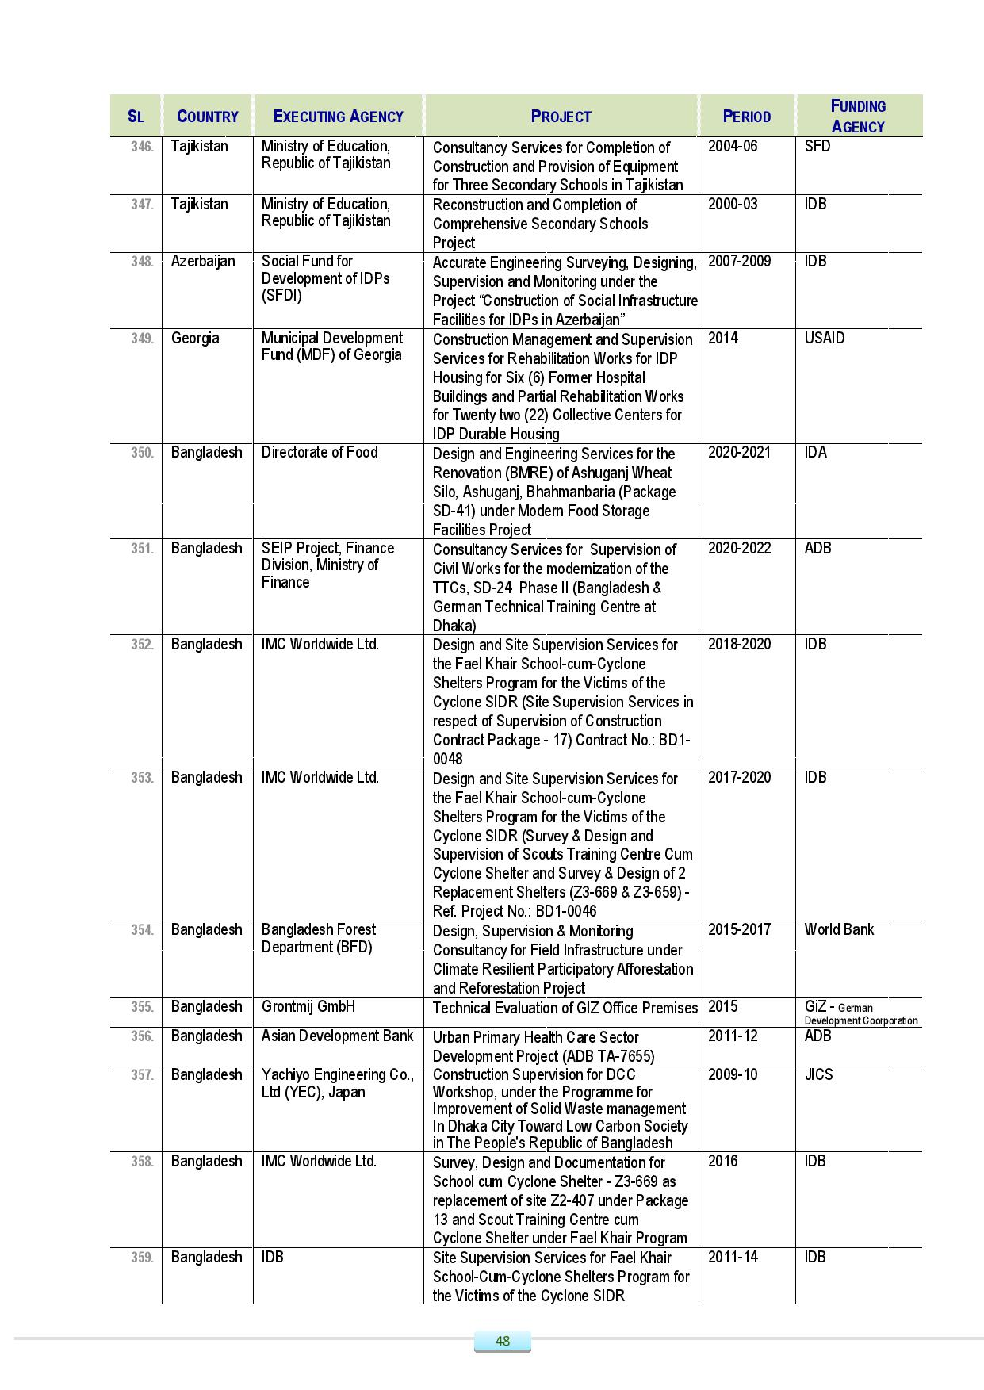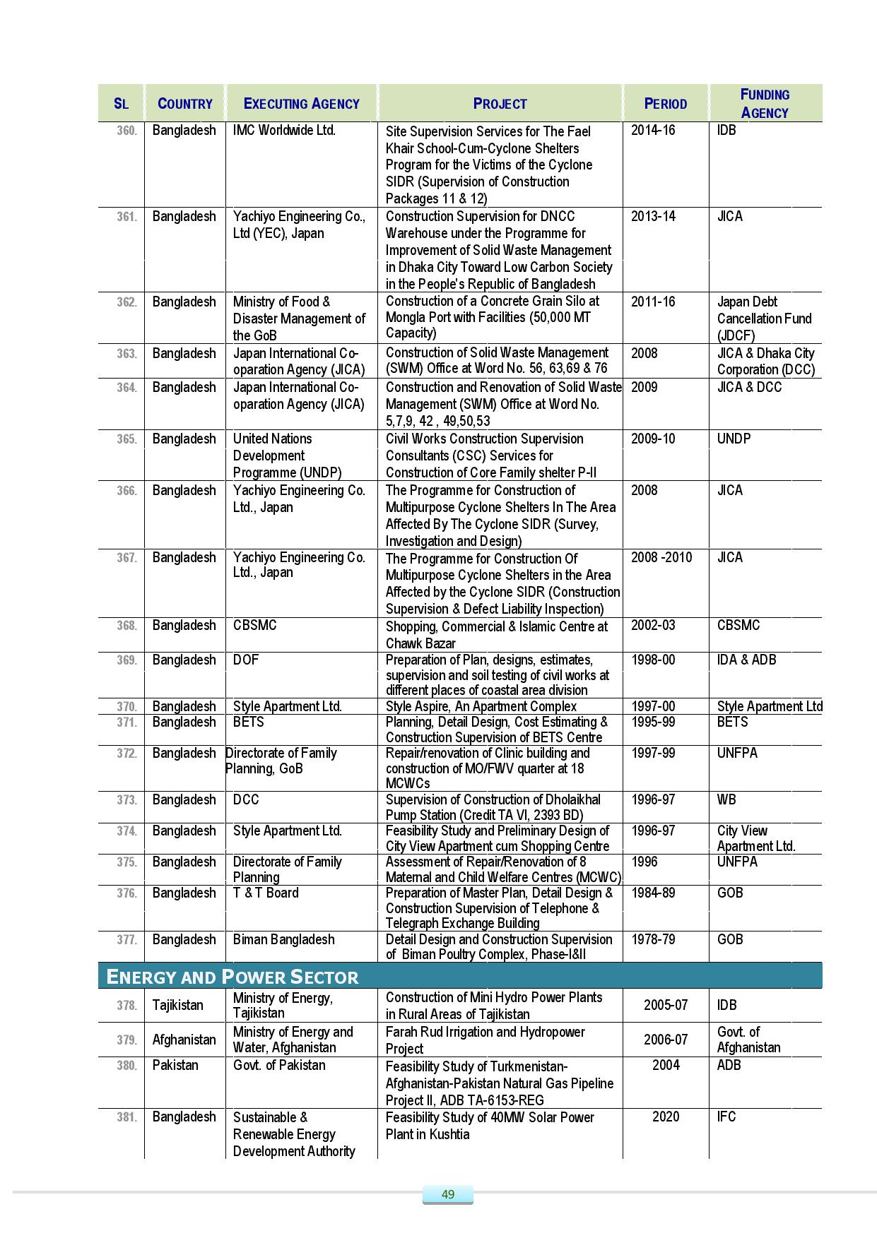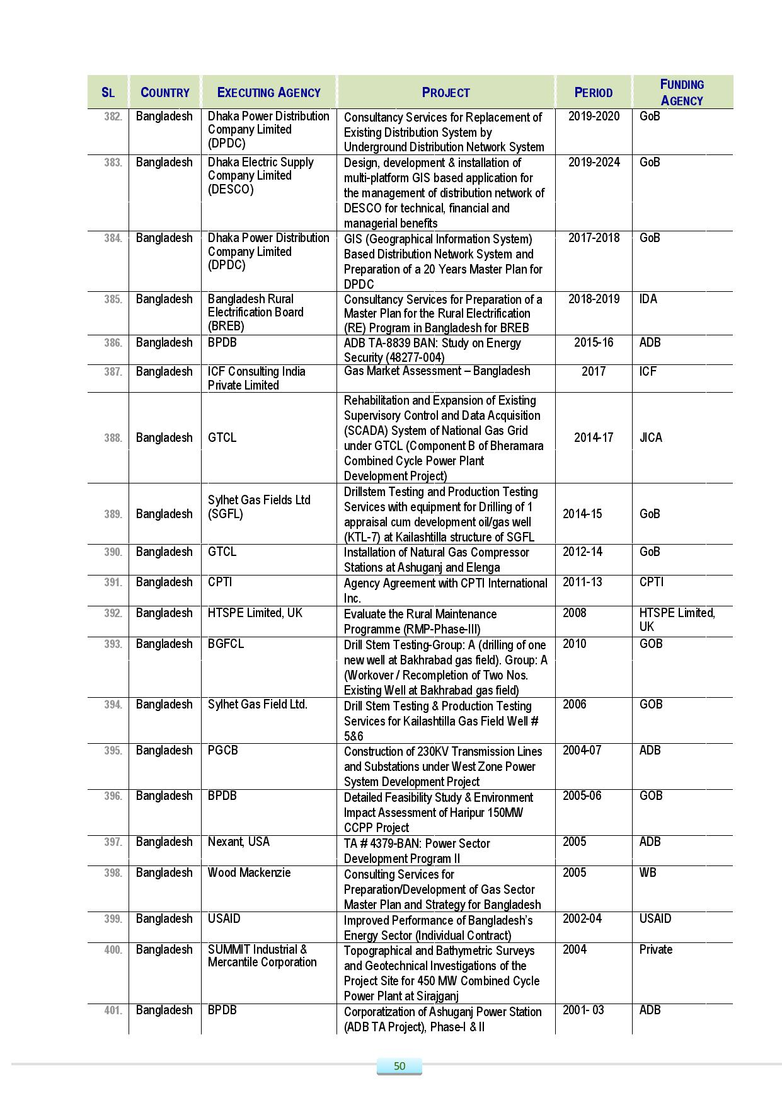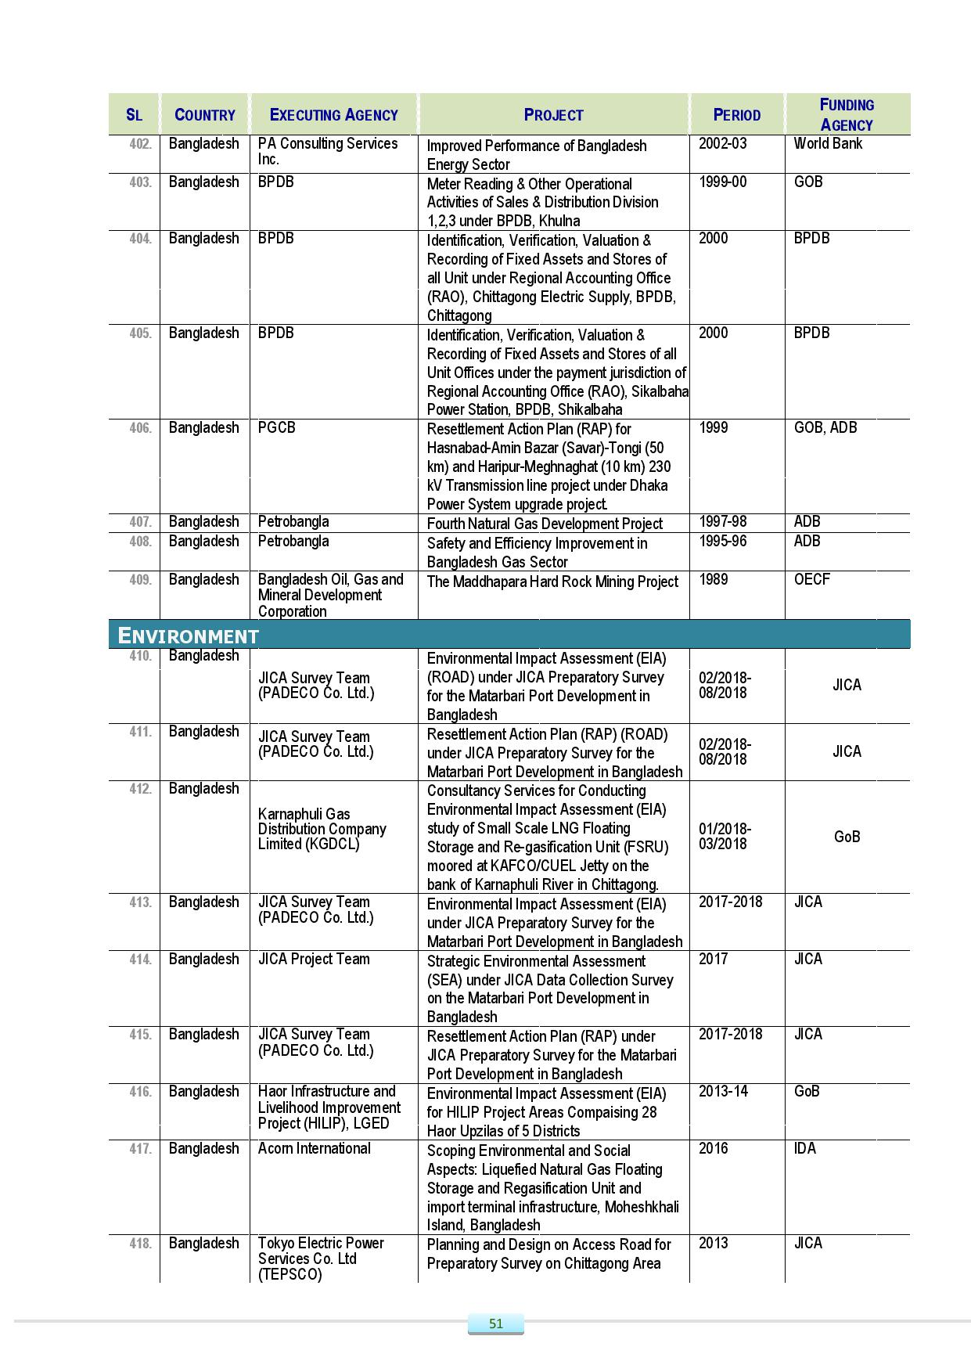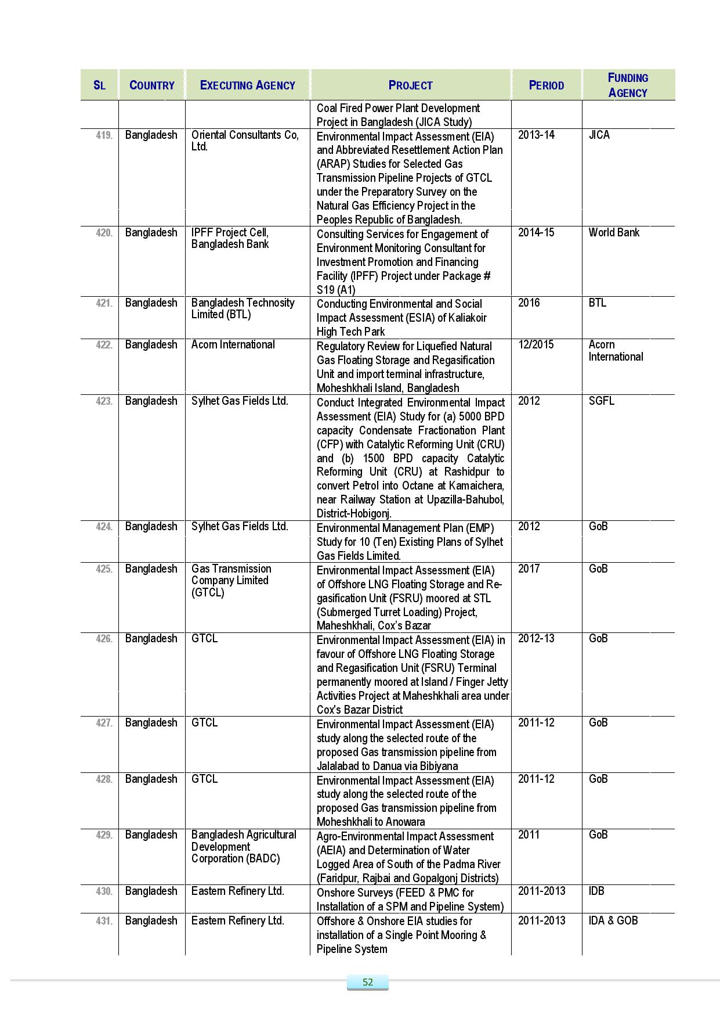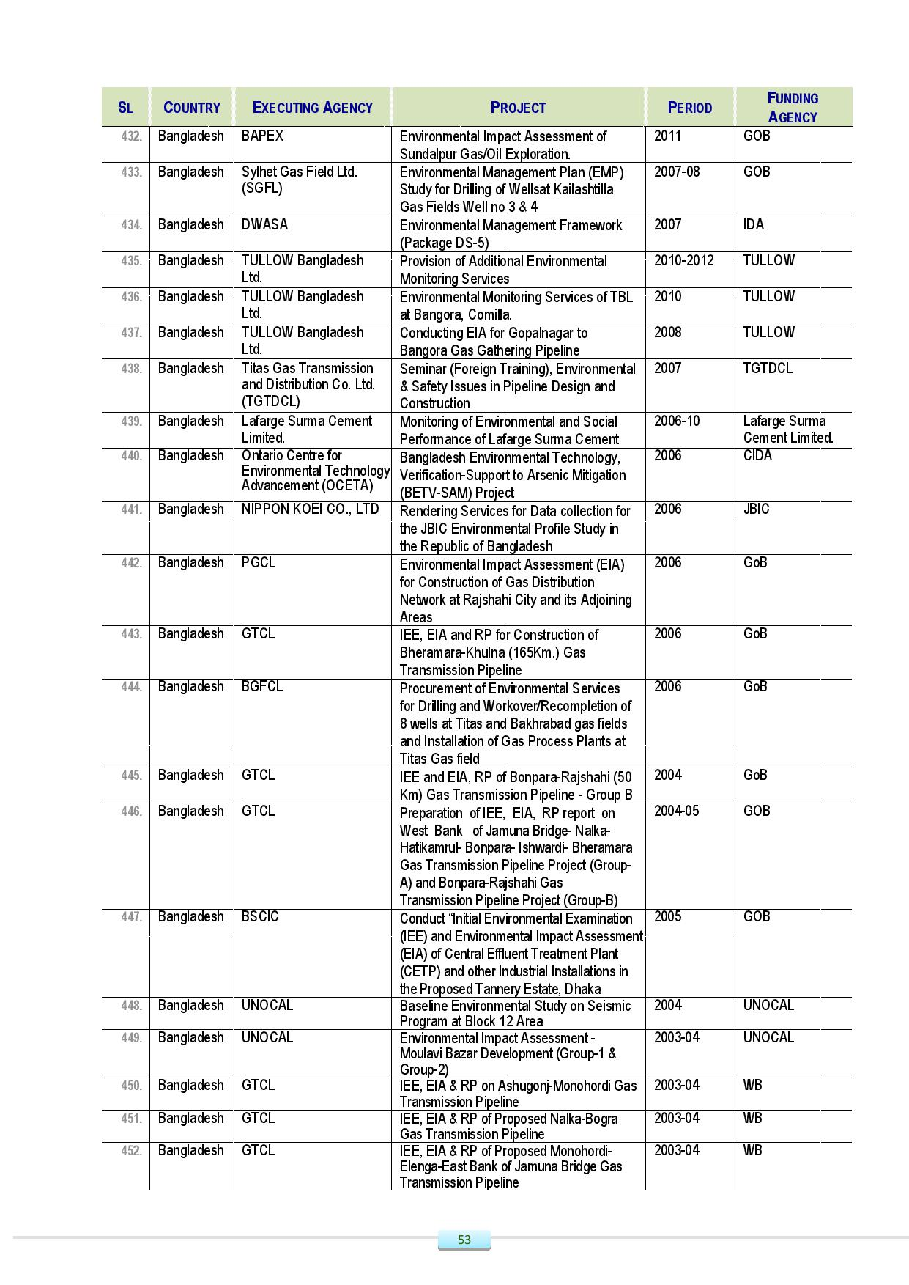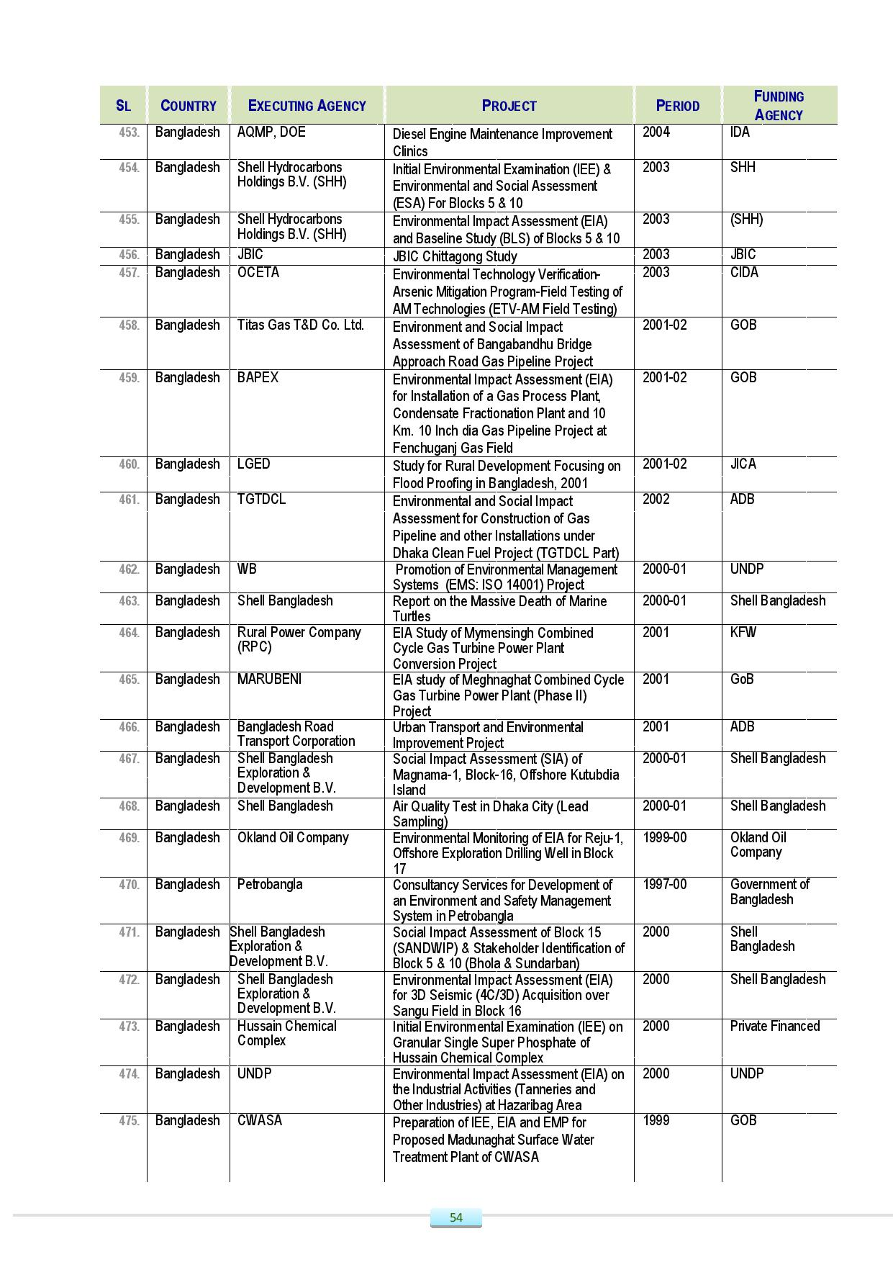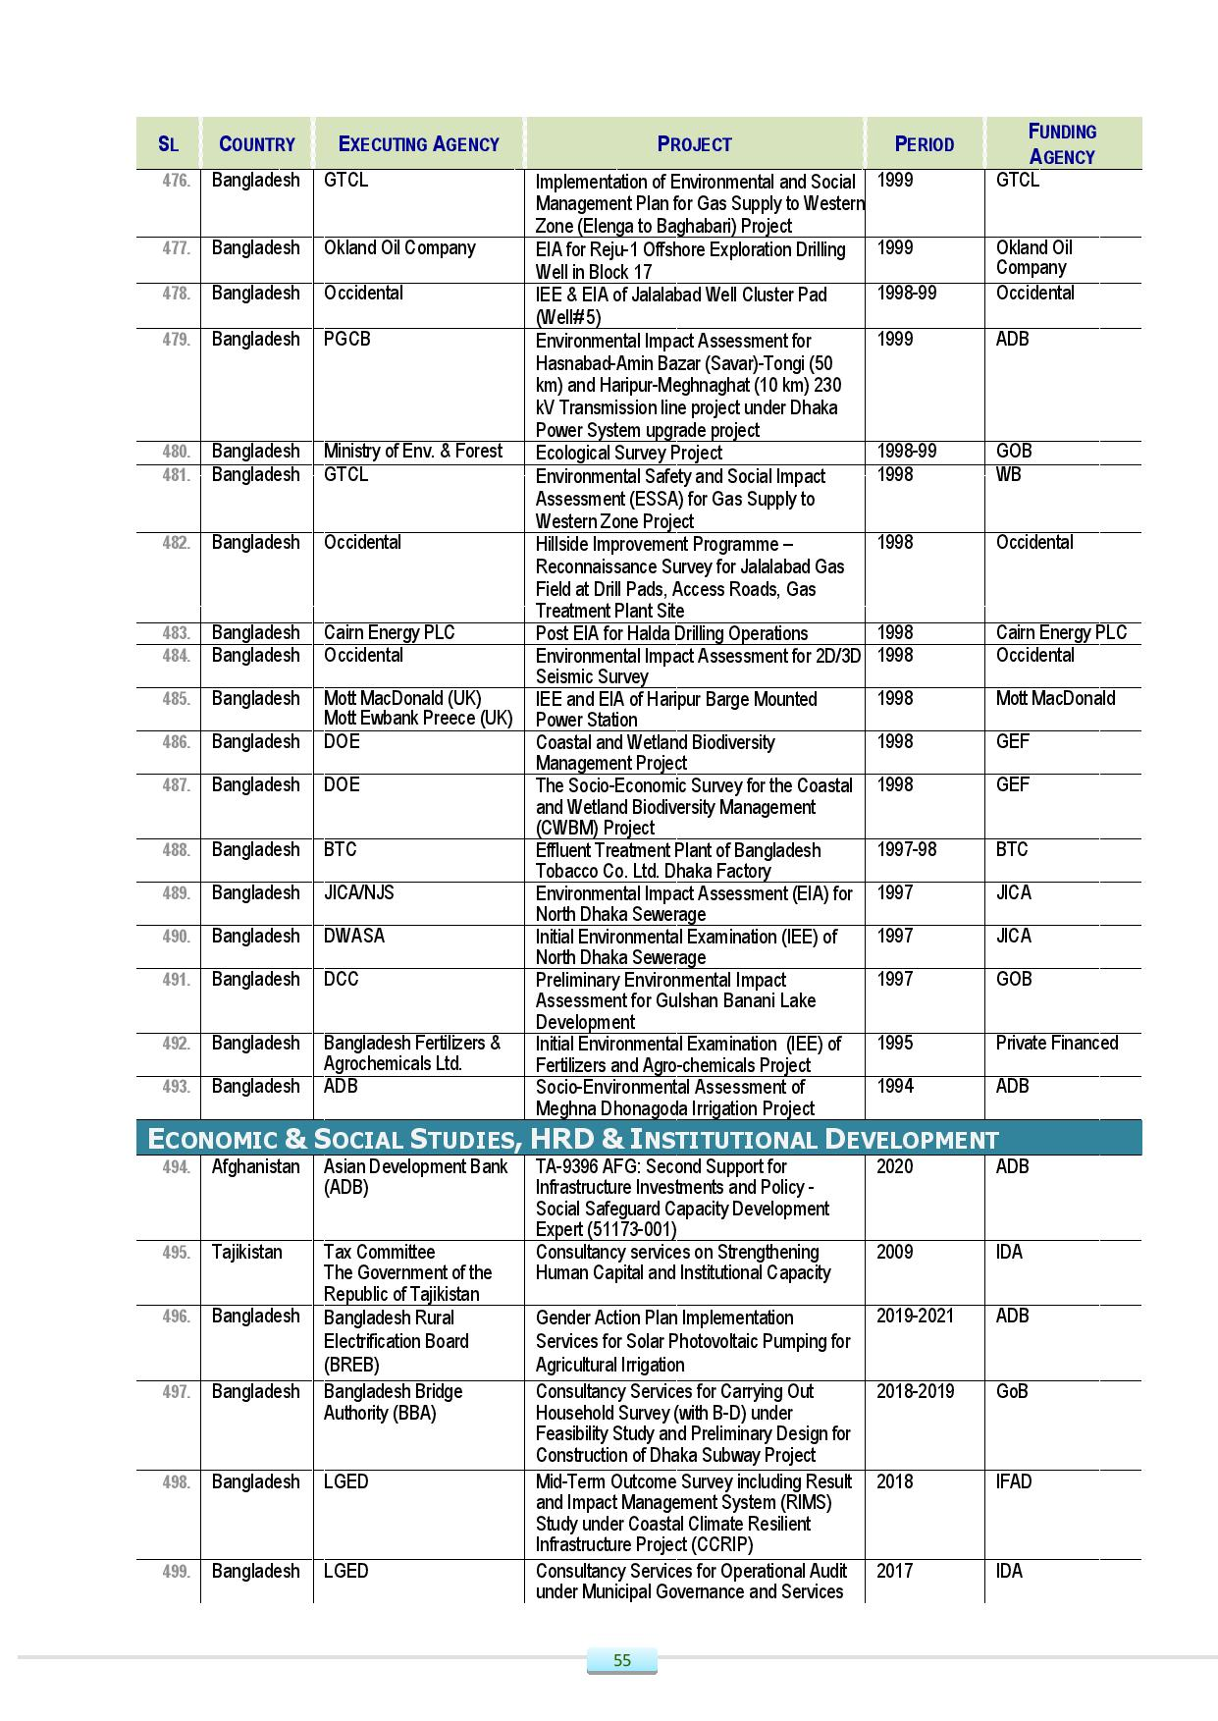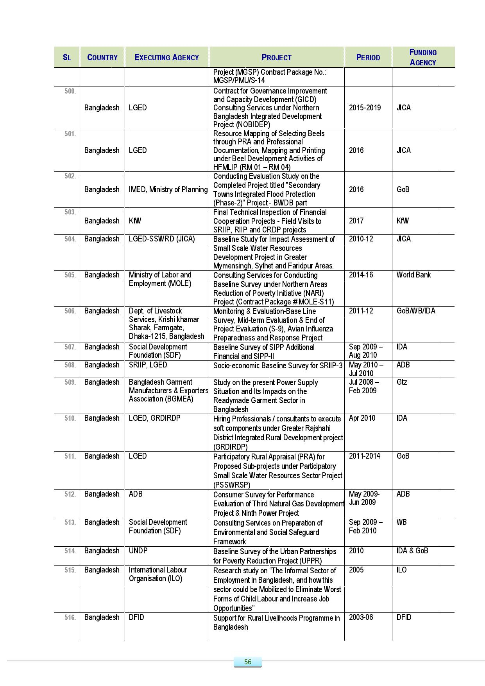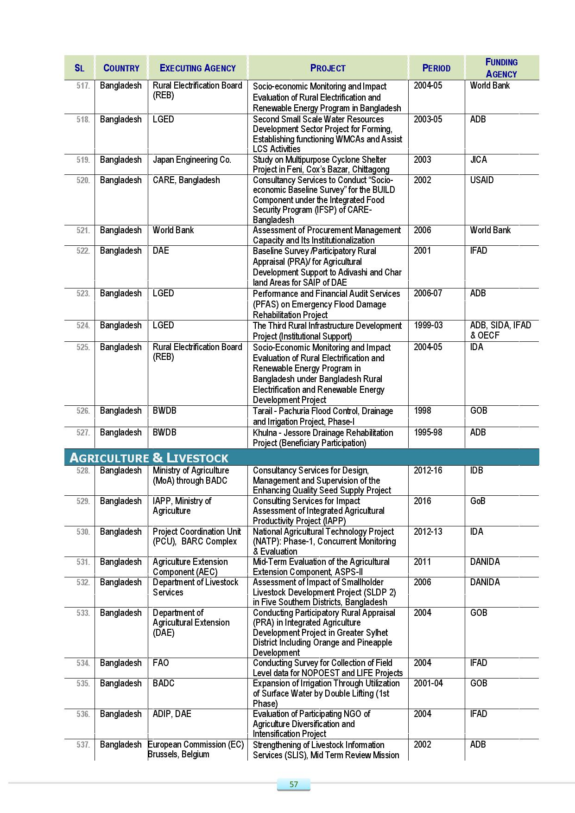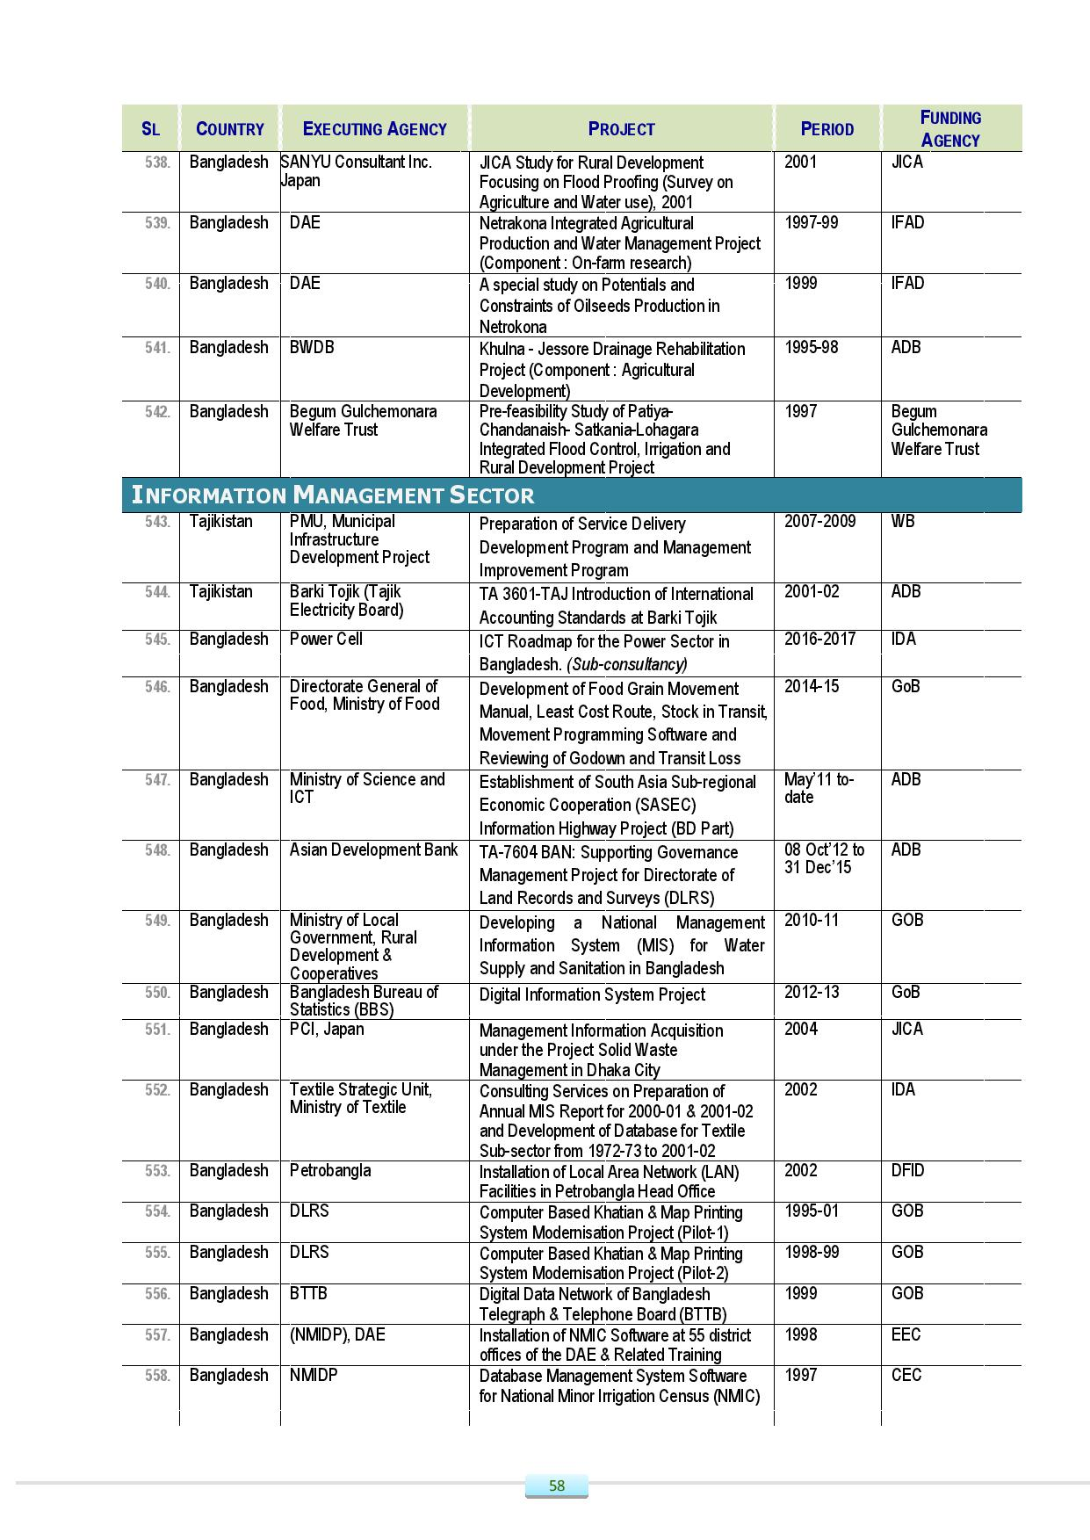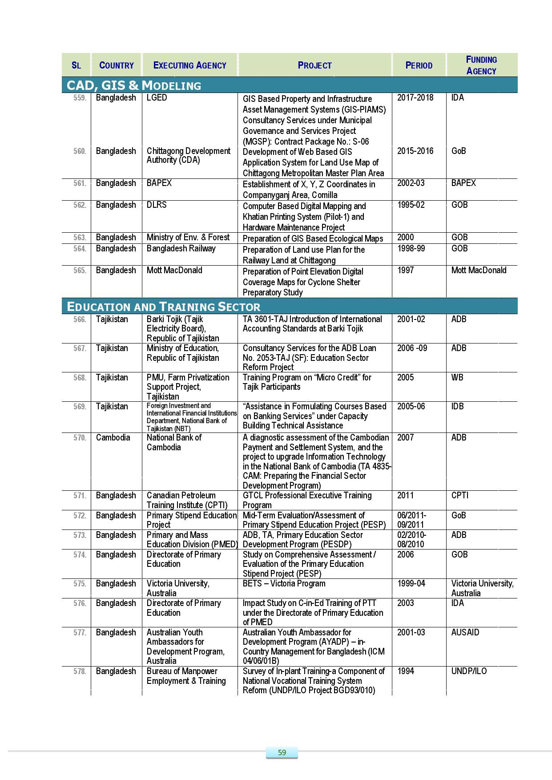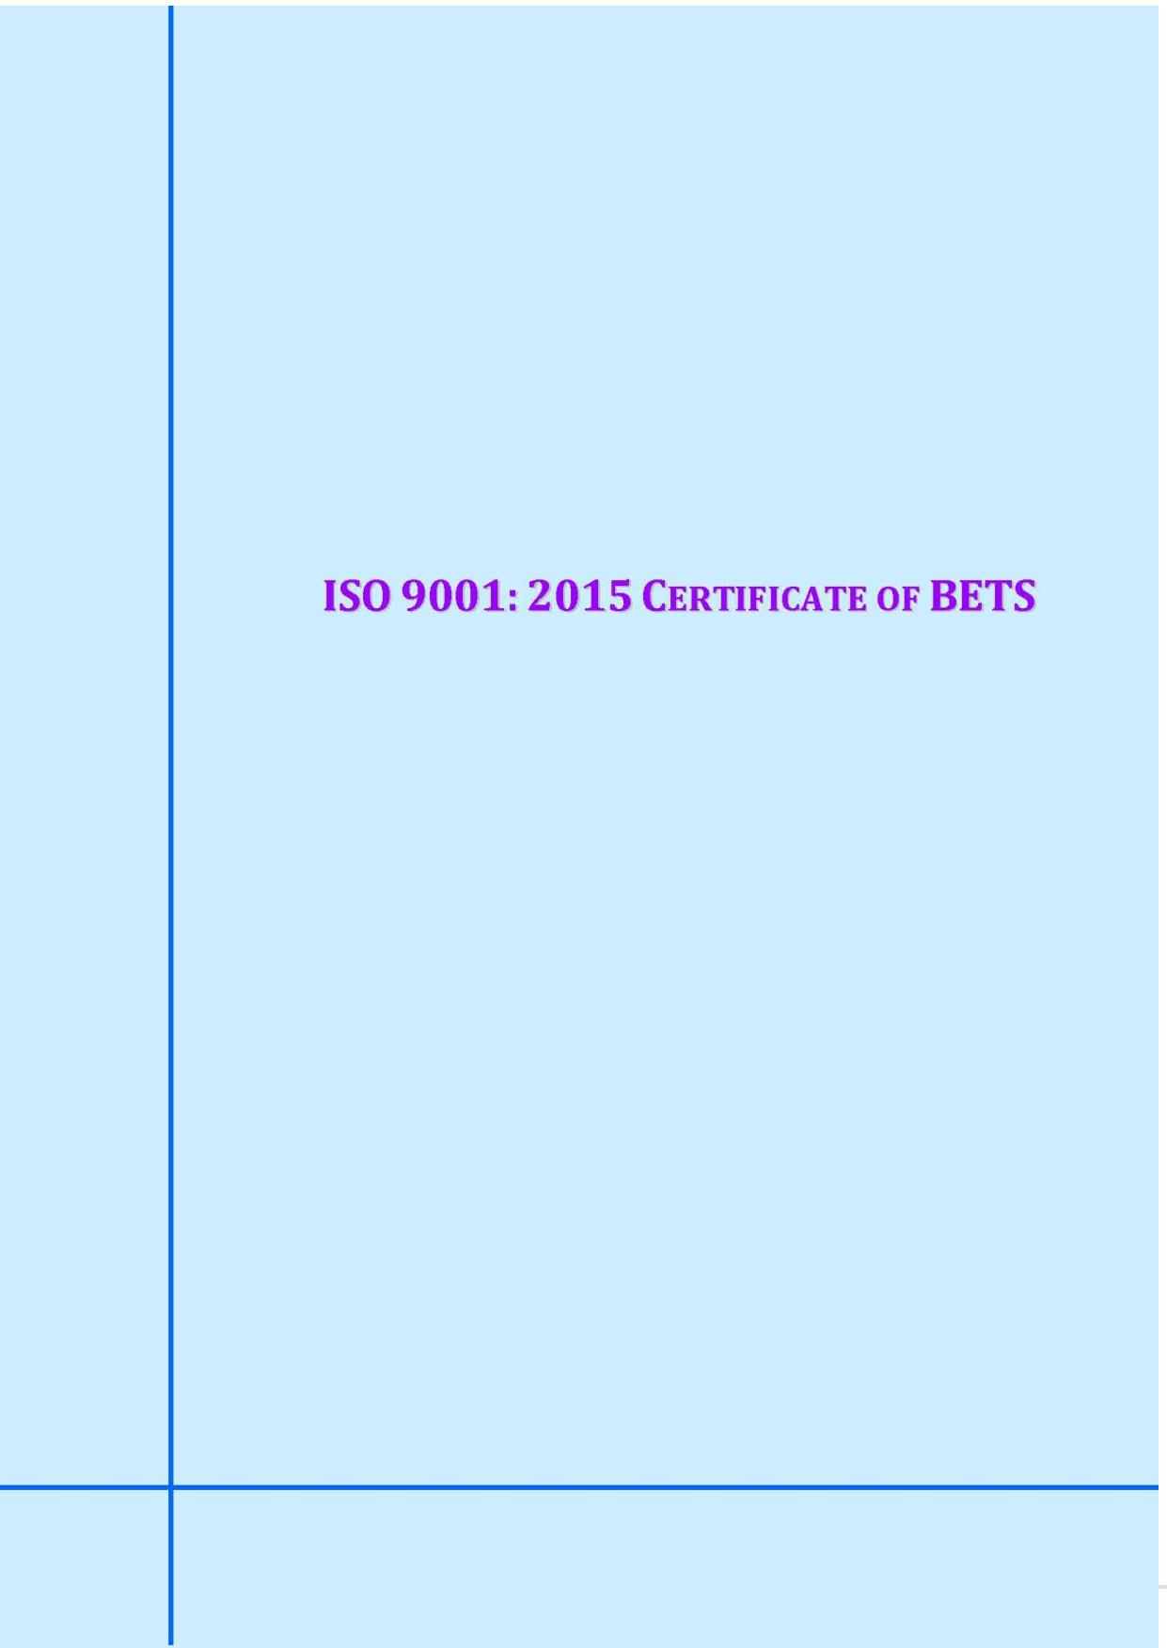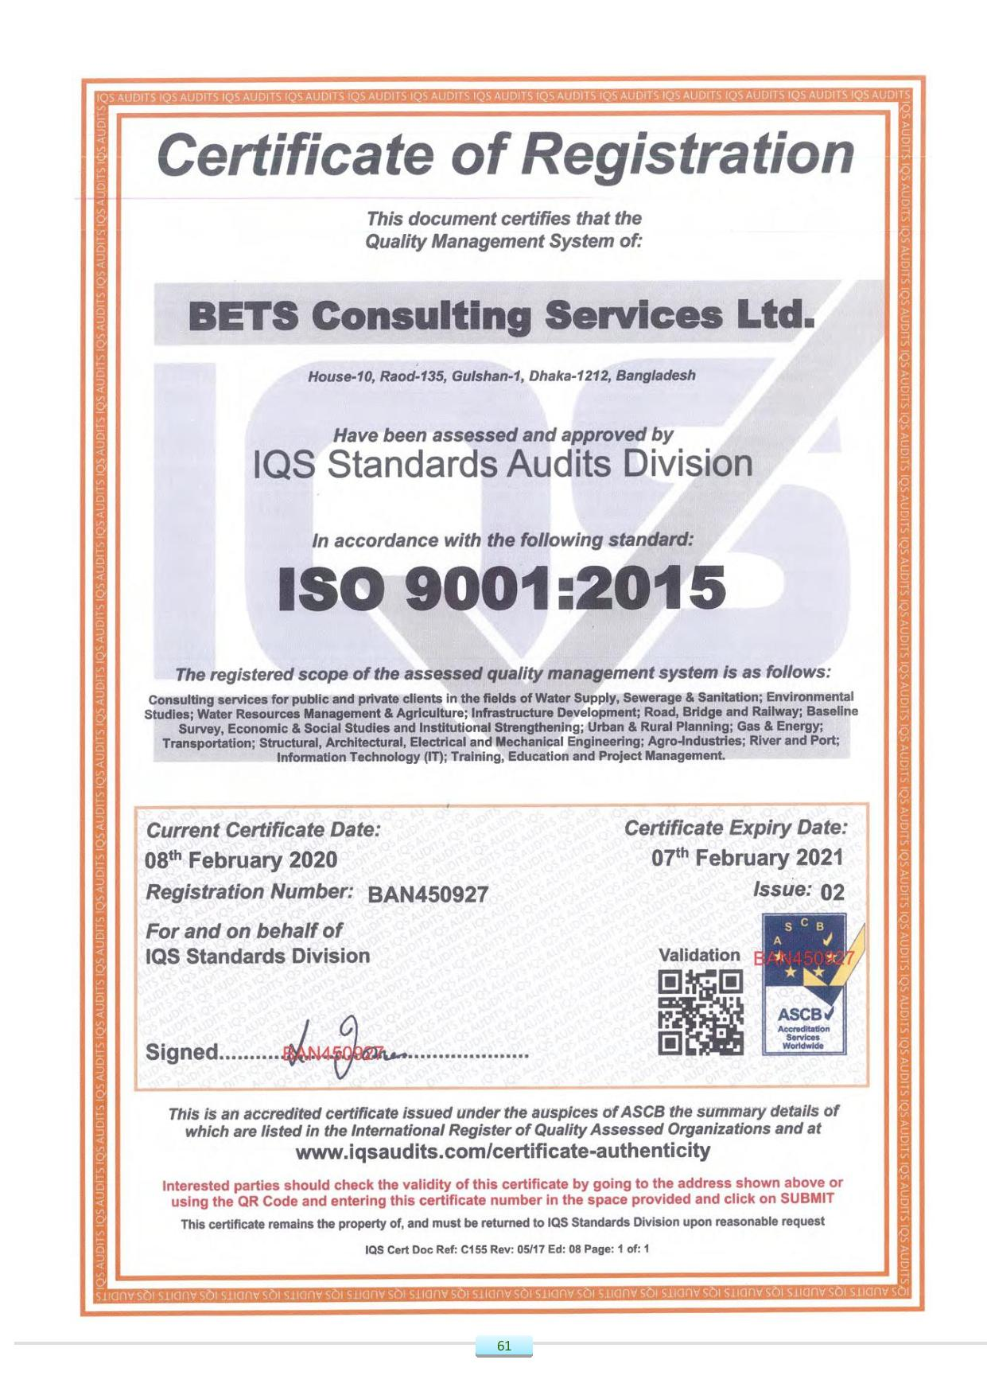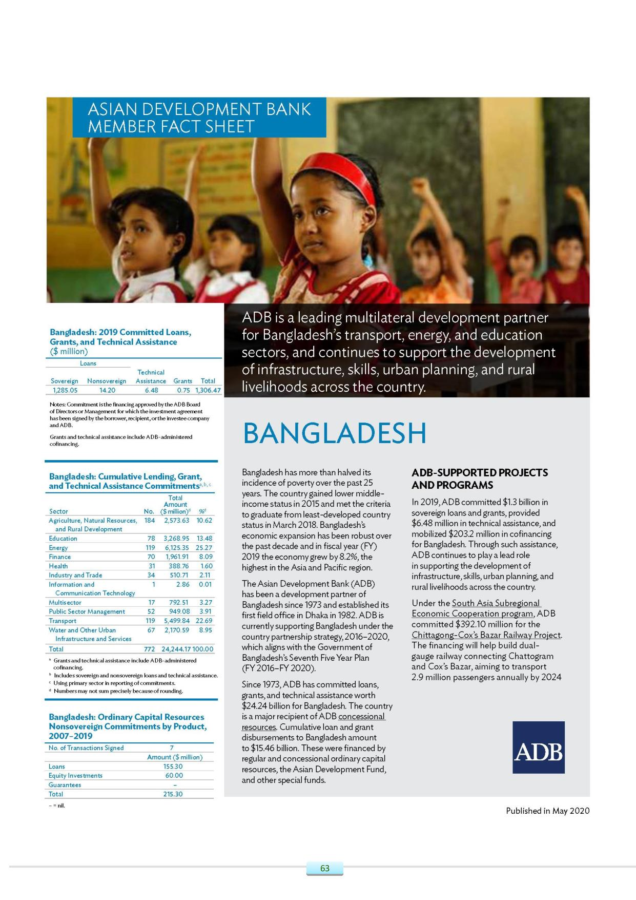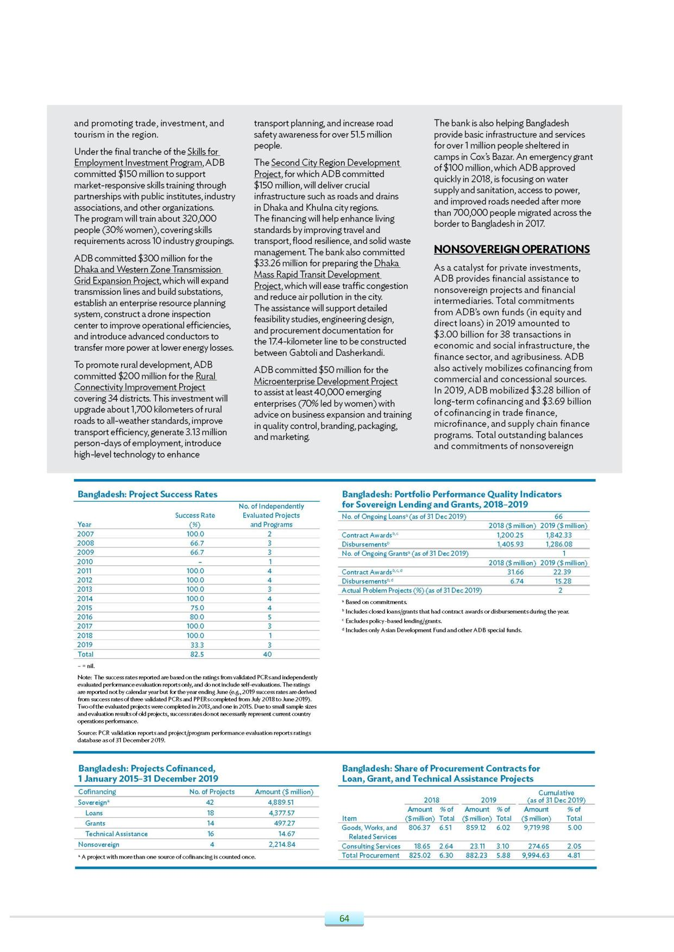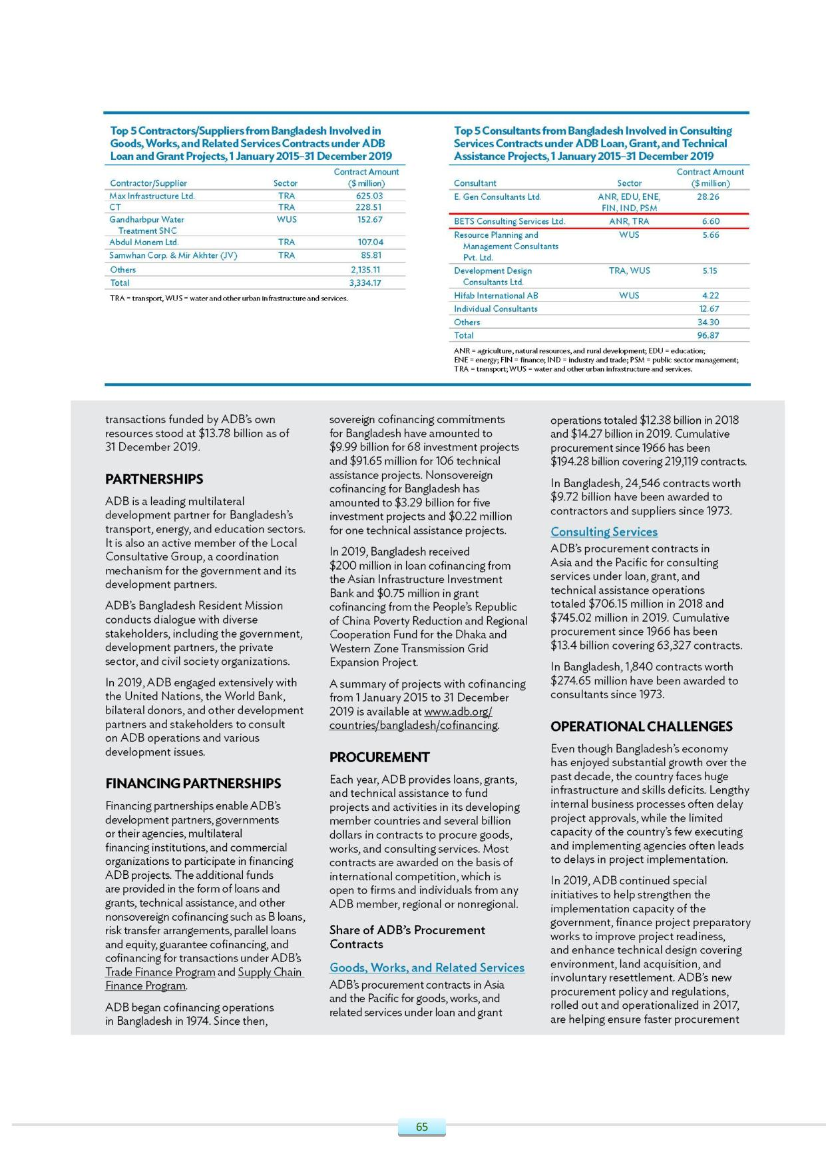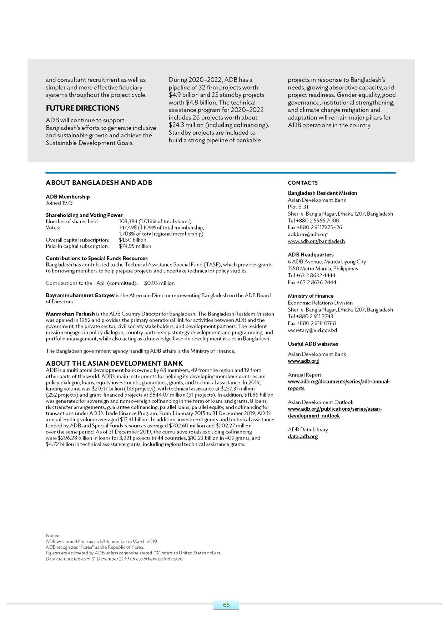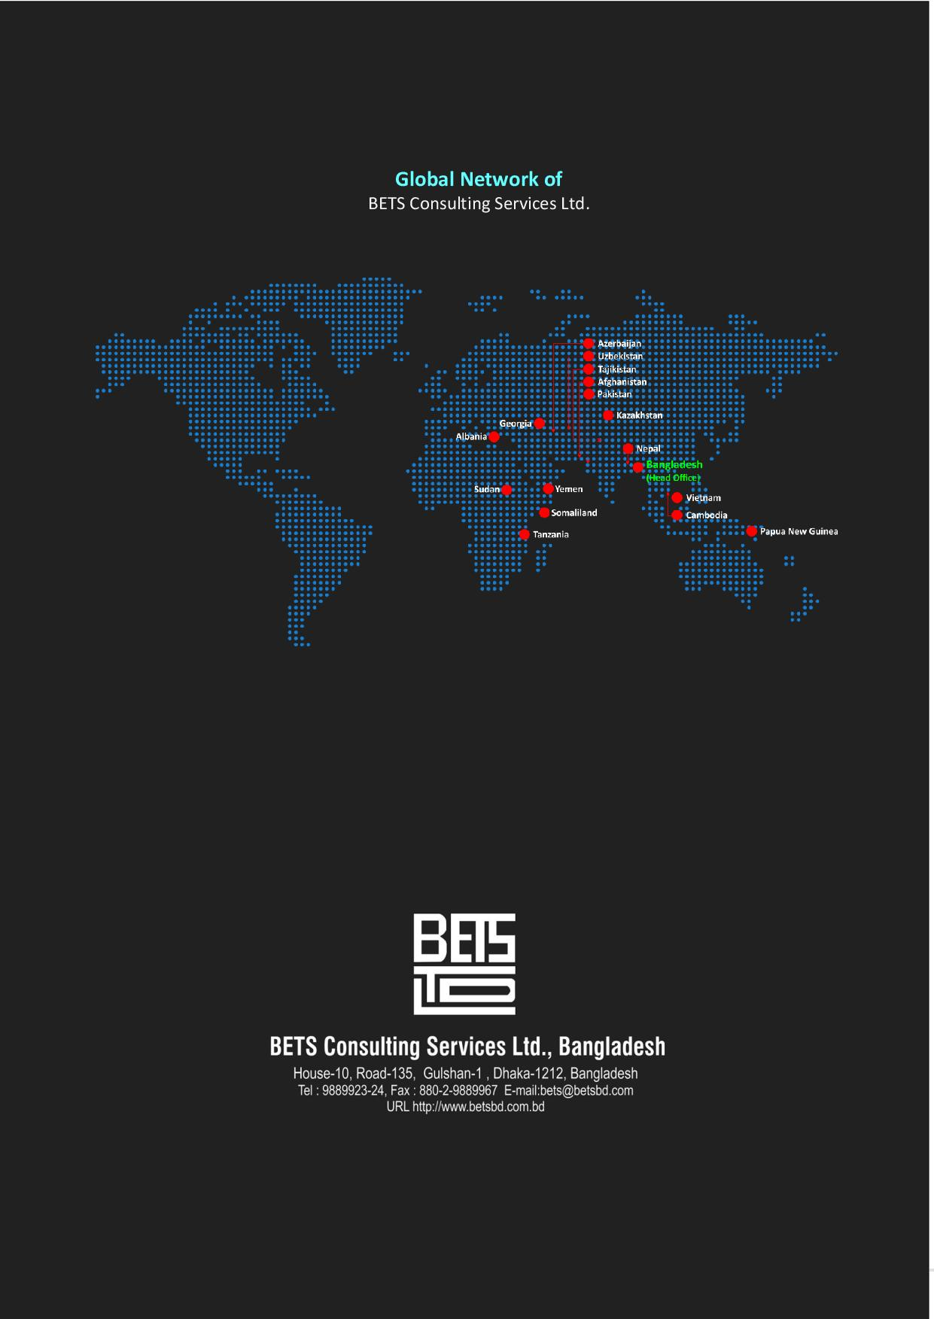

# Section-2: Similar Service Experience Records of the Firms

## 2.1. Sheba Technologies Ltd.

|  |  |
| --- | --- |
| **Assignment Name:**  **Digital LAB Monitoring and Management Solution (POC)** | **Approx. Value of the Contract**  (in currency)  N/A |
| **Country:** Bangladesh  Assignment Location within Country: Dhaka District | **Duration of Assignment (Months):** 7 |
| **Name of Client:**  DoICT, Ministry of ICT  **Address:** ICT Tower, E-14/X, BCC Bhaban, Dhaka 1207 | **Total No. of person-months of the assignment:**  50 |
| **Funded By:** Government of the People’s Republic of Bangladesh |
| **Start Date** (month/year): August 2019  **Completion Date** (month/year): March 2020 |
| **Name of Associate Consultants, if any:**  N/A |

## 2.2. BETS Consulting Services Ltd.

* **List of Similar projects:**

| **Sl. No.** | **Name of Project** | **Name of Client** | **Contract Amount** | **Period of Execution** | **PDS NO** |
| --- | --- | --- | --- | --- | --- |
| Summary of Ongoing Assignment | | | | |  |
|  | Consultancy Services for Design, Development & Installation of Multi-platform GIS (Geographical Information System) Web Based Application System for the Management of Distribution Network of DESCO for technical, financial and managerial benefits” | Dhaka Electric Supply Company (DESCO) Ltd. | BDT 338,475,182 | Aug 2019  Till date | **PDS-1** |
| 2. | GIS Based Property and Infrastructure Asset Management systems (GIS-PIAMS) Web Based Application System. Consultancy Services under Municipal Governance and services Project (MGSP) Contract Package No.:06 | Local Government Engineering Department (LGED) | BDT 69,660,059 | May 2017  Mar 2021 | **PDS-2** |
| 3. | Third Party Monitoring & Evaluation of Overall Project Implementation of Coastal Embankment Improvement Project, Phase-I (CEIP-I), | Bangladesh Water Development Board (BWDB) | USD 3.49 million | Sep 2014  Feb 2017 | **PDS-3** |
| Summary of Completed Assignment | | | | |  |
| 4. | Consultancy Services for GIS (Geographical Information System) Based Distribution Network System and Preparation of a 20 years Master Plan for DPDC” | Dhaka Power Distribution Company Ltd. (DPDC) | USD 4,684,480.00 | Jan 2017  Dec 2019 | **PDS-4** |
| 5. | TA-7604 BAN: Supporting Governance Management Project  [Web Based Digital Land Management System(DLMS)] | Asian Development Bank (ADB) | USD 219,041 | Oct 2012  Sep 2015 | **PDS-5** |
| 6. | ADB TA 8074-REG: Applying Remote Sensing Technology in River Basin Management  [Web Based GIS] | ADB & Japan Aerospace Exploration Agency (JAXA) | USD 5,95,500 | Nov 2012  Mar 2014 | **PDS-6** |
| 7. | Digital Information System Project  [Web Based GIS] | Bangladesh Bureau of Statistics (BBS) | BDT 12,50,000 | Sep 2012  Aug 2013 | **PDS-7** |
| 8. | Development of Web Based GIS Application System for Land Use Map of Chittagong Metropolitan Master Plan Area | Chittagong Development Authority (CDA) | BDT 17,56,250 | Aug 2014  Dec 2014 | **PDS-8** |
| 9. | Developing a National Management Information System (NMIS) for Water Supply and Sanitation in Bangladesh - Funded by DANIDA [**GIS Based Web Application System**] | Ministry of Local Government, Rural Development & Cooperatives | BDT 22,082,500 | Nov 2010  Nov 2011 | **PDS-9** |
| 10. | Preparation of GIS Based Ecological Maps | National Conservation Strategy (NCS) Implementation Project- Ministry of Environment and Forest | USD 0.018 million | Sept 2000  Oct 2000 | **PDS-10** |
| 11. | Rehabilitation of Computer System, Database Up gradation and Backlog Data Entry and Processing | Bangladesh Water Development Board (BWDB) | USD 10.40 Million | Mar 2001  Sep 2001 | **PDS-11** |
| 12. | Database Management System Software for National Minor Irrigation Census (NMIC) | National Minor Irrigation Development Project (NMIDP) | USD 0.003 million | Jul 1997 | **PDS-12** |

* **Details of Similar projects are as follows:**
* **Detail Description of On-going Projects:**

|  |  |
| --- | --- |
| **PDS-1** | |
| **Assignment Name:**  **Consultancy Services for Design, Development & Installation of Multi-platform GIS (Geographical Information System) Web Based Application for the Management of Distribution Network of DESCO for technical, financial and managerial benefits”** | **Approx. Value of the Contract**  (in currency)  USD: 1,480,935.00 (Equivalent of BDT.124,398,540.00 @$= Tk. 84.00) and BDT 338,475,182.00 |
| **Country:** Bangladesh  Assignment Location within Country:Dhaka District | **Duration of Assignment (Months):** 24 |
| **Name of Client:**  Dhaka Electric Supply Company (DESCO) Ltd.  **Address:** House No. 22/B, FarukSarani, Nikunja – 2, Khikhet, Dhaka - 1229, Bangladesh. | **Total No. of person-months of the assignment:**  214  **Professional Staff Provided by BETS (JV Partner)**  **No. of Staff:** 11; **No. of Person-Months:** 115 |
| **Funded By:** Government of the People’s Republic of Bangladesh | **Approx. value of the services provided by BETS under the Contract** (in current BDT):  BDT 15,23,13, 832.00 (Equivalent to USD 1,813,259.90 @ $=BDT 84.00) |
| **Start Date** (month/year): 7thAugust 2019  **Completion Date** (month/year): 6thAugust 2021 |
| **Name of Associate Consultants, if any:**  Trident TechlabsPvt. Ltd. (JV Lead partner)  BETS Consulting Services Ltd. (JV partner)  Arc Bangladesh Ltd. (JV partner) | **No. of Person-Months of Professional Staff Provided by Associate Consultants:** 36 (International), 63 (National) |
| **Name of professional**   1. TusharBhanudasBorole – Team Leader 2. PratapDhumale – Deputy Team Leader (Survey) 3. Dr.RathindraNath Sharma – Deputy Team leader (Database Design and Digital Mapping) 4. ProsadShenoy – Deputy Team Leader (Distribution System Planning and Network Analysis) 5. Rajib Kumar - DTL (Power System Planning Software) 6. Md. Mokaddas - DTL (Survey) 7. Mohidur Rahman Khan - DTL (Database Design / Digital Mapping) 8. Aminur Rahman – DTL (Distribution Master Plan) 9. ShamimHasan – DTL (Power System Plan) 10. Abdus Salam – Coordinator, Survey 1 11. QuaziGholam Hossain – Coordinator, Survey 2 12. Lutfor Rahman – Coordinator, Database Design / Digital Mapping - 1 13. Md. Zakir Hossain – Coordinator, Database Design / Digital Mapping -2 14. Mohammad Abu Taher - Coordinator, Distribution & System Planning – 1 15. S.M Tarique – Coordinator, Distribution & System Planning – 2 16. Md. Abdul Gaffar - Supervisor - 1, Survey Stuff, 132/33/11/0.4 KV Feeder and related data 17. ShishirChoudhuary - Supervisor - 2, Survey Stuff, 132/33/11/0.4 KV Feeder and related data 18. Sunil Chandra Dey - Supervisor - 3, Survey Stuff, 132/33/11/0.4 KV Feeder and related data 19. ShaikhAtaur Rahman - Supervisor - 4, Survey Stuff, 132/33/11/0.4 KV Feeder and related data 20. BorhanUddin Ahmed - Supervisor - 5, Survey Stuff, 132/33/11/0.4 KV Feeder and related data 21. EhsanUddin Ahmed - Supervisor - 6, Survey Stuff, 132/33/11/0.4 KV Feeder and related data 22. Md. Jahangir Hossain - Supervisor - (Sub Station / Switching Stations) | |
| **Detailed Narrative Description of Project:**  Dhaka Electric Supply Company Ltd. (DESCO) has planned to expedite planning and implementation, renovation/augmentation of the existing distribution system as well as expansion of the same within its jurisdiction, enrich the existing database, ease required access to the database for its stakeholders and finally ensure a better consumer service by introducing GIS based mapping of area under DESCO. The purpose of the services are:   1. Comprehensive survey of Distribution System Network under DESCO with Preparation of Database of Existing Network Elements and Preparation of short term, mid-term and long-term plan for Renovation and Expansion of Distribution Network up to 2035 2. GIS Based Mapping for future distribution system network planning using state-of-the-art GIS software having electrical distribution analysis tool. 3. Introducing a load-flow study through a state-of-the-art load-flow study software for DESCO system at different voltage level for distribution system analysis, the software must have the provision to integrate with GIS and SCADA system. 4. Preparing database of consumers, poles, power and distribution transformers, all O/H & U/G lines, 132/33 kV & 33/11 kV Sub-stations, 11 kV switching stations, 33kV, 11kV feeders, RMUs, and synchronizing those databases with the existing database systems of DESCO and finally, imposing the synchronized data into the GIS map. 5. Capacity Building of DESCO Personnel. | |
| **Detailed Description of Actual Services Provided by BETS:**   * Pre-Survey of Distribution System, preparation of Line Sketch, Single Line Diagram, up-gradation of Database and Plan for Immediate Renovation and Expansion Works of 11 kV level and below (Feeder wise) * GIS Based Mapping and Engineering Analysis * Develop Enterprise GIS based Web Software application and GIS based Desktop Software functionalities, containing the following module  |  |  |  |  | | --- | --- | --- | --- | | 1. *Viewing and search /querying* | 1. *Layer Management* | 1. *User Management* | 1. *Report generation and printing* |  * GIS Survey works * Design & Develop software application (Android OS) for collecting date using Tablet computer (for DESCO Substation Survey, Feeder Survey, Pole Survey, Consumer Survey) * Prepare System specification of hardware & software tools and technology * Preparation of Master Plan * Capacity Building of DESCO Personnel – (i) Local Training (ii) On Job Training (iii) Overseas Training (iv) Pilot project * Support Services | |

**IPE 4416 BAN**

|  |  |
| --- | --- |
| **PDS-2** | |
| **Assignment Name:**  GIS Based Property and Infrastructure Asset Management systems (GIS-PIAMS) Web Based Application System. Consultancy Services under Municipal Governance and services Project (MGSP) Contract Package No.:06 | **Approx. Value of the Contract** (in current BDT):6,96,60,059.00 |
| **Country:** Bangladesh  **Location within Country:** Narayangonj, Daudkandi, Chandina, comilla, Chaddgram, Feni, Mirsharai, Sitakunda, Patiya, Chakoria, Madhabdi, Bhairab, Madhabpur, Shaistagonj, Sylhet, Bhaluka, Trishal, Tangail, Elenga, sherpur, Gobindagonj, Rangpur, Saidpur, Madaripur, Shariatpur, Gopalgonj | **Duration of Assignment** (months): 18 |
| **Donor:** World Bank | **No. of Staff:**   * **Key-Professionals:** 06 * **Non-Key Professionals**: 13 |
| **Name of Client:**, Local Government Engineering Department (LGED), | **Total No. of Staff-months of the assignment:**   * **Key-Professionals**: 108 * **Non-Key Professionals**: 234 |
| **Address:**  Chief Engineer, LGED Bhaban, Agargaon, Sher-e-Bangla Nagar, Dhaka, Bangladesh | **Approx. value of the services provided by BETS under the Contract** (in current BDT):6,96,60,059.00 |
| **Start Date** (Month/Year) : 31 May, 2017  **Completion Date** (Month/Year) : 31 March,2021 | **No. of professional Staff-months provided by associated Consultants:** N/A |
| **Name of Associated Consultants, if any :**  ARAVEE Associates Architects Engineer & Consultants Pvt. Ltd., India, ANA Group Ltd., New Zealand | **Name of Senior Staff of the firm involved and functions performed** (Indicate most significant profiles such as Project Director/Coordinator, Team Leader):   * **Team Leader** – ShamimHasan * **Lead GIS Specialist –** Md. ImrulHasan * **Lead Database Management Specialist-** Md. Zakir Hossain Chowdhury * **Local Government Development Specialist-** Md. Mizanur Rahman * **Economist –** IshtiaqueZaman PhD * **Capacity Development Specialist** – Shamaun-Al-Noor |
| **Narrative Description of Project:**  LGED is seeking a consulting firm to develop and develop web based GIS-PIAMS to improve to local revenue mobilization and more effectively optimize the performance of infrastructure assets from a technical and economic point of view. This will be carried out under the capacity Building component of MGSP. The GIS-PIAMS will be piloted in 4 of the pre indentified26 ULBs under MGSP. After successful completion of the pilot phase, the program will be rolled out to the remaining 22 ULBs  **The specific objectives of the project are:**  The 2 ULBs will be selected prior to the start of the assignment and based on an assessment of their technical and institutional readiness. Satisfactory completion of each phase is a condition for proceeding to the next phase. The scope of work is divided into three distinct phases:   * Phase 1: Needs Assessment and Database Management * Phase 2: Design and Development of the GIS-PIAMS * Phase 3: Piloting and Scale Up of the GIS-PIAMS | |
| **Description of Actual Services provided by the Staff within the Assignment:**  **Phase 1: Needs Assessment and Database Management**  **1.1:** Inventory of GIS Based projects  **1.2:** Database development  **1.3:** Inventory of GIS Software Packages and Hardware Platforms  **Outputs:**   1. Inventory of agencies and projects using GIS technology for urban management 2. Assessment, Framework and development of Database for 2 pilot URBs 3. Inventory of GIS software and hardware platforms in-country 4. Stakeholder and Expert workshop to discuss results of Phase 1   **Phase 2: Design and Development of the GIS-PIAMS**  **2.1:** Design and development of the GIS-PIAMS  **Outputs:**   1. GIS PIAMS Model 2. Operational Manual 3. Workshop to discuss training strategy and the result of phase 2   **Phase 3: Piloting and Scale Up of the GIS-PIAMS**  **3.1:** GIS-PIAMS Pilot Installations of 2ULBs  **Outputs:**   1. GIS-PIAMs system installed and functioning (test-run) at LGED and 2 Pilot ULBs 2. Memorandum of agreement with LGED and ULBs 3. Organic Project Team Formed per ULB 4. Technology and knowledge transfer program implemented 5. GIS-PIAMS installation and data collection completion report per ULB   **3.2:** GIS-PIAMS Trial Operation and Turn Over  **Outputs:**   1. Functioning GIS-PIAMS 2. Trial operation assessment report 3. GIS-PIAMS operations manual and source code 4. Training conducted as per training Strategy   **3.3:** Development of Scaling UP strategy  **Output:**   1. Scaling UP strategy   **3.4:** Conduct Conference on GIS-PIAMS  **Outputs:**   1. Conference Design and information materials 2. Conference concluded with completion report   **3.5:** ULB orientation and Enrolment  **Outputs:**   1. Orientation Clusters concluded with completion reports 2. MOA with remaining ULBS 3. Work Plan   **3.6:** GIS-PIAMS Installations, Trial Operations and Turn Over’s  **Outputs:**   1. Work Plan per ULB 2. ULB organic project team formed 3. Delivery of hardware & software per ULB 4. Field Data collection reports 5. GISA-PIAMS installation completion report per ULB 6. Technology Transfer program implemented per ULB 7. Capacity development activities conducted per ULB 8. Trial operation assessment report per ULB 9. GIS-PIAMS operations manual and source code per ULB   **3.7**: Development of Nationwide GIS-PIAMS Roll Out Strategy  **Output:**   1. Nationwide GIS-PIAMS Roll Out Strategy   **3.7:**Conduct of Project Completion Conference  **Output:**   1. Conference design and information materials 2. National conference concluded with completion report | |

ESS 0515 BAN

|  |  |
| --- | --- |
| **PDS-3** | |
| **Assignment Name:**  THIRD PARTY MONITORING & EVALUATION OF OVERALL PROJECT IMPLEMENTATION OF COASTAL EMBANKMENT IMPROVEMENT PROJECT, PHASE-I (CEIP-I), FUNDED BY IDA | **Approx. Value of the Contract:** US$ 3.49 million |
| **Country:** Bangladesh  **Location within Country:** 17 Polders in the coastal zone of Bangladesh | **Duration of assignment** (months): 60 months |
| **Name of Client:** Bangladesh Water Development Board (BWDB) | **Total NO of Staff-months of the assignment:** 261 |
| **Address:** Project Director, CEIP-1, Bangladesh Water Development Board (BWDB), Motijheel C/A, Dhaka, Bangladesh | **Approx. value of the services provided by BETS under the Contract** (in current US $):  US$ 2.094 million |
| **Start Date** (Month/Year) : October 2015  **Completion Date** (Month/Year) : Ongoing | **No. of professional Staff-months provided by associated Consultants:**  52 (Staff-months of Lead Firm) |
| **Name of associated Consultants, if any:**  Sheladia Associates Inc. (SHELADIA), USA (Lead Firm) | **Name of Senior professional staff of the firm involved and functions performed** (Indicate most significant profiles such as Project Director/Coordinator, Team Leader):  Md. Mahidur Rahman Khan -Deputy Team Leader / GIS & Information Management Specialist  A.B.M. MurshedAlam - Agricultural Economist /  Siddiqui M&E Specialist  Dr. AKM Mizanur Rahman- Environmental Specialist  Md. Mizanur Rahman - Social Safeguard  Management Specialist  Md. Badiuzzaman - Information Management Specialist  H.S. MozaddadFaruque - Water Resources Engineer |
| **Narrative Description of Project:**  The project development objectives are to: (a) increase the area protected in selected polders from tidal flooding, salinity intrusion and frequent storm surges, which are expected to worsen due to climate change; (b) improve agricultural production by reducing saline water intrusion in selected polders; and (c) improve the Government of Bangladesh’s capacity to respond promptly and effectively to an eligible crisis or emergency.  The Project is designed to achieve the above objectives through the following components:  Component A: Rehabilitation and Improvement of Polders, which includes Rehabilitation and Improvement of Polder and Afforestation   * Component B: **Implementation of Social Action and Environment Management Plans, which includes Implementation & monitoring of Social Action Plan; Implementation and monitoring of Resettlement Action Plans; Implementation and monitoring of Environment Management Plan** * Component C: Construction Supervision, Monitoring & Evaluation of Project Impact, Supervision of Social and Environment Plans, and Delta Monitoring, which includes Detailed Design and Construction Supervision; **Monitoring and Evaluation of Project Impact and Supervision of EMP, SAP/RAP**; Long Term Monitoring, Research and Analysis of Bangladesh Delta and Coastal Zone * Component D: Project Management, Technical Assistance, Training and Strategic Studies * Component E: Contingent Emergency Response Component | |
| **Description of actual services provided by the Staff within the assignment:**  Task-1: Monitoring and evaluation of implementation progress of all project works and activities  Task-2: Monitoring and Evaluation of Project Impact  Task 3: Create a comprehensive monitoring and evaluation framework for the CEIP-I  Task 4: Develop baselines for the key project indicators for tracking project inputs, outputs and outcomes.  Task 5: Track key indicators (outcome, and operational risks) during project implementation  Task 6: Carry out process monitoring of the Project  Task 7: Develop a user-friendly, interactive, web-based computerized Project Monitoring Information System (PMIS) for monitoring all CEIP-I activities.  Task 8: Recommend appropriate corrective actions and recommendations  Task 9: **Supervise and monitoring of the implementation and compliance of the Environmental Management Framework (EMF) and Social /Resettlement Policy Framework**.  Task 10: Prepare and submit consolidated quarterly and annual progress reports to the PSC  Task 11: Prepare Mid Term Review (MTR) Report  Task 12: Prepare Implementation Completion Report (ICR)  Task 13: Establish and maintain a comprehensive project information website in the PMU that provides all project related information including outputs and impacts  Task 14: Strengthen the capacity of the project implementing agencies, including the PMU, to monitor project impacts and use the PMIS by providing on-the-job training | |

**WRA-0513-BAN**

|  |  |
| --- | --- |
| **PDS-4** | |
| **Assignment Name:**  Consultancy Services for GIS (Geographical Information System) Based Distribution Network System and Preparation of a 20 years Master Plan for DPDC” | **Approx. Value of the Contract**  (in currency)  USD: 1,546,231.25 (BDT 262,985,181.51)  (USD 47,53,367.35)  **Project Cost**: |
| **Country:** Bangladesh  Assignment Location within Country: Dhaka District | **Duration of Assignment (Months):** 24 |
| **Name of Client:**  Dhaka Power Distribution Company Ltd. (DPDC)  **Address:** Level – 12, Bidyut Bhaban  1 Abdul Ghani Road, Dhaka – 1000, Bangladesh. | **Total No. of person-months of the assignment:**  197  **Professional Staff Provided by BETS (JV Partner)**  **No. of Staff:** 12  **No. of Person-Months:** 124 |
| **Funded By:** Government of the People’s Republic of Bangladesh | **Approx. value of the services provided by BETS under the Contract** (in current BDT):  BDT 256,205,181.50  (USD22,44,995.00) |
| **Start Date** (month/year):26th January2017  **Completion Date** (month/year): 25th December 2019 |
| **Name of Associate Consultants, if any:**  Trident TechlabsPvt. Ltd. (JV Lead partner)  CYME International T&D Inc. Canada (Sub-consultant)  Arc Bangladesh Ltd. (JV partner) | **No. of Person-Months of Professional Staff Provided by Associate Consultants:** 31 (International), 42 (National) |
| **Name of professional**   1. Rajinder Kumar Kachroo – Team Leader 2. Mridul Kumar – Deputy Team Leader (Survey) 3. Dr.RathindraNath Sharma – Deputy Team leader (Database Design and Digital Mapping) 4. L. Radha Krishna – Deputy Team Leader (Distribution System Planning ) 5. S.M Abdur Rahim - DTL (Survey) 6. Mr.ShamimHasan - DTL (Database Design/ Digital Mapping) 7. Mr.Mosihuddin Ahmed - DTL (Dist. System Planning) 8. QuaziGholam Hossain – Coordinator, Survey 1 9. Md. Mojibur Rahman – Coordinator, Survey 2 10. Abdus Salam - Coordinator, Database Design / Digital Mapping -1 11. Md. Zakir Hossain – Coordinator, Database Design / Digital Mapping -2 12. Mokaddas Hossain - Coordinator, Distribution & System Planning – 1 13. Mr.Jasmuttah – Coordinator, Distribution & System Planning – 2 14. Abdul Alim - Supervisor - 1, Survey Stuff, 132/33/11/0.4 KV Feeder and related data 15. Abdul Quader - Supervisor - 2, Survey Stuff, 132/33/11/0.4 KV Feeder and related data 16. ShaikhAtaur Rahman - Supervisor - 3, Survey Stuff, 132/33/11/0.4 KV Feeder and related data 17. Enayet Hossain - Supervisor - 4, Survey Stuff, 132/33/11/0.4 KV Feeder and related data 18. EhsanUddin Ahmed - Supervisor - 5, Survey Stuff, 132/33/11/0.4 KV Feeder and related data 19. ShishirChowdhury - Supervisor - 6, Survey Stuff, 132/33/11/0.4 KV Feeder and related data 20. Abdul MannanMollah - Supervisor - (Sub Station / Switching Stations) | |
| **Detailed Narrative Description of Project:**  Dhaka Power Distribution Company Ltd. (DPDC) has planned to expedite planning and implementation, renovation/augmentation of the existing distribution system as well as expansion of the same within its jurisdiction, enrich the existing database, ease required access to the database for its stakeholders and finally ensure a better consumer service by introducing GIS based mapping of area under DPDC. The purpose of the services are:   1. Comprehensive survey of Distribution System Network under DPDC with Preparation of Database of Existing Network Elements and Preparation of short term, mid-term and long-term plan for Renovation and Expansion of Distribution Network up to 2035 2. GIS Based Mapping for future distribution system network planning using state-of-the-art GIS software having electrical distribution analysis tool. 3. Introducing a load-flow study through a state-of-the-art load-flow study software for DPDC system at different voltage level for distribution system analysis, the software must have the provision to integrate with GIS and SCADA system. 4. Preparing database of consumers, poles, power and distribution transformers, all O/H & U/G lines, 132/33 kV & 33/11 kV Sub-stations, 11 kV switching stations, 33kV, 11kV feeders, RMUs, and synchronizing those databases with the existing database systems of DPDC and finally, imposing the synchronized data into the GIS map. 5. Capacity Building of DPDC Personnel. | |
| **Detailed Description of Actual Services Provided by BETS:**   * Pre-Survey of Distribution System, preparation of Line Sketch, Single Line Diagram, up-gradation of Database and Plan for Immediate Renovation and Expansion Works of 11 kV level and below (Feeder wise) * GIS Based Mapping and Engineering Analysis * Develop Enterprise GIS based Web Software application and GIS based Desktop Software functionalities, containing the following module  |  |  |  |  | | --- | --- | --- | --- | | 1. *Viewing and search /querying* | 1. *Layer Management* | 1. *User Management* | 1. *Report generation and printing* |  * GIS Survey works * Design & Develop software application (Android OS) for collecting date using Tablet computer (for DPDC Substation Survey, Feeder Survey, Pole Survey, Consumer Survey) * Prepare System specification of hardware & software tools and technology * Preparation of Master Plan * Capacity Building of DPDC Personnel – (i) Local Training (ii) On Job Training (iii) Overseas Training (iv) Pilot project * Support Services | |

IPE-2815-BAN

|  |  |
| --- | --- |
| **PDS-5** | |
| **Assignment Name:**  TA-7604 BAN : SUPPORTING GOVERNANCE MANAGEMENT PROJECT [Web Based Digital Land Management System (DLMS) ] | **Approx. Value of the Contract** (Tk. Lacs):  USD 219,041 |
| **Country:** Bangladesh  **Location within Country:** Dhaka | **Duration of Assignment** (months): 36 |
| **Name of Client:** Asian Development Bank (ADB) | **Total No. of Staff-months of the assignment:**170.76 |
| **Address:**  Asian Development Bank, BRM  E-31 Sher-e-Bangla Nagar  Agargaon, Dhaka - 1207  Dhaka, Bangladesh | **Approx. value of the services provided by BETS under the Contract** (Tk. Lacs):  USD 219,041 |
| **Start Date** (Month/Year) : 08 October, 2012  **Completion Date** (Month/Year) : 31 December, 2015 | **No. of professional Staff-months provided by associated Consultants:** NIL |
| **Name of Joint Venture / Associated Consultants, if any**  DataSoft Systems Bangladesh Limited (DATASoft), Bangladesh | **Name of Senior Staff of the firm involved and functions performed** (Indicate most significant profiles such as Project Director/Coordinator, Team Leader):  - **Project Implementation Expert / Team Leader** – Mohammad Badiuzzaman   * **IT Expert-Land Digitization** – John Sarker/ Md. Obayedullah (Mizan) |
| **Narrative Description of Project:**  The Technical Assistance (TA) for Supporting Governance Management Project is piggy-backed to the Strengthening Governance Management Project to enhance the capability of the relevant agencies to effectively manage the project.  The main objective of the Project is to help the EA to implement the SGMP in DLRS, through which transparency and accountability in land record administration and enhance accessibility in the government service delivery system will be improved. 45 upazilas (sub-districts) of 7 districts (Gopalganj, Gazipur, Sherpur, Jamalpur, Pabna, Dinajpur and Rajshahi) will have DLMS consisting of digitized land records, (digitizing text Data, digitized cadastral paper maps,) and linking all spatial and text files. The impact of Project will be to strengthen the institutional and functional capacity of the government with regards to procurement, monitoring, execution consistent with transparency and accountability and remain coherent and congruent in order to attain the specific outputs as outlined.  Keeping into perspective the strategic goal and specific outcomes as against the set of outputs, the outcome of this TA will lead towards establishing firmly a process which would be instrumental in ensuring an operating method in place, transparency is institutionally internalized and ensured, a system of accountability of service delivery is embedded with the system itself (Staff, Policies, Operating method/system, etc). | |
| **Description of Actual Services provided by the Staff within the Assignment:**   * Assessment of the potential for digitization of Land Records processes and systems in place. To design specification for Software and Hardware for preparation of Bid Document for “procurement of DLMS and implementation and operationalization of the system and provide necessary maintenance of the ICT system and develop/modify a platform for the online connectivity” * Study of existing ICT capacity of the DLRS offices by providing necessary computer and ICT equipments which facilitates synchronized online connectivity and strengthen capacity by taking necessary initiatives to maintain LAN, WAN and other online connectivity among pilot Upazillas, DC Offices and the DLRS through BTCL's Latest net connectivity policy and VPN integration * Identification of existing policies and procedures in place and involve relevant stakeholders to assist DLRS, MoL to provide improved 20 Online Land Record information centers and services by designing, setting and managing Land Information and Service Centers * Manage hands-on training on ICT management for concerned counterpart Officials of Ministry of Land and DLRS for capacity development. * Assist the PIU in taking necessary initiatives for building up awareness from the Project. | |

**ESS-1612-BAN**

|  |  |
| --- | --- |
| **PDS-6** | |
| **Assignment Name:**  **APPLYING REMOTE SENSING TECHNOLOGY IN RIVER BASIN MANAGEMENT [ADB TA 8074-REG]** | **Approx. value of the contract** (in current USD):  5,95,500 US$ |
| **Country:** Bangladesh, Philippines and Vietnam  **Location within country:** Jamalpur, Kurigram, Bangladesh | **Duration of assignment** (months):17 months |
| **Name of Client:** ADB& Japan Aerospace Exploration Agency (JAXA) | **Total no. of person-months of the assignment:** 8 |
| **Address:** Manila, Philippine | **Approx. value of the services provided by BETS under the contract**: USD 28,000 |
| **Start date** (Date/Month/Year): 01 November 2012  **Completion date** (Date/Month/Year): 31 March 2014 | **No. of professional person-months provided by joint venture partner or sub-Consultants:** 44 |
| **Name of joint venture partner or sub-Consultants, if any:**  IDEA (Japan), NEC Corporation (Japan) Remote Sensing Technology Center of Japan, BERKMAN (Philippines) and DHI (Vietnam) | **Name of Senior regular full time employees of BETS involved and functions performed** (Indicate most significant profiles such as Project Director/Coordinator, Team Leader):  Mahidur Rahman Khan - ICT Specialist  Mohammad Ali - Monitoring & Evaluation Specialist |
| **Narrative description of project:**  Applying Remote Sensing Technology in River Basin Management will assist Bangladesh, the Philippines and Vietnam to improve monitoring and warning system on Flood risk management with reasonable cost and practical knowledge. | |
| **Description of actual services provided in the assignment:**  Major activities under the project included amongst other the following:   * Developing an application methodology for the use of Space-based Technology (SBT) and Information and Communication Technology (ICT) for flood risk management. * Developing strategies and programs for flood risk reduction by applying SBT and ICT. * Developing capacity for SBT and ICT. The TA will also help developing member countries (DMCs) in the region develop their capacity to fully benefit from the use of SBT and ICT in river basin management by providing additional technical support to Asian Development Bank (ADB) projects and surveys, and by disseminating knowledge and best practices. | |

**WRA-0612-BAN**

|  |  |
| --- | --- |
| **PDS-7** | |
| **Assignment Name:**  **DIGITAL INFORMATION SYSTEM PROJECT [Web Based GIS System Application]** | **Approx. Value of the Contract** (in current BDT):  TK. 12,50,000/- |
| **Country:** Bangladesh  **Location within Country:** Dhaka | **Duration of Assignment** (months): 10 |
| **Donor:** GOB | **No. of Staff:** 01 |
| **Name of Client:** Bangladesh Bureau of Statistics (BBS) | **Total No. of Staff-months of the assignment:**10 |
| **Address:**  Bangladesh Bureau of Statistics (BBS)  ParishankhanBhaban (2nd Floor, Block - 1), E-27/A, Agargaon, Dhaka - 1207 | **Approx. value of the services provided by BETS under the Contract** (in current BDT):  TK. 12,50,000/- |
| **Start Date** (Month/Year) : 27 September, 2012  **Completion Date** (Month/Year) : 31 August 2013 | **No. of professional Staff-months provided by associated Consultants:** NIL |
| **Name of Associated Consultants, if any**  NIL | **Name of Senior Staff of the firm involved and functions performed** (Indicate most significant profiles such as Project Director/Coordinator, Team Leader):  **Consultant, GIS –**Md.Mahidur Rahman Khan |
| **Narrative Description of Project:**  For introducing a smart data management, Bangladesh Bureau of Statistics (BBS) practiced geo-coding system in 1978 and statistical cartography for censuses and surveys in 1983. In connection with the process control and dissemination of population and housing census, those initiatives has been well-appreciated. Development of digital database (Geospatial) in relational format and establishment of linkage between the digital data coverage, geo-reference and attribute data and dissemination of output geographically are the demand of time. The major objectives of the project are the following:   * To develop web enabled GIS based on systematic storing of all censuses and surveys data of the divisions, zilas, upazilas/thanas, unions and mauzas of Bangladesh and preserve them digitally in web server of Bangladesh Bureau of Statistics to meet the global requirements and 2021 digital vision of the Government. * To establish linkage between the dataset of spatial data coverage and attribute database in user friendly and easily accessible format to the decision makers, planners and researchers. * To develop dataset by geographic and administrative areas for development and implementation of different components of the economy; and * To impart training on ICT/GIS to the officers and staff members of BBS to improve their professional efficiency. | |
| **Description of Actual Services provided by the Staff within the Assignment:**  Provides the service of an expert consultant for a period of 10 months to do the jobs mentioned below:   * Assist the PD in designing the format and elements of each Digital Information System (DIS); * Assist the PD in development and manipulation of coverage and data layer; * Assist the PD in imparting training to the working group; * Assist the PD in ground truth with DGPS; * Design and develop of Relational Database for GEOCODE; * Assist the PD in development of web enabled GIS based on census and survey data of all division, zilas, upazilas, unions and mauzas; * Assist the PD to establish linkages between the datasets of spatial data coverage and attribute database in user friendly and easily accessible format; * Assist the PD in imparting training on ICT/GIS to the officers and staff members of BBS; * Any other job assigned by PD and the DG * Within fifteen days of receiving the work order it will submit the inception report wih demonstration of implementation plan. * During the last month of the assignment it has to arrange a demonstration to client about the services/output it has delivered; and * At the end of the assignment it has to hand over the job to the client. | |

**ESS-1912-BAN**

|  |  |
| --- | --- |
| **PDS-8** | |
| **Assignment Name:**  Development Of Web Based GIS Application System for LAND Use Map Of Chittagong Metropolitan Master Plan Area | **Approx. Value of the Contract** (in current BDT):  TK. 17,56,250 |
| **Country:** Bangladesh  **Location within Country:** Chittagong | **Duration of Assignment** (months): 04 |
| **Donor:** CDA own fund | **No. of Staff:** 07 |
| **Name of Client:** Chittagong Development Authority (CDA) | **Total No. of Staff-months of the assignment:**38 |
| **Address:**  CDA Building (2nd Floor), Court Road, Kotowali Circle, Chittagong | **Approx. value of the services provided by BETS under the Contract** (in current BDT):  TK. 17,56,250 |
| **Start Date** (Month/Year) : 28August, 2014  **Completion Date** (Month/Year) : 28 December, 2014 | **No. of professional Staff-months provided by associated Consultants:** NIL |
| **Name of Associated Consultants, if any**  NIL | **Name of Senior Staff of the firm involved and functions performed** (Indicate most significant profiles such as Project Director/Coordinator, Team Leader):  **Project Manager –**ShahabUddin  **GIS Specialist** - Md. Mahbubur Rahman  **GIS Programmer** - Md. Mahidur Rahman Khan  **Web Developer** - Mohammad Kamruzzaman  **Survey Engineer -** Mohammad Eunus Ali  **Tester -**Md. Rabbuil Islam  **Maintenance Engineer** - Md. ObayedullahMizan |
| **Narrative Description of Project:**  The CDA is responsible for overall planning, identification of investment projects and coordination of development activities. To coordinate, monitor and evaluate the activities of the sector and to determine future work a comprehensive up-to-date integrated ‘Web Based GIS System’ is essential. Hence, Chittagong Development Authority (CDA) needs Web Based GIS Software for the easiness for finding land use, proposed road, existing road, area marking, record Keeping etc. Therefore, the development objective of the Web Based GIS Application System Project largely focus on the design of a project aiming at improving the easiness for finding land use, proposed road, existing road, area marking, record Keeping etc.  The rationale behind this is that by producing utility maps and develop GIS application with due linkages to the existing GIS System, it will provide an improved information base for the CDA Authority and thereby improving the accessibility of the GIS data for the easiness for finding land use, proposed road, existing road, area marking, record Keeping etc. | |
| **Description of Actual Services provided by the Staff within the Assignment:**  Following activities have been performed under this project-   * Conducted system study on the existing set-up of Hardware, software, Database, applications and Network * Development of Database in GIS: The detailed activities on database development are given below: * *Collection of source map* * *Map Projection* * *Data Attribution* * Field verification and Creation of Maps: * *Verification from satellite Image/Google maps/ other reliable source image* * Existing GIS initiatives to be incorporated in the proposed GIS software including Data conversion. * Development of Web based GIS system * Report generation and printing * *Providing facility to the Users to customize reports for Urban Infrastructure development module* * Interpretation of high-resolution data satellite imagery for capturing of Building, Roads, Major Landmarks and other visible features. (From Google Maps) * Technology transfer to the CDA official. * Technical and Manual handed over to the authority planning department * Post implementation support | |

ESS-3013-BAN

|  |  |
| --- | --- |
| **PDS-9** | |
| **Assignment Name:**  Developing a National Management Information System (NMIS) for Water Supply and Sanitation in Bangladesh [GIS Based Web Application System] | **Approx. Value of the Contract** (in current BDT):  BDT TK.22,082,500 |
| **Country:** Bangladesh  **Location within Country:** All over the country | **Duration of Assignment** (months): 12 |
| **Donor:** DANIDA | **No. of Staff:** 13 |
| **Name of Client:** Sector Policy Support Unit, Ministry of Local Government, Rural Development & Cooperatives | **Total No. of Staff-months of the assignment:**  92 |
| **Address:**  Md. Shariful Alam; Project Director, 14, Captain Mansur Ali Sarani, DPHE Bhaban (Grnd floor), Kakrail, Dhaka-1000 | **Approx. value of the services provided by BETS under the Contract** (in current BDT):  BDT TK.18,412,500 |
| **Start Date** (Month/Year) :November 04, 2010  **Completion Date** (Month/Year) : November 2011 | **No. of professional Staff-months provided by associated Consultants:** 40 |
| **Name of Associated Consultants, if any**  Institute of Water Modelling (IWM).  ARC Bangladesh Ltd. (ABL). | **Name of Senior Staff of the firm involved and functions performed** (Indicate most significant profiles such as Project Director/Coordinator, Team Leader):  **Team Leader / MIS Specialist** – Md. Badiuzzaman |
| **Narrative Description of Project:**  The Local Government Division of Ministry of Local Government, Rural Development and Cooperative is mandated to provide overall guidance to Public sector activities for water and sanitation. The Local Government Division is responsible for overall planning, identification of investment projects and coordination of activities of agencies under it (viz. DPHE, LGED, WASA) and local government bodies, private sector, NGOs and CBOs. The coordinate, monitor and evaluated the activities of the sector and to determine future work and comprehensive up-to-date integrated MIS and GIS is essential.  As a consequence Sector Policy Support Component (PSU) for the Local Government Division of the MOLGRD&C, has taken an initiative to establish National IT based integrated MIS and GIS system where DPHE is the anchorage as the as the principal national agency responsible for planning, designing and implementing WSS work throughout Bangladesh.  The focus of the Project is to prepare a national level integrated MIS\_GIS system for water supply and sanitation. The National level integrated MIS-GIS system is intended to provide DPHE with a live, up to date and secure web based system through which to monitor access to safe drinking water and basic sanitation. Specifically the web-based M & E System is intended for use as a:   * Central repository for data on a variety of water parameter describing present status of water and sanitation e.g. water supply activities, water coverage, water quality, water discharge, ground water table, rainfall water coverage as well as hardware data etc. * Storehouse and knowledge management tool for water sanitation activity reports, quarterly reports, special reports on household to cluster-based information etc; and as well as the information of different WATSAN/WASH Committee. * Live access tool with the ability to log on and view textual and spatial data at any time, from any location (urban to rural), as long as user has required authorized access. * It should be noted that the system is designed to aid regular monitoring, and thus facilitate more analytical evaluation on grassroots level sanitation, safe water and hygiene issues etc. | |
| **Description of Actual Services provided by the Staff within the Assignment:**   1. Design and development of integrated MIS-GIS system software  * **Review of existing MIS of water supply and sanitation of DPHE and other relevant organizations working in WSS sector;** * Identifying water and sanitation variables e.g. water coverage, water quality, water discharge, ground water table, rainfall water coverage, etc. ; * Design and development of relational water sanitation data base with E-R diagram; * Procurement/preparation/collection of Mouza level spatial data with the following layers; * Geo-coded well/hardware location, * administrative boundary, * road network, growth center, * river, water bodies and others relevant layers  1. **Data collection, data entry and compilation (all digitally available data from relevant agencies);** 2. Supply and installation of required GIS layers and Map Integration Technology; 3. **Domain registration, domain hosting with database crystal report and GIS support under net platform;** 4. Training and technology transfer in the direction of Capacity Building; 5. **Preparation of technical and user manual;** 6. **Designing and development of data sharing and the validation policy among stakeholders;** 7. **Procuring Hardware and software for National MIS and GIS cell;** 8. **Organizing and assisting Procure authority to collect Hardware and Software for national MIS-GIS Cell;** 9. Finalizing maintenance plan of proposed system for sustainability; 10. **Development of Protocol for data sharing approach among stake holders.** | |

ESS-0610-BAN

|  |  |  |
| --- | --- | --- |
| **PDS-10** | | |
| **Assignment Name:**  **PREPARATION OF GIS BASED ECOLOGICAL MAPS** | | **Country:**  Bangladesh |
| **Project Location within Country:**  Dhaka, Bangladesh | | **Professional Staff Provided by BETS:** |
| **Name of Client:**  National Conservation Strategy (NCS) Implementation Project-1 Ministry of Environment and Forest  Address: House# 50/1, Road# 11A, Dhanmondi R/A, Dhaka-1209 | | **No. of Staff:** 3  **No. of Man-months:** 3.5 |
| **Donor:** GOB | | |
| **Start Date (month/year):**  September 2000 | **Completion Date (month/year):**  October 2000 | **Approx. Value of Services:**  USD 0.018 million |
| **Name of associated firm(s) if any:**  Environmental Conservation & Management Consultants Ltd. (ECOMAC) | | **No. of Man-months of professional staff provided by associated firm(s):** 1 |
| **Name of Senior Staff (Project Director/Coordinator, Team Leader) involved and functions performed:**  Team Leader/Ecologist - Dr.Ansarul Karim  DBM/System Analysts - Mr. B.C. Sarker  GIS Specialist - Selim Reza | | |
| **Detailed Narrative Description of Project:**  The National Conservation Strategy (NCS) Implementation Project-1 had already developed a prototype GIS system to make ecological assessment and used for ecological mapping of the project area. The Study of preparation of GIS based ecological map aimed at providing such a dynamic Database Management System with both spatial and attributes data for the remaining area to be covered. | | |
| **Detailed Description of Actual Services Provided:**   * Provide and supplement computerized database management system for the selected NCSIP project area. * Prepares GIS based ecological maps of the selected area NCSIP-1 Project that has not been covered under Ecological Survey Project earlier. | | |

LP-353

|  |  |  |
| --- | --- | --- |
| **PDS-11** | | |
| **Assignment Name :**  **REHABILITATION OF COMPUTER SYSTEM, DATABASE UPGRADATION AND BACKLOG DATA ENTRY AND PROCESSING** | | **Country:** Bangladesh |
| **Project Location within Country :**  Dhaka, Bangladesh | | **Professional Staff Provided by BETS:**  **No. of Staff :** 2 |
| **Name of Client:**  BWDB  Department of Hydrology, BWDB office, Green Road, Dhaka | | **No. of Man-months :** 10 |
| **Start Date (month/year):**  March 2001 | **Completion Date (month/year):**  September 2001 | **Approx. Value of Services:**  USD 0.086 million |
| **Name of associated firm(s) if any:**  DPMC (Bangladesh)  SWMC (Bangladesh) | | **No. of Man-months of professional staff provided by associated firm(s):** 20 |
| **Name of Senior Staff (Project Director/Coordinator, Team Leader) involved and functions performed:**  Mohammad Badizzaman - System Analyst  M. M. A Samad - Hydro Geologist | | |
| **Detailed Narrative Description of Project :**  Hydrology Directorate of BWDB is responsible for field investigation of hydrological parameters, processing and quality control of the hydrological data and computerization and storage and retrieval for the various users. The objective of the project was to rehabilitate the data processing capability of the organization by providing a bare minimum of hardware and software, rehabilitate the database and data processing system; providing some new data processing program and providing training to the existing staff. | | |
| **Detailed Description of Actual Services provided:**  The following services were provided:   * Make an inventory and assess the existing hardware and software of the organization, existing database and to assess the training need. * Installed a local area network (LAN) to serve the data processing, storage and retrieval of data. * Make an assessment of Backlog data and assessment of existing computerized data. * Develop the data processing software for Hydrological data (surface water data, ground Water data and morphological data) * Design of data tables for all basic data (Hydrology, Morphological and Ground water data) obtained from the field. * Developed GIS system for all Hydrologic Network Stations. * Database management programs provided facilities for data entry, data quality control and data validation, graphical display of data and provision for editing, making assessment of available data in the computer and data security and achieving | | |

P-428

|  |  |  |
| --- | --- | --- |
| **PDS-12** | | |
| **Assignment Name:**  **DATABASE MANAGEMENT SYSTEM SOFTWARE FOR NATIONAL MINOR IRRIGATION CENSUS (NMIC)** | | **Country:**  Bangladesh |
| **Project Location within Country:** Dhaka | | **Professional Staff Provided by BETS:**  **No. of Staff:** 2 |
| **Name of Client:** National Minor Irrigation Development Project (NMIDP) | | **No. of Man-months:** 2.0 |
| **Donor:** CEC | | |
| **Start Date (month/year):**  July 1997 | **Completion Date (month/year):**  July 1997 | **Approx. Value of Services:**  USD 0.003 million |
| **Name of associated firm(s) if any:** | | **No. of Man-months of professional staff provided by associated firm(s):** |
| **Name of Senior Staff (Project Director/Coordinator, Team Leader) involved and functions performed:**  Dr.Riazul Hamid - Team Leader  Mr.Subir Chandra Kar - Programmer | | |
| **Detailed Narrative Description of Project:**  The NMIDP has carried out a National Minor Irrigation Census (NMIC). The objective is to develop software for database management and training of selected staff on the use of the software. | | |
| **Detailed Description of Actual Services provided :**  The following services were performed :   * The NMIC software was developed using FoxPro 2.6 for Windows . The Software has data entry processing and report generation facilities. * The software was successfully installed at the NMIDP Computers. * 5-day training for 20 DAE officials was organized to introduce them on basics of computer, operating Systems (DOS & Windows) and use of customized NMIC Software. | | |

LP-204

|  |
| --- |
| **Name of Senior Staff (Project Director/Coordinator, Team Leader) involved and functions performed:**  1. Shafiqur Rahman – Software Team Lead  2. Mujahidul Islam – Project Manager  3. Tayab Khan – Configuration Manager  4. MD. Saiful Islam - Infra  5. Rafid Mehdi – UI/UX  6. Tahsin Muhsin – Documentation Specialist  7. A.K.M Ariful Islam Shimul – Programmer  8. Saiful Islam Shojib – IOS Developer  9. Rakib Hasan – Android Developer  10. Rezwanul Reaz - Programmer  11. Nipun Ferdous - Testing  12. Istiak Shovon - QA  13. Salman Kabir Shuvo – UI/UX  14. MD Jeshad - QA  15. Tajid Hasan – Support Engineer  16. Sulayman Shikder - Support Engineer  17. SNA Nilim – Machine Learning Specialist  18. Iqbal Khan - Programmer  19. Farzan Shaikat - Testing |
| **Detailed Narrative Description of Project:**  With the' aim to digitalize the nation through Vision-2021, the Government of the People's Republic of Bangladesh (GoB) has been undertaken a project called Establishment of Computer and Language Training Lab in Educational Institutions all over the Country Project (i.e Sheikh Russell Digital Lab) supervised by the Department of ICT (DoICT) to implement computer labs with language learning at educational institutions countrywide.  Under the same project titled 'Establishment of Computer and Language Training Labs in Educational Institutions', a total of 4001 computer labs including 65 language training ones, as digital class rooms have already been set up in High schools, Madrasha and Colleges across the country.  Working relentlessly upon this initiative, the project authority, users along with the management need to monitor and manage all the lab's activities into a single dashboard. Also give and manage support service from a single point. To do so, the development of Lab Monitoring and Management System (LMMS) was proposed to be developed to transform the management reporting into an automated one. So that the labs scheduling, communication and management between authorities can be easier. |
| **Detailed Description of Actual Services Provided by STL:**  STL has developed the entire application (mobile & web channels) required to monitor all the equipment in the SRDL labs such as computers, laptops, tabs & other computer HW. |

# Section-3: Experiences of the Firm in Key Operating Areas

## 3.1. Sheba Technologies Ltd.

| **SL#** | **Software’s/Products Name** | **Clients Name & Address** |
| --- | --- | --- |
| 1 | EKYC Application | **Client Name:** Guardian Life Insurance  **Address:** Police Plaza Concord (13th Floor), Tower- 02,  Plot # 02, Road # 144, Gulshan Avenue, Dhaka- 1212. |
| 2 | EKYC, United Commercial Bank (POC) | **Client Name:** United Commercial Bank  **Address:** Bulus Center (Level - 3), Plot - CWS- (A)-1, Road No – 34, Gulshan Avenue, Dhaka-1212 |
| 3 | Bio-Metric Verification Solution (EKYC) | **Client Name:** GrameenPhone Limited  **Address:** GP House, Bashundhara, Baridhara, Dhaka 1229 |
| 4 | Robi Subscriber Verification System (EKYC) | **Client Name:** Robi Axiata Limited  **Address:** Robi Corporate Office, 53, Gulshan South Avenue, Gulshan-1, Dhaka-1212 |
| 5 | Mobile Device Management solution | **Client Name:** GrameenPhone Limited  **Address:** GP House, Bashundhara, Baridhara, Dhaka 1229 |
| 6 | Robi Single Application (Red Cube) | **Client Name:** Robi Axiata Limited  **Address:** Robi Corporate Office, 53, Gulshan South Avenue, Gulshan-1, Dhaka-1212 |
| 7 | Uttara Motors Smart Service | **Client Name:** Uttara Motors Ltd.  **Address:** H. No102, Uttara Center, Shaheed Tajuddin Ahmed Ave, Dhaka 1208 |
| 8 | BYLC Graduate Portal | **Client Name:** Bangladesh Youth Leadership Center (BYLC)  **Address:** Plot-3 Road No. 20, Block J Baridhara, Dhaka 1212 |
| 9 | Robi Enterprise Resource locator | **Client Name:** Robi Axiata Limited  **Address:** Robi Corporate Office, 53, Gulshan South Avenue, Gulshan-1, Dhaka-1212 |
| 10 | Restaurant Point of Sale | **Client Name: The** Coffee Bean & Tea Leaf  **Address:** House No 11/A, Road 117, Gulshan 2, Dhaka 1212 |
| 11 | T-Cash Mobile App For Trust Bank (POC) | **Client Name:** Trust Bank Ltd.  **Address:** Shadhinata Tower, Bir Srestha Shaheed Jahangir Gate, Dhaka Cantonment, Dhaka-1206 |
| 12 | Digital LAB Monitoring and Management Solution (POC) | **Client Name:** DoICT, Ministry of ICT  **Address:** ICT Tower, E-14/X, BCC Bhaban, Dhaka 1207 |

## 3.2. BETS Consulting Services Ltd.

| **Sl** | **Country** | **Executing Agency** | **Project** | **Period** | **Funding Agency** |
| --- | --- | --- | --- | --- | --- |
| **Water Supply and Sanitation** | | | | | |
|  | Tajikistan | State Unitary Enterprise "Khojagii Manzilii Kommunali" | Grant 0352-TAJ: Building Climate Resilience in the Pyanj River Basin Implementation Support to State unitary enterprise for housing and communal services (KMK), Rural Water Supply | 2015-2018 | Asian Development Bank (ADB) |
|  | Tajikistan | Executive Body of the State Power of the City of Dushanbe | Dushanbe Solid Waste Management Project | 2010-2014 | EBRD *(European Bank for Reconstruction & Development)* |
|  | Tajikistan | SUE Khojagii Manziliyu Kommunali in Kurgan-Tyube City, Tajikistan | Kurgan-Tyube Solid Waste - Project Implementation Support, Engineering Design Services and Contract Supervision, Tajikistan | 2015-2018 | EBRD |
|  | Tajikistan | Dushanbe Water Supply PMU, Dushanbe | Detailed Design, Bidding Documents and Supervision of Works under Dushanbe Water Supply Project | 2007-2010 | Islamic Dev. Bank (IDB) |
|  | Tajikistan | Municipal Infrastructure Development Project (AF MIDP) | Additional Financing for Municipal Infrastructure Development Project | 2013-2015 | IDA |
|  | Tajikistan | PMU, Municipal Infrastructure Development Project | Water Distribution System Leak Detection Program under Municipal Infrastructure Development Project | 2007-09 | World Bank (WB) |
|  | Afghanistan | Afghan Urban Water Supply and Sewerage Cooperation (AUWSSC) | Water Supply of the City of Kabul - Implementation of Mid-Term Programme 1 (MTP 1) | 2015-2018 | KfW |
|  | Afghanistan | Ministry of Urban Development and Housing (MUDH) | Extension of the Water Supply System of Kabul (Water Supply Kabul-II), Afghanistan | 2005-2010 | KfW-Entwick-lungsbank |
|  | Afghanistan | Sub-Contractor Agreement for Northern Provinces Afghanistan Urban Water Supply Programme II | Ministry of Urban Development Affairs (MUDA) and Afghan Urban Water Supply & Sewerage Corporation (AUWSSC) [WSE 0111 AFG] | 2010-2012 | Govt. of Afghanistan |
|  | Afghanistan | Afghan Association Coordination Unit (AACA) | Re-establishment & Operation of Water Supply and Sanitation Services in Selected Provincial Towns | 2003-11 | International Development Association (IDA) |
|  | Somaliland | Hargeisa Municipality , Republic of Somaliland | Private Sector Development Reengagement Phase II, Consulting Services Solid Waste Management, Somaliland | 2012-13 | World Bank |
|  | Sudan | Institutional Capacity Building for Improvement Access to Water & Sanitation in Port Sudan (ICBIAWS/PS) | Consultant Services for Design & Supervision of Emergency Water Supply Rehabilitation Works & Construction of Septage Treatment Plant | 2018-2021 | AfDB |
|  | Vietnam | The government of Socialist Republic of Vietnam | Emergency Rehabilitation of Calamity Damage Project Vietnam *(Sub-consultancy)* | 2009 | Asian Development Bank (ADB) |
|  | Bangladesh | Chattogram Water Supply and Sewerage Authority (CWASA) | Engineering Design and Construction Supervision of Project for Establishment of Sewerage System in Chattogram Metropolitan (Phase-1) | 2019-2023 | GOB |
|  | Bangladesh | Department of Public Health Engineering (DPHE) | Design and Supervision of Water Supply Systems & Environmental Management (Drainage, Faecal Sludge and Solid Waste Management) in 32 Pourashavas, Dhaka | 2019-2021 | GOB |
|  | Bangladesh | Mongla Port Authority | Installation of Surface Water Treatment Plant of Mongla Port Authority | 2019-2020 | GOB |
|  | Bangladesh | Dhaka WASA [WSE-1415-BAN]  Hankuk Engineering Consultants (H.E.C.), Korea-BETS-SODEV-STC (India) | Consultancy Services for Reviewing of the Design, Construction Supervision of EPC/Turnkey Contract & Contract Management for 500 MLD Capacity of Dasherkandi Sewage Treatment Plant Project. | 2017-2020 | China EXIM Bank |
|  | Bangladesh | JICA | Groundwater Survey for the Data Collection Survey for Water Resource of Southern Chattogram Region, Bangladesh | 2020 | JICA |
|  | Bangladesh | Bangladesh Economic Zones Authority (BEZA) | Business Case and Transaction Implementation for the Centralized Effluent Treatment Plant (CETP) for the Mirsarai-2A Economic Zone | 2018-19 | World Bank |
|  | Bangladesh | DPHE [WSE-1216-BAN] | Feasibility Study and Design for Improvement for Improved Latrine in Extremely Hard to Reach Areas under National Sanitation Project (Phase-III) | 2017-18 | GoB |
|  | Bangladesh | Chittagong Water Supply & Sewerage Authority (CWASA)[NJS Consultants Co.-BETS-WAPCOS] | Design, Construction Supervision and Related Services under Karnaphuli Water Supply Project-Phase-2 (KWSP2) | 2014-21 | JICA |
|  | Bangladesh | KWASA | TA-7872 BAN: Khulna Water Supply Project (42171-013) | 2016 | ADB |
|  | Bangladesh | ADB | ADB TA 7820 BAN: Khulna Sewerage Master Plan- 2015-2016 | 11/2015-02/2016 | ADB |
|  | Bangladesh | CWASA[NJS Consultants Co.-BETS-WAPCOS] | Feasibility Study, Design and Construction Supervision of Modunaghat Water Treatment Plant and related Transmission Pumping Facilities[WSE0111BAN] | 2013-16 | IDA |
|  | Bangladesh | DPHE | Technical Assistance and Supervision of 40 Pourashavas and Growth Centre Water Supply & Environmental Sanitation Project (Phase-II) | 2015-2017 | GoB |
|  | Bangladesh | Hyundai Rotem | Engineering Services Relating to Well Field Construction Project at Tetulzhora-Bhakurta Area of Savar Upazilla in Dhaka, Bangladesh*(Sub-Consultancy)* | 2015 | Hyundai Rotem |
|  | Bangladesh | Khulna Water Supply and Sewerage Authority (KWASA) | Design and Supervision Consultancy Services for Khulna Water Supply Project (ADB Component)[WSE0311 BAN] | 2012-17 | ADB |
|  | Bangladesh | Eastern Housing Limited | Preparation of Design & Estimation of Sewerage & Storm Water Network of Jahurul Islam City (Aftabnagar) | 2018 | Eastern Housing Limited |
|  | Bangladesh | Chittagong Port Authority | Installation of Surface Water Treatment Plant at CPA Premises [WSE-3212-BAN-Green Dot] | 2013-14 | GoB |
|  | Bangladesh | Dhaka WASA | Padma (Jashaldia) Water Treatment Plant (Phase-1) Project (PJWTPP) | 2014-19 | China EXIM Bank |
|  | Bangladesh | WASTE | BRAC WASH Low Cost Sanitation | 2013-14 | IRC |
|  | Bangladesh | World Health Organization | Establishing Water Safety Plan (WSP) in Water Supplies of Sylhet City Corporation. | 2014-15 | World Health Organization |
|  | Bangladesh | TULLOW Bangladesh Ltd. | Provision of LQ Water Sampling & Microbiological Analysis Services. | 2012-13 | TULLOW |
|  | Bangladesh | TULLOW Bangladesh Ltd. | Provision of EQS Sampling & Analysis Services | 2012 | TULLOW |
|  | Bangladesh | TULLOW Bangladesh Ltd. | Provision of Black & Grey Water Sample Analysis Services | 2012 | TULLOW |
|  | Bangladesh | TULLOW Bangladesh Ltd. | Provision of Radiation Monitoring Services | 2012 | TULLOW |
|  | Bangladesh | NJS Consultants Co. Ltd | The Preparatory Survey on Chittagong Water Supply Improvement Project (Ground Level Survey & Social Survey). | 2012 | JICA |
|  | Bangladesh | DPHE | Technical Assistance and Supervision of the IDB Assisted Water Supply and Sanitation Project in Cyclone Prone Coastal Areas of Bangladesh [WSE1711BAN] | 2012-15 | IDB |
|  | Bangladesh | DPHE | Consultancy Services for 37 District Towns Water Supply Project [WSE1511BAN] | 2012-14 | GoB |
|  | Bangladesh | Khulna Water Supply and Sewerage Authority (KWASA) | Detail Design and Construction Supervision for Development of Water Supply System in Khulna City | 01/2011-12/2012 | GoB |
|  | Bangladesh | World Bank | Data Collection Survey on Water Supply Sector in Local Municipalities in Bangladesh[WSE1412BAN] | 2012 | World Bank Group |
|  | Bangladesh | Tokyo Engineering Consultants (TEC) Co. Ltd. | Data Collection Survey on Water Supply Sector in Local Municipalities in Bangladesh[WSE1412BAN] | 2012 | JICA |
|  | Bangladesh | Dhaka WASA | Technical Assistance to Provide Supervision Services of the Project Implementation for Saidabad Water Treatment Plant Project Phase II | 2010-2014 | DANIDA |
|  | Bangladesh | Dhaka WASA | Design and Management Consultancy (DMC) of Dhaka Water Supply Sector Development Project (DWSSDP) | 2009-2014 | Asian Development Bank (ADB) |
|  | Bangladesh | Dhaka WASA | Consultancy Services to Provide Technical Assistance to PMU, DWSSP of DWASA (PACKAGE # S-17A) | 2011-2014 | International Development Association (IDA) |
|  | Bangladesh | TULLOW Bangladesh Ltd. | Sludge Sample Analysis and Reporting Services [WSE-2011-BAN] | 2011 | TULLOW |
|  | Bangladesh | NJS Consultants Co, Ltd. | Advancing NRW Reduction Initiative of Chittagong WASA (PANI) [WSE-1309 (3rd Phase)] | 2011-13 | JICA |
|  | Bangladesh | Dhaka WASA | Water Supply System Expansion and Rehabilitation of Narayangonj Town. | 2010-2012 | GoB |
|  | Bangladesh | Chittagong WASA | GIS Mapping of Distribution Network for The Project for Advancing Non Revenue Water (NRW) Reduction Initiative of Chittagong WASA | 2010-2012 | JICA |
|  | Bangladesh | Chittagong WASA | Field Verification and Underground Utility Survey of Distribution Network for The Project for Advancing NRW Reduction Initiative of Chittagong WASA | 2010-2011 | JICA |
|  | Bangladesh | Chittagong WASA | Test Excavation and Supplemental Topographic Survey of Distribution Network for The Project for Advancing NRW Reduction Initiative of Chittagong WASA | 2010-2011 | JICA |
|  | Bangladesh | Chittagong WASA | Public Campaign Assistance for The Project for Advancing NRW Reduction Initiative of Chittagong WASA | 2010-2011 | JICA |
|  | Bangladesh | Chittagong WASA | Institutional Development Consultants under Karnaphuli Water Supply Project (KWSP) | 2010-2012 | JICA |
|  | Bangladesh | DPHE | Ground Water Management and TPP for Survey, Investigation and Feasibility Study in Upazilla and Growth Center Level Pourasava having no Piped Water System under Mathematical Modelling for Surface Water Source Identification | 2010-2012 | GoB |
|  | Bangladesh | LGSU | Support Organization (SO) in Barisal Region under the Water Supply and Sanitation Sector Support Program | 2008-2011 | DANIDA-HYSAWA |
|  | Bangladesh | DPHE | Water Supply Sanitation and Drainage Project in Sylhet and Barisal City | 2008-2012 | GoB |
|  | Bangladesh | PSU, LGED | Review and Revision of Sector Development Program for Water Supply and Sanitation Sub-sector in Bangladesh | 2009-2010 | DANIDA |
|  | Bangladesh | Policy Support Unit (PSU), Sector Policy Support for the Water Supply and Sanitation Sector, LGD | Review and Revisions of the Sector Development Programme (SDP) for the Water and Sanitation Sub-sector in Bangladesh | 2008-2010 | GoB-Danida |
|  | Bangladesh | Dhaka WASA | Water Quality and Industrial Pollution Monitoring System Program Design Feasibility and Engineering Studies under Dhaka Integrated Environmental and Water Resources Management Project | 2009-2010 | IDA |
|  | Bangladesh | PSU, LGED | Formulation of National Guidelines on Water Safety Framework (WSF) in Bangladesh | 2009-2010 | DANIDA |
|  | Bangladesh | NJS Consultants Co. Ltd. - KWASA | Preparation of Base Map of Khulna City for Khulna Water Supply Improvement Project | 2009 | JICA |
|  | Bangladesh | NJS Consultants Co. Ltd. - KWASA | Water Quality Analysis of Khulna Water Supply Improvement Project | 2009-2010 | JICA |
|  | Bangladesh | NJS Consultants Co. Ltd. - KWASA | Land use Survey, Social and Environmental Study and Sub-soil Investigation of Khulna Water Supply Improvement Project | 2010 | JICA |
|  | Bangladesh | NJS Consultants Co. Ltd. - KWASA | Water Quality Analysis Phase-2 of Khulna Water Supply Improvement Project | 2010 | JICA |
|  | Bangladesh | NJS Consultants Co. Ltd. - KWASA | Environmental and Social Considerations Study for Khulna Water Supply Improvement Project | 2010 | JICA |
|  | Bangladesh | NJS Consultants Co. Ltd. - KWASA | Survey Works for Water Distribution Network for Khulna Water Supply Improvement Project | 2010 | JICA |
|  | Bangladesh | LGSU | National Consultant to Conduct a Study on Governance of Union Parishad (UP) in HYSAWA Project Areas | 2009-2010 | DANIDA -HYSAWA |
|  | Bangladesh | Department of Environment (DOE)-DWASA | Social and Environmental Assessment (ESA) under Dhaka Integrated Environmental and Water Resources Management Project (DIEWRMP) | 2009-2010 | IDA |
|  | Bangladesh | Chittagong Water Supply & Sewerage Authority (CWASA) | Engineering Consultancy Services for Detailed Design, Construction, Supervision and Related Services under Karnaphuli Water Supply Project | 2008-12 | JICA |
|  | Bangladesh | CWASA | Engineering Consulting Services for Mohara & Kalurghat Water Treatment Plant Rehabilitation | 2008-11 | GoB |
|  | Bangladesh | CWASA | Brief Cost Estimation and Hydraulic Analysis of Pipe Network Water Supply of Detailed Planned Area of Chittagong | 2008 | KOICA |
|  | Bangladesh | Local Government Support Unit (LGSU), DPHE | Support Organization (SO) in Rajshahi District under the Water Supply and Sanitation Sector Support Program | 2008-10 | DANIDA-HYSAWA |
|  | Bangladesh | Department of Public Health Engineering (DPHE) | Service and Design of Treatment Plant (Iron – Arsenic) at Hobiganj under “Rehabilitation and Development of Water Supply System in Pourashavas including regeneration of Tubewell project | 2007-08 | GoB |
|  | Bangladesh | LGED/GHD, Australia | Feasibility Study and Design of Sub-projects in three Selected Pourashavas | 2007 | GoB |
|  | Bangladesh | DPHE | Detail Engineering Design and Construction Supervision of Water Supply and Environmental Sanitation Project in Mongla Pourashava | 2007-10 | GoB |
|  | Bangladesh | ADP / BAMWSP,  DPHE | Feasibility Study and Preparation of Project Proposal on Rural Piped Water Supply Scheme | 2005 | World Bank (WB) |
|  | Bangladesh | Sukhi Paribar Sangstha (SPS), BAMWSP, DPHE | Conducting Inception Report, Feasibility Study and Project Proposal of Rural Piped Water Supply Scheme in Shakrail and Chandoir Village of Manikgonj Sadar Upazila | 2005-2009 | IDA |
|  | Bangladesh | DWASA | Dhaka Water Supply Project (ADB TA No. 4651 BAN) | 2006 | ADB |
|  | Bangladesh | Economisti Associati, Italy | Small Scale Private Service Provider in Water Supply and Electricity. | 2006 | WB |
|  | Bangladesh | OCETA | Execute the BETV-SAM (Bangladesh Environmental Technology Varification- Support to Arsenic Mitigation) Verification Field Testing. | 2006 | OCETA |
|  | Bangladesh | Eastern Housing Ltd. | Design of drainage system of Eastern Housing Pallabi Phase II Land Project. | 2005 | EHL |
|  | Bangladesh | Unit for Policy Implementation (UPI) | Sample Survey for Region-Wise Drinking Water Supply Coverage | 2005 | DANIDA |
|  | Bangladesh | DWASA | Removal of Water Logging in Dhaka City | 2004-05 | GoB |
|  | Bangladesh | LGED | Feasibility Study of Banderban Pourashava Water Supply Municipal Services Project : IDA Credit # 3177-BD | 2004-05 | IDA |
|  | Bangladesh | NJS Consultants, Japan | Feasibility Study of Karnaphuli Water Supply Project | 2005 | JICA |
|  | Bangladesh | CWASA | Karnafuli Water Supply Project (SAPROF Study) | 2005 | JBIC |
|  | Bangladesh | Department of Public Health Engineering (DPHE) | Feasibility Study, Detail Design and Construction Supervision of Water Supply and Sanitation Project at Gopalgonj, Tungipara and three other Thanas (Gopalgonj Pourashava and Thana Water Supply & Sanitation Project) | 1998-04 | GOB |
|  | Bangladesh | PCI, Japan | Waste Generation Amount and Composition Survey | 2004 | JICA |
|  | Bangladesh | PCI, Japan | Recycling Market Study | 2004 | JICA |
|  | Bangladesh | PCI, Japan | Water Quality Analysis Survey | 2004 | JICA |
|  | Bangladesh | The Royal Danish Embassy | Rural and Arsenic Transition Component Description under the Second Phase Water and Sanitation Sector Program Support (WSSPS II) in Bangladesh | 2004 | DANIDA |
|  | Bangladesh | Unit for Policy Implementation (UPI) | Monitoring and Rapid Assessment of Month-Long Sanitation Campaign in Bangladesh | 2003 | DFID |
|  | Bangladesh | LGED | Participatory and Partnership Approach (PPA) Consultancy for Municipal Services Project | 2000-03 | IDA |
|  | Bangladesh | DWASA | Identify and Diagnosing Problems Including the Recommendation of Remedial Measurement for Smooth Operation and Maintenance of Dholaikhal Pumping Station after Determining Workability and Present Condition | 2003 | GoB |
|  | Bangladesh | The Unit for Policy Implementation (UPI) | Monitoring and Rapid Assessment of Month-long Sanitation Campaign in Bangladesh | 2003 | DFID |
|  | Bangladesh | DPHE | Formulation of Standard Design Criteria for Urban Water Supply & Sanitation in Bangladesh | 2001-02 | WHO |
|  | Bangladesh | DPHE | Design of Water Treatment Plants at Rajbari, Serajganj and Chandpur Pourashava (Municipality) | 2001-02 | GOB |
|  | Bangladesh | Kukusai Kogyo Co. Ltd. | Tubewell Screening, Map Preparation and Social Survey In Keshabpur Thana, Jessore | 2002 | JICA |
|  | Bangladesh | CWASA & DWASA | Study of Organizational Capability of CWASA & DWASA | 2002 | JBIC |
|  | Bangladesh | DPHE | User Level Survey, Institutional Review Phase-I, Water Supply and Sanitation Sector | 2002 | DFID |
|  | Bangladesh | DPHE | Study of the Groundwater Development of Deep Aquifers for Safe Drinking Water Supply to Arsenic Affected Areas in Western Bangladesh | 2000-01 | JICA |
|  | Bangladesh | DPHE | Assessment of Groundwater Resources and Their Optimal Utilization and Protection in the Coastal Belt of Bangladesh | 2000-01 | DANIDA |
|  | Bangladesh | DPHE | Consultancy Services for Detailed Design & Construction Supervision of Water Supply Project for Rajshahi Metropolitan City | 1996-00 | GoB |
|  | Bangladesh | DPHE | Design of Overhead Water Tank and Iron Removal Plant under "23 Towns Water Supply Project | 1999-00 | GOB |
|  | Bangladesh | DPHE | Study and Detailed Design of Iron Removal Plant (Approx. Capacity 500M3/D) at Chittagong BIT | 2000 | GOB |
|  | Bangladesh | CWASA | Feasibility Study of Karnafuli Water Supply Project | 2005 | JBIC |
|  | Bangladesh | DPHE | IDB Assisted Water Supply and Sanitation Project in the Coastal Belt Areas | 1999-00 | IDB |
|  | Bangladesh | DPHE | Rapid Assessment of Household Level Arsenic Mitigation Techniques | 2000 | DFID |
|  | Bangladesh | DWASA | Management and Operational Support (Twinning) Program | 1997-00 | WB |
|  | Bangladesh | DPHE | Consultancy Services for DPHE-DANIDA Water Supply and Sanitation Components (CCU) | 2000 | DANIDA |
|  | Bangladesh | CWASA | Extension and Expansion Project of Mohora Water Treatment Plant, CWASA | 2000 | JICA |
|  | Bangladesh | DPHE | 18 District Town Water Supply & Sanitation Project | 1989-99 | DGIS, Netherlands |
|  | Bangladesh | DWASA | Improved Sanitation Services Project | 1997-99 | WB |
|  | Bangladesh | DPHE | Redesign and Monitoring of Distribution System in Different Pourashava under “Tube-well Regeneration and Water Supply System Rehabilitation and Development in 20 Pourashavas” | 1999 | GoB |
|  | Bangladesh | UNICEF | Review the Cost and Design of the Water and Sanitation Facilities of School Sanitation Program | 1998-99 | UNICEF |
|  | Bangladesh | DPHE | Evaluation of 350 Mini Tara Hand Pumps | 1998-99 | UNICEF |
|  | Bangladesh | DWASA | Detail Assessment of Damage caused and Rehabilitation required in Water Supply System of Dhaka WASA due to Recent Devastating Flood. | 1999 | WB |
|  | Bangladesh | DWASA | Detail Assessment of Damage caused by Recent Flood in the Sewer System of DWASA due to Recent Devastating Flood | 1999 | WB |
|  | Bangladesh | DPHE | Monitoring the activities UNICEF assisted Water Supply and Sanitation Project | 1998-99 | UNICEF |
|  | Bangladesh | DWASA | Strategy Study to Mobilize Finance and Increase Efficiency in Dhaka Water Supply and Sewerage Sector | 1997-99 | WB |
|  | Bangladesh | Bangladesh Tobacco Company Ltd. (BTC) | Effluent Treatment Plant of Bangladesh Tobacco Company Ltd., Dhaka Factory | 1997-98 | GOB |
|  | Bangladesh | DPHE | Conducting an Consultancy Services for Independent Check on the Survey Tara Hand pumps | 1996-97 | UNICEF |
|  | Bangladesh | DPHE | Evaluation of the Performance of 50 Tara Pump Converted from Conventional Deep Set Pump | 1997 | UNICEF |
|  | Bangladesh | DWASA | Isolation of Zone-IV & V and Macro-metering to Determine Available Water in each Zone | 1996-97 | WB |
|  | Bangladesh | DWASA | Immediate Action Program (Training) to Reduce Unaccounted for Water | 1994-97 | WB |
|  | Bangladesh | DPHE | Feasibility Study of Water Supply, Sanitation and Drainage Project for Rajshahi Metropolitan City | 1994 | GoB |
|  | Bangladesh | CAAB | Detailed Survey and Investigation for Improvement of the Residential Water Supply System of CAAB, Dhaka | 1993 | GOB |
|  | Bangladesh | DWASA | Leak Detection and Waste Prevention Program | 1988-91 | WB |
|  | Bangladesh | DPHE | Study and Design of a Small Bore Sewer Pilot Project at Mymensingh | 1988-89 | WB |
|  | Bangladesh | DPHE | Performance Improvement Water Supply & Sanitation Project, Khulna | 1988 | DGIS |
|  | Bangladesh | CAAB | Detailed Design of Standby Water Supply System of Zia International Airport | 1986-87 | GOB |
| **Water Resources Management** | | | | | |
|  | Tajikistan | Agency for Land Reclamation and Irrigation of the Republic of Tajikistan (ALRI) | TAJ Water Resources Management in Pyanj River Basin-5 Project Implementation and Monitoring Consulting Services for ALRI | 2017-2021 | ADB |
|  | Tajikistan | State Institute Project Management Unit Ferghana Valley Water Resources Management Project, Tajikistan | Technical Support for Development of Feasibility Report for Flood Controlling Measures on Flood Channel Tebalaisai Above the City of Kulyab for its Protection [WRA-0115-TAJ] | 2015-2016 | IDA |
|  | Tajikistan | State Institution Project Management Unit Ferghana Valley Water Resources Management Project, Tajikistan | Development of a comprehensive framework for the introduction of River Basin Management to Tajikistan and Support to Local Authorities in the Project Area, Responsible for the Operation and Management of Irrigation and Drainage Schemes | 2011 | European Union |
|  | Tajikistan | Ministry of Water Resources and Land Reclamation (MWRLR) | Khatlon Province Flood Risk Management Project [ADB LOAN NO. 40046] | 2008-12 | ADB |
|  | Tajikistan | MWRLR | Strengthening Embankment along Pyanj River under Irrigation Rehabilitation Project | 2006 | ADB |
|  | Tajikistan | MWRLR | Consultancy Services for Management, Design, Monitoring and Supervision of Irrigation Rehabilitation Project  ADB LOAN NO. 2124‑TAJ (SF) | 2006-12 | ADB |
|  | Tajikistan | Project Management Unit (PMU), FVWRMP | Design of Works and Installations for Rehabilitation of Irrigation and Drainage Systems and for Strengthening of Reservoir Embankments under Ferghana Valley Water Resources Management Project | 2008-09 | IDA |
|  | Tajikistan | Ministry of Water Management &Amelioration | Construction Supervision of Dangara Valley Irrigation Project (Phase-1) | 2002-05 | IDB |
|  | Tajikistan | Ministry of Water Management & Amelioration | Consultancy Services for Developing a Comprehensive Bankable Document, Detailed Engineering Design and Tender Documents for the Dangara Valley Project | 2000-01 | IDB |
|  | Afghanistan | AECOM  Afghan Accenture Consulting Services (AACS) as Lead & BETS as Subconsultant | Conducting Feasibility Study of the Khush Tepa Irrigation Scheme and Power Generation (KTISPG) in Kunduz Balkh and Jawazjan Provinces of Afghanistan for Projects in Support of USAID/AECOM's SWIM Project Activities | 2018-2019 | USAID |
|  | Afghanistan | Ministry of Energy & Water (MEW), Afghanistan | Dahla Dam Project ("Arghandab Irrigation Rehabilitation Project") in Afghanistan *(Sub-consultancy)* | 2009-12 | CIDA |
|  | Afghanistan | ARDS under Ministry of Energy & Water | Detailed Survey and Design of Small and Medium Dams and Related Structures *(Sub-consultancy)* | 2010-11 | Govt. of Afghanistan |
|  | Afghanistan | Ministry of Energy and Water (MEW), AFG | Golbahar Storage Dam Project, Social Survey, Environmental Assessment and Economic Feasibility Study | 2008-09 | MEW |
|  | Afghanistan | Ministry of Energy & Water (MoEW) | Feasibility Study of Kelagai Storage Dam Project’ | 2007-08 | IDA |
|  | Afghanistan | MoEW | Feasibility Study for Small and Medium  Dams Project | 2006-08 | IDA |
|  | Vietnam | DRSIP, Ministry of Agriculture and Rural Development | Vietnam Dam Rehabilitation and Safety Improvement Project (DRSIP) - Project Implementation Consultant (PIC), Vietnam | 2019-2022 | IDA |
|  | Nepal  [Eptisa, Spain & BETS, Bangladesh, BEAM, SILT, TAEC and TSE – Nepal] | Melamchi Water Supply Board  **[WRA-0215-NEP]** | Melamchi Water Supply Project - Design and Construction Supervision Consulting Services during Construction for Headworks and Melamchi Diversion Tunnel, Tunnel Contract MDS/DT/02  (Contract No.: MWSP/CS/01 (2015) | 2015-2017 | Government of Nepal |
|  | Uzbeistan | ADB | Project Preparatory Consultant for the Sustainable Hydropower Project (Sub-consultancy) | 2017-2018 | ADB |
|  | Yemen | Ministry of Agriculture and Irrigation, Yemen | Consultancy Services for Major Works in Wadi Ahwar under 'Irrigation Improvement Project' *(Sub-consultancy)* | 2008 | IDA |
|  | Bangladesh | BWDB through Govt. of Netherlands (GoN) | Char Development and Settlement Project Bridging (CDSP-B) | 2019-2022 | GoN, IFAD |
|  | Bangladesh | LGED | Small Scale Water Resources Development Project (Phase-2) | 2018-2023 | JICA |
|  | Bangladesh | BWDB  [WRA-0513-BAN} [Sheladia, USA & BETS] | Consultants Services for Third Party Monitoring & Evaluation of Overall Project Implementation under Coastal Embankment Improvement Project, Phase-1 (IDA Credit #5280-BD)  [Contract No. CEIP-1/C2/S3] | 2015-2021 | IDA |
|  | Bangladesh | BWDB | Irrigation Management Operator (IMO) for Muhuri Irrigation Project (MIP) | 2016-2021 | ADB |
|  | Bangladesh | LGED | Feasibility Study and Detail Design of PSSWRSP | 2014-2015 | ADB |
|  | Bangladesh | BWDB  [Nippon Koei Co. BETS, Center for Natural Resource Studies (CNRS)] | Consultancy Services for Management, Design & Supervision and Other Related Services for Haor Flood Management and Livelihood Improvement Project **[WRA-0114-BAN]** | 2015-2022 | JICA |
|  | Bangladesh | BWDB and DAE | Integrated Planning for Sustainable Water Management (IPSWAM) - Blue Gold Program | 2013-2019 | Government of the Kingdom of the Netherlands |
|  | Bangladesh | LGED | Detail Designs (DD) of Subprojects under the Sustainable Small Scale Water Resources Development Project (SSSWRDP) (Package No: PD/SSSWRDP/SD-18/2018) | 2019-2021 | GoB |
|  | Bangladesh | LGED | Feasibility Study and Detailed Design (FSDD) of Subprojects under the Participatory Small Scale Water Resources Sector Project in Greater Mymensingh, Sylhet and Faridpur Areas | 2010-2013 | Government of Japan |
|  | Bangladesh | The JICA Expert Team | JICA Project for Capacity Development of Management for UGIISustainable Water Related Infrastructure in The People's Republic of Bangladesh[WRA-0713-BAN] | 2013-16 | JICA |
|  | Bangladesh | JICA Expert to BWDB  **[WRA-0215-BAN]** | The Inventory Survey of Hydraulic Structures of Water Resources Development along the Manu River in Moulvibazar O&M Division, BWDB | 2015 | JICA |
|  | Bangladesh | JICA  Nippon Koei Co. Ltd. | Preparatory Survey on Upper Meghna River Basin Watershed Management Improvement Project**[WRA-0413-BAN]** | 2013 | JICA |
|  | Bangladesh | JICA | Upper MeghnaBasin StudyProject | 2011 | JICA |
|  | Bangladesh | JICA | Primary Compaction Test of Embankment Material in Khaliajuri | 2015 | JICA |
|  | Bangladesh | The JICA Expert Team (IDEA Consultants) | Geotechnical Investigation and Cross-Section Survey for Stability Assessment of Damaged Embankment | 2014 | JICA |
|  | Bangladesh | The JICA Expert Team (IDEA Consultants) | Geotechnical Investigation and Topographic Survey for Detailed Embankment Design of Pilot Project | 2014 | JICA |
|  | Bangladesh | ADB | Innovations for More Food with Less Water - Task 2: Country and Project-Specific Recommendations and Pilot Initiatives (4572-001) -(Sub-consultancy Agreement with Lahmeyer International) | 2013-14 | BWDB |
|  | Bangladesh | ADB [IDEA Consultants, NEC Corporation, Remote Sensing Technology Center of Japan (RESTEC) and BETS] | TA-8074 REG: Applying Remote Sensing Technology in River Basin Management **[WRA-0612-BAN]** | 2012-2014 | ADB |
|  | Bangladesh | LGED | Field Survey, Investigation and Feasibility Study (FISIS) of 5 (five) Nos. Rubber Dam | 2013-2014 | GoB |
|  | Bangladesh | The JICA Study Team (Nippon Koei Co. Ltd.) | JICA Data Collection Survey on Water Resources Management in Haor Area of Bangladesh**[WRA-0113-BAN]** | 2013 | JICA |
|  | Bangladesh | JICA Expert | Feasibility Study for Capacity-Building Project for Sustainable Development of Water-Related Infrastructure Part-3 WRA 0311 BAN | 2012 | JICA |
|  | Bangladesh | JICA Expert | Feasibility Study for Capacity-Building Project for Sustainable Development of Water-Related Infrastructure Part-2 WRA 0311 BAN | 2011-12 | JICA |
|  | Bangladesh | JICA Study Team | Data Collection under the Project "Support to JICA Study Team for Water Resources Development Poject in Meghna Basin" (*Sub-Consultancy) WRA 0211 BAN* | 2011 | JICA |
|  | Bangladesh | JICA Expert | Information Research on Water Resources for Low Water Control in Bangladesh | 2013 | JICA |
|  | Bangladesh | BWDB | Feasibility Study of Capital Dredging and Sustainable River Management in Bangladesh.**[WRA 1210 BAN]** | 2011-13 (24 months) | GoB |
|  | Bangladesh | LGED | Feasibility Study and Detailed Design (FSDD) of Subprojects under the Participatory Small Scale Water Resources Sector Project**[WRA-1110-BAN]** | 2011-12 | ADB |
|  | Bangladesh | BWDB, LGED & DoF | Char Development and Settlement Project-IV (CDSP lV)**[WRA 1310 BAN]** | 2011-21 | Government of Netherlands & IFAD |
|  | Bangladesh | LGED | Providing Investigation & Feasibility Study of Rubber Dam under Construction of Rubber Dams in Small & Medium Rivers for Increasing of Food Production Project (Package-1) (WRA 0610 BAN) | 2010-12 | GoB |
|  | Bangladesh | JICA | Feasibility Study for Capacity Building Project for Sustainable Development of WaterRelated Infrastructure Part-2 &3 | 2011 - 2013 | JICA |
|  | Bangladesh | BWDB | Feasibility Study for Sureswar Flood Control, Drainage & Irrigation Project **(WRA-0810-BAN)** | 2010 - 2011 | GoB |
|  | Bangladesh | BWDB | Feasibility Study for Integrated Water Management Project of Gungiajuri Haor Area | Jun 2010- Mar 2011 | GoB |
|  | Bangladesh | BWDB | Estuary Development Program (EDP)  (under Dutch Assistance) | 2007-10 | GoN(Govt. of Netherlands) |
|  | Bangladesh | BWDB | Feasibility Study and Detailed Engineering for Ganges Barrage | 2009-10 | Government of Bangladesh (GoB) |
|  | Bangladesh | BWDB | Flood Damage Rehabilitation -2007 Works Under WMIP (Contract Package no : BWDB:S-8.1) | 2009-11 | IDA |
|  | Bangladesh | BWDB | Detail Engineering Design for Kurigram Irrigation Project (North Unit) | 2008-09 | GoB |
|  | Bangladesh | Local Government Engineering Department (LGED) | Inventory Survey Related to Water Resources Development in Greater Mymensingh | 2005 | JICA |
|  | Bangladesh | BWDB | The Inventory Survey of Hydraulic Structures of Water Resources Development Schemes in Cox's bazar O & M Division BWDB | 2016 | JICA |
|  | Bangladesh | IDEA Consultants Inc., Japan | Pre-feasibility Study for Drainage Improvement of Dhaka-Narayangonj-Demra (DND) Irrigation Project | 2007-08 | IDEA Consultants Inc., Japan |
|  | Bangladesh | BWDB | Command Area Development Project-II | 2007-08 | ADB |
|  | Bangladesh | BWDB | Feasibility Study for Integrated Water Resources Management of Chalan Beel Area including Halti Development Project | 2005-07 | GoB |
|  | Bangladesh | Dutch Embassy | Char Development and Settlement Project | 2005-10 | Dutch funded |
|  | Bangladesh | Local Government Engineering Department (LGED) | Data Collection, Engineering Surveys, Feasibility Studies and Detailed Design of Small Scale Water Resources Development Sector Project (SSWRDSP) | 2003 -07 | ADB |
|  | Bangladesh | BWDB | Detail Design and Construction Supervision (Phase-II) of Shrimp and Aquaculture Component under Fourth Fisheries Project | 2003-06 | WB |
|  | Bangladesh | BWDB | FAP-21 Monitoring and BWDB Training Project | 2003-05 | KfW |
|  | Bangladesh | BWDB | Consultancy services for updating / upgrading feasibility study of three sub-project under group-A (Teesta irrigation project (Phase-II); Kurigram irrigation project (North Unit & South Unit) | 2005 | GOB |
|  | Bangladesh | LGED | Master Plan on Small Scale Water Resources Development at Union and Upazila Level | 2001-05 | JICA |
|  | Bangladesh | LGED | District Water Resources Assessment under Second Small Scale Water Resources Development Sector Project – ADB Loan No. 181 BAN(SF) of LGED | 2004-05 | ADB |
|  | Bangladesh | BWDB | Detailed Design & Construction Supervision of Fish-Pass and Fish-Friendly Structures-Phase-II under Fourth Fisheries Project | 2003-04 | IDA |
|  | Bangladesh | CARE-Bangladesh | Explore the Causes of Failure of a Wave Protection Wall of FPP | 2004 | CARE-Bangladesh |
|  | Bangladesh | BWDB | Feasibility Study of Chandpur Comilla Integrated FCDI Project | 2003-04 | GoB |
|  | Bangladesh | Kokusai Kogyo Co., Japan | Topographical Survey for the Project on Strengthening of Water Examination System | 2004 | JICA |
|  | Bangladesh | JICA | Topographical Survey & Hydrological Investigation (Ph-II) for Feasibility Study of the Padma Bridge | 2004 | JICA |
|  | Bangladesh | JICA | Geotechnical Investigation for the Feasibility Study of the Padma Bridge | 2004 | JICA |
|  | Bangladesh | Nippon Koei Co. Ltd., Japan | Natural Condition Survey (Hydrology & Topography) for the Feasibility Study of Padma Bridge (Phase-I) | 2003 | JICA |
|  | Bangladesh | Nippon Koei Co. of Japan | Inventory Survey on Meteorological and Hydrological Observation System and Electric Communication System under feasibility Study for Improvement of Flood Forecasting and Warning System | 2002-03 | JICA |
|  | Bangladesh | Nippon Koei Co. of Japan | “Survey on Evacuation Condition and Awareness of Flood Victim” for the Feasibility Study for Improvement of Flood Forecasting and Warning Services in Bangladesh | 2002-03 | JICA |
|  | Bangladesh | Nippon Koei Co. of Japan | The Workshop on Improvement of Flood Forecasting and Warning System in Bangladesh | 2003 | JICA |
|  | Bangladesh | CDSP | Feasibility Study on the Development of the Char Baggar Dona Area | 2000-02 | DGIS |
|  | Bangladesh | GFA Terr Systems GmbH, Germany | Sustainable Water Management in Chittagong Hill Tracts Region | 2002 | Netherlands Govt. |
|  | Bangladesh | WARPO | National Water Management Plan | 1998-01 | WB |
|  | Bangladesh | BWDB | Feasibility Study (Phase-1) of Shrimp and Coastal Aquaculture Project | 2001 | WB |
|  | Bangladesh | BWDB | Feasibility Study (Phase-I) of Fish-Pass and Fish-Friendly Structures under Fourth Fisheries Project | 2001 | WB |
|  | Bangladesh | BWDB | Study on Options for Ganges Dependent Area (GDA) Project | 2001 | WB |
|  | Bangladesh | DAE | A Study on the Impact of Polder Rehabilitation on the NIAPWMP | 2000 | IFAD |
|  | Bangladesh | CARE, Bangladesh | Development of Design Manual for Structural Flood Proofing Measures | 2000 | USAID |
|  | Bangladesh | BWDB | Gorai River Restoration Project | 1999-00 | DGIS |
|  | Bangladesh | WARPO | North-East Regional Water Management Project (FAP-6) | 1991-00 | CIDA |
|  | Bangladesh | BWDB | Feasibility Study for Re-Excavation of Betna River and Branch Khal | 2000 | GOB |
|  | Bangladesh | WARPO | Ghutail Revetment Test Structure under FAP 21 - Bank Protection Project | 1999-00 | KfW, Germany  & AFD, France |
|  | Bangladesh | BWDB | Preparation of O&M Manual of Teesta Barrage and its Canal Head Regulator | 1998-99 | GOB |
|  | Bangladesh | WARPO | Bank Protection and River Training/AFPM Pilot Project (FAP 21/22) | 1991-99 | KfW, CCCE |
|  | Bangladesh | BWDB | Evaluation of Drainage and Flood Control-II Project | 1988-99 | WB |
|  | Bangladesh | WARPO | Training Program for the River Survey Project FAP-24 | 1998-99 | EEC |
|  | Bangladesh | WARPO | Kalni Kushiyara Pilot Dredging Project under North-East Regional Water Management Project (FAP-6) | 1994-99 | CIDA |
|  | Bangladesh | Ministry of Shipping BIWTA | Assessment and Verification of 1998 Flood Damages of BIWTA and BIWTC | 1998 | IDA |
|  | Bangladesh | BWDB | BWDB Systems Rehabilitation Project | 1990-98 | DGIS |
|  | Bangladesh | BWDB | Feasibility Study of Baral Basin Development Project | 1996-97 | GOB |
|  | Bangladesh | BWDB | O&M Strengthening of the Second Bhola Irrigation Project | 1995-97 | ADB |
|  | Bangladesh | JICA | Study of Narayanganj - Narsinghdi Flood Protection and Irrigation Project | 1996-97 | OECF |
|  | Bangladesh | WARPO | Bahadurabad Revetment Test Structure under FAP 21 - Bank Protection Project | 1995-97 | KfW, Germany & AFD, France |
|  | Bangladesh | WARPO & BWDB | Compartmentalization Pilot Project (CPP/FAP 20)-Phase I | 1991-96 | DGIS, Netherlands; KFW, Germany |
|  | Bangladesh | BWDB | Second Small Scale Flood Control Drainage and Irrigation (SSFCDI) Project | 1994-96 | CIDA, IDA |
|  | Bangladesh | WARPO | River Survey Project FAP24: Management Unit | 1993-96 | EEC |
|  | Bangladesh | BWDB | Pre-feasibility Study of Second Small Scale Flood Control Drainage and Irrigation Project | 1988-93 | CIDA, IDA |
|  | Bangladesh | BWDB | Flood Damage Restoration Project | 1987-93 | WB |
|  | Bangladesh | CPA & MPA | Mathematical Model Study of Pashur-Sibsa River System and Karnaphuli River Entrance | 1990-92 | DANIDA |
|  | Bangladesh | Flood Plan Co-ordination Organization | North Central Regional Study (FAP 3) | 1991-92 | CIDA |
|  | Bangladesh | BWDB | Meghna River Bank Protection Short Term Study (FAP - 9B) | 1990-92 | WB |
|  | Bangladesh | BWDB | Feasibility Study of the Second Bhola Irrigation Project | 1991 | ADB |
|  | Bangladesh | BWDB | Implementation of Revised Water Rate Act Study, 1990 | 1990-91 | DGIS |
|  | Bangladesh | BWDB | Small Scale Irrigation Sector Project (SSISP) | 1988-90 | EEC |
|  | Bangladesh | BWDB | Operation & Maintenance Plan for EIP Programme | 1990 | DGIS |
|  | Bangladesh | BIWTA | Reassessment of BIWTA Marine Workshop | 1990 | NORAD |
|  | Bangladesh | BWDB | Haor Development Project | 1989 | CIDA |
|  | Bangladesh | BWDB | Pre-feasibility Study for Flood Control in Bangladesh | 1989 | EEC, French |
|  | Bangladesh | BWDB | Fourth Evaluation of EIPs Project | 1988 | DGIS, SIDA |
|  | Bangladesh | LGED | Small Catchment Rainfall Runoff Study | 1986-87 | ODA (UK) |
| **Road / Bridge, Railway Sector** | | | | | |
|  | Tajikistan | Ministry of Transport, Republic of Tajikistan | Institutional and Policy Support to the Transport Sector, Tajikistan | 2004 | ADB |
|  | Tajikistan | Ministry of Transport, Republic of Tajikistan | Dushanbe-Kyrgyz Border Road Rehabilitation Project (Phase-II) | 2005 | ADB |
|  | Afghanistan | Ministry of Public Works, Afghanistan | Construction Supervision of Fayzabad-Behrak Road Project | 2012-14 | Govt. of Afghanistan |
|  | Afghanistan | Ministry of Public Works, Afghanistan | Capacity Building to Ministry of Public Works - Transport Network Development Investment Program, Tranche 1 | 2014-15 | Asian Development Bank (ADB) |
|  | Afghanistan | ARDS under Ministry of Public Works | Supervision Consultancy for Construction of Road between Jabul Saraj – Sourbi (50 KM) [Jabul – Nijrab] | 2010-2016 | ADB |
|  | Afghanistan | The Ministry of Public Works (MPW) | Detailed Engineering Design, Procurement Assistance, Project Management and Construction Supervision Consultancy Services of Andkhoy-Aquina Road, Con-II | 2007-2013 | IDB |
|  | Afghanistan | The Ministry of Public Works (MPW) | Consultancy Services for Detailed Engineering Design, Procurement Assistance, Project Management and Construction Supervision of Doshi-Pol E Khomri Road , Con-I | 2007-2016 | IDB |
|  | Kazakhstan | Committee for Roads, Ministry of Transport and Communications | CAREC Transport Corridor I (Taraz-Korday Section) Investment Program; CSP-1 Project Management Consultant | 2009-2013 | ADB |
|  | Albania | IDB | Structural Configuration of Buna Bridge and Cost Comparison Between Early Designed Multispan Bridge and Proposed New Bridge Schemes with Movable Span in Albania | 2005-06 | IDB |
|  | Bangladesh | ADB | TA-9408 BAN: Updating the Road Master Plan | 2019-21 | ADB |
|  | Bangladesh | Bangladesh Railway | Engagement of Architects, Design Engineers and Support Staffs for Designing and Design Review of Station & Buildings Package under Padma Bridge Rail Link Project in Bangladesh | 2019 | China EXIM Bank |
|  | Bangladesh | Bangladesh Bridge Authority (BBA) through TYPSA | Consultancy Services for Carrying Out Feasibility Study and Preliminary Design for Construction of Dhaka Subway, Bangladesh - Transportation Surveys Management | 2019 | GOB |
|  | Bangladesh | Roads and Highways Department (RHD) | Project Implementation Consultancy Services for SASEC Road Connectivity Project II: Improvement of Elenga-Hatikamrul-Rangpur Road to a 4-Lane Highway | 2018-2022 | ADB |
|  | Bangladesh | Bangladesh Railway | Feasibility Study and Detail Design for Construction of Dhaka-Chittagong via Comilla/Laksam High Speed Railway | 2018-2019 | China EXIM Bank |
|  | Bangladesh | Bangladesh Bridge Authority (BBA) | Consultancy Services for Carrying Out Feasibility Study and Preliminary Design for Construction of Dhaka Subway Project-- Geotechnical Site Investigation Management | 2018-2020 | GoB |
|  | Bangladesh | Bangladesh Bridge Authority (BBA) | Geotechnical Site Investigation Management.of Carrying Out Feasibility Study and Preliminary Design for Construction of Dhaka Subway, Bangladesh | 2019-2020 | GoB |
|  | Bangladesh | Dhaka South City Corporation *[WSE-1315-BAN]* | Detailed Feasibility Study for Construction of Common Utility Tunnel in the Primary Roads of Dhaka South City Corporation Area (App. 6 Km) | 2016 | Dhaka South City Corporation |
|  | Bangladesh | LGED  **[IPE-1414-BAN]** | Consultancy Services for Screening and Feasibility Study of Route Options Connecting Chittagong, Bangladesh and NE Border Area, and Survey, Detail Design of Road Connecting Thegamukh and Highway to Chittagong under Bangladesh Trade and Transport Studies RETF Project (BTTSRP), Contract Package No. MOS-S4. | 2015 | GoB |
|  | Bangladesh | Tokyo Electric Power Services Co. Ltd (TEPSCO)  **[IPE-0313-BAN &**  **WSE-0613-BAN]** | Consulting Services for Planning and Design on Access Road for Preparatory Survey on Chittagong Area Coal Fired Power Plant Development Project in Bangladesh (JICA Study) | 2013 | JICA |
|  | Bangladesh | LGED | Integrated Performance Audit Consultant (IPAC) of Second Rural Transport Improvement Project (RTIP-II) **[IPE-2213-BAN]** | 2014-18 | World Bank |
|  | Bangladesh | Ministry of Communication | TA 7840-BAN: Road Safety Improvement Programs | 2013 | ADB |
|  | Bangladesh | Bangladesh Bridge Authority, Setu Bhaban, Dhaka  **[IPE 0311 BAN]** | Feasibility Study (a) for construction of Bridge at ferry location at 70th km on Labukhali-Dumki-Bogra-Dashmina-Golachipa-Amragachi Road (Z8806) (b) for Construction of Bridge At ferry location at 53rd km on Barishal - Jhalokathi - Bhandaria-Pirojpur Road (R-870) over the river Kocha & (c) for construction of Bridge at ferry location at 8th km on Rahmatpur-Babuganj-Muladi-Hizlakok Road (Z8034) | 2011-12 | GoB |
|  | Bangladesh | Dhaka Transport Coordination Board (DTCB) | Development of the BRT and Corridor Restructuring Implementation Study and Preliminary Design work for the Uttara - Mohakhali - Ramna - Sadarghat Corridor in Dhaka. [IPE 2309 BAN] | 2011-13 | IDA |
|  | Bangladesh | DTCB | Dhaka bus network and regulatory reform implementation study and design work [IPE 1410 BAN] | 2011-13 | World Bank |
|  | Bangladesh | Asian Development Bank (ADB) | Greater Dhaka Sustainable Urban Transport Corridor TA Nº: 7415 | Jul’10-Apr’11 | ADB |
|  | Bangladesh | Rajdhani Unnayan Kartripakkha (RAJUK) | Consulting Services for Supervision of 7 Nos. of Bridge Construction Work of Purbachal New Town Project | 2009-2011 | GoB |
|  | Bangladesh | Local Government Engineering Department (LGED) | Carrying out Performance and Financial Auditing (FA) under ADB assisted "Emergency Flood Damage Rehabilitation Project" 2004. (Part: A Rural Infrastructure & Part E: Municipal Infrastructure) | 2006-07 | ADB |
|  | Bangladesh | Roads and Highway Department (RHD) | Carrying out Performance and Financial Auditing (FA) under ADB assisted "Emergency Flood Damage Rehabilitation Project" 2004. (Part: B Roads) ADB | 2005-07 | ADB |
|  | Bangladesh | Bangladesh Railway | JBIC Special Assistance for Project Implementation (SAPI) for Dhaka-Chittagong Railway Development Project | 2008 | JBIC |
|  | Bangladesh | Bangladesh Railway | JBIC Special Assistance for Project Formation (SAPROF) for Dhaka-Chittagongn Trunk Railway Transportation Capacity Enhancement Project | 2006 | JBIC |
|  | Bangladesh | Department (RHD) | Rehabilitation and Privatization of Eight Ferry Services in Patuakhali and Barguna | 2001-03 | DANIDA |
|  | Bangladesh | Bangladesh Railway | ADB TA : Organizational Reform of Bangladesh Railways (Phase-III) | 2002-03 | ADB |
|  | Bangladesh | RHD | Carrying out Performance and Financial Auditing (FA) of 4 ADB Funded Road Transport Project in Bangladesh. | 2007-10 | ADB |
|  | Bangladesh | Bangladesh Railway | ADB TA : Regional Traffic Enhancement Project, Bangladesh Railway | 2002 | ADB |
| **Land-use Planning and Infrastructure Development** | | | | | |
|  | Uzbekistan | “Qishloq Qurilish Invest” LLC  [IPE-0117-UZB/Grant Thornton, HOLIS & BETS] | Construction of Modern Rural Houses (Phase 1) Technical Review of the Constructed Houses and Associated Infrastructures (access and internal roads, access and internal water supply system) in Samarkand, Tashkent and Fergana Regions Istisn’a Agreement (UZB-0075) | 2017 | IDB |
|  | Tanzania | City Director, Mbeya City Council, Mbeya, Tanzania | Provision of Construction Supervision Consultancy Services for Urban Infrastructure Development in Mbeya City under The Tanzania Strategic Cities Project (TSCP) | 2011-14 | International Development Association (IDA) |
|  | Papua New Guinea | Korea Engineering Consultants Corp. (KECC), Korea | Consulting Services for Construction Supervision Lae Tidal Basin Project, Phase-I [IPE0312PNG] | 2012-14 | ADB |
|  | Bangladesh | Bangladesh Tourism Board | Preparation of Tourism Master Plan of Bangladesh | 2019-21 | GOB |
|  | Bangladesh | Bangladesh Forest Department (BFD) | Widening of approach road and development of other essential infrastructure of Bangabandhu Sheikh Mujib Safari Park, Gazipur, Bangladesh | 2019-2021 | GoB |
|  | Bangladesh | Dhaka North City Corporation (DNCC) | Full time supervision, design review & as-build drawing preparation etc. for Improvement of damaged Roads, Drainage, Footpath and Road Safety of Different Zones under DNCC | 2019-2021 | GoB |
|  | Bangladesh | Bangladesh Economic Zines Authority (BEZA) | Transaction Advisory Services for Design and Supervision of works at Mirsarai EZ, Bangabandhu Sheikh Mujib Shilpanagar under Bangladesh Economic Zones Development Project (Phase-1), BEZA | 2019-2021 | GoB |
|  | Bangladesh | Bangladesh Land Port Authority (BLPA) | Feasibility Study of Ramgarh as Well as Detail Design of Ramgarh, Bhomra and Benapole Land Ports project (Package No.: BLPA/S-3, IDA Credit No. 6002-BD) | 2019-2020 | IDA |
|  | Bangladesh | LGED | Management Design and Supervision (MDS) Consultancy Services (Package No. UGIIP-III-AF/MDS/02) | 2017-2021 | ADB |
|  | Bangladesh | LGED  [IPE-0616-BAN] | City Region Economic Development Investment Program (City Region Development Project - II), CRDP - II for Preparation, Design and Supervision (PDS) Consultancy Services | 2017-2020 | ADB |
|  | Bangladesh | JICA Project Team | The Logistic Condition Survey at Land Ports for The Data Collection Survey on Matarbari Port Development in the People's Republic of Bangladesh | 2017 | JICA |
|  | Bangladesh | Hifab International AB | TA-9160 BAN: Preparing Information Technology Parks for Employment and Innovation[IPE-4016-BAN] | 2017 | ADB |
|  | Bangladesh | Bangladesh Economic Zones Authority (BEZA) | Pre-Feasibility Study of Bogra and Natore Economic Zone | 2017-2018 | GoB |
|  | Bangladesh | Bangladesh Economic Zones Authority (BEZA) | Support to Capacity Building of Bangladesh Economic Zones Authority (under Private Sector Development Support Project) - (IDA Credit No. 4866-BD, DFID Grant No. TF 099730) | 2016 | World Bank |
|  | Bangladesh | Local Govt. Engineering Department (LGED) | TA 39295-032 BAN: Preparing Urban Governance and Infrastructure Improvement (UGIIP-III) **[IPE 4412]** | 2013-2015 | ADB [HIFAB + BETS] |
|  | Bangladesh | Local Govt. Engineering Department (LGED)  [IPE 3214 BAN] | Preparation of Action Area Plan for Gazipur City Corporation under Preparation of Action Area Plan for Narayangonj and Gazipur City Corporation | 2015-2017 | GoB |
|  | Bangladesh | Conservator of Forests, Wildlife and Nature Conservation Circle [IPE-3712-BAN] | Design, Estimate and Supervision of Construction for the Bangabandhu Sheikh Mujib Safari Park, Gazipur, Bangladesh | 2013-2014 | GoB |
|  | Bangladesh | LGED | Preparation of Master Plan for Kishoreganj Paurashava Under District Towns Infrastructure Development Project [IPE3012BAN] | 2013-2014 | GoB |
|  | Bangladesh | LGED | Preparation of Municipal Development Programs (Western Part: Rajshahi, Rangpur, Khulna and Barisal Divisions) | 2012 | IDA |
|  | Bangladesh | LGED | Preparation of Master Plan for Pourashavas under Upazila Towns Infrastructure Development Project – Package No.: 02 (Two) – Mymensingh | Mar’2008-Mar’2010 | GoB |
|  | Bangladesh | AECOM Asia Co. Ltd. | ADB's TA project "TA-7902-BAN: Climate Resilient Infrastructure Improvement in Coastal Zone Project-1" | 2012 | ADB |
|  | Bangladesh | JICA | Traffic Count Survey (Haor Area) | 2010-2011 | JICA |
|  | Bangladesh | LGED | Sustainable Rural Infrastructure Improvement Project | Apr-Aug, 2010 | ADB |
|  | Bangladesh | LGED | Technical Assistance under Market Infrastructure Development Project in Charland Region (MIDPCR) | 2008-2013 | GoB |
|  | Bangladesh | RAJUK | Preparation of Detailed Area Plan for Airport-Demra Bypass and its influenced Area (Location-6) | 1999-2007 | GoB |
|  | Bangladesh | PKSF | Impact Evaluation Study of "Financial Services for the Poorest Project" | 2007 | GoB |
|  | Bangladesh | Power Cell | Generation Support Framework and Financing Strategy to Implement Least Cost Inv | 2007 | Ministry of Power, Energy |
|  | Bangladesh | RAJUK | Consultancy Services for Reviewing Land-use Plan, Preparation of Various Detailed Infrastructure and Utility Plans, Detailed Design of Associated Elements for Jhilmil Residential Town Project | 2006-2007 | GOB |
|  | Bangladesh | RAJUK | Consulting Services for Planning and Designing of Various Infrastructural and Utility Plans and Components with Ancillary Works for Purbachal New Town Project | 2006-2007 | GOB |
|  | Bangladesh | Monirampur Pourashava Authority | Preparation of Landuse / Master Plan for Monirampur Pourashava | 1998-1999 | GoB |
|  | Bangladesh | Bangladesh Railway | Preparation of Land use Plan for the Railway Land at Chittagong | 1998-1999 | GOB |
|  | Bangladesh | LGED | Urban Governance & Infrastructure Improvement Project (UGIIP) – Governance Project Development (GDP) Component | 2004-2005 | ADB |
|  | Bangladesh | ADB | Supporting Urban Governance Reform (ADB TA No. 4005 BAN) | 2004-2005 | ADB |
|  | Bangladesh | JICA Study Team | Topographic and Bathymetric Survey of Padma River and River Bank and Approach Road along The Proposed Alignment of the Padma Bridge site at Mawa-Janjira and Sub-Soil Investigation under Padma Bridge Feasibility Project (Phase-II) | 2004 | JICA |
|  | Bangladesh | Rupali Bank Ltd. | Enterprise Growth and Bank Strengthening Project, Financial Advisor For Rupali Bank Limited, Project Id No: P 081969 Component: Valuation of Collaterals (Mortgaged assets) of Rupali Bank Ltd. | 2004 | ADB |
|  | Bangladesh | Ministry of Land/GOB | Computerization of land record management and administration Project | 1997-2002 | GOB/MOL |
|  | Bangladesh | Rajdhani Unnayan Kartripakkha (RAJUK) | Preparation of Detailed Area Plan, DND North | 1999-2001 | GoB |
|  | Bangladesh | RAJUK | Preparation of Detailed Area Plan, Airport-Demra bypass Area | 1999-2001 | GoB |
|  | Bangladesh | Ministry of Chittagong Hill Tracts Affairs (MCHTA) | Chittagong Hill Tracts Regional Development Plan | 2000-2001 | ADB |
|  | Bangladesh | ADB | Poverty Impact Study and Land Acquisition and Resettlement Plan for the Proposed Gas Sector Development Project, Bangladesh | 2000 | ADB |
|  | Bangladesh | Ministry of Land | Land Administration Reform Project | 1998-00 | IDA & ADB |
|  | Bangladesh | Char Development & Settlement Project (CDSP) | Need Assessment and Preparation of Proposal to Modernize Land Records and Processes for Strengthening Capacity of DC, TNO and AC (Land) Office, CDSP | 1999-00 | The Netherlands |
|  | Bangladesh | DLRS | Modernization of Land Administration Project (Phase-II) | 1997-98 | ADB |
|  | Bangladesh | Finance Division, Ministry of Finance, Govt. of Bangladesh | Financial Advisor for Rupali Bank Ltd. under Enterprise Growth and Bank Modernization Project | 2004-05 | WB |
| **Port,Harbour and Inland Water way** | | | | | |
|  | Bangladesh | BIWTA | Architectural Design and Social Impact Assessment Service for the Project titled "Feasibility Study for Modernization of Port Facilities for Khulna, Narshingdi, Barduna and Development of Galachipa, Mongla, Meghna, Sunamganj, Tekerghat, Ghorashal, Kanchpur port, Mojuchowdhuryghat, Daudkandi-Bausia River Port" | 2018-2019 | WB |
|  | Bangladesh | BIWTA | Inland Waterway Dredging Feasibility Study Bangladesh Trade and Transport Facilitation Studies RETF Project (BIWTA Component) | 2016 | World Bank |
|  | Bangladesh | Power Cell | Technical Advisory to carry out Site Study and Basis of Design for the proposed Onshore LNG Import and Regasification Terminal at Moheshkhali, Bangladesh (Phase-I) *(Sub-Consultancy)* | 2017 | IFC |
|  | Bangladesh | Payra Port Authority  (WSE-1314-BAN) | Detailed Techno Feasibility Study and Conceptual Master Planning at Payra Port (Einvironmental and Social Assessment) | 2015 | British Fund  [HR Wallingford Ltd + Interport BD Ltd. + BETS] |
|  | Bangladesh | GTCL | Environmental Impact Assessment (EIA) in favour of Offshore LNG Floating Storage and Regasification Unit (FSRU) Terminal permanently moored at Island / Finger Jetty Activities Project at Maheshkhali area under Cox's Bazar District | 2012-13 | GoB |
|  | Bangladesh | Eastern Refinery Ltd. | Offshore & Onshore EIA Studies for Installation of A Single Point Mooring & Pipeline System) | 2011-12 | IDA & GOB |
|  | Bangladesh | Chittagong Port Authority (CPA) | Construction of a Container Terminal at New Mooring, Chittagong, Bangladesh | 2004-2005 | CPA’s own fund. |
|  | Bangladesh | Mongla Port Authority | Environmental & Social Impact Assessment to Support Feasibility Study for Improvement of Navigability of Mongla Port | 2003-04 | GoB |
|  | Bangladesh | BIWTA | Master Plan for Inland Water Ways Study | 1998-89 | DGIS |
|  | Bangladesh | Ministry of Shipping BIWTA, BIWTC | Assessment and Verification of 1998 Flood Damages of BIWTA and BIWTC | 1998 | IDA |
|  | Bangladesh | Ministry of Shipping | Design and Coordination Consultancy for Implementation of the Third Inland Water Transport Project | 1997-99 | IDA |
|  | Bangladesh | Royal Danish Embassy | Review of Inland Water Transport Sector | 1996 | DANIDA |
|  | Bangladesh | CPA & MPA | Mathematical Model Study of Pashur-Sibsa River System and Karnaphuli River Entrance | 1990-92 | DANIDA |
| **Building** | | | | | |
|  | Tajikistan | Project Implementation Unit (PIU), Ministry of Education and Science, Republic of Tajikistan | Construction and Equipping Number of Secondary Schools Project, Phese-IV  (Loan No. 10/695) | 2018-2021 | Saudi Fund for Development (SFD) |
|  | Tajikistan | PIU, Ministry of Education and Science, Republic of Tajikistan | Construction and Equipment For Schools Project, Phase-III, Tajikistan  (SFD Financing, Loan No. 5/481) | 2015-2017 | SFD |
|  | Tajikistan | PIU, Ministry of Education and Science, Republic of Tajikistan | Construction and Equipment For Schools Project, Phase- II, Tajikistan | 2009-2014 | SFD |
|  | Tajikistan | PIU, Ministry of Education and Science, Republic of Tajikistan | Construction and Equipment For Schools Project, Phase-I, Tajikistan | 2007-2009 | SFD |
|  | Tajikistan | Ministry of Education, Republic of Tajikistan | Design and Detailed Engineering for the National Testing Center in Dushanbe | 2011-13 | IDA |
|  | Tajikistan | Ministry of Education, Republic of Tajikistan | Consultancy Services for Completion of Construction and Provision of Equipment for Three Secondary Schools in Tajikistan | 2004-06 | SFD |
|  | Tajikistan | Ministry of Education, Republic of Tajikistan | Reconstruction and Completion of Comprehensive Secondary Schools Project | 2000-03 | IDB |
|  | Azerbaijan | Social Fund for Development of IDPs (SFDI) | Accurate Engineering Surveying, Designing, Supervision and Monitoring under the Project “Construction of Social Infrastructure Facilities for IDPs in Azerbaijan” | 2007-2009 | IDB |
|  | Georgia | Municipal Development Fund (MDF) of Georgia | Construction Management and Supervision Services for Rehabilitation Works for IDP Housing for Six (6) Former Hospital Buildings and Partial Rehabilitation Works for Twenty two (22) Collective Centers for IDP Durable Housing | 2014 | USAID |
|  | Bangladesh | SEIP Project, Finance Division, Ministry of Finance | Consultancy Services for Supervision of Civil Works for the modernization of the TTCs, SD-24 Phase II (Bangladesh & German Technical Training Centre at Dhaka) | 2020-2022 | ADB |
|  | Bangladesh | IMC Worldwide Ltd.  **[IPE-5016-BAN]** | Design and Site Supervision Services for the Fael Khair School-cum-Cyclone Shelters Program for the Victims of the Cyclone SIDR (Site Supervision Services in respect of Supervision of Construction Contract Package - 17) Contract No.: BD1-0048 | 2018-2020 | IDB |
|  | Bangladesh | IMC Worldwide Ltd.  **[IPE-5016-BAN]** | Design and Site Supervision Services for the Fael Khair School-cum-Cyclone Shelters Program for the Victims of the Cyclone SIDR (Survey & Design and Supervision of Scouts Training Centre Cum Cyclone Shelter and Survey & Design of 2 Replacement Shelters (Z3-669 & Z3-659) - Ref. Project No.: BD1-0046 | 2017-2020 | IDB |
|  | Bangladesh | Bangladesh Forest Department (BFD)  **[IPE 2114 BAN]** | Design, Supervision & Monitoring Consultancy for Field Infrastructure under Climate Resilient Participatory Afforestation and Reforestation Project | 2015-2017 | World Bank |
|  | Bangladesh | Grontmij GmbH | Technical Evaluation of GIZ Office Premises | 2015 | GiZ - German Development Coorporation |
|  | Bangladesh | Asian Development Bank | Urban Primary Health Care Sector Development Project (ADB TA-7655) | 2011-12 | ADB |
|  | Bangladesh | Yachiyo Engineering Co., Ltd (YEC), Japan | Construction Supervision for DCC Workshop, under the Programme for Improvement of Solid Waste management In Dhaka City Toward Low Carbon Society in The People's Republic of Bangladesh | 2009-10 | JICS |
|  | Bangladesh | IMC Worldwide Ltd.  **[IPE-2515-BAN]** | Survey, Design and Documentation for School cum Cyclone Shelter - Z3-669 as replacement of site Z2-407 under Package 13 and Scout Training Centre cum Cyclone Shelter under Fael Khair Program [IPE-0309A-BAN] | 2016 | IDB |
|  | Bangladesh | IDB | Site Supervision Services for Fael Khair School-Cum-Cyclone Shelters Program for the Victims of the Cyclone SIDR [IPE-0309A-BAN] | 2011-14 | IDB |
|  | Bangladesh | IMC Worldwide Ltd. | Site Supervision Services for The Fael Khair School-Cum-Cyclone Shelters Program for the Victims of the Cyclone SIDR (Supervision of Construction Packages 11 & 12) | 2014-16 | IDB |
|  | Bangladesh | Yachiyo Engineering Co., Ltd (YEC), Japan  **[IPE-0613-BAN]** | Construction Supervision for DNCC Warehouse under the Programme for Improvement of Solid Waste Management in Dhaka City Toward Low Carbon Society in the People's Republic of Bangladesh | 2013-14 | JICA |
|  | Bangladesh | Ministry of Food & Disaster Management of the GoB | Construction of a Concrete Grain Silo at Mongla Port with Facilities (50,000 MT Capacity) [IPE 2210 BAN] | 2011-16 | Japan Debt Cancellation Fund (JDCF) |
|  | Bangladesh | Japan International Co-oparation Agency (JICA) | Construction of Solid Waste Management (SWM) Office at Word No. 56, 63,69 & 76 | 2008 | JICA & Dhaka City Corporation (DCC) |
|  | Bangladesh | Japan International Co-oparation Agency (JICA) | Construction and Renovation of Solid Waste Management (SWM) Office at Word No. 5,7,9, 42 , 49,50,53 | 2009 | JICA & DCC |
|  | Bangladesh | United Nations Development Programme (UNDP) | Civil Works Construction Supervision Consultants (CSC) Services for Construction of Core Family shelter P-II | 2009-10 | UNDP |
|  | Bangladesh | Yachiyo Engineering Co. Ltd., Japan | The Programme for Construction of Multipurpose Cyclone Shelters In The Area Affected By The Cyclone SIDR (Survey, Investigation and Design) | 2008 | JICA |
|  | Bangladesh | Yachiyo Engineering Co. Ltd., Japan | The Programme for Construction Of Multipurpose Cyclone Shelters in the Area Affected by the Cyclone SIDR (Construction Supervision & Defect Liability Inspection) | 2008 -2010 | JICA |
|  | Bangladesh | CBSMC | Shopping, Commercial & Islamic Centre at Chawk Bazar | 2002-03 | CBSMC |
|  | Bangladesh | DOF | Preparation of Plan, designs, estimates, supervision and soil testing of civil works at different places of coastal area division | 1998-00 | IDA & ADB |
|  | Bangladesh | Style Apartment Ltd. | Style Aspire, An Apartment Complex | 1997-00 | Style Apartment Ltd. |
|  | Bangladesh | BETS | Planning, Detail Design, Cost Estimating & Construction Supervision of BETS Centre | 1995-99 | BETS |
|  | Bangladesh | Directorate of Family Planning, GoB | Repair/renovation of Clinic building and construction of MO/FWV quarter at 18 MCWCs | 1997-99 | UNFPA |
|  | Bangladesh | DCC | Supervision of Construction of Dholaikhal Pump Station (Credit TA VI, 2393 BD) | 1996-97 | WB |
|  | Bangladesh | Style Apartment Ltd. | Feasibility Study and Preliminary Design of City View Apartment cum Shopping Centre | 1996-97 | City View Apartment Ltd. |
|  | Bangladesh | Directorate of Family Planning | Assessment of Repair/Renovation of 8 Maternal and Child Welfare Centres (MCWC) | 1996 | UNFPA |
|  | Bangladesh | T & T Board | Preparation of Master Plan, Detail Design & Construction Supervision of Telephone & Telegraph Exchange Building | 1984-89 | GOB |
|  | Bangladesh | Biman Bangladesh | Detail Design and Construction Supervision of Biman Poultry Complex, Phase-I&II | 1978-79 | GOB |
| **Energy and Power Sector** | | | | | |
|  | Tajikistan | Ministry of Energy, Tajikistan | Construction of Mini Hydro Power Plants in Rural Areas of Tajikistan | 2005-07 | IDB |
|  | Afghanistan | Ministry of Energy and Water, Afghanistan | Farah Rud Irrigation and Hydropower Project | 2006-07 | Govt. of Afghanistan |
|  | Pakistan | Govt. of Pakistan | Feasibility Study of Turkmenistan-Afghanistan-Pakistan Natural Gas Pipeline Project II, ADB TA-6153-REG | 2004 | ADB |
|  | Bangladesh | Dhaka Power Distribution Company Limited (DPDC) | Consultancy Services for Replacement of Existing Distribution System by Underground Distribution Network System | 2019-2020 | GoB |
|  | Bangladesh | Dhaka Electric Supply Company Limited (DESCO) | Design, development & installation of multi-platform GIS based application for the management of distribution network of DESCO for technical, financial and managerial benefits | 2019-2024 | GoB |
|  | Bangladesh | Dhaka Power Distribution Company Limited (DPDC)  [IPE-2815-BAN] | GIS (Geographical Information System) Based Distribution Network System and Preparation of a 20 Years Master Plan for DPDC | 2017-2018 | GoB |
|  | Bangladesh | Bangladesh Rural Electrification Board (BREB) | Consultancy Services for Preparation of a Master Plan for the Rural Electrification (RE) Program in Bangladesh for BREB | 2018-2019 | IDA |
|  | Bangladesh | BPDB | ADB TA-8839 BAN: Study on Energy Security (48277-004) [IPE-1815-BAN] | 2015-16 | ADB |
|  | Bangladesh | ICF Consulting India Private Limited | Gas Market Assessment – Bangladesh  [IPE 0517 BAN] | 2017 | ICF |
|  | Bangladesh | GTCL | Rehabilitation and Expansion of Existing Supervisory Control and Data Acquisition (SCADA) System of National Gas Grid under GTCL (Component B of Bheramara Combined Cycle Power Plant Development Project) | 2014-17 | JICA |
|  | Bangladesh | Sylhet Gas Fields Ltd (SGFL)  [IPE-0214-BAN] | Drillstem Testing and Production Testing Services with equipment for Drilling of 1 appraisal cum development oil/gas well (KTL-7) at Kailashtilla structure of SGFL | 2014-15 | GoB |
|  | Bangladesh | GTCL | Installation of Natural Gas Compressor Stations at Ashuganj and Elenga | 2012-14 | GoB |
|  | Bangladesh | CPTI | Agency Agreement with CPTI International Inc.[IPE 3011 BAN] | 2011-13 | CPTI |
|  | Bangladesh | HTSPE Limited, UK | Evaluate the Rural Maintenance Programme (RMP-Phase-III) | 2008 | HTSPE Limited, UK |
|  | Bangladesh | BGFCL | Drill Stem Testing-Group: A (drilling of one new well at Bakhrabad gas field). Group: A (Workover / Recompletion of Two Nos. Existing Well at Bakhrabad gas field) | 2010 | GOB |
|  | Bangladesh | Sylhet Gas Field Ltd. | Drill Stem Testing & Production Testing Services for Kailashtilla Gas Field Well # 5&6 | 2006 | GOB |
|  | Bangladesh | PGCB | Construction of 230KV Transmission Lines and Substations under West Zone Power System Development Project | 2004-07 | ADB |
|  | Bangladesh | BPDB | Detailed Feasibility Study & Environment Impact Assessment of Haripur 150MW CCPP Project | 2005-06 | GOB |
|  | Bangladesh | Nexant, USA | TA # 4379-BAN: Power Sector Development Program II | 2005 | ADB |
|  | Bangladesh | Wood Mackenzie | Consulting Services for Preparation/Development of Gas Sector Master Plan and Strategy for Bangladesh | 2005 | WB |
|  | Bangladesh | USAID | Improved Performance of Bangladesh’s Energy Sector (Individual Contract) | 2002-04 | USAID |
|  | Bangladesh | SUMMIT Industrial & Mercantile Corporation | Topographical and Bathymetric Surveys and Geotechnical Investigations of the Project Site for 450 MW Combined Cycle Power Plant at Sirajganj | 2004 | Private |
|  | Bangladesh | BPDB | Corporatization of Ashuganj Power Station (ADB TA Project), Phase-I & II | 2001- 03 | ADB |
|  | Bangladesh | PA Consulting Services Inc. | Improved Performance of Bangladesh Energy Sector | 2002-03 | World Bank |
|  | Bangladesh | BPDB | Meter Reading & Other Operational Activities of Sales & Distribution Division 1,2,3 under BPDB, Khulna | 1999-00 | GOB |
|  | Bangladesh | BPDB | Identification, Verification, Valuation & Recording of Fixed Assets and Stores of all Unit under Regional Accounting Office (RAO), Chittagong Electric Supply, BPDB, Chittagong | 2000 | BPDB |
|  | Bangladesh | BPDB | Identification, Verification, Valuation & Recording of Fixed Assets and Stores of all Unit Offices under the payment jurisdiction of Regional Accounting Office (RAO), Sikalbaha Power Station, BPDB, Shikalbaha | 2000 | BPDB |
|  | Bangladesh | PGCB | Resettlement Action Plan (RAP) for Hasnabad-Amin Bazar (Savar)-Tongi (50 km) and Haripur-Meghnaghat (10 km) 230 kV Transmission line project under Dhaka Power System upgrade project. | 1999 | GOB, ADB |
|  | Bangladesh | Petrobangla | Fourth Natural Gas Development Project | 1997-98 | ADB |
|  | Bangladesh | Petrobangla | Safety and Efficiency Improvement in Bangladesh Gas Sector | 1995-96 | ADB |
|  | Bangladesh | Bangladesh Oil, Gas and Mineral Development Corporation | The Maddhapara Hard Rock Mining Project | 1989 | OECF |
| **Environment** | | | | | |
|  | Bangladesh | JICA Survey Team (PADECO Co. Ltd.)WSE-2617-BAN | Environmental Impact Assessment (EIA) (ROAD) under JICA Preparatory Survey for the Matarbari Port Development in Bangladesh | 02/2018-08/2018 | JICA |
|  | Bangladesh | JICA Survey Team (PADECO Co. Ltd.)  WSE-2817-BAN | Resettlement Action Plan (RAP) (ROAD) under JICA Preparatory Survey for the Matarbari Port Development in Bangladesh | 02/2018-08/2018 | JICA |
|  | Bangladesh | Karnaphuli Gas Distribution Company Limited (KGDCL)  WSE-0218-BAN | Consultancy Services for Conducting Environmental Impact Assessment (EIA) study of Small Scale LNG Floating Storage and Re-gasification Unit (FSRU) moored at KAFCO/CUEL Jetty on thebank of Karnaphuli River in Chittagong. | 01/2018-03/2018 | GoB |
|  | Bangladesh | JICA Survey Team (PADECO Co. Ltd.) | Environmental Impact Assessment (EIA) under JICA Preparatory Survey for the Matarbari Port Development in Bangladesh | 2017-2018 | JICA |
|  | Bangladesh | JICA Project Team | Strategic Environmental Assessment (SEA) under JICA Data Collection Survey on the Matarbari Port Development in Bangladesh | 2017 | JICA |
|  | Bangladesh | JICA Survey Team (PADECO Co. Ltd.)  [WSE-2717-BAN] | Resettlement Action Plan (RAP) under JICA Preparatory Survey for the Matarbari Port Development in Bangladesh | 2017-2018 | JICA |
|  | Bangladesh | Haor Infrastructure and Livelihood Improvement Project (HILIP), LGED | Environmental Impact Assessment (EIA) for HILIP Project Areas Compaising 28 Haor Upzilas of 5 Districts | 2013-14 | GoB |
|  | Bangladesh | Acorn International | Scoping Environmental and Social Aspects: Liquefied Natural Gas Floating Storage and Regasification Unit and import terminal infrastructure, Moheshkhali Island, Bangladesh | 2016 | IDA |
|  | Bangladesh | Tokyo Electric Power Services Co. Ltd (TEPSCO) | Planning and Design on Access Road for Preparatory Survey on Chittagong Area Coal Fired Power Plant Development Project in Bangladesh (JICA Study) | 2013 | JICA |
|  | Bangladesh | Oriental Consultants Co, Ltd. | Environmental Impact Assessment (EIA) and Abbreviated Resettlement Action Plan (ARAP) Studies for Selected Gas Transmission Pipeline Projects of GTCL under the Preparatory Survey on the Natural Gas Efficiency Project in the Peoples Republic of Bangladesh. | 2013-14 | JICA |
|  | Bangladesh | IPFF Project Cell, Bangladesh Bank  [WSE 0614 BAN] | Consulting Services for Engagement of Environment Monitoring Consultant for Investment Promotion and Financing Facility (IPFF) Project under Package # S19 (A1) | 2014-15 | World Bank |
|  | Bangladesh | Bangladesh Technosity Limited (BTL) [WSE-0516-BAN] | Conducting Environmental and Social Impact Assessment (ESIA) of Kaliakoir High Tech Park | 2016 | BTL |
|  | Bangladesh | Acorn International  **[WSE-1715-BAN]** | Regulatory Review for Liquefied Natural Gas Floating Storage and Regasification Unit and import terminal infrastructure, Moheshkhali Island, Bangladesh | 12/2015 | Acorn International |
|  | Bangladesh | Sylhet Gas Fields Ltd. | Conduct Integrated Environmental Impact Assessment (EIA) Study for(a) 5000 BPD capacity Condensate Fractionation Plant (CFP) with Catalytic Reforming Unit (CRU) and(b) 1500 BPD capacity Catalytic Reforming Unit (CRU) at Rashidpur to convert Petrol into Octane at Kamaichera, near Railway Station at Upazilla-Bahubol, District-Hobigonj. | 2012 | SGFL |
|  | Bangladesh | Sylhet Gas Fields Ltd. | Environmental Management Plan (EMP) Study for 10 (Ten) Existing Plans of Sylhet Gas Fields Limited.[WSE-2211-BAN] | 2012 | GoB |
|  | Bangladesh | Gas Transmission Company Limited (GTCL)  [WSE-2117-BAN] | Environmental Impact Assessment (EIA) of Offshore LNG Floating Storage and Re-gasification Unit (FSRU) moored at STL (Submerged Turret Loading) Project, Maheshkhali, Cox’s Bazar | 2017 | GoB |
|  | Bangladesh | GTCL | Environmental Impact Assessment (EIA) in favour of Offshore LNG Floating Storage and Regasification Unit (FSRU) Terminal permanently moored at Island / Finger Jetty Activities Project at Maheshkhali area under Cox's Bazar District | 2012-13 | GoB |
|  | Bangladesh | GTCL | Environmental Impact Assessment (EIA) study along the selected route of the proposed Gas transmission pipeline from Jalalabad to Danua via Bibiyana [WSE1311BAN] | 2011-12 | GoB |
|  | Bangladesh | GTCL | Environmental Impact Assessment (EIA) study along the selected route of the proposed Gas transmission pipeline from Moheshkhali to Anowara [WSE1411BAN][WSE1311BAN] | 2011-12 | GoB |
|  | Bangladesh | Bangladesh Agricultural Development Corporation(BADC) | Agro-Environmental Impact Assessment(AEIA) and Determination of Water Logged Area of South of the Padma River (Faridpur, Rajbai and Gopalgonj Districts)[WSE-3410-BAN] | 2011 | GoB |
|  | Bangladesh | Eastern Refinery Ltd. | Onshore Surveys (FEED & PMC for Installation of a SPM and Pipeline System) | 2011-2013 | IDB |
|  | Bangladesh | Eastern Refinery Ltd. | Offshore & Onshore EIA studies for installation of a Single Point Mooring & Pipeline System | 2011-2013 | IDA & GOB |
|  | Bangladesh | BAPEX | Environmental Impact Assessment of Sundalpur Gas/Oil Exploration.[WSE 0210 BAN] | 2011 | GOB |
|  | Bangladesh | Sylhet Gas Field Ltd. (SGFL) | Environmental Management Plan (EMP) Study for Drilling of Wellsat Kailashtilla Gas Fields Well no 3 & 4 | 2007-08 | GOB |
|  | Bangladesh | DWASA | Environmental Management Framework (Package DS-5) | 2007 | IDA |
|  | Bangladesh | TULLOW Bangladesh Ltd. | Provision of Additional Environmental Monitoring Services | 2010-2012 | TULLOW |
|  | Bangladesh | TULLOW Bangladesh Ltd. | Environmental Monitoring Services of TBL at Bangora, Comilla. | 2010 | TULLOW |
|  | Bangladesh | TULLOW Bangladesh Ltd. | Conducting EIA for Gopalnagar to Bangora Gas Gathering Pipeline | 2008 | TULLOW |
|  | Bangladesh | Titas Gas Transmission  and Distribution Co. Ltd. (TGTDCL) | Seminar (Foreign Training), Environmental & Safety Issues in Pipeline Design and Construction | 2007 | TGTDCL |
|  | Bangladesh | Lafarge Surma Cement Limited. | Monitoring of Environmental and Social Performance of Lafarge Surma Cement | 2006-10 | Lafarge Surma Cement Limited. |
|  | Bangladesh | Ontario Centre for Environmental Technology Advancement (OCETA) | Bangladesh Environmental Technology, Verification-Support to Arsenic Mitigation (BETV-SAM) Project | 2006 | CIDA |
|  | Bangladesh | NIPPON KOEI CO., LTD | Rendering Services for Data collection for the JBIC Environmental Profile Study in the Republic of Bangladesh | 2006 | JBIC |
|  | Bangladesh | PGCL | Environmental Impact Assessment (EIA) for Construction of Gas Distribution Network at Rajshahi City and its Adjoining Areas | 2006 | GoB |
|  | Bangladesh | GTCL | IEE, EIA and RP for Construction of Bheramara-Khulna (165Km.) Gas Transmission Pipeline | 2006 | GoB |
|  | Bangladesh | BGFCL | Procurement of Environmental Services for Drilling and Workover/Recompletion of 8 wells at Titas and Bakhrabad gas fields and Installation of Gas Process Plants at Titas Gas field | 2006 | GoB |
|  | Bangladesh | GTCL | IEE and EIA, RP of Bonpara-Rajshahi (50 Km) Gas Transmission Pipeline - Group B | 2004 | GoB |
|  | Bangladesh | GTCL | Preparation of IEE, EIA, RP report on West Bank of Jamuna Bridge- Nalka- Hatikamrul- Bonpara- Ishwardi- Bheramara Gas Transmission Pipeline Project (Group-A) and Bonpara-Rajshahi Gas Transmission Pipeline Project (Group-B) | 2004-05 | GOB |
|  | Bangladesh | BSCIC | Conduct “Initial Environmental Examination (IEE) and Environmental Impact Assessment (EIA) of Central Effluent Treatment Plant (CETP) and other Industrial Installations in the Proposed Tannery Estate, Dhaka | 2005 | GOB |
|  | Bangladesh | UNOCAL | Baseline Environmental Study on Seismic Program at Block 12 Area | 2004 | UNOCAL |
|  | Bangladesh | UNOCAL | Environmental Impact Assessment - Moulavi Bazar Development (Group-1 & Group-2) | 2003-04 | UNOCAL |
|  | Bangladesh | GTCL | IEE, EIA & RP on Ashugonj-Monohordi Gas Transmission Pipeline | 2003-04 | WB |
|  | Bangladesh | GTCL | IEE, EIA & RP of Proposed Nalka-Bogra Gas Transmission Pipeline | 2003-04 | WB |
|  | Bangladesh | GTCL | IEE, EIA & RP of Proposed Monohordi-Elenga-East Bank of Jamuna Bridge Gas Transmission Pipeline | 2003-04 | WB |
|  | Bangladesh | AQMP, DOE | Diesel Engine Maintenance Improvement Clinics | 2004 | IDA |
|  | Bangladesh | Shell Hydrocarbons Holdings B.V. (SHH) | Initial Environmental Examination (IEE) & Environmental and Social Assessment (ESA) For Blocks 5 & 10 | 2003 | SHH |
|  | Bangladesh | Shell Hydrocarbons Holdings B.V. (SHH) | Environmental Impact Assessment (EIA) and Baseline Study (BLS) of Blocks 5 & 10 | 2003 | (SHH) |
|  | Bangladesh | JBIC | JBIC Chittagong Study | 2003 | JBIC |
|  | Bangladesh | OCETA | Environmental Technology Verification-Arsenic Mitigation Program-Field Testing of AM Technologies (ETV-AM Field Testing) | 2003 | CIDA |
|  | Bangladesh | Titas Gas T&D Co. Ltd. | Environment and Social Impact Assessment of Bangabandhu Bridge Approach Road Gas Pipeline Project | 2001-02 | GOB |
|  | Bangladesh | BAPEX | Environmental Impact Assessment (EIA) for Installation of a Gas Process Plant, Condensate Fractionation Plant and 10 Km. 10 Inch dia Gas Pipeline Project at Fenchuganj Gas Field | 2001-02 | GOB |
|  | Bangladesh | LGED | Study for Rural Development Focusing on Flood Proofing in Bangladesh, 2001 | 2001-02 | JICA |
|  | Bangladesh | TGTDCL | Environmental and Social Impact Assessment for Construction of Gas Pipeline and other Installations under Dhaka Clean Fuel Project (TGTDCL Part) | 2002 | ADB |
|  | Bangladesh | WB | Promotion of Environmental Management Systems (EMS: ISO 14001) Project | 2000-01 | UNDP |
|  | Bangladesh | Shell Bangladesh | Report on the Massive Death of Marine Turtles | 2000-01 | Shell Bangladesh |
|  | Bangladesh | Rural Power Company (RPC) | EIA Study of Mymensingh Combined Cycle Gas Turbine Power Plant Conversion Project | 2001 | KFW |
|  | Bangladesh | MARUBENI | EIA study of Meghnaghat Combined Cycle Gas Turbine Power Plant (Phase II) Project | 2001 | GoB |
|  | Bangladesh | Bangladesh Road Transport Corporation | Urban Transport and Environmental Improvement Project | 2001 | ADB |
|  | Bangladesh | Shell Bangladesh Exploration & Development B.V. | Social Impact Assessment (SIA) of Magnama-1, Block-16, Offshore Kutubdia Island | 2000-01 | Shell Bangladesh |
|  | Bangladesh | Shell Bangladesh | Air Quality Test in Dhaka City (Lead Sampling) | 2000-01 | Shell Bangladesh |
|  | Bangladesh | Okland Oil Company | Environmental Monitoring of EIA for Reju-1, Offshore Exploration Drilling Well in Block 17 | 1999-00 | Okland Oil Company |
|  | Bangladesh | Petrobangla | Consultancy Services for Development of an Environment and Safety Management System in Petrobangla | 1997-00 | Government of Bangladesh |
|  | Bangladesh | Shell Bangladesh Exploration & Development B.V. | Social Impact Assessment of Block 15 (SANDWIP) & Stakeholder Identification of Block 5 & 10 (Bhola & Sundarban) | 2000 | Shell Bangladesh |
|  | Bangladesh | Shell Bangladesh Exploration & Development B.V. | Environmental Impact Assessment (EIA) for 3D Seismic (4C/3D) Acquisition over Sangu Field in Block 16 | 2000 | Shell Bangladesh |
|  | Bangladesh | Hussain Chemical Complex | Initial Environmental Examination (IEE) on Granular Single Super Phosphate of Hussain Chemical Complex | 2000 | Private Financed |
|  | Bangladesh | UNDP | Environmental Impact Assessment (EIA) on the Industrial Activities (Tanneries and Other Industries) at Hazaribag Area | 2000 | UNDP |
|  | Bangladesh | CWASA | Preparation of IEE, EIA and EMP for Proposed Madunaghat Surface Water Treatment Plant of CWASA | 1999 | GOB |
|  | Bangladesh | GTCL | Implementation of Environmental and Social Management Plan for Gas Supply to Western Zone (Elenga to Baghabari) Project | 1999 | GTCL |
|  | Bangladesh | Okland Oil Company | EIA for Reju-1 Offshore Exploration Drilling Well in Block 17 | 1999 | Okland Oil Company |
|  | Bangladesh | Occidental | IEE & EIA of Jalalabad Well Cluster Pad (Well# 5) | 1998-99 | Occidental |
|  | Bangladesh | PGCB | Environmental Impact Assessment for Hasnabad-Amin Bazar (Savar)-Tongi (50 km) and Haripur-Meghnaghat (10 km) 230 kV Transmission line project under Dhaka Power System upgrade project | 1999 | ADB |
|  | Bangladesh | Ministry of Env. & Forest | Ecological Survey Project | 1998-99 | GOB |
|  | Bangladesh | GTCL | Environmental Safety and Social Impact Assessment (ESSA) for Gas Supply to Western Zone Project | 1998 | WB |
|  | Bangladesh | Occidental | Hillside Improvement Programme – Reconnaissance Survey for Jalalabad Gas Field at Drill Pads, Access Roads, Gas Treatment Plant Site | 1998 | Occidental |
|  | Bangladesh | Cairn Energy PLC | Post EIA for Halda Drilling Operations | 1998 | Cairn Energy PLC |
|  | Bangladesh | Occidental | Environmental Impact Assessment for 2D/3D Seismic Survey | 1998 | Occidental |
|  | Bangladesh | Mott MacDonald (UK)  Mott Ewbank Preece (UK) | IEE and EIA of Haripur Barge Mounted Power Station | 1998 | Mott MacDonald |
|  | Bangladesh | DOE | Coastal and Wetland Biodiversity Management Project | 1998 | GEF |
|  | Bangladesh | DOE | The Socio-Economic Survey for the Coastal and Wetland Biodiversity Management (CWBM) Project | 1998 | GEF |
|  | Bangladesh | BTC | Effluent Treatment Plant of Bangladesh Tobacco Co. Ltd. Dhaka Factory | 1997-98 | BTC |
|  | Bangladesh | JICA/NJS | Environmental Impact Assessment (EIA) for North Dhaka Sewerage | 1997 | JICA |
|  | Bangladesh | DWASA | Initial Environmental Examination (IEE) of North Dhaka Sewerage | 1997 | JICA |
|  | Bangladesh | DCC | Preliminary Environmental Impact Assessment for Gulshan Banani Lake Development | 1997 | GOB |
|  | Bangladesh | Bangladesh Fertilizers & Agrochemicals Ltd. | Initial Environmental Examination (IEE) of Fertilizers and Agro-chemicals Project | 1995 | Private Financed |
|  | Bangladesh | ADB | Socio‑Environmental Assessment of Meghna Dhonagoda Irrigation Project | 1994 | ADB |
| **Economic & Social Studies, HRD & Institutional Development** | | | | | |
|  | Afghanistan | Asian Development Bank (ADB) | TA-9396 AFG: Second Support for Infrastructure Investments and Policy - Social Safeguard Capacity Development Expert (51173-001) | 2020 | ADB |
|  | Tajikistan | Tax Committee  The Government of the Republic of Tajikistan | Consultancy services on Strengthening Human Capital and Institutional Capacity | 2009 | IDA |
|  | Bangladesh | Bangladesh Rural Electrification Board (BREB) | Grant-0584 BAN: Power System Efficiency Improvement (Off-Grid Solar Photovoltaic Pumping Systems Component) - Consulting Services for Gender Action Plan Implementation Services (37113-014) in Bangladesh | 2019-2021 | ADB |
|  | Bangladesh | Bangladesh Bridge Authority (BBA) | Consultancy Services for Carrying Out Household Survey (with B-D) under Feasibility Study and Preliminary Design for Construction of Dhaka Subway Project | 2018-2019 | GoB |
|  | Bangladesh | LGED | Mid-Term Outcome Survey including Result and Impact Management System (RIMS) Study under Coastal Climate Resilient Infrastructure Project (CCRIP) | 2018 | IFAD |
|  | Bangladesh | LGED | Consultancy Services for Operational Audit under Municipal Governance and Services Project (MGSP) Contract Package No.: MGSP/PMU/S-14 | 2017 | IDA |
|  | Bangladesh | LGED [IPE-1113-BAN] | Contract for Governance Improvement and Capacity Development (GICD) Consulting Services under Northern Bangladesh Integrated Development Project (NOBIDEP) | 2015-2019 | JICA |
|  | Bangladesh | LGED (ESS 2115, 2215, 2315, 2415 BAN) | Resource Mapping of Selecting Beels through PRA and Professional Documentation, Mapping and Printing under Beel Development Activities of HFMLIP (RM 01 – RM 04) | 2016 | JICA |
|  | Bangladesh | IMED, Ministry of Planning [ ESS-1515-BAN] [IPE-1113-BAN] | Conducting Evaluation Study on the Completed Project titled "Secondary Towns Integrated Flood Protection (Phase-2)" Project - BWDB part | 2016 | GoB |
|  | Bangladesh | KfW [IPE-4417-BAN] | Final Technical Inspection of Financial Cooperation Projects - Field Visits to SRIIP, RIIP and CRDP projects | 2017 | KfW |
|  | Bangladesh | LGED-SSWRD (JICA) | Baseline Study for Impact Assessment of Small Scale Water Resources Development Project in Greater Mymensingh, Sylhet and Faridpur Areas. | 2010-12 | JICA |
|  | Bangladesh | Ministry of Labor and Employment (MOLE) | Consulting Services for Conducting Baseline Survey under Northern Areas Reduction of Poverty Initiative (NARI) Project (Contract Package # MOLE-S11) | 2014-16 | World Bank |
|  | Bangladesh | Dept. of Livestock Services, Krishi khamar Sharak, Farmgate, Dhaka-1215, Bangladesh | Monitoring & Evaluation-Base Line Survey, Mid-term Evaluation & End of Project Evaluation (S-9), Avian Influenza Preparedness and Response Project | 2011-12 | GoB/WB/IDA |
|  | Bangladesh | Social Development Foundation (SDF) | Baseline Survey of SIPP Additional Financial and SIPP-II | Sep 2009 –Aug 2010 | IDA |
|  | Bangladesh | SRIIP, LGED | Socio-economic Baseline Survey for SRIIP-3 | May 2010 – Jul 2010 | ADB |
|  | Bangladesh | Bangladesh Garment Manufacturers & Exporters Association (BGMEA) | Study on the present Power Supply Situation and Its Impacts on the Readymade Garment Sector in Bangladesh | Jul 2008 – Feb 2009 | Gtz |
|  | Bangladesh | LGED, GRDIRDP | Hiring Professionals / consultants to execute soft components under Greater Rajshahi District Integrated Rural Development project (GRDIRDP) | Apr 2010 | IDA |
|  | Bangladesh | LGED | Participatory Rural Appraisal (PRA) for Proposed Sub-projects under Participatory Small Scale Water Resources Sector Project (PSSWRSP) | 2011-2014 | GoB |
|  | Bangladesh | ADB | Consumer Survey for Performance Evaluation of Third Natural Gas Development Project & Ninth Power Project | May 2009-Jun 2009 | ADB |
|  | Bangladesh | Social Development Foundation (SDF) | Consulting Services on Preparation of Environmental and Social Safeguard Framework | Sep 2009 – Feb 2010 | WB |
|  | Bangladesh | UNDP | Baseline Survey of the Urban Partnerships for Poverty Reduction Project (UPPR) | 2010 | IDA & GoB |
|  | Bangladesh | International Labour Organisation (ILO) | Research study on “The Informal Sector of Employment in Bangladesh, and how this sector could be Mobilized to Eliminate Worst Forms of Child Labour and Increase Job Opportunities” | 2005 | ILO |
|  | Bangladesh | DFID | Support for Rural Livelihoods Programme in Bangladesh | 2003-06 | DFID |
|  | Bangladesh | Rural Electrification Board (REB) | Socio-economic Monitoring and Impact Evaluation of Rural Electrification and Renewable Energy Program in Bangladesh | 2004-05 | World Bank |
|  | Bangladesh | LGED | Second Small Scale Water Resources Development Sector Project for Forming, Establishing functioning WMCAs and Assist LCS Activities | 2003-05 | ADB |
|  | Bangladesh | Japan Engineering Co. | Study on Multipurpose Cyclone Shelter Project in Feni, Cox’s Bazar, Chittagong | 2003 | JICA |
|  | Bangladesh | CARE, Bangladesh | Consultancy Services to Conduct “Socio-economic Baseline Survey” for the BUILD Component under the Integrated Food Security Program (IFSP) of CARE-Bangladesh | 2002 | USAID |
|  | Bangladesh | World Bank | Assessment of Procurement Management Capacity and Its Institutionalization | 2006 | World Bank |
|  | Bangladesh | DAE | Baseline Survey /Participatory Rural Appraisal (PRA)/ for Agricultural Development Support to Adivashi and Char land Areas for SAIP of DAE | 2001 | IFAD |
|  | Bangladesh | LGED | Performance and Financial Audit Services (PFAS) on Emergency Flood Damage Rehabilitation Project | 2006-07 | ADB |
|  | Bangladesh | LGED | The Third Rural Infrastructure Development Project (Institutional Support) | 1999-03 | ADB, SIDA, IFAD & OECF |
|  | Bangladesh | Rural Electrification Board (REB) | Socio-Economic Monitoring and Impact Evaluation of Rural Electrification and Renewable Energy Program in Bangladesh under Bangladesh Rural Electrification and Renewable Energy Development Project | 2004-05 | IDA |
|  | Bangladesh | BWDB | Tarail - Pachuria Flood Control, Drainage and Irrigation Project, Phase-I | 1998 | GOB |
|  | Bangladesh | BWDB | Khulna - Jessore Drainage Rehabilitation Project (Beneficiary Participation) | 1995-98 | ADB |
| **Agriculture & Livestock** | | | | | |
|  | Bangladesh | Ministry of Agriculture (MoA) through BADC | Consultancy Services for Design, Management and Supervision of the Enhancing Quality Seed Supply Project | 2012-16 | IDB |
|  | Bangladesh | IAPP, Ministry of Agriculture  [ESS-0116-BAN] | Consulting Services for Impact Assessment of Integrated Agricultural Productivity Project (IAPP) | 2016  [BETS-ABL] | GoB |
|  | Bangladesh | Project Coordination Unit (PCU), BARC Complex | National Agricultural Technology Project (NATP):Phase-1, Concurrent Monitoring & Evaluation | 2012-13 | IDA |
|  | Bangladesh | Agriculture Extension Component (AEC) | Mid-Term Evaluation of the Agricultural Extension Component, ASPS-II | 2011 | DANIDA |
|  | Bangladesh | Department of Livestock Services | Assessment of Impact of Smallholder Livestock Development Project (SLDP 2) in Five Southern Districts, Bangladesh | 2006 | DANIDA |
|  | Bangladesh | Department of Agricultural Extension (DAE) | Conducting Participatory Rural Appraisal (PRA) in Integrated Agriculture Development Project in Greater Sylhet District Including Orange and Pineapple Development | 2004 | GOB |
|  | Bangladesh | FAO | Conducting Survey for Collection of Field Level data for NOPOEST and LIFE Projects | 2004 | IFAD |
|  | Bangladesh | BADC | Expansion of Irrigation Through Utilization of Surface Water by Double Lifting (1st Phase) | 2001-04 | GOB |
|  | Bangladesh | ADIP, DAE | Evaluation of Participating NGO of Agriculture Diversification and Intensification Project | 2004 | IFAD |
|  | Bangladesh | European Commission (EC) Brussels, Belgium | Strengthening of Livestock Information Services (SLIS), Mid Term Review Mission | 2002 | ADB |
|  | Bangladesh | SANYU Consultant Inc. Japan | JICA Study for Rural Development Focusing on Flood Proofing (Survey on Agriculture and Water use), 2001 | 2001 | JICA |
|  | Bangladesh | DAE | Netrakona Integrated Agricultural Production and Water Management Project (Component : On-farm research) | 1997-99 | IFAD |
|  | Bangladesh | DAE | A special study on Potentials and Constraints of Oilseeds Production in Netrokona | 1999 | IFAD |
|  | Bangladesh | BWDB | Khulna - Jessore Drainage Rehabilitation Project (Component : Agricultural Development) | 1995-98 | ADB |
|  | Bangladesh | Begum Gulchemonara Welfare Trust | Pre-feasibility Study of Patiya-Chandanaish- Satkania-Lohagara Integrated Flood Control, Irrigation and Rural Development Project | 1997 | Begum Gulchemonara Welfare Trust |
| **Information Management Sector** | | | | | |
|  | Tajikistan | PMU, Municipal Infrastructure Development Project | Preparation of Service Delivery Development Program and Management Improvement Program | 2007-2009 | WB |
|  | Tajikistan | Barki Tojik (Tajik Electricity Board) | TA 3601-TAJ Introduction of International Accounting Standards at Barki Tojik | 2001-02 | ADB |
|  | Bangladesh | Power Cell  [ESS-2414-BAN] | ICT Roadmap for the Power Sector in Bangladesh. *(Sub-consultancy)* | 2016-2017 | IDA |
|  | Bangladesh | Directorate General of Food, Ministry of Food  [ESS1313BAN]-Technohaven+BETS +DPC+ABL | Development of Food Grain Movement Manual, Least Cost Route, Stock in Transit, Movement Programming Software and Reviewing of Godown and Transit Loss | 2014-15 | GoB |
|  | Bangladesh | Ministry of Science and ICT | Establishment of South Asia Sub-regional Economic Cooperation (SASEC) Information Highway Project (BD Part) | May’11 to-date | ADB |
|  | Bangladesh | Asian Development Bank  [ESS-1612-BAN] | TA-7604 BAN: Supporting Governance Management Projectfor Directorate of Land Records and Surveys(DLRS) | 08 Oct’12 to 31 Dec’15 | ADB |
|  | Bangladesh | Ministry of Local Government, Rural Development & Cooperatives | Developing a National Management Information System (MIS) for Water Supply and Sanitation in Bangladesh(ESS-0610-BAN) | 2010-11 | GOB |
|  | Bangladesh | Bangladesh Bureau of Statistics (BBS) | Digital Information System Project[ESS-1912-BAN] | 2012-13 | GoB |
|  | Bangladesh | PCI, Japan | Management Information Acquisition under the Project Solid Waste Management in Dhaka City | 2004 | JICA |
|  | Bangladesh | Textile Strategic Unit, Ministry of Textile | Consulting Services on Preparation of Annual MIS Report for 2000-01 & 2001-02 and Development of Database for Textile Sub-sector from 1972-73 to 2001-02 | 2002 | IDA |
|  | Bangladesh | Petrobangla | Installation of Local Area Network (LAN) Facilities in Petrobangla Head Office | 2002 | DFID |
|  | Bangladesh | DLRS | Computer Based Khatian & Map Printing System Modernisation Project (Pilot-1) | 1995-01 | GOB |
|  | Bangladesh | DLRS | Computer Based Khatian & Map Printing System Modernisation Project (Pilot-2) | 1998-99 | GOB |
|  | Bangladesh | BTTB | Digital Data Network of Bangladesh Telegraph & Telephone Board (BTTB) | 1999 | GOB |
|  | Bangladesh | (NMIDP), DAE | Installation of NMIC Software at 55 district offices of the DAE & Related Training | 1998 | EEC |
|  | Bangladesh | NMIDP | Database Management System Software for National Minor Irrigation Census (NMIC) | 1997 | CEC |
| **CAD, GIS & Modeling** | | | | | |
|  | Bangladesh | LGED | GIS Based Property and Infrastructure Asset Management Systems (GIS-PIAMS) Consultancy Services under Municipal Governance and Services Project (MGSP): Contract Package No.: S-06 | 2017-2018 | IDA |
|  | Bangladesh | Chittagong Development Authority (CDA) | Development of Web Based GIS Application System for Land Use Map of Chittagong Metropolitan Master Plan Area | 2015-2016 | GoB |
|  | Bangladesh | BAPEX | Establishment of X, Y, Z Coordinates in Companyganj Area, Comilla | 2002-03 | BAPEX |
|  | Bangladesh | DLRS | Computer Based Digital Mapping and Khatian Printing System (Pilot-1) and Hardware Maintenance Project | 1995-02 | GOB |
|  | Bangladesh | Ministry of Env. & Forest | Preparation of GIS Based Ecological Maps | 2000 | GOB |
|  | Bangladesh | Bangladesh Railway | Preparation of Land use Plan for the Railway Land at Chittagong | 1998-99 | GOB |
|  | Bangladesh | Mott MacDonald | Preparation of Point Elevation Digital Coverage Maps for Cyclone Shelter Preparatory Study | 1997 | Mott MacDonald |
| **Education and Training Sector** | | | | | |
|  | Tajikistan | Barki Tojik (Tajik Electricity Board), Republic of Tajikistan | TA 3601-TAJ Introduction of International Accounting Standards at Barki Tojik | 2001-02 | ADB |
|  | Tajikistan | Ministry of Education, Republic of Tajikistan | Consultancy Services for the ADB Loan No. 2053-TAJ (SF): Education Sector Reform Project | 2006 -09 | ADB |
|  | Tajikistan | PMU, Farm Privatization Support Project, Tajikistan | Training Program on “Micro Credit” for Tajik Participants | 2005 | WB |
|  | Tajikistan | Foreign Investment and International Financial Institutions Department, National Bank of Tajikistan (NBT) | “Assistance in Formulating Courses Based on Banking Services” under Capacity Building Technical Assistance | 2005-06 | IDB |
|  | Cambodia | National Bank of Cambodia | A diagnostic assessment of the Cambodian Payment and Settlement System, and the project to upgrade Information Technology in the National Bank of Cambodia (TA 4835-CAM: Preparing the Financial Sector Development Program) | 2007 | ADB |
|  | Bangladesh | Canadian Petroleum Training Institute (CPTI) | GTCL Professional Executive Training Program | 2011 | CPTI |
|  | Bangladesh | Primary Stipend Education Project | Mid-Term Evaluation/Assessment of Primary Stipend Education Project (PESP) [ESS-3610-BAN] | 06/2011-09/2011 | GoB |
|  | Bangladesh | Primary and Mass Education Division (PMED) | ADB, TA, Primary Education Sector Development Program (PESDP) | 02/2010-08/2010 | ADB |
|  | Bangladesh | Directorate of Primary Education | Study on Comprehensive Assessment / Evaluation of the Primary Education Stipend Project (PESP) | 2006 | GOB |
|  | Bangladesh | Victoria University, Australia | BETS – Victoria Program | 1999-04 | Victoria University, Australia |
|  | Bangladesh | Directorate of Primary Education | Impact Study on C-in-Ed Training of PTT under the Directorate of Primary Education of PMED | 2003 | IDA |
|  | Bangladesh | Australian Youth Ambassadors for Development Program, Australia | Australian Youth Ambassador for Development Program (AYADP) – in-Country Management for Bangladesh (ICM 04/06/01B) | 2001-03 | AUSAID |
|  | Bangladesh | Bureau of Manpower Employment & Training | Survey of In-plant Training-a Component of National Vocational Training System Reform (UNDP/ILO Project BGD93/010) | 1994 | UNDP/ILO |

# Section-4: Financial Capacity of the Firm

## 4.1. Sheba Technologies Ltd.

Last 3 years Audit Report & Bank Statement

|  |
| --- |
| **2016-2017** |
| F:\Auditors' Report- STL 2016-2017-07.jpg |
| F:\Auditors' Report- STL 2016-2017-06.jpgF:\Auditors' Report- STL 2016-2017-05.jpgF:\Auditors' Report- STL 2016-2017-13.jpgF:\Auditors' Report- STL 2016-2017-12.jpgF:\Auditors' Report- STL 2016-2017-11.jpgF:\Auditors' Report- STL 2016-2017-10.jpgF:\Auditors' Report- STL 2016-2017-09.jpg |

|  |
| --- |
| **2017-2018** |
| F:\Auditor's Report and FS of STL for 2017-2018-14.jpg |
| F:\Auditor's Report and FS of STL for 2017-2018-13.jpgF:\Auditor's Report and FS of STL for 2017-2018-12.jpgF:\Auditor's Report and FS of STL for 2017-2018-11.jpgF:\Auditor's Report and FS of STL for 2017-2018-10.jpgF:\Auditor's Report and FS of STL for 2017-2018-07.jpgF:\Auditor's Report and FS of STL for 2017-2018-06.jpgF:\Auditor's Report and FS of STL for 2017-2018-05.jpgF:\Auditor's Report and FS of STL for 2017-2018-04.jpgF:\Auditor's Report and FS of STL for 2017-2018-15.jpg |

|  |
| --- |
| **2018-2019** |
| F:\STL Audit Report 2018-June-30,2019-14.jpg |
| F:\STL Audit Report 2018-June-30,2019-13.jpgF:\STL Audit Report 2018-June-30,2019-11.jpgF:\STL Audit Report 2018-June-30,2019-09.jpgF:\STL Audit Report 2018-June-30,2019-08.jpgF:\STL Audit Report 2018-June-30,2019-07.jpgF:\STL Audit Report 2018-June-30,2019-06.jpgF:\STL Audit Report 2018-June-30,2019-15.jpg |

## 4.2. BETS Consulting Services Ltd.

**BETS** uses a network-based accounting software package which integrates general ledger, project report, debtor and fixed asset ledgers into a uniform format linked with the in-country project offices enabling rapid and transparent project review.

**BETS,** under Bangladesh law, as a Bangladeshi registered company is required to be regularly and independently audited to confirm its integrity to manage domestic and international projects.

* **Evidence of Bank Account (Bank Solvency certificate)**
* **Annual Turnover for the Last 3 (three) Years**

|  |  |  |  |
| --- | --- | --- | --- |
|  | **2019**  *(Currency in BDT)* | **2018**  *(Currency in BDT)* | **2017**  *(Currency in BDT)* |
| **Total Assets** | 265,533,036 | 226,945,569 | 173,723,222 |
| **Total Liabilities** | 450,000 | 450,000 | 450,000 |
| **Operating Expense** | 50,938,021 | 49,874,239 | 49,858,972 |
| **Taxes Paid** | 18,559,463 | 25,189,990 | 17,549,055 |
| **Profit After Tax** | 38,587,467 | 53,222,347 | 37,302,599 |
| **Turnover** | **556,996,972** | **414,922,010** | **517,087,958** |
| **Liquid Asset** | 1,769,963 | 1,804,620 | 2,789,355 |
| **Net worth** | 265,533,036 | 226,495,569 | 173,273,222 |
| **Current Assets** | 214,595,015 | 177,071,330 | 123,864,250 |
| **Gross Profit** | 98,923,378 | 120,531,605 | 96,290,204 |

* **Audit Reports for the Last Fiscal Year**

*Audit Reports for the last Fiscal year shown in following pages:*

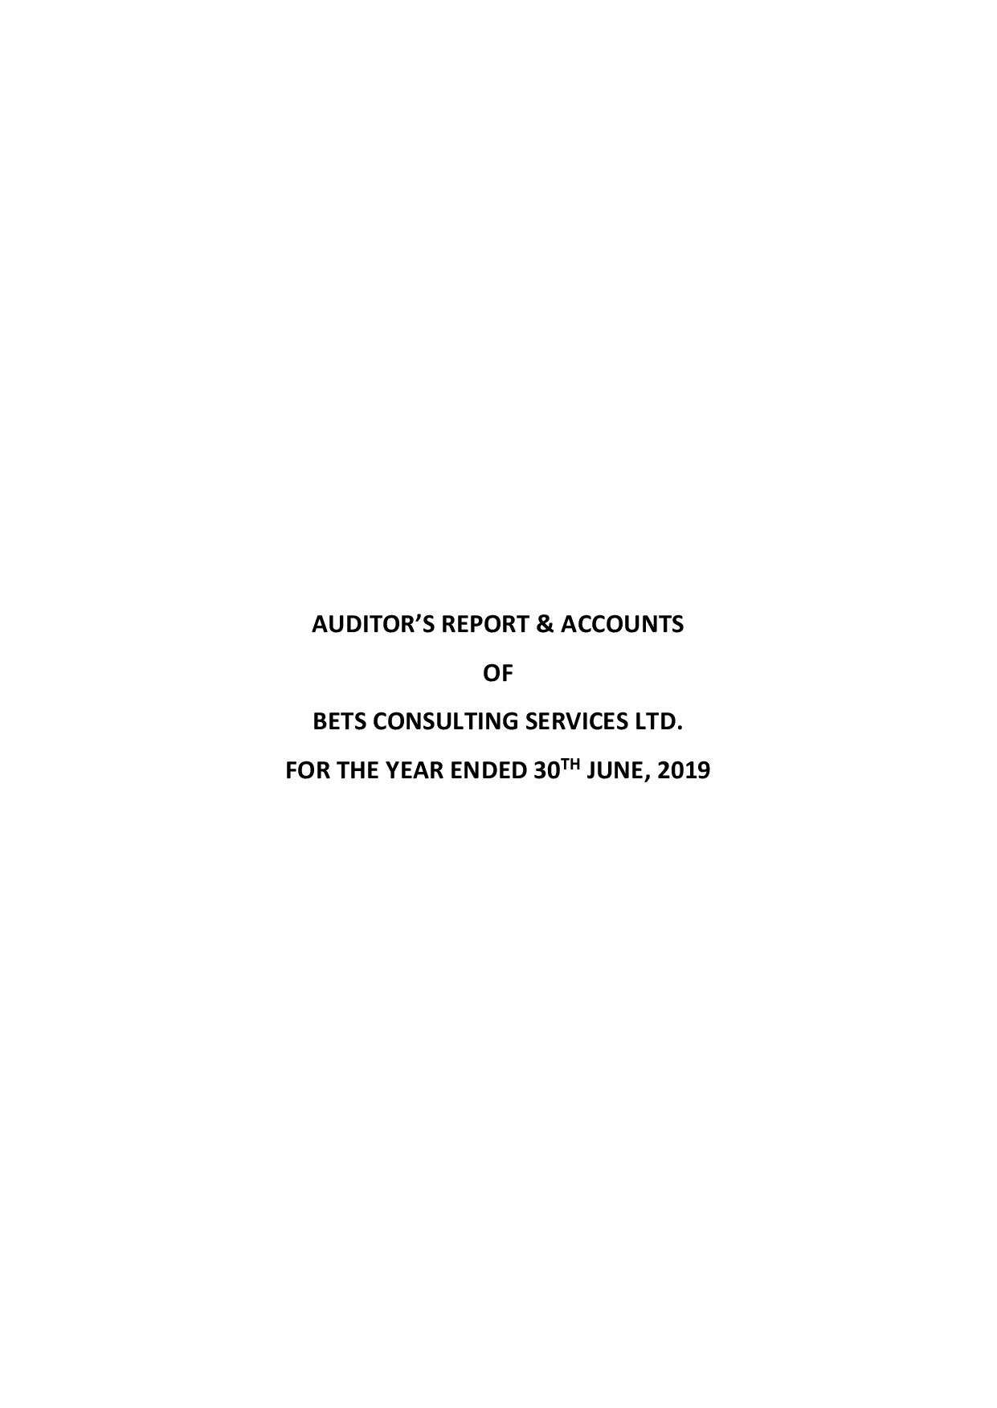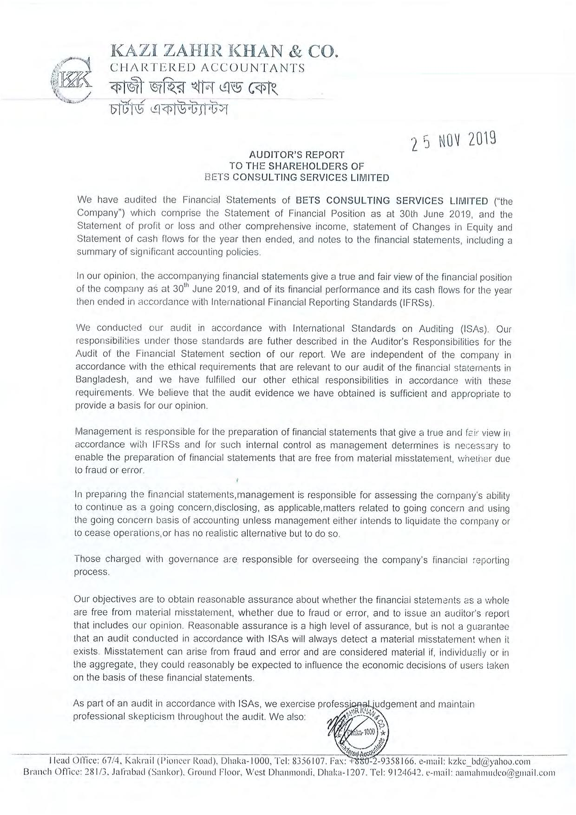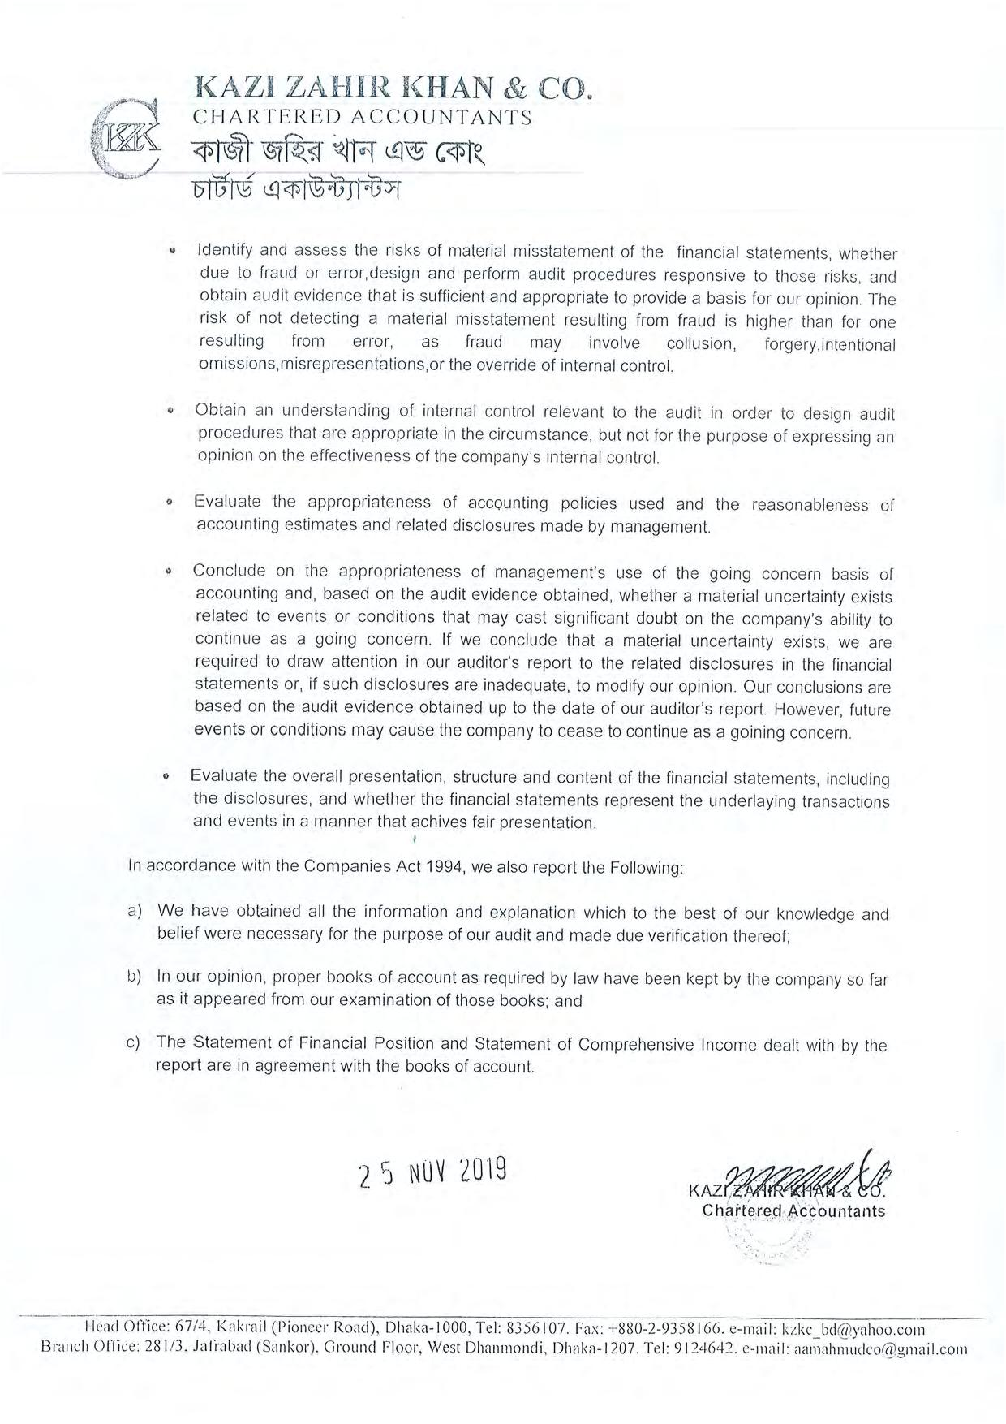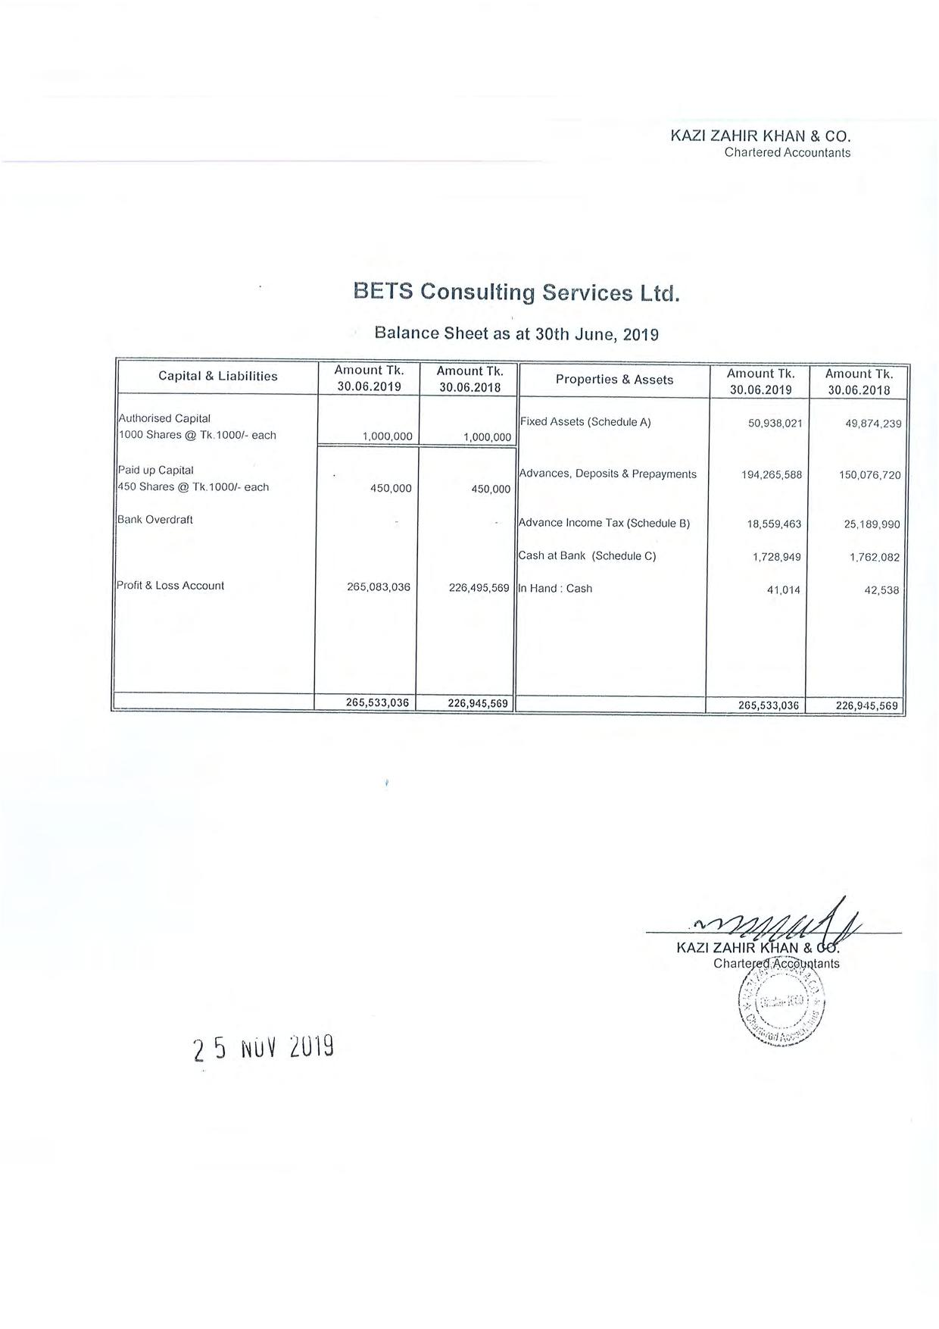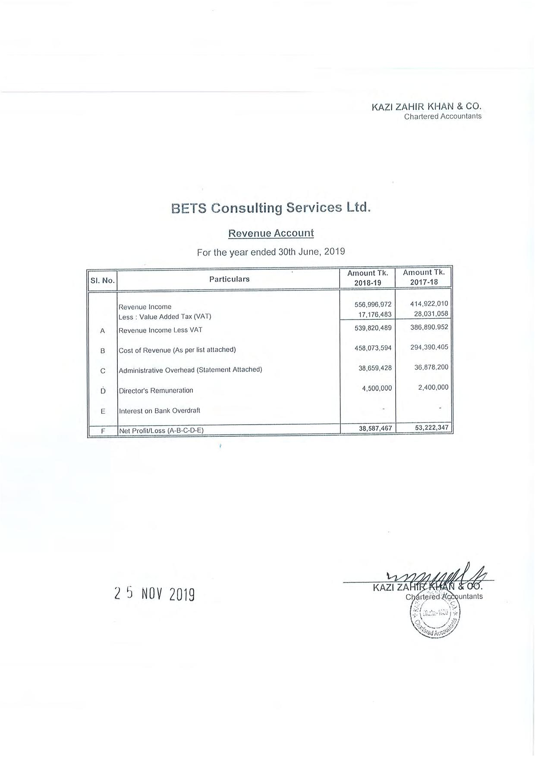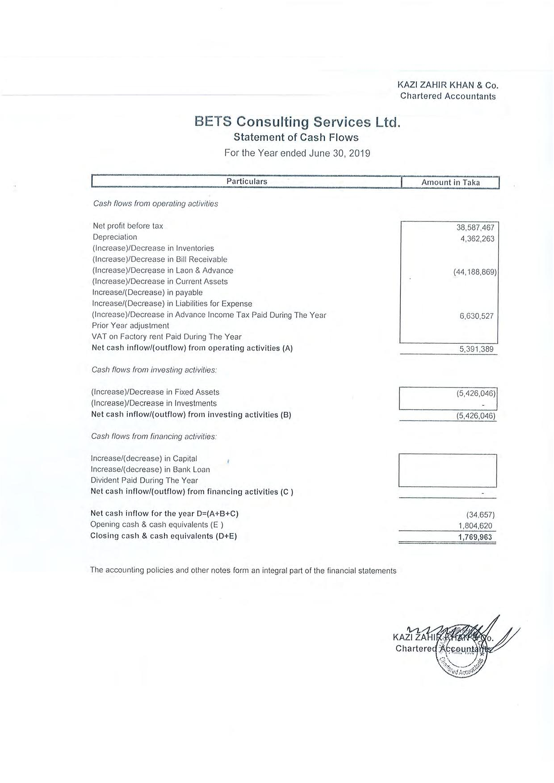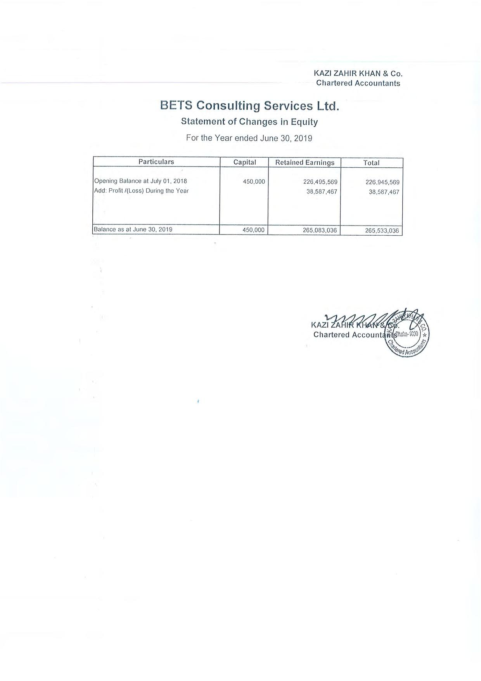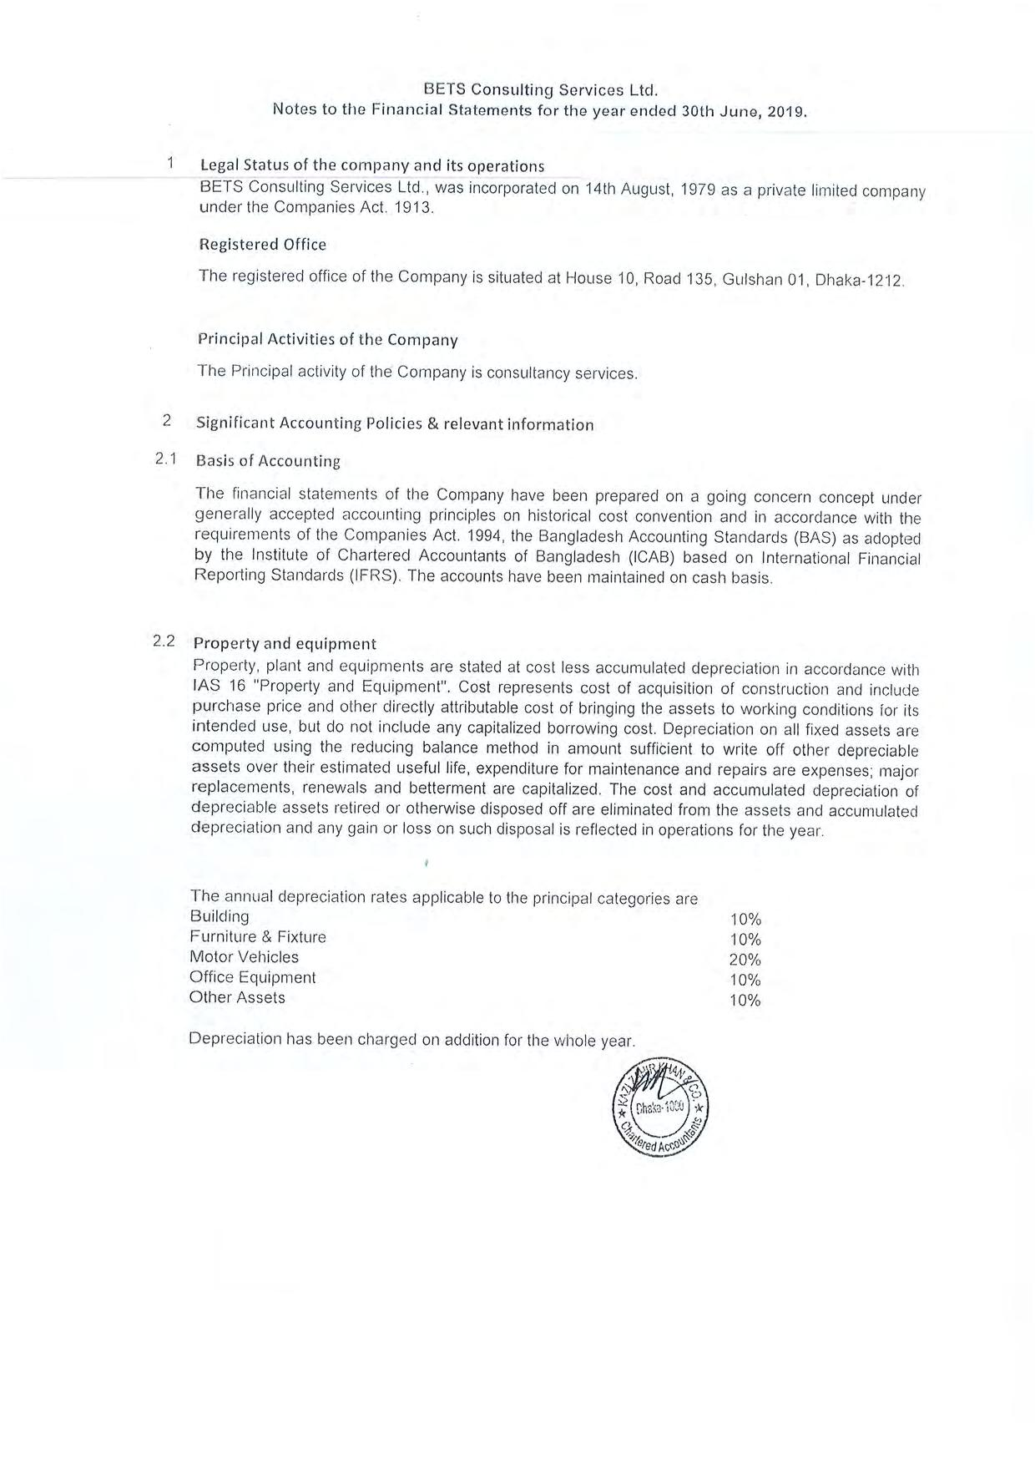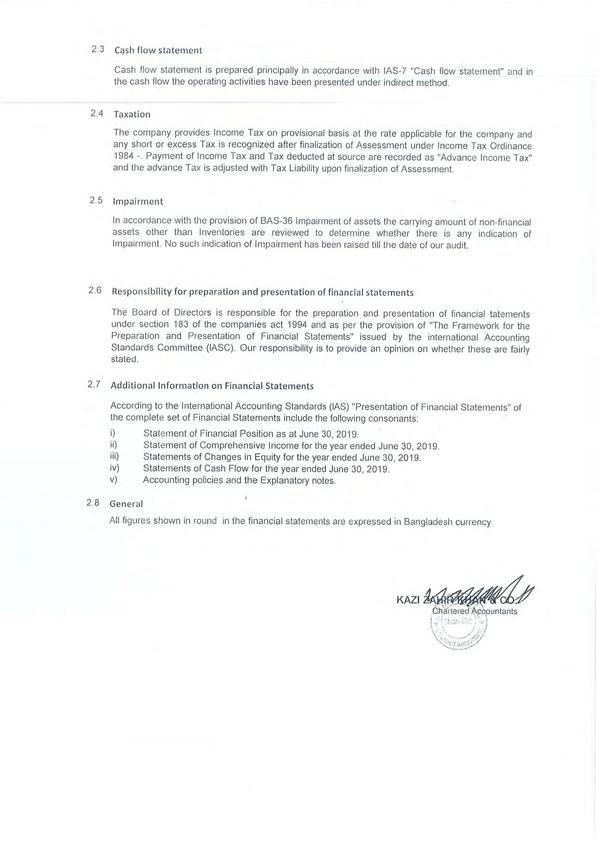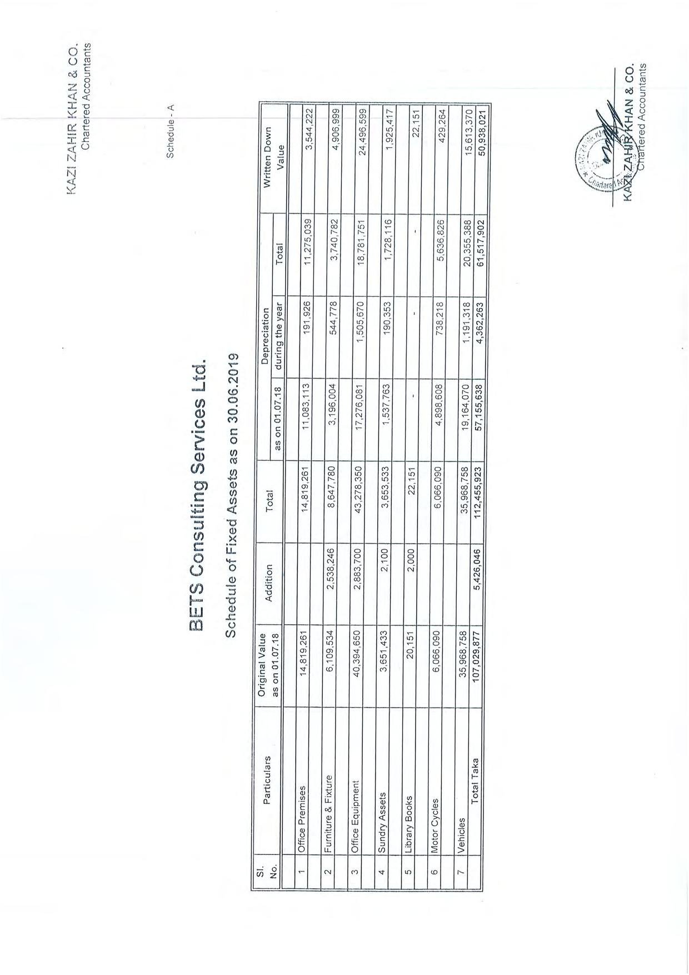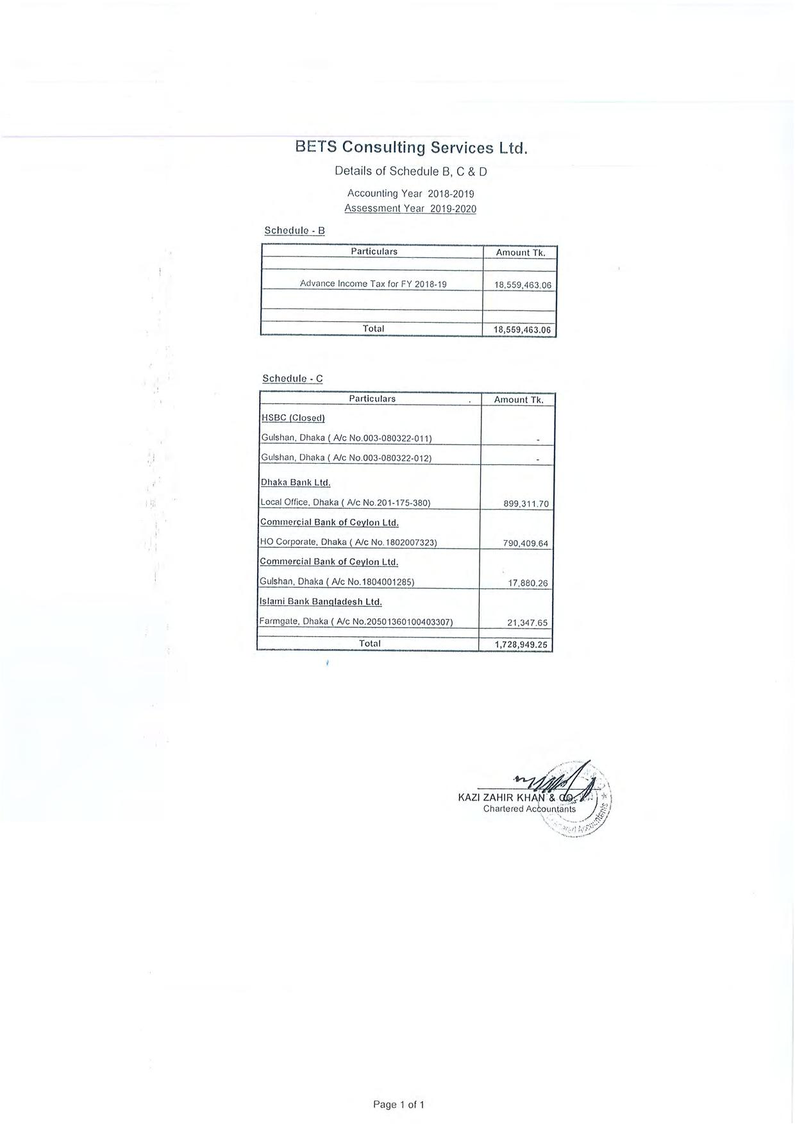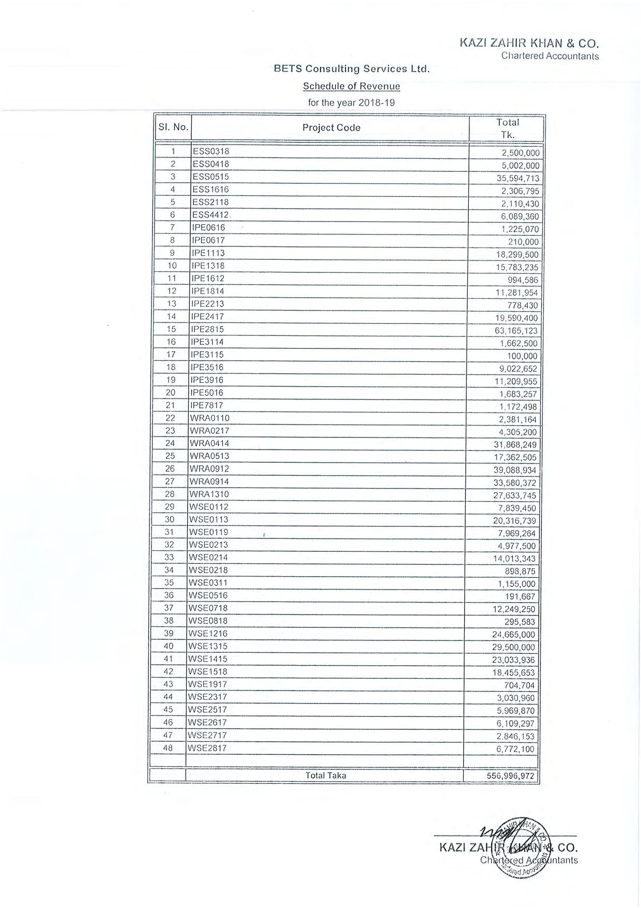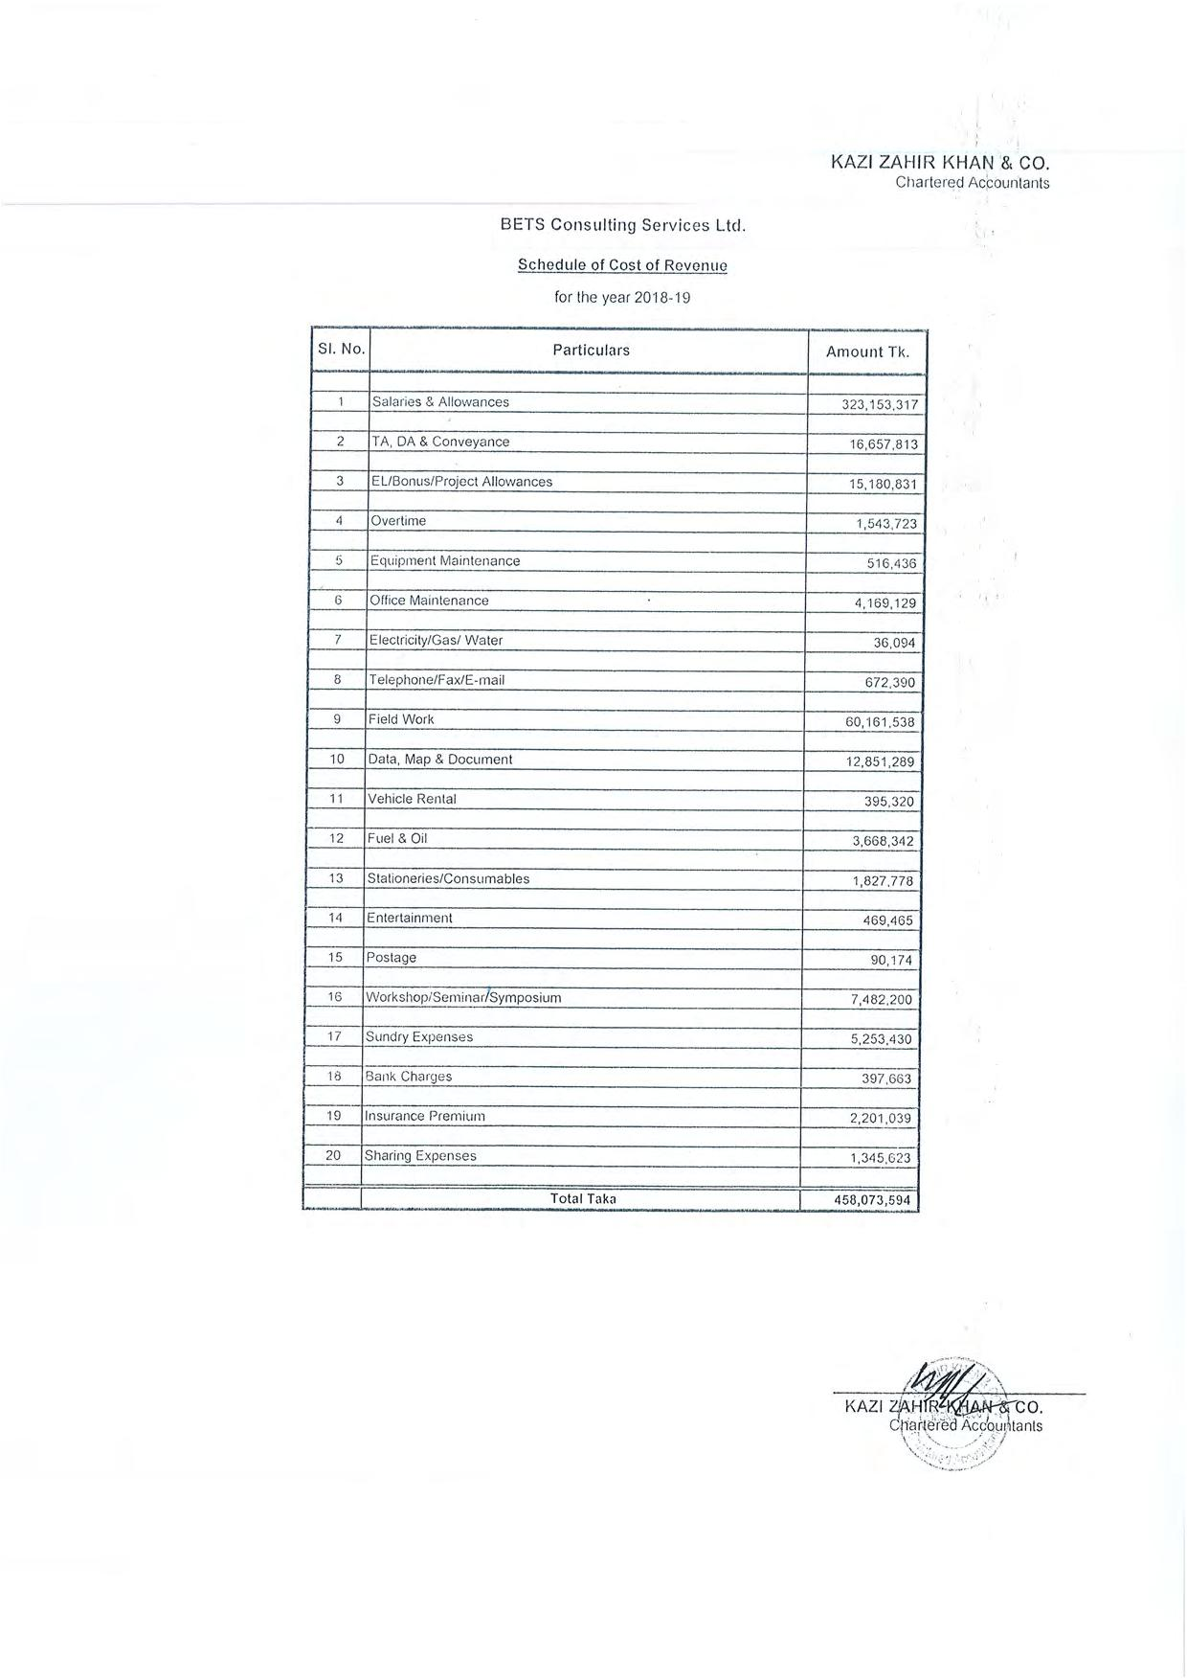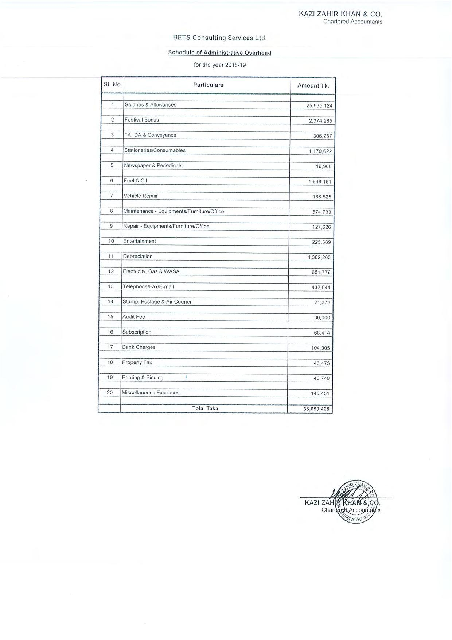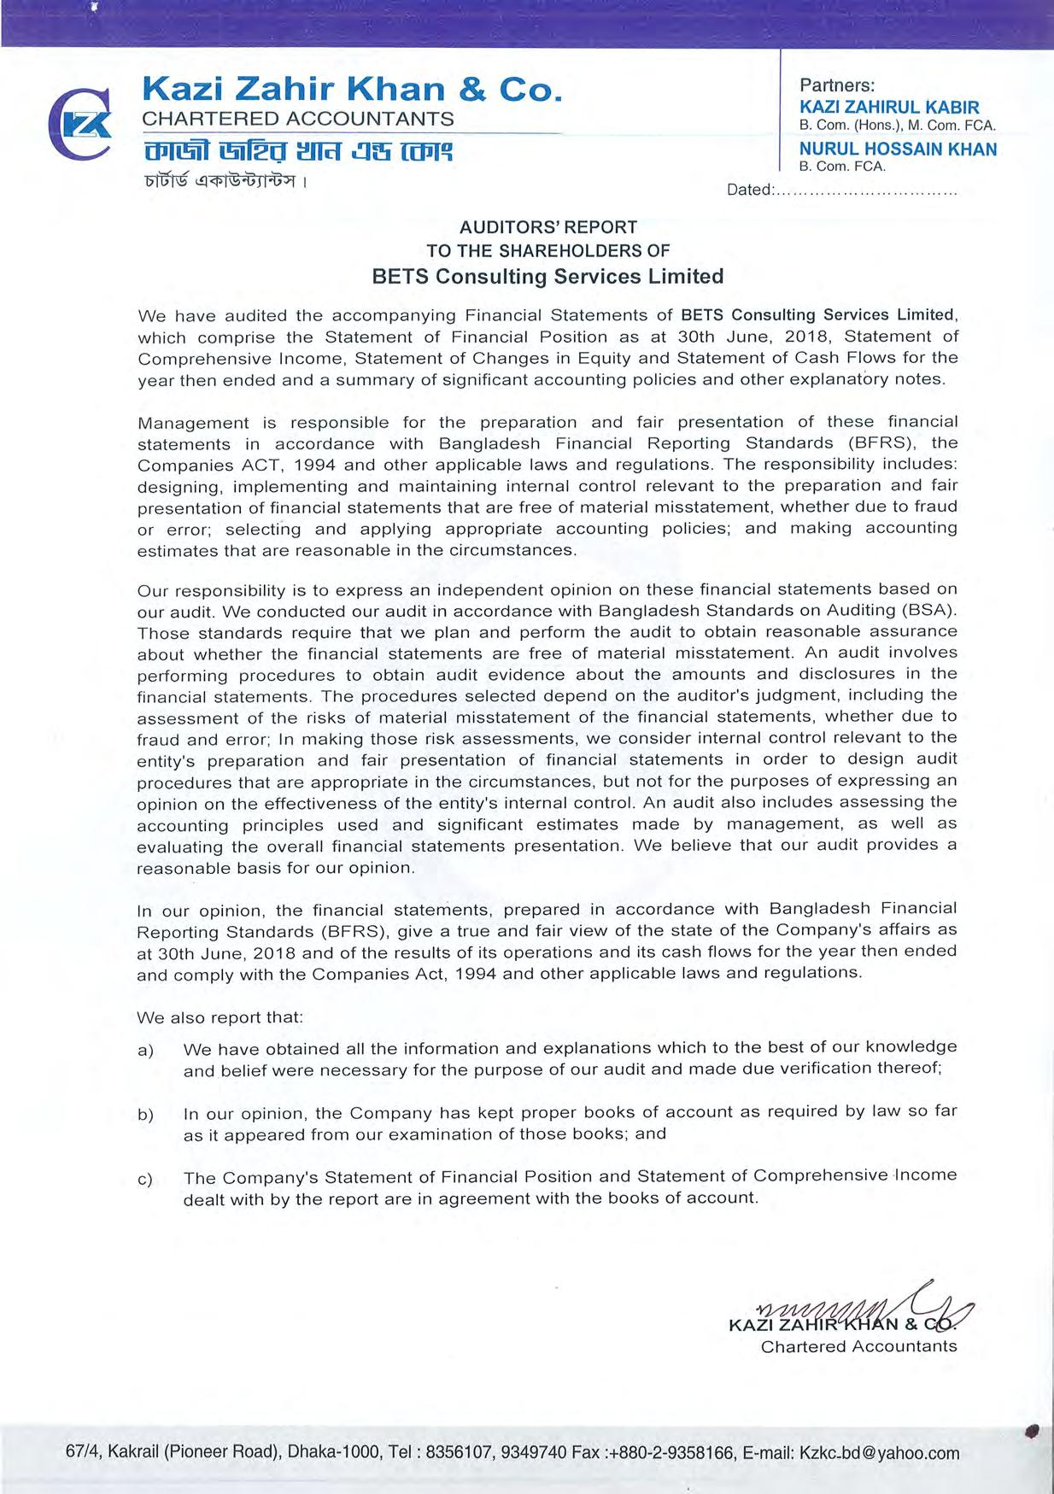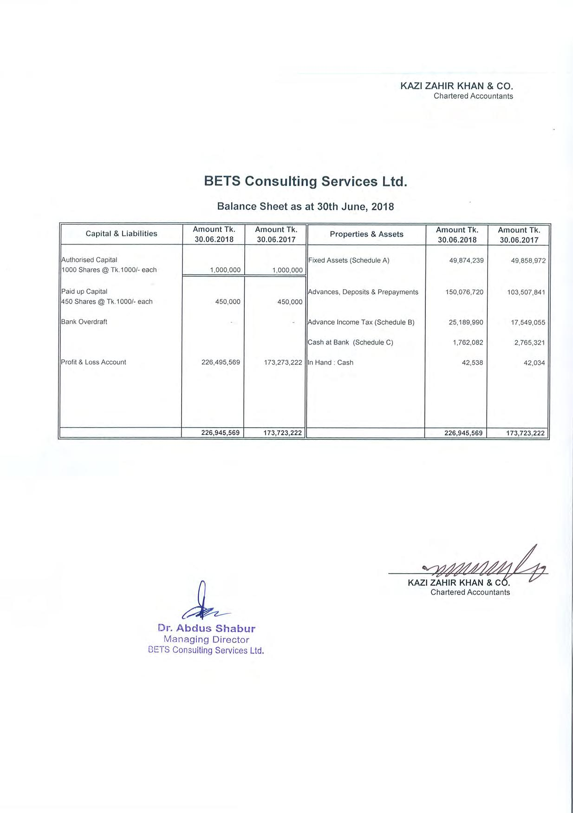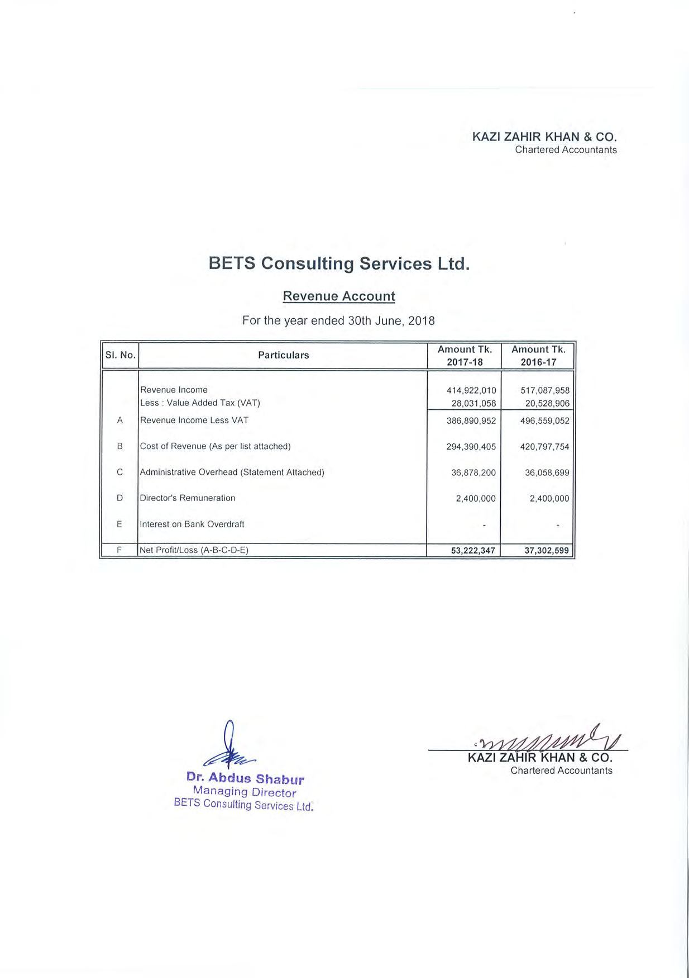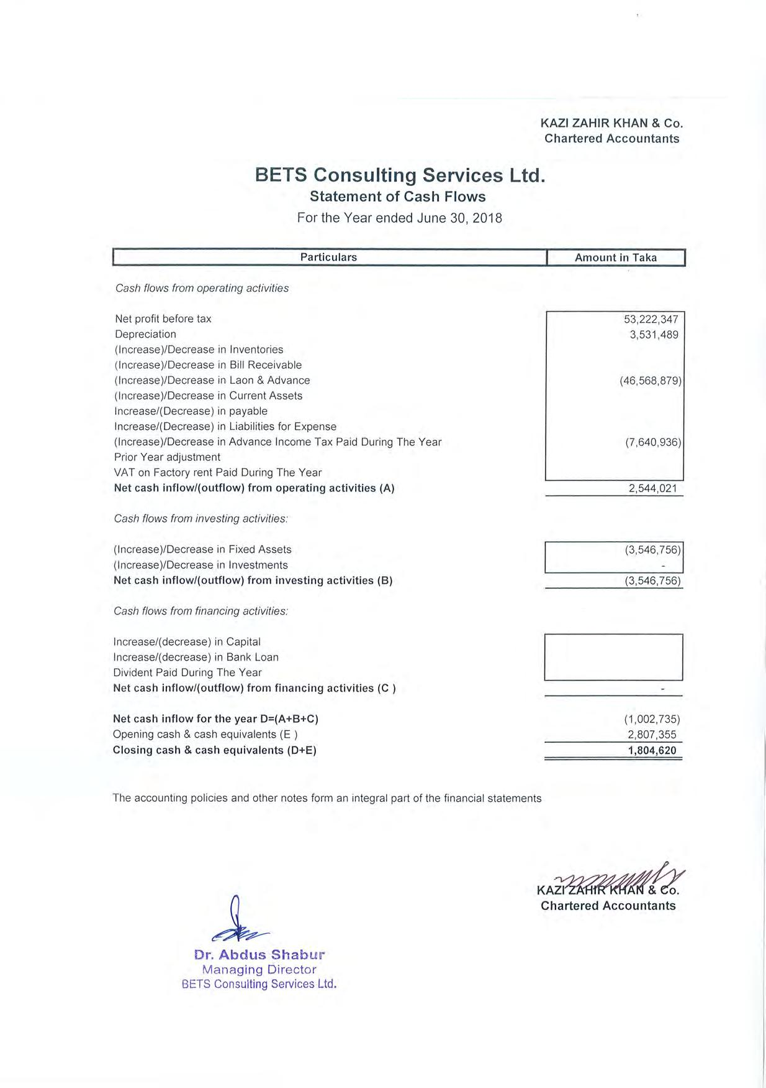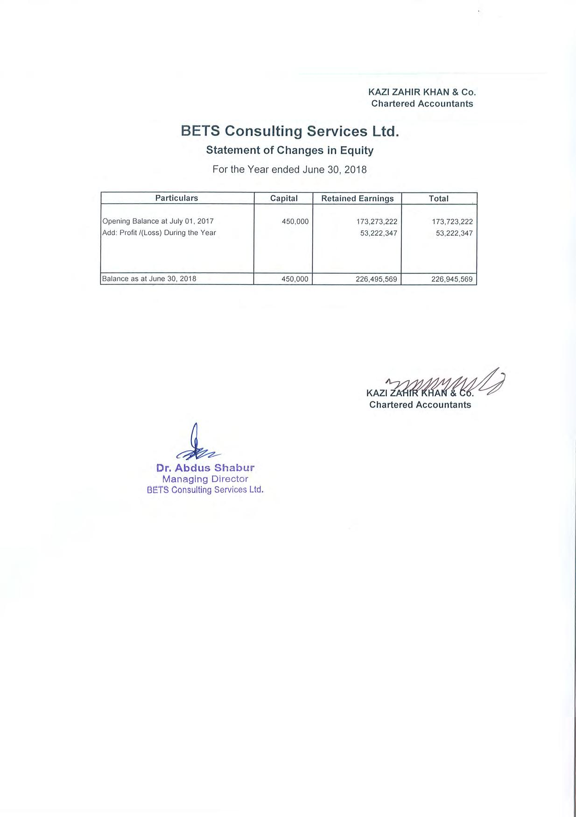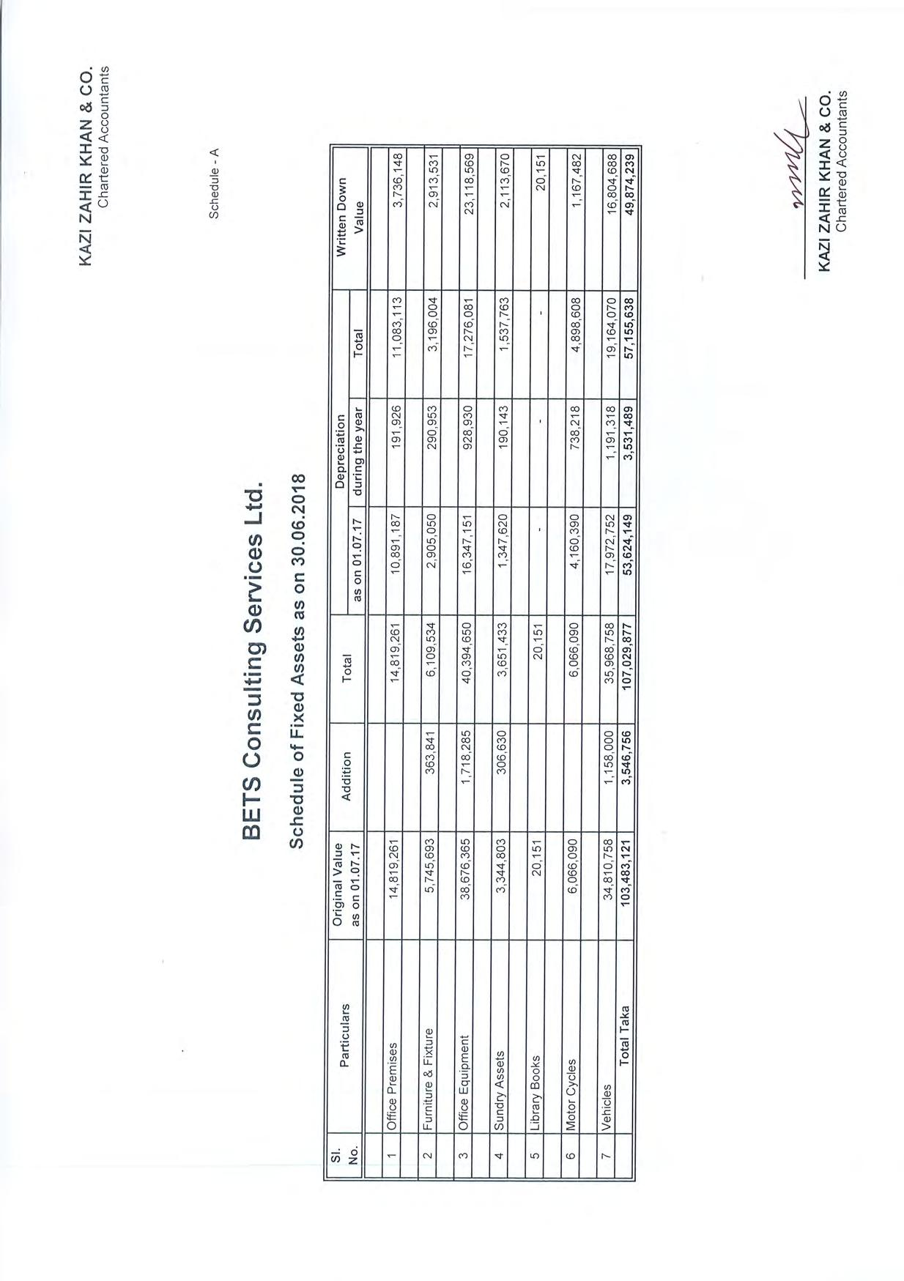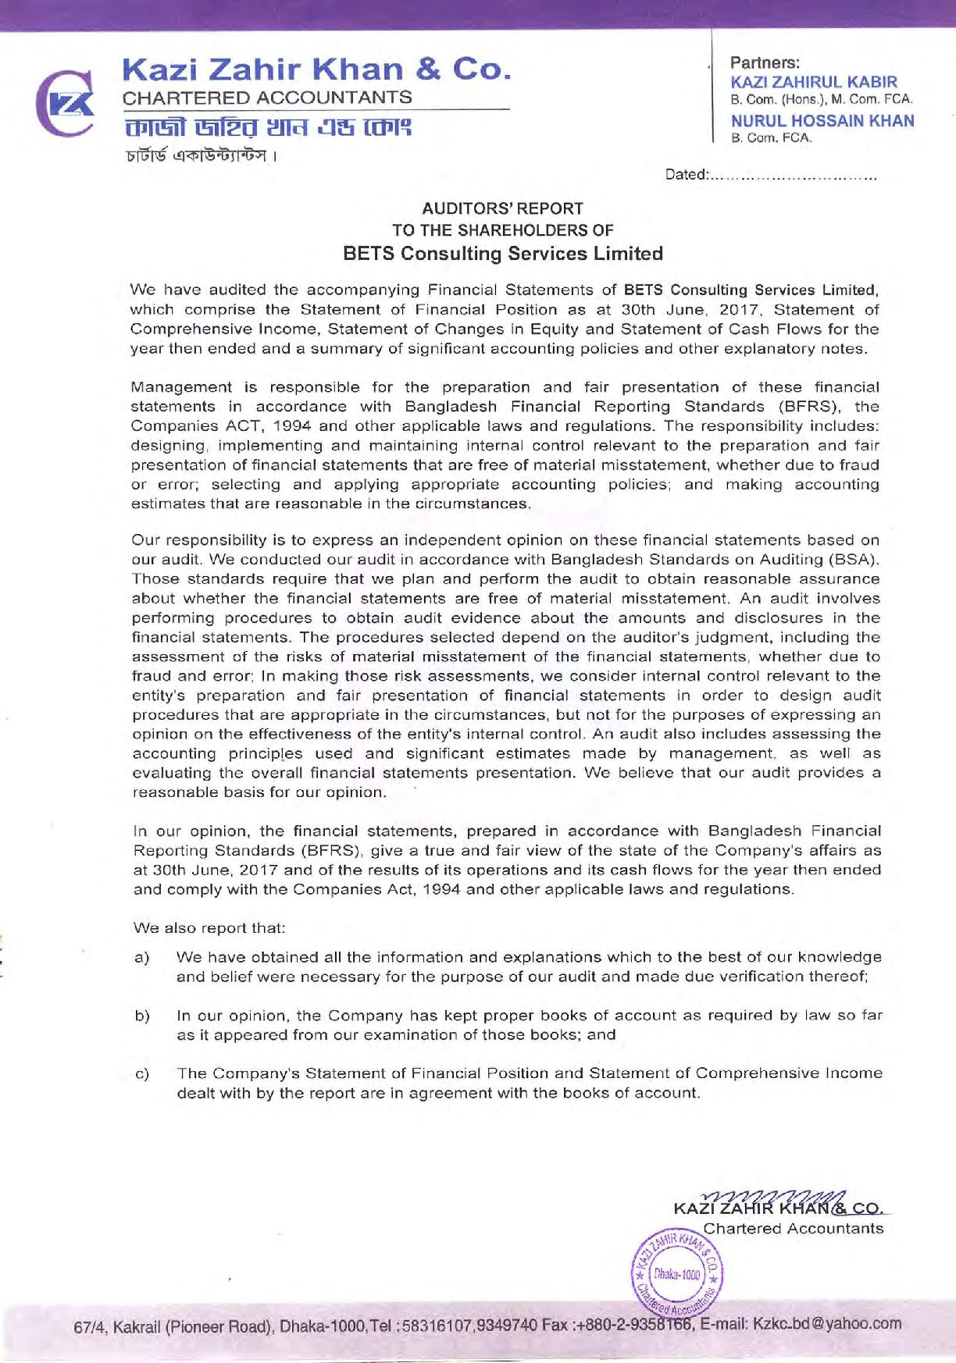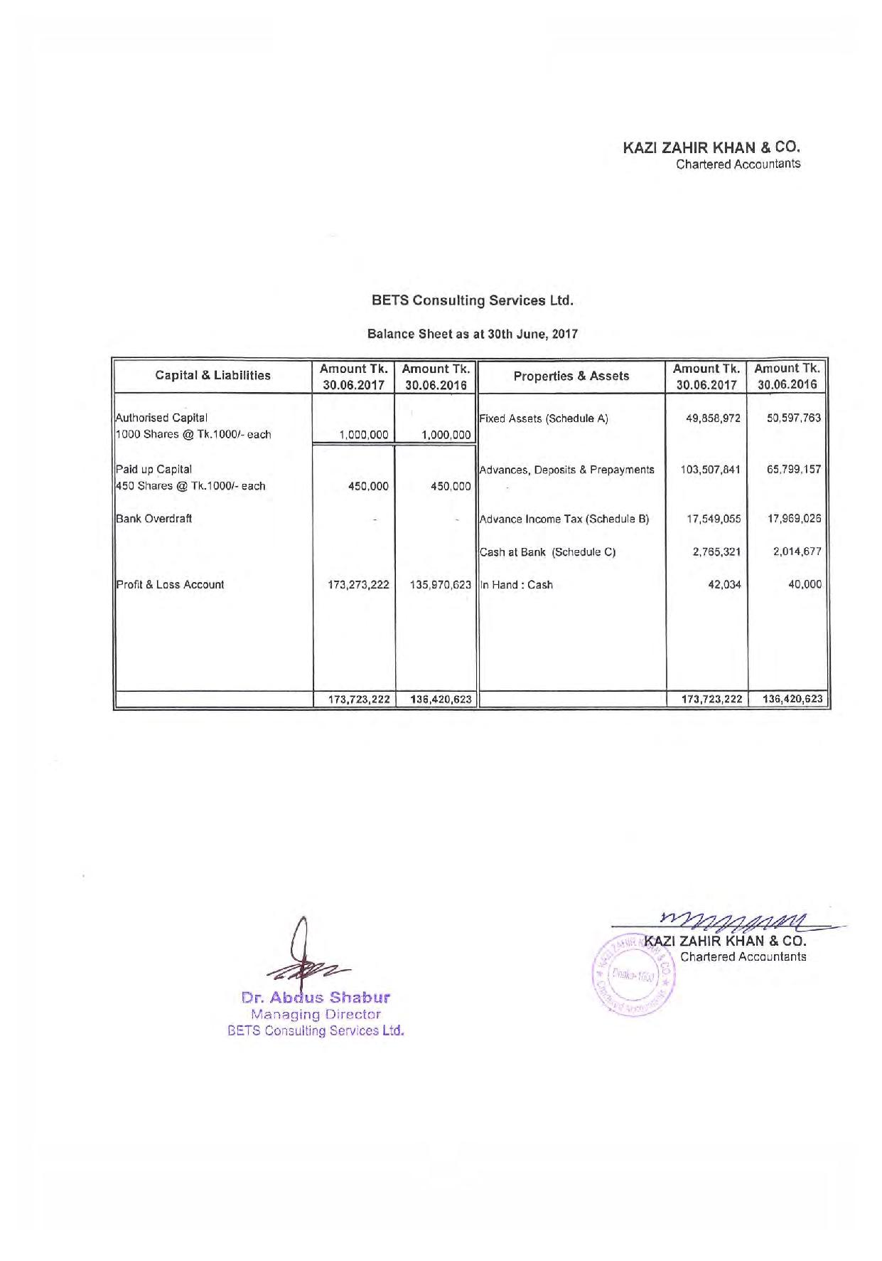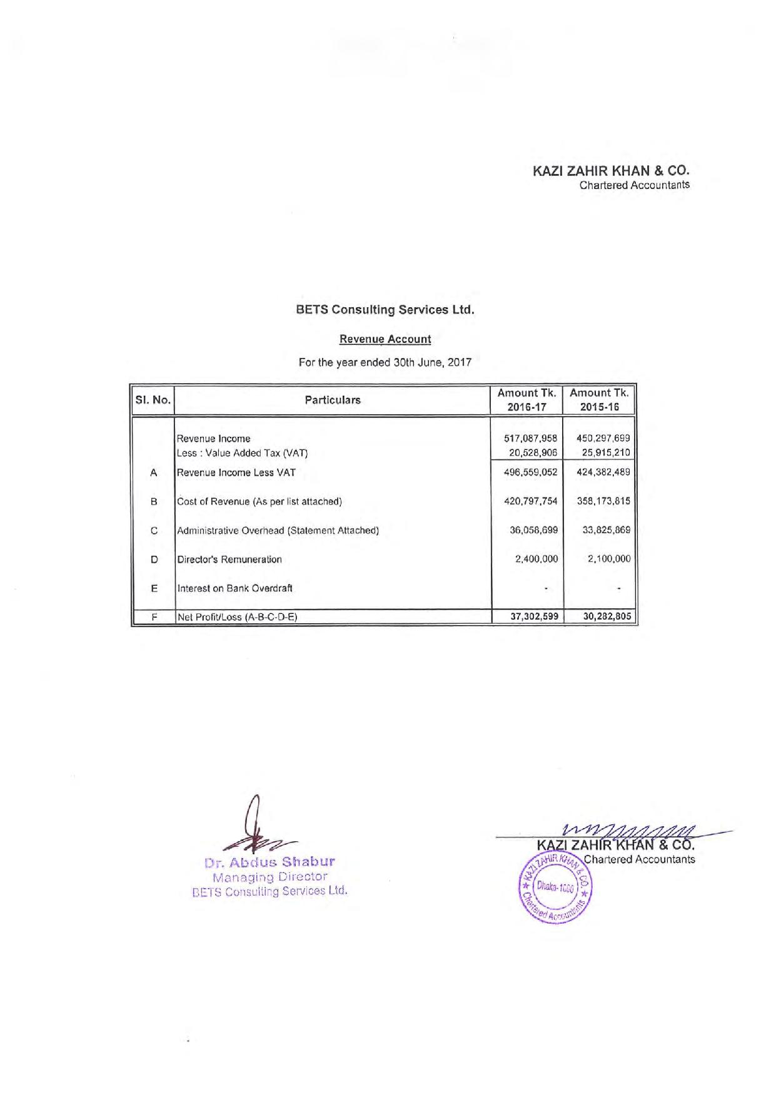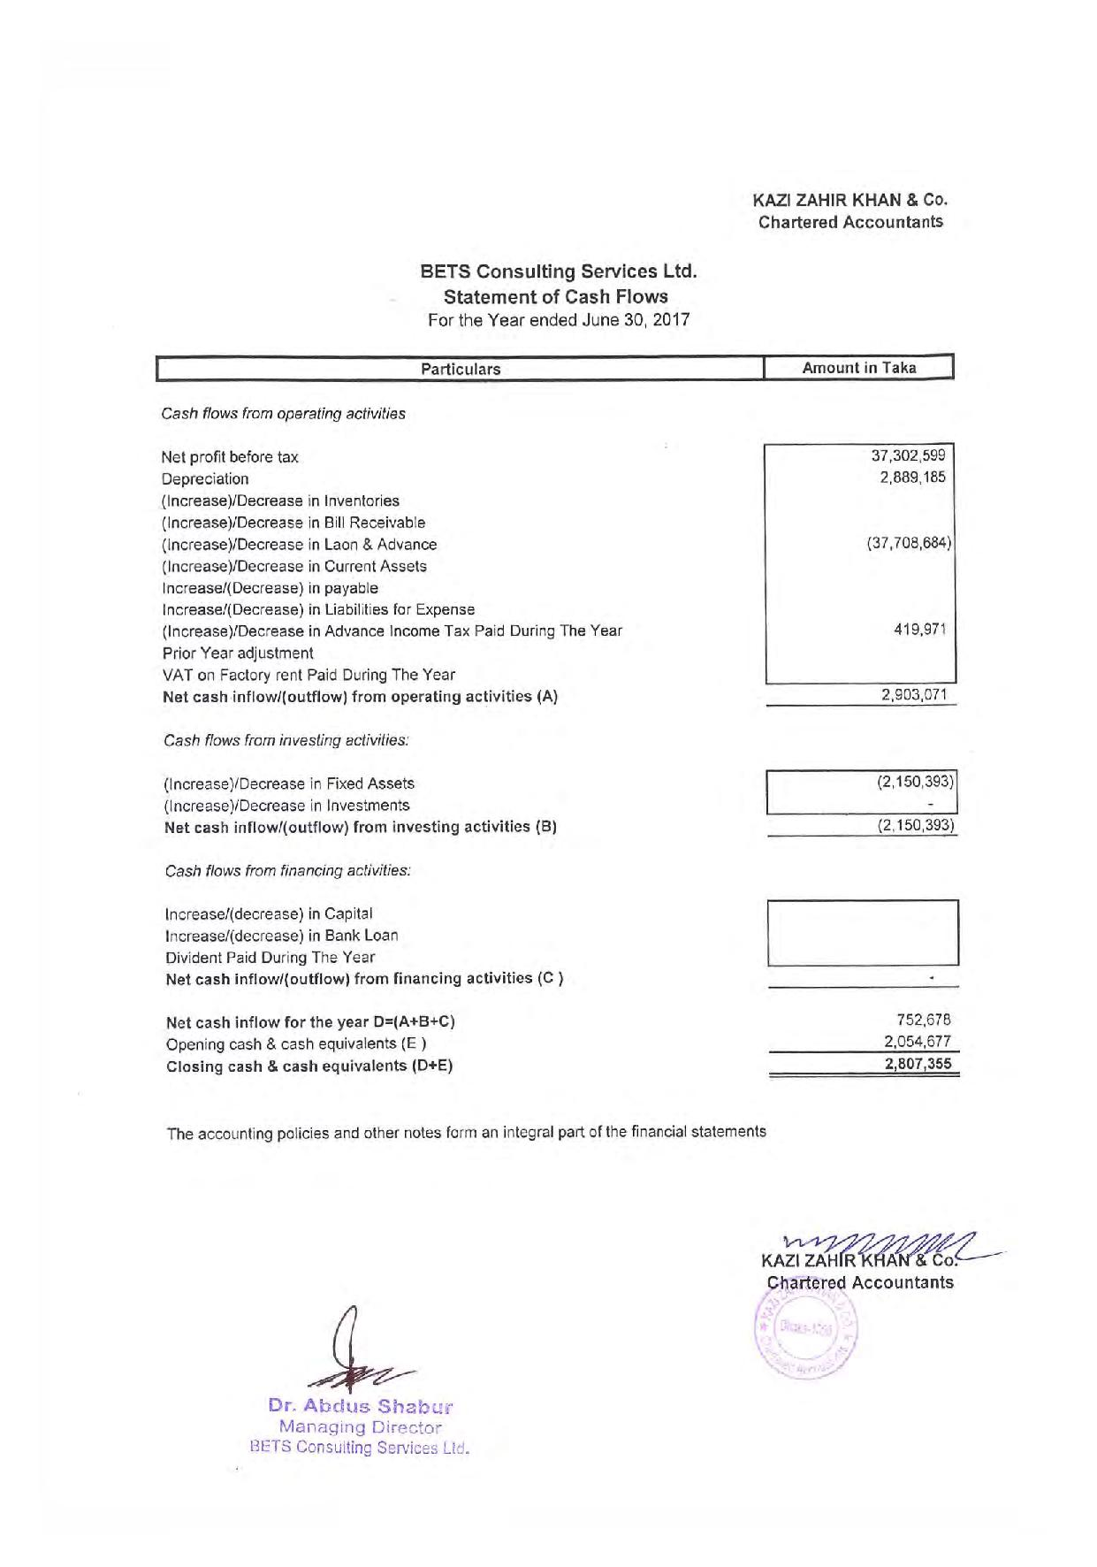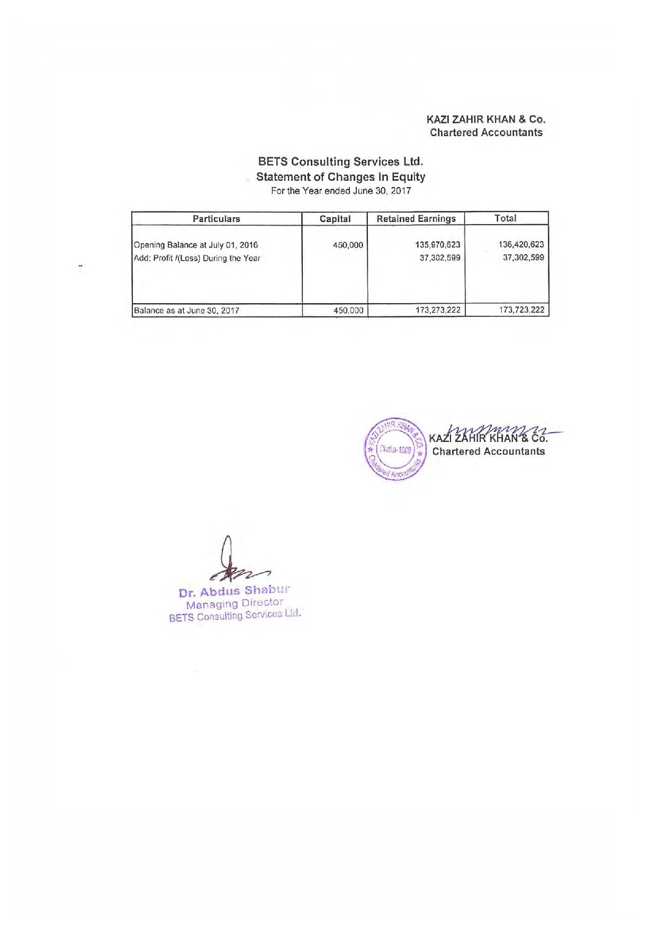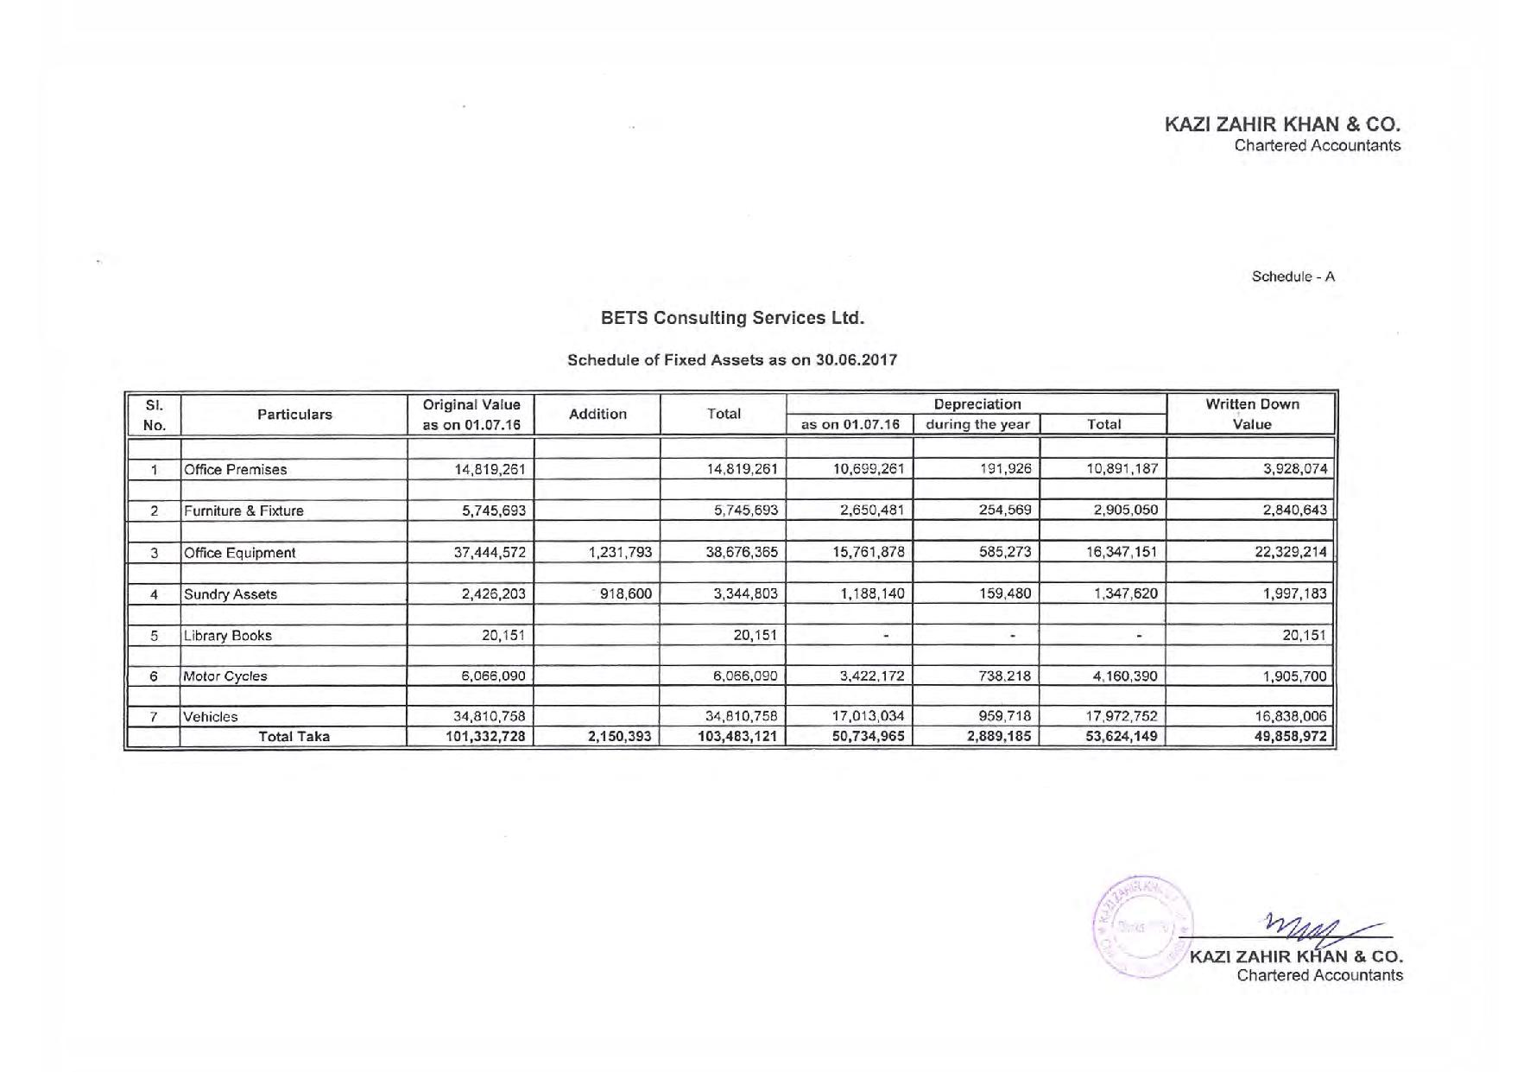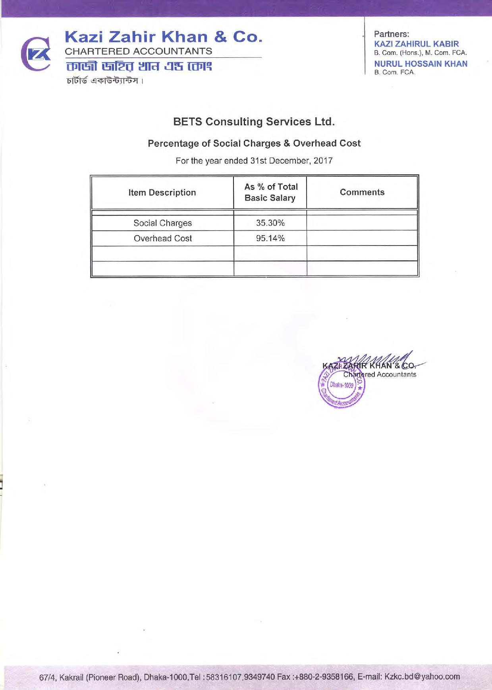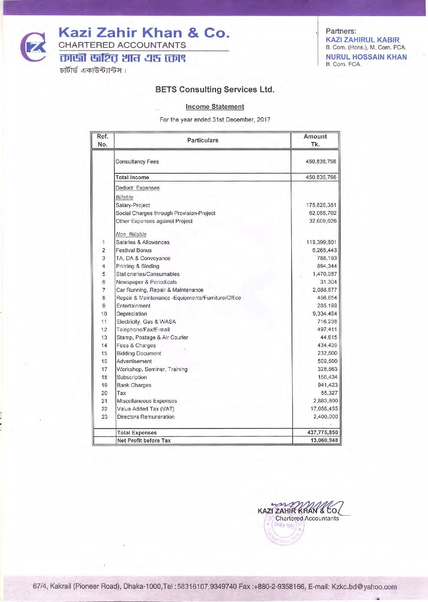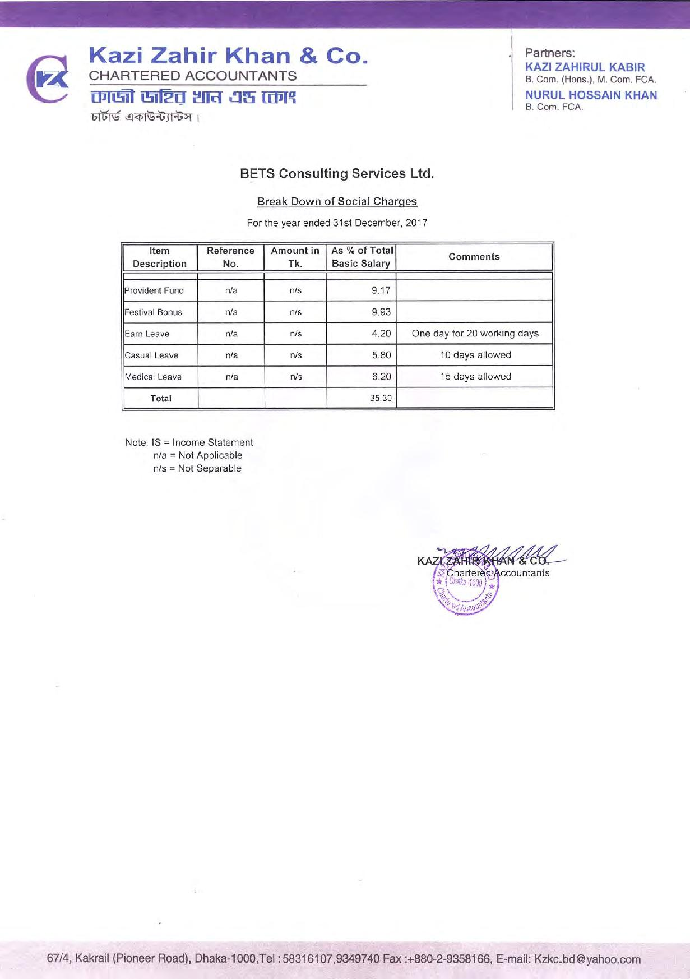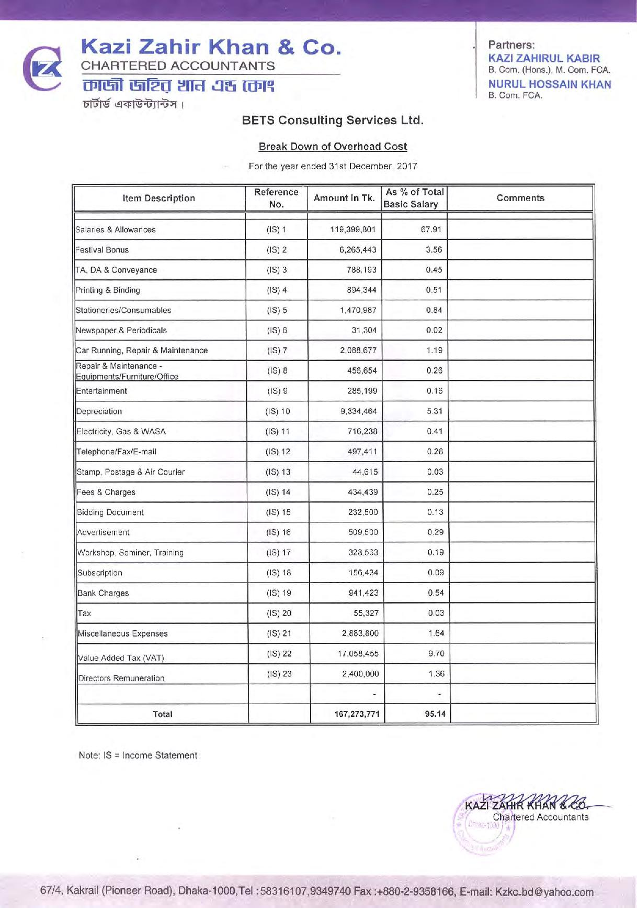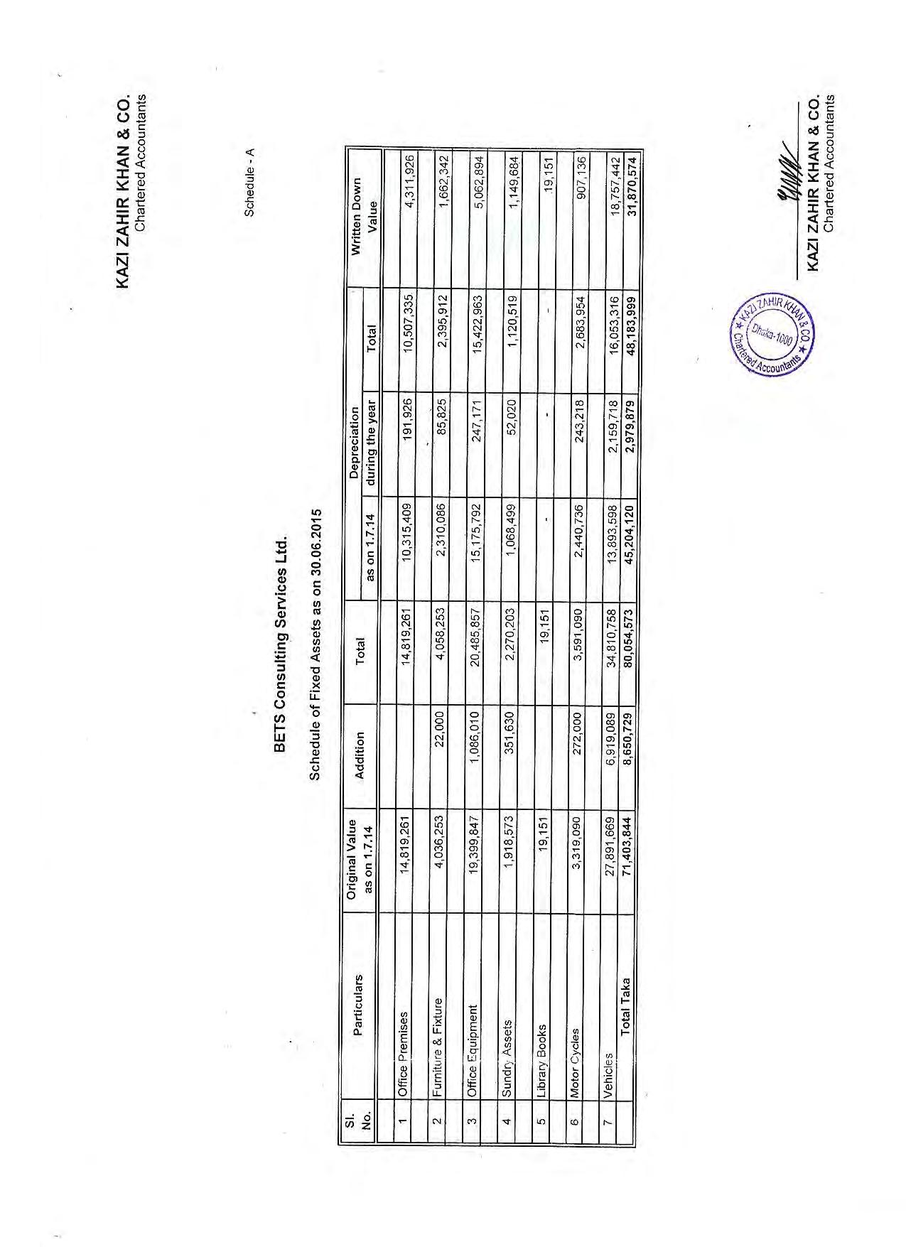

# Section-5: Organizational Capability of the Firms

## 5.1. Sheba Technologies Ltd.

|  |  |
| --- | --- |
| **Name** | **Somael Kabir** |
| Designation | CTO |
| Years of experience | 16 years + |
| Technology | IT Systems, Security, Architecture, Telecom Infrastructure, Datacom, Project Management |
| Certification | CEH,C|CISO,RHCVA,RHCEv5 |
| Degree | B.Sc. in CSE, East West University |
| Short Description | 16+ years of experience in managing telecom billing operations, ICT network, systems and databases. In-depth knowledge and experience in infrastructure planning, capacity analysis, system implementation. Handle regulatory and corporate affairs. Vendor management and business plan analysis. |
| Functional Area Expertise | Self/assisted on-boarding, data capture, identity verification, integration, system security, reporting, cross channel platform development, system architechture and mobile app development. |

|  |  |
| --- | --- |
| **Name** | **Farhan Islam** |
| Designation | Senior Manager, Business Operations |
| Years of experience | 16 years + |
| Technology | IT Systems, Security, Architecture, Telecom Infrastructure, Datacom, Project Managment, Product Management |
| Degree | B.Sc. (Hons) in Computer Science, University of Portsmouth, United Kingdom |
| Short Description | **Farhan Islam** is working as a Product Manager for Sheba Technologies Limited. He has completed his B.Sc. (Hons) Computer Science from University of Portsmouth, United Kingdom. He has gathered extensive experience of over 16 + years in diversified fields of ICT as Software Developer, Technical Writer, Systems Analyst and Project Manager both in United Kingdom & in Bangladesh. Developed in-depth knowledge on Software development life cycle, help documentations & white papers for software developers. Recognized for translating technical information into easy to understand English. Committed to collaborate with Clients & Software development team in order to maintain smooth communication & also to provide defect free solutions. |
| Functional Area Expertise | Self/assisted on-boarding, data capture, identity verification, integration, system security, reporting, cross channel platform development, system architechture and mobile app development. |

|  |  |
| --- | --- |
| **Name** | **Mujahidul Islam** |
| Designation | System Analyst |
| Years of experience | 10 years + |
| Database | Microsoft SQL Server 2000 to 2016, MSSQL DB Clustering, Oracle 10g, MySQL, Project |
| Reporting Tools | Microsoft BI (SSRS, SSIS), QlikView, Crystal Reports. |
| Language | PL/SQL, Database Programming |
| Degree | B.Sc. in CSE |
| Short Description | Worked on System Analysis and Design, Requirements analysis as well as ensure the synchronization of business process and system development in Renowned Groups, IT Enabled Firms. Developed interactive dashboards and reports in different Business Intelligence tools. Also worked in several RDBMS including DB programming and Administration. |
| Functional Area Expertise | Self/assisted on-boarding, data capture, identity verification, integration, system security, reporting, cross channel platform development, system architechture, database architechture, project management and mobile app development, cloud environments. |

|  |  |
| --- | --- |
| **Name** | **Md. Shafiqur Rahman** |
| Designation | Senior Software Developer |
| Years of experience | 10 years + |
| Language | PhP, ASP .NET |
| Scripting language | node js, Vue js, JavaScript, jquery |
| Database | Sql Server 2008, 2014, Oracle 10g, 12c, MySQL |
| Version control tool | TortoiseSVN, Git, TFS |
| Degree | M.Sc. in IT |
| Short Description | 10+ years of software development experience. Currently working as a Senior software engineer. Have more than 7 years of diversified experience in the field of ICT. Worked for Renowned ICT industry in Bangladesh. Extensive knowledge on Enterprise Appications, ERP, CRM System, Telecom Billing Solution. |
| Functional Area Expertise | Self/assisted on-boarding, data capture, identity verification, integration, system security, reporting, cross channel platform development, system architechture, database architechture, software development and mobile app development, cloud environments. |

|  |  |
| --- | --- |
| **Name** | **Tayab Khan** |
| Designation | Head of Infrastructure |
| Years of experience | 12 years + |
| Technology | IT Systems, Security, Architecture, Telecom Infrastructure, Datacom. |
| Degree | B.Sc. in CSE |
| Training | Cyber Security Concepts & Principles  RHCSA and RHCE  CCNA |
| Short Description | 12+ years of core IT, infrastructure and cyber security systems experience. |
| Functional Area Expertise | Infrastructure mapping, hardware sizing, systems support & security. |

|  |  |
| --- | --- |
| **Name** | **Tahsin Muhsin** |
| Designation | Assistant Manager, Business Operations (Documentation Specialist) |
| Years of experience | 6 years + |
| Technology | SRS, BRS & Technical documentation specialist. |
| Degree | BA Hons in Marketing, Cardiff Metropolitan University, Wales. |
| Short Description | 6 years of experience in technical documentation. |
| Functional Area Expertise | UAT, SRS, User Manual, Training & other documentation. |

|  |  |
| --- | --- |
| **Name** | **MD. Saiful Islam** |
| Designation | Sr. Executive, IT Services |
| Years of experience | 7 years + |
| Technology | IT Systems, Security, Architecture, Telecom Infrastructure, Datacom. |
| Degree | B.Sc. in CSE |
| Short Description | 7+ years of core IT, infrastructure and cyber security systems experience. |
| Functional Area Expertise | Infrastructure mapping, hardware sizing, systems support & security. |

|  |  |
| --- | --- |
| **Name** | **A.K.M Ariful Islam Shimul** |
| Designation | Lead Application Developer |
| Years of experience | 8 years + |
| Technology | IT Systems, Security, Architecture, BLL. |
| Degree | B.Sc. in CSE, MSC in CSE |
| Short Description | 8+ years of application development experience. |
| Functional Area Expertise | Mobile application development, platform development, security and architechture. |

|  |  |
| --- | --- |
| **Name** | **Rafid Mehedi Bhuiyan** |
| Designation | UI/UX Expert |
| Years of experience | 6 years + |
| Technology | UI, UX, Mock-up and prototype development. |
| Degree | MSC in ICT |
| Short Description | 6+ years of application UI/UX development experience. |
| Functional Area Expertise | UI/UX development, ituitive design and customer journey expert. |

|  |  |
| --- | --- |
| **Name** | **Saiful Islam Shojib** |
| Designation | Mobile App Developer |
| Years of experience | 7 years + |
| Language | PhP, ASP .NET, SWIFT, JAVA |
| Scripting language | node js, Vue js, JavaScript, jquery |
| Database | Sql Server 2008, 2014, Oracle 10g, 12c, MySQL |
| Version control tool | TortoiseSVN, Git, TFS |
| Degree | BSc. in CSE |
| Short Description | 7+ years of Android & IOS development experience. |
| Functional Area Expertise | IOS mobile application developer |

|  |  |
| --- | --- |
| **Name** | **Rakib Hasan** |
| Designation | Mobile App Developer |
| Years of experience | 3 years + |
| Language | SWIFT, JAVA |
| Degree | BSc. in CSE |
| Short Description | 3+ years of Android & IOS development experience. |
| Functional Area Expertise | Android mobile application development |

|  |  |
| --- | --- |
| **Name** | **Rezwanul Reaz** |
| Designation | Software Developer Developer |
| Years of experience | 7 years + |
| Language | PhP, ASP .NET |
| Scripting language | node js, Vue js, JavaScript, jquery |
| Database | Sql Server 2008, 2014, Oracle 10g, 12c, MySQL |
| Version control tool | TortoiseSVN, Git, TFS |
| Degree | BSC. in CSE |
| Short Description | 7+ years of software development experience. |
| Functional Area Expertise | Software platform development, system security & integration. |

|  |  |
| --- | --- |
| **Name** | **Fahima Chowdhury** |
| Designation | Software Developer Developer |
| Years of experience | 4 years + |
| Language | PhP, ASP .NET |
| Scripting language | node js, Vue js, JavaScript, jquery |
| Database | Sql Server 2008, 2014, Oracle 10g, 12c, MySQL |
| Version control tool | TortoiseSVN, Git, TFS |
| Degree | BSC. in CSE |
| Short Description | 4+ years of software development experience. |
| Functional Area Expertise | Software development, backend dashboard, MIS, testing and QA. |

|  |  |
| --- | --- |
| **Name** | **Nipun Ferdous** |
| Designation | Tester & QA |
| Years of experience | 2 years + |
| Degree | BSC. in CSE |
| Short Description | 2 years of software application testing experience and QA experience. |
| Functional Area Expertise | Testing, QA and documentation. |

|  |  |
| --- | --- |
| **Name** | **Salman Kabir Shuvo** |
| Designation | UI/UX Expert |
| Years of experience | 3 years + |
| Technology | UI, UX, Mock-up and prototype development. |
| Degree | BSc in CSE |
| Short Description | 3+ years of application UI/UX development experience. |
| Functional Area Expertise | UI/UX development, visuals & application graphics. |

|  |  |
| --- | --- |
| **Name** | **MD Jeshad** |
| Designation | Tester & QA |
| Years of experience | 3 years + |
| Technology | Testing, QA & documentation |
| Degree | BSc in CSE |
| Short Description | 3+ years of application UI/UX development experience. |
| Functional Area Expertise | Testing, QA and documentation. |

|  |  |
| --- | --- |
| **Name** | **Tajid Hasan** |
| Designation | Senior ICT Engineer |
| Years of experience | 10 years + |
| Technology | IT Systems, Security, Architecture, Telecom Infrastructure, Datacom. |
| Degree | B.Sc. in CSE |
| Training | Cyber Security Concepts & Principles  RHCSA and RHCE  CCNA |
| Short Description | 10+ years of core IT, infrastructure and cyber security systems experience. |
| Functional Area Expertise | Infrastructure mapping, systems support & security specialist. |

|  |  |
| --- | --- |
| **Name** | **SNA Nilim** |
| Designation | Software Developer |
| Years of experience | 4 years + |
| Technology | Machine Learning, AI & R&D |
| Degree | BBA, MBA |
| Short Description | 4+ years of in machine learning, AI and R&D |
| Functional Area Expertise | Machine Learning, AI & R&D |

|  |  |
| --- | --- |
| **Name** | **Iqbal Khan** |
| Designation | Mobile App Developer |
| Years of experience | 4 years + |
| Language | SWIFT, JAVA |
| Degree | BSc. in CSE |
| Short Description | 4+ years of Android development experience. |
| Functional Area Expertise | Android mobile application development and integration specialist. |

## 5.2. BETS Consulting Services Ltd.

| **Sl. No.** | **Name**  **Position** | **Academic Qualification**  **(Degree, Discipline, Institute)** | **Key Qualifications** | **Years of Experience** |
| --- | --- | --- | --- | --- |
| **Computer Network Design Engineers**  **/IT Personnel/GIS/CAD** | | | | | |
|  | Md. BADIUZZAMAN  MIS Specialist | M.Sc. in Applied Mathematics, Dhaka University, 1977 | Received advance training on Electronic Data Processing (equivalent to post graduate diploma of Computer Science) from Federal Republic of Germany. Attended workshops and training courses relating to planning & development of computer system and management of database software both at home and abroad | 40 |
|  | Md. RAZAUL KARIM  Programmer | Studying MS in Computer Science and Engineering (IBAIS University);  Diploma in IT (Advance Java) under Assumption University (ABAC), Bangkok, Thailand;  M.Sc. (Mathematics)  Dhaka University, 1995 | Experienced in System analysis, Design & development of database software; Adequate knowledge on Accounting software, microcredit management information software (MIS), Tax management database (TMD), Micro-Banking System (MBS), etc.; Customization/update database software; Prepared/Update training materials, manuals, etc.; Design and develop static website; Maintenance Local Area Network (LAN) | 22 |
|  | Md. ZAKIR HOSSAIN CHOWDHURY  Programmer | Master of Computer Applications, The University of Comilla (Dhaka Campus), Bangladesh, 2003;.  B. Sc (Computer Science), Bangalore University, Bangalore, India, 2000 | Experienced in preparing integrated 4W database in SQL server 2014 accumulating ‘Who does What, Where and When’ in various format like MS Excel, MS Access, ArcGIS Server | 17 |
|  | Md. MAHIDUR RAHMAN KHAN  GIS Specialist | M.Sc. in Computer Science, IBAIS University, Dhaka, Bangladesh, 2012;  B. Sc. Engg. (Civil), 1996  BIT Dhaka;  Dip. Engineering (Civil)  BTEB, 1991 | Conversant with GIS database development & analysis, map digitization, Geo-referencing, map overlay, production of GIS coverage, various geographic & analysis, surface modelling for volume & area calculations network analysis, sizing of infrastructure facilities, suitable mapping, image processing, watershed analysis Dem, industry standard formats facilitating, cross platform capability | 26 |
|  | Md. MIZANUR RAHMAN  GIS & CAD Operator | B.A. in 2003  Government Sayed Hatem Ali Collage, Barisal | Experienced in drawing various types of Architectural, Structural (Civil), Bridges, Mapping both manually & using AutoCAD software and digitization of maps using GIS | 14 |
|  | Md. LUTFOR RAHMAN    GIS Expert | M. Sc. (Agricultural Engg.) in Irrigation and Water Management, Bangladesh Agricultural University, Mymensingh, 1992;  B. Sc. Agricultural Engineering (Major: I & W M),  BAU, Mymensingh, 1989 | Extensive experience and skill in GIS ranging from digitising and editing to analysis, visualization and manipulation of spatial layers | 28 |

# Section-6: Logistics Resources of the Firm

## 6.1. Sheba Technologies Ltd.

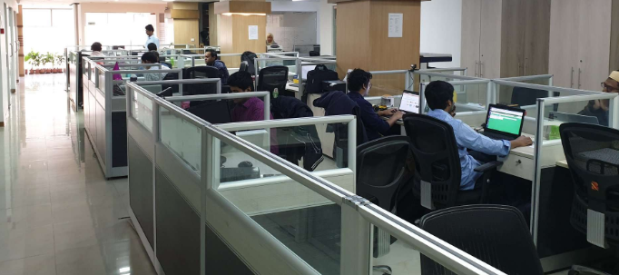The work center of Sheba Technologies Limited offers excellent environment with all modern facilities of hardware, software and networking. The total floor space is approximately 5000 sft and is equipped with a wide array of hardware including sophisticated and powerful PCs, Laptops, Laser Printers, Scanners and color printers. STL is fully equipped to provide all necessary logistic support for various Software development, training and consultancy project activities. It has all sorts of modern and up-to date computers and peripheral equipment.

STL uses modern IT equipment, servers and peripherals to accomplish its business activities which are designed to fulfill the needs of Internal and External Clients efficiently. The hardware consists of:

|  |  |  |
| --- | --- | --- |
| SL | Items | Quantity |
| 1 | Desktop PC | 40 |
| 2 | Laptop (Core i3, i5, i7) | 35 |
| 3 | Brother LaserJet Network Printer (Color) | 1 |
| 4 | HP Laserjet Network Printer | 3 |
| 5 | Scanner | 3 |
| 6 | Multi Media Projector | 2 |
| 7 | IP Telephone/ SIP Phone (AASTRA/ HUAWEI) | 15 |

## 6.2. WINGS Learning Center. (WLC)

Wings Learning Center. (WLC) is equipped with large facilities at Dhaka Office and has several project offices at Dhaka and in the field. The description of offices with support facilities is presented here.

| **Sl.**  **No.** | **Physical Resources Available with the Firm** | | |  |
| --- | --- | --- | --- | --- |
| **Items** | **Quantities /**  **Nos. Available** | **Year of purchase**  **(If applicable)** |
|  | **Office Space**  *(Office Space available at various location)* |  |  |  |
|  | 1. Head Office at Gulshan-1 | 10,000 Sq. ft. |  |  |
|  | 1. Project Office at Gulshan-2 (CEIP) | 3,000 Sq. ft. |  |  |
|  | 1. Project Office at Gulshan-1 (Haor) | 3,000 Sq. ft. |  |  |
|  | 1. Project Office at Banani (IPAC) | 2,000 Sq. ft. |  |  |
|  | 1. Project Office at Tajgaon Link Road, Niketon (SCADA) | 1,500 Sq. ft. |  |  |
|  | 1. Project Office at Banani (Thegamukh) | 2,200 Sq. ft. |  |  |
|  | 1. Project Office at Chittagong (KWSP) | 2,300 Sq. ft. |  |  |
|  | 1. Project Office at Mongla (Silo) | 3,000 Sq. ft. |  |  |
|  | 1. Project Office at Laxmipur (SIDR) | 1,800 Sq. ft. |  |  |
|  | 1. Project Office at Bhola (SIDR) | 1,500 Sq. ft. |  |  |
|  | 1. Project Office at Patukhali (SIDR) | 1,500 Sq. ft. |  |  |
|  | 1. Project Office at Barguna (SIDR) | 1,500 Sq. ft. |  |  |
|  | 1. Project Office at Noakhali (CDSP) | 4,000 Sq. ft. |  |  |
|  | 1. Project Office at Fani (Muhuri) | 4,000 Sq. ft. |  |  |
|  | 1. Project Office at Satkhira (Blue Gold) | 3,000 Sq. ft. |  |  |
|  | 1. Project Office at Khulna (Blue Gold) | 3,000 Sq. ft. |  |  |
|  | 1. Project Office at Patukhali (Blue Gold) | 2,000 Sq. ft. |  |  |
|  | *and number of Field Offices at Different Locations of Bangladesh* | | | | |
|  | **Overseas Project Offices**   * 3 Offices at Dushanbe, Tajikistan * Two Offices at Kabul, Afghanistan | | | | |

**Details of Vechicles, Office Equipment and Instrument**

| **Sl. No.** | **Name, Brand of the Vechicles/Equipment, Year of Manufacture** | **Model No. Serial No. /**  **Registration No.** | | **Present Condition** |
| --- | --- | --- | --- | --- |
| 1. **Vechicles** *(Types of available Vehicles available with Nos.)* | | | | |
|  | Toyota Land Cruiser Jeep | Dhaka Metro GHA-11-1693 | | *Good* |
|  | Toyota X-Corrolla | DHAKA Metro .GA -19- 1416 | | *Good* |
|  | Toyota PRADO Jeep | Dhaka Metro GHA-11-2885 | | *Good* |
|  | Toyota Premio "F" | Dhaka Metro GA-19-0102 | | *Good* |
|  | Dihatsu Be-GO | Dhaka Metro gha-11-9674 | | *Good* |
|  | Toyota Premio "g" | Dhaka Metro GA-19-8182 | | *Good* |
|  | Toyota Sucssed | Dhaka Metro GA-21-8387 | | *Good* |
|  | Toyota LX-LTD | Dhaka Metro . GA -12-4447 | | *Good* |
|  | Toyota Station Wagoan | Dhaka Metro KHA-11-6444 | | *Good* |
|  | Toyota Corolla | Dhaka Metro GA -13-9605 | | *Good* |
|  | Toyota Probox | Dhaka Metro GA - 21-6535 | | *Good* |
|  | Toyota Probox | Dhaka Metro GA- 21-8392 | | *Good* |
|  | X-Corolla | Dhaka Metro GA- 23-4351 | | *Good* |
|  | XE-Corolla | Dhaka Metro GA -11-8533 | | *Good* |
|  | Pickup HI-LUX | Dhaka Metro THA- 11-0079 | | *Good* |
|  | Pickup HI-LUX | Dhaka Metro THA -11-0025 | | *Good* |
|  | Noah Microbus | Dhaka Metro CHA-51-6037 | | *Good* |
|  | Noah Microbus | Dhaka Metro CHA-13-7172 | | *Good* |
|  | Toyota HIACH Microbus | Dhaka Metro CHA-53-8409 | | *Good* |
|  | Toyota F-Premio | Dhaka Metro GA-37-5184 | | *Good* |
|  | Toyota F-Premio | Dhaka Metro GA-39-0189 | | *Good* |
|  | Toyota SURFE Jeep | Dhaka Metro GHA-11-2023 | | *Good* |
|  | Toyota Hilux Picup DHAKA. | Dhaka Metro THA-14-0021 | | *Good* |
|  | Motor Cycle | 40 nos. | | *Good* |
|  | **Computers with printers**  *(Types of computers available with Nos.)* |  |  |  |
|  | 1. Rack Mount Server (HP Proliant NL 350) | 1 no. | 2010 | *Good* |
|  | 1. Intel Pentium 4 Server | 1 no. | 2000 | *Good* |
|  | 1. Laptop (HP, Toshiba, Del, Compaq, ASUS, Sony) | 30 nos. | 2000-16 | *Good* |
|  | 1. Desktop Computer (Intel Corei7, i5, i3, Core 2 Duo, Pentium Duel Core, IV) | 70 nos. | 2000-16 | *Good* |
|  | 1. Ricoh Aficio MP C2000 PCL6 | 1 no. | 2014 | *Good* |
|  | 1. Toshiba Studio 2050c | 1 no. | 2015 | *Good* |
|  | 1. Toshiba Studio 2051c | 1 no. | 2015 | *Good* |
|  | 1. Toshiba Studio 2051c | 1 no. | 2013 | *Good* |
|  | 1. HP T610 Plotter | 1 No. | 2000 | *Good* |
|  | 1. HpColor LaserJet 2025 Printer | 3 Nos. | 2014 | *Good* |
|  | 1. EPSON Color LaserJet C1100 Printer | 1 No. | 2012 | *Good* |
|  | 1. HP LaserJet 4250 Printer | 1 No. | 2008 | *Good* |
|  | 1. HP LaserJet 4200 Printer | 1 No. | 2007 | *Good* |
|  | 1. HP LaserJet 1200 Printer | 3 Nos. | 2000-2004 | *Good* |
|  | 1. HP LaserJet 4 Printer | 1 No. | 1998 | *Good* |
|  | 1. HP LaserJet 5P Printer | 2 Nos. | 2003-4 | *Good* |
|  | 1. HP DeskJet K7100 Printer | 3 No. | 2010 | *Good* |
|  | 1. HP DeskJet 1180C Printer | 1 No. | 2012 | *Good* |
|  | 1. HP DeskJet 1120C Printer | 1 No. | 2008 | *Good* |
|  | 1. HpDeskJet 930 Printer | 1 No. | 2004 | *Good* |
|  | 1. EPSON Dot Matrix Printer LQ1170 | 1 no. | 1998 | *Good* |
|  | 1. EPSON Dot Matrix Printer LQ 2170 | 2 nos. | 1995-6 | *Good* |
|  | 1. HP Scanner | 7 Nos. | 2000-16 | *Good* |
|  | **Photo Copier, Drafting Equipment, Survey Equipment etc.**  *(Types and available with Nos.)* |  |  |  |
|  | **Photo Copier** |  |  |  |
|  | 1. Toshiba e-studio 452 | 1 no. | 2012 | *Good* |
|  | 1. Toshiba e-studio 452 | 1 no. | 2010 | *Good* |
|  | **Drafting Equipment, Survey Equipment etc.**  *(Types and available with Nos.)* |  |  |  |
|  | 1. GPRS | 8 nos. | 2015-16 | *Good* |
|  | 1. EDM (Electronic Distance Measuring Equipment) fitted with Theodolite (Pentax) | 2 nos. |  | *Good* |
|  | 1. Theodolite (Kern : DMK-2, DKMR) with accessories | 4 nos. |  | *Good* |
|  | 1. Plane Table set | 10 nos. |  | *Good* |
|  | 1. Total Station (Topcon) with Data Logger | 1 no. |  | *Good* |
|  | 1. Reflectors & accessories | 1 no. |  | *Good* |
|  | 1. Reflectors (3-Prism) and Accessories | 2 nos. |  | *Good* |
|  | 1. RTK GPS, DGPS & GPS | 1 nos. each |  | *Good* |
|  | 1. Prismatic Compass | 12 nos. |  | *Good* |
|  | 1. Magnetic Compass | 10 nos. |  | *Good* |
|  | 1. Measuring Chain with pins | 15 nos. |  | *Good* |
|  | 1. Steel tape | 6 nos. |  | *Good* |
|  | 1. Ranging Poles | 24 nos. |  | *Good* |
|  | 1. Pentograph | 3 nos. |  | *Good* |
|  | 1. Lettering Set | 6 nos. |  | *Good* |
|  | 1. Radiograph pen | 12 nos. |  | *Good* |
|  | 1. Instrument Box | 6 nos. |  | *Good* |
|  | 1. Drawing Table | 6 nos. |  | *Good* |
|  | 1. Light Table | 1 no. |  | *Good* |
|  | 1. Road Curve | 4 nos. |  | *Good* |
|  | 1. Templates | 10 nos. |  | *Good* |
|  | **Audio Visual Equipment**  *(Types and available with Nos.)* |  |  |  |
|  | 1. 3M Multimedia System | 1 no. |  | *Good* |
|  | 1. S. VHS Compact Video Camera | 1 no. |  | *Good* |
|  | 1. Still Camera | 2 nos. |  | *Good* |
|  | 1. Over Head Projector | 1 no. |  | *Good* |
|  | **Computer Software List** |  |  |  |
|  | Operating System: 1. Windows Server 2003 (Standard Edition)  2. LINUX-Fedora  3. Windows 2008  4. Windows 2007  5. Windows XP |  |  |  |
|  | Microsoft Office 1. MS Office 2013  2. MS Office 2010  3. MS Office XP  4. MS Project 2010 & 2007 |  |  |  |
|  | MS SQL Server |  |  |  |
|  | Oracle |  |  |  |
|  | Enterprise 9i Enterprise Edition |  |  |  |
|  | Solid Converter |  |  |  |
|  | VNC Viewer |  |  |  |
|  | Google Earth |  |  |  |
|  | Arc GIS |  |  |  |
|  | AutoDesk Map |  |  |  |
|  | AutoDesk Raster Design |  |  |  |
|  | Adobe Acrobat Professional |  |  |  |
|  | Adobe Photoshop |  |  |  |
|  | Adobe Illustrator |  |  |  |
|  | Page Maker |  |  |  |
|  | CorelDraw |  |  |  |
|  | Quark Xpress |  |  |  |
|  | Omnipage |  |  |  |
|  | Text Bridge |  |  |  |
|  | Bijoy Bangla System |  |  |  |
|  | Micro Soft Publisher |  |  |  |
|  | Prabartana (Bangla) |  |  |  |
|  | Clipper 5.1-5.3 |  |  |  |
|  | Micro Soft Foxpro |  |  |  |
|  | PC ARC INFO |  |  |  |
|  | PC MAP INFO |  |  |  |
|  | ARCVIEW |  |  |  |
|  | 3D Studio |  |  |  |
|  | Autodesk AutoCAD |  |  |  |
|  | AUTO CADMAP |  |  |  |
|  | ILWIS |  |  |  |
|  | IDRISI |  |  |  |
|  | Geomedia |  |  |  |
|  | Image Analysis |  |  |  |
|  | Erdas Imagine |  |  |  |
|  | MathCAD, Ver.5.0 |  |  |  |
|  | VersaCAD |  |  |  |
|  | Planix Home |  |  |  |
|  | Visual Basic |  |  |  |
|  | GWM (Ground Water Modeling) |  |  |  |
|  | Loop-SemerBramh |  |  |  |
|  | CFA-88 |  |  |  |
|  | PASSFEM |  |  |  |
|  | TurboC |  |  |  |
|  | Turbo basic |  |  |  |
|  | Q. basic |  |  |  |
|  | Borland C++ Ver. 4.0 |  |  |  |

**GIS, RS & CAD FACILITIES**

**Introduction**

BETS maintains a fully equipped computer centre with state of art hardware and software facilities. The center is capable to provide specialized services on Geographic Information System (GIS), Remote sensing (RS), Computer Aided Design (CAD), Computer Modelling & Simulations, Software Development, Database Management and development of different Management Information System (MIS) with traditional ease to the satisfaction of clients.

The center provides relevant services related to Geographic Information, surface modelling, volume and area calculations, network analysis, sitting and sizing of infrastructure facilities, mapping, image processing, watershed analysis, DEM and DTM, mapping, contouring and GPS survey. Databases of spatial and descriptive information are established in standard formats facilitating cross platform compatibilities. Sophisticated database, statistical analysis and statistical models are carried out. Tailor-made macros and interfaces are developed suiting specific project needs.

BETS has already completed a number of GIS/CAD application projects successfully for various clients and presently engaged in image processing, archiving and preparation of hypertext based database in addition to GIS/CAD applications.

The centre deals with the advanced application of GIS, CAD and most of the available engineering modelling software. Highly skilled professionals operate each of the sections with long experience in their respective fields. BETS has gained high reputation particularly in this field. The centre is continuously updating its skill with new versions of software.

Computers with customized GIS/RS/CAD tools are employed to enhance accurate responses to customer’s problems. These tools are constantly updated to keep abreast of the dynamics of technological change.

**Support Facilities**

Digital Theodolite, Electronic Distance Measuring Machines (EDM), Total Stations, Differential Global Positioning System (DGPS) etc., are utilized by GIS, RS & CAD Unit of BETS to provide data collection for survey data and soil exploration services by a team of expert surveyors and Engineers. Geographic Information system (GIS), Digital Terrain Modelling (DTM), Digital Photogrammetry and Image Processing are also employed to provide a comprehensive range of services.

**Path to Future**

Adaptation of new and latest emerging technologies has given GIS & CAD Unit of BETS a distinct edge over others. This has led to diversification form building road and bridge design to river modernization. GIS & CAD Unit of BETS has always explored new opportunities to enhance the quality and quantity of services to wider customer base with diverse technological needs. The technology perfected is also available for export. Technical challenges overcome in complicated projects have enthused confidence in the company to see and take up international assignments on a firm foundation.

# Section-7: Availability of Technical Experts for Performing the Assignment

|  |  |  |  |  |  |  |
| --- | --- | --- | --- | --- | --- | --- |
|  | Recent Photo of the Individual |  | | | | |
| 1 | PROPOSED POSITION FOR  THIS PROJECT | **Trainer**: Project Manager | | | | |
| 2 | NAME OF PERSON | **Mujahidul Islam** | | | | |
| 3 | DATE OF BIRTH | 26-08-1989 | | | | |
| 4 | NATIONALITY | Bangladeshi | | | | |
| 5 | MEMBERSHIP IN PROFESSIONALSOCIETIES | *N/A* | | | | |
| 6 | EDUCATION: | *B.Sc. in CSE, Military Institute of Science and Technology(2010)* | | | | |
| 7 | OTHER TRAINING | Basics of C.F of PHP  Networking Basics | | | | |
| 8 | LANGUAGES & DEGREE OF  PROFICIENCY | Language | | Speaking | Reading | Writing |
|  | *English* | | *Fluent* | *Excellent* | *Excellent* |
| 9 | COUNTRIES OF WORK EXPERIENCE | Bangladesh | | | | |
| 10 | EMPLOYMENT RECORD |  | | | | |
|  | **EMPLOYER: 1**  **Sheba Technologies Ltd.**  <http://www.shebatech.com.bd/>  8th Floor, Khawaja Tower, 95 Mohakhali C/A, Dhaka-1212.  Position Held: **Technical Project Manager / Senior System Analyst**  **Duties and Responsibilities:**   * Practitioner in Project Management, Monitor and ensure end to end Project from Analysis phase to Deployment phase. * Performing as Technical PM and Analyst for critical and major accounts of Private and Govt sector Customers to ensure successful delivery of Projects, especially for services with Telecom operators. * Creating Project Plans and Track as well. * Requirements analysis as well as ensure the synchronization of business process owners and Development Team. * Preparing Technical Proposals, BRS and SRS for Solution or Product. * Coordinate UAT, Prepare test cases, User Manual and Coordinate with Developers, Operations and QA Team. * Database Design and Practitioner in MS SQL Database Administration. * Back end Database scripting and programming like developing Stored Procedure, Triggers, Functions as per business process requirements. | | FROM:  **December, 2016** | | TO:  **Present** | |
|  | **EMPLOYER: 2**  **Transcom group**  Position Held: **System Analyst**  **Duties and Responsibilities:**   * Requirements analysis of business processes with internal stakeholders and Design accordingly. * Develop interactive dashboards and reports in QLIKVIEW and SSRS according to top Business requirements. * Develop and Extract Transform and Load (ETL) in SSIS to consolidate distributed data of 17 sister concern and 30 Sales and Distribution house. * Mobile based Order and Sales Force management system implementation and maintenance. * Developing Stored Procedure, Triggers, Functions as per business process requirements. * MS SQL Database and ERP Environment configuration. * Back end troubleshooting, Overall Monitoring of Supply Chain of daily transaction ERP. | | FROM:  **April, 2012** | | TO:  **Oct, 2016** | |
|  | **EMPLOYER: 3**  **Synesis IT**  ICT Incubator. Level 3,  BDBL Bhaban 12 Kawran Bazar.  Position Held: **Assistant Programmer**  **Duties and Responsibilities:**   * Developing Reports & designing forms in PL/SQL. * Oracle Database server configuration. * Oracle Application server configuration. * Linux installation. * Deal with the scopes of a complete ERP. * Maintenance and management of an ERP. | | FROM:  **Dec, 2009** | | TO:  **March, 2012** | |

CERTIFICATION

I, the undersigned, certify that (i) I was not a former employee of the Client immediately before the submission of this proposal, and (iii) to the best of my knowledge and belief, this biodata correctly describes myself, my qualifications, and my experience. I understand that any wilful mis-statement described herein may lead to my disqualification or dismissal, if engaged.

I have been employed by **Sheba Technologies Ltd.** continuously for the last forty six (46) months as regular full time staff. Indicate “Yes” or “No” in the boxes below:

|  |  |  |  |  |  |  |  |  |  |  |  |  |  |  |  |
| --- | --- | --- | --- | --- | --- | --- | --- | --- | --- | --- | --- | --- | --- | --- | --- |
|  |  |  | **YES** |  |  |  | **NO** |  |  |  |  |  |  |  |  |

|  |  |
| --- | --- |
| Signature |  |
| Date of Signing | **04-03-2020**  Day / Month / Year |

|  |  |  |  |  |  |  |
| --- | --- | --- | --- | --- | --- | --- |
|  | Recent Photo of the Individual |  | | | | |
| 1 | PROPOSED POSITION FOR  THIS PROJECT | **Domain Expert** | | | | |
| 2 | NAME OF PERSON | **Farhan Islam** | | | | |
| 3 | DATE OF BIRTH | 19-11-1982 | | | | |
| 4 | NATIONALITY | Bangladeshi | | | | |
| 5 | MEMBERSHIP IN PROFESSIONALSOCIETIES | *N/A* | | | | |
| 6 | EDUCATION: | *BSc. Computer Science,*  *University of Portsmouth, United Kingdom* | | | | |
| 7 | OTHER TRAINING | N/A | | | | |
| 8 | LANGUAGES & DEGREE OF  PROFICIENCY | Language | | Speaking | Reading | Writing |
|  | *English* | | *Fluent* | *Excellent* | *Excellent* |
| 9 | COUNTRIES OF WORK EXPERIENCE | Bangladesh | | | | |
| 10 | EMPLOYMENT RECORD |  | | | | |
|  | **EMPLOYER: 1**  **Sheba Technologies Ltd.**  <http://www.shebatech.com.bd/>  8th Floor, Khawaja Tower, 95 Mohakhali C/A, Dhaka-1212.  Position Held: **Senior Manager, Business Operations**  **Duties and Responsibilities:**   * Report to CEO on Business Development & Operations; * Collect reports on upcoming project opportunities; * Lead Technical Documentation Team; * Lead Software Quality Assurance & Software Testing Group; * Lead Business Analysts; * Taken Responsibility as Head of Software Engineering Process Group (SEPG); * Provide and support the implementation of business solutions by building relationships and partnerships with key stakeholders; identifying business needs; determining and carrying out necessary processes and practices; monitoring progress and results; recognizing and capitalizing on improvement opportunities; and adapting to competing demands, organizational changes and new responsibilities; * Monitor Project schedules, milestone completions, track all phases of the project lifecycle; * Manage Project team regularly to review project deliverables and deadlines; * Manage existing products and its upcoming feature roadmap; | | FROM:  **2020** | | TO:  **Ongoing** | |
|  | **EMPLOYER: 2**  **Sheba Technologies Ltd.**  <http://www.shebatech.com.bd/>  8th Floor, Khawaja Tower, 95 Mohakhali C/A, Dhaka-1212.  Position Held: **Senior Business Analyst**  **Duties and Responsibilities:**   * Lead UI/UX Team; * Support and align efforts to meet customer and business needs; * Manage customer relationships and expectations by developing a communication process; * Capture and clearly document business and systems requirements; * Lead or participate in multiple projects by completing and updating project documentation; managing project scope; adjusting schedules when necessary; determining daily priorities; ensuring efficient and on-time delivery of project tasks and milestones; following proper escalation paths; and managing customer and supplier relationships; * Provide project level analysis – producing required project analysis documentation (business requirements, scope matrix, use cases, sequence diagrams, future state proposals, UAT plan); * Analyze Customer Business Requirements and present them with Non-Functional Prototypes to allow them to visualize and experience the solution to be; * Create and maintain issue logs, meeting minutes, meeting schedules, project summaries and updates; * Create and maintain project schedules by developing project plans and specifications, estimating time and resources, monitoring milestone completion, tracking all phases of the project lifecycle, providing timely reporting of issues that impact project progress, coordinating actions and resolving conflicts; * Develop and execute test plans; * Support system conversions, upgrades, enhancements; * Oversee the design of new products, assisting with market trends in order to guide the design team; | | FROM:  **2019** | | TO:  **2020** | |
|  | **EMPLOYER: 3**  **Sheba Technologies Ltd.**  <http://www.shebatech.com.bd/>  8th Floor, Khawaja Tower, 95 Mohakhali C/A, Dhaka-1212.  Position Held: **Product Manager**  **Duties and Responsibilities:**   * Lead the product development process, including user research, prototyping, and business case generation while working very closely with the Technical Team; * Develop and implement product strategies consistent with company vision; * Collect and analyze feedback from customers, stakeholders and other teams to shape requirements, features and end products; * Work with senior management to create product plans and road maps; * Produce and review product requirement documents (PRD); * Ensure products release as per “Go to Market” (G2M) Strategy; * Managing the product through the delivery process, including managing key vendors / partners and influencing internal stakeholders; * Monitoring product key performance indicators and continuously improving operational delivery to maximize performance; * Preparing and conducting PoC (Proof of Concept), UAT (User Acceptance Test), User Manual, operation and quality control processes; * Continuously communicate with customers and end users to meet their expectation and minimize gap; * Recommending the nature and scope of present and future product lines by reviewing product specifications and requirements; appraising new product ideas and/or product or packaging changes; * Assessing market competition by comparing the company's product to competitors' products; * Providing source data for product line communications by defining product marketing communication objectives; * Obtaining product market share by working with sales to develop product sales strategies; * Providing information for management by preparing short-term and long-term product sales forecasts and special reports and analyses; answering questions and requests; * Facilitating inventory turnover and product availability by reviewing and adjusting inventory levels and production schedules; * Bringing new products to market by analyzing proposed product requirements and product development programs; preparing return-on-investment analyses; establishing time schedules with development; * Introduces and markets new products by developing time-integrated plans with sales, advertising, and production; * Determines product pricing by utilizing market research data; reviewing production and sales costs; anticipating volume; costing special and customized orders;  |  |  | | --- | --- | | FROM: TO:  **2010 2016** | TO:  **2019** |   **EMPLOYER: 4**  **SkyHigh Communications, HK Limited**  Position Held: **Partner & Chief Business Development Manager**  **Duties and Responsibilities:**   * Reaching out to interconnect with variety of other telecomm carrier’s worldwide; * Negotiating Voice Traffic Wholesale Rates as per destination and caller prefix; * Keeping Local Capacity Suppliers available at all times with numerous **E1** capacity; * Reviewing and Analyzing Call Success Rates along with Average Call durations every hour; * Troubleshooting any issues that might arise while Routing VOIP traffic from Customer To Supplier To Soft switch (VOS3000); * Maintain Monthly Traffic Revenue Accounts and Clearing Payments to all stakeholders.  |  |  | | --- | --- | | FROM: TO:  **2009 2010** | TO:  **2019** |   **EMPLOYER: 5**  **Bangladesh Internet Press Ltd. (BIPL), Bangladesh**.  Position Held: **Manager Key Accounts & Client Relationship**  **Duties and Responsibilities:**   * Use variety of resources to scan through Prospective Tenders & create relationship with the client’s high-end authorities to find & gather in depth project related information; * Schedule & Plan Tender Participation techniques and brief in-house team member to work accordingly; * Actively participate in preparing Technical & Financial Proposal; * Work as a bridge between existing Clients and our Development Team to ensure all Projects related work are well documented & maintained as per CMMI (Level 3) standards; * Assist HR Department to scan through applicants in order to employ consultants for upcoming projects & also for any replacement in the ongoing projects; * Work closely together with the Managing Director & the top-level management officials to identify future prospects of the Company.  |  |  | | --- | --- | | FROM: TO:  **2006 2008** | TO:  **2019** |   **EMPLOYER: 5**  **Bangladesh Internet Press Ltd. (BIPL), Bangladesh**  Position Held: **Information Technology Manager**  **Duties and Responsibilities:**   * In charge of providing Network and Technical support for the company; * Analyze, Design & Develop Merchandizing software for the company; * Also participated in developing complete flash based “Cotton Textile Group” Website;  |  |  | | --- | --- | | FROM: TO:  **2004 2005** | TO:  **2019** |   **EMPLOYER: 6**  **Apollo Fire detectors Limited, United Kingdom**  Position Held: **Technical Maintenance Engineer**  **Duties and Responsibilities:**   * In charge of providing maintenance support to the shop floor which consists of a wide variety of machines in the production line of fire detectors; * Also engaged partially in charge of Health and Safety from the electrical section, as to perform PAT test to make sure that all the items in use are safe to handle.  |  |  | | --- | --- | | FROM: TO:  **2002 2003** | TO:  **2019** |   **EMPLOYER: 7**  **iCubed Technologies Ltd. United Kingdom**  Position Held: **Industrial Placement Engineer**  **Duties and Responsibilities:**   * iCubed Technologies mainly focuses on providing solutions for real time control systems in commerce and industry; * Involved in Software development, Web Applications development, Embedded Applications Testing, User Interfaces Design and Documentation. | | FROM:  **2016** | | TO:  **2019** | |

CERTIFICATION

I, the undersigned, certify that (i) I was not a former employee of the Client immediately before the submission of this proposal, and (iii) to the best of my knowledge and belief, this biodata correctly describes myself, my qualifications, and my experience. I understand that any wilful mis-statement described herein may lead to my disqualification or dismissal, if engaged.

I have been employed by **Sheba Technologies Ltd.** continuously for the last forty eight (48) months as regular full time staff. Indicate “Yes” or “No” in the boxes below:

|  |  |  |  |  |  |  |  |  |  |  |  |  |  |  |  |
| --- | --- | --- | --- | --- | --- | --- | --- | --- | --- | --- | --- | --- | --- | --- | --- |
|  |  |  | **YES** |  |  |  | **NO** |  |  |  |  |  |  |  |  |

|  |  |
| --- | --- |
| Signature |  |
| Date of Signing | **04-03-2020**  Day / Month / Year |

|  |  |  |  |  |  |  |
| --- | --- | --- | --- | --- | --- | --- |
|  | Recent Photo of the Individual |  | | | | |
| 1 | PROPOSED POSITION FOR  THIS PROJECT | **Software Architect** | | | | |
| 2 | NAME OF PERSON | **MD. SHAFIQUR RAHMAN** | | | | |
| 3 | DATE OF BIRTH | 01-07-1989 | | | | |
| 4 | NATIONALITY | Bangladeshi | | | | |
| 5 | MEMBERSHIP IN PROFESSIONALSOCIETIES | *N/A* | | | | |
| 6 | EDUCATION: | *Masters in Information Technology, University of Dhaka, 2016.* | | | | |
| 7 | OTHER TRAINING | CCNA  Linux | | | | |
| 8 | LANGUAGES & DEGREE OF  PROFICIENCY | Language | | Speaking | Reading | Writing |
|  | *English* | | *Fluent* | *Excellent* | *Excellent* |
| 9 | COUNTRIES OF WORK EXPERIENCE | Bangladesh | | | | |
| 10 | EMPLOYMENT RECORD |  | | | | |
|  | **EMPLOYER: 1**  **Sheba Technologies Ltd.**  <http://www.shebatech.com.bd/>  8th Floor, Khawaja Tower, 95 Mohakhali C/A, Dhaka-1212.  Position Held: **Senior Developer (Software Development)**  **Duties and Responsibilities:**   * Design / Architect software solutions * Supervise and conduct development activities of a software life cycle | | FROM:  **Nov, 2017** | | TO:  **Present** | |
|  | **EMPLOYER: 2**  **2RA Technologies Ltd**  Position Held: **Assistant Manager (Development)**  **Duties and Responsibilities:**   * Developed online VISA tracking system. * Electricity production and consumption monitoring system. | | FROM:  **April, 2014** | | TO:  **Nov, 2017** | |
|  | **EMPLOYER: 3**  **Noman Group of Industries**  Dhaka, Bangladesh.  Position Held: **Senior Programmer**  **Duties and Responsibilities:**   * Developed HR & Payroll Software. * Developed Inventory Management Software. * Developed Production Management Software. * Developed Requisition to Procurement Management Software. * Developed Ticketing Software. | | FROM:  **Sep, 2009** | | TO:  **April, 2014** | |

CERTIFICATION

I, the undersigned, certify that (i) I was not a former employee of the Client immediately before the submission of this proposal, and (iii) to the best of my knowledge and belief, this biodata correctly describes myself, my qualifications, and my experience. I understand that any wilful mis-statement described herein may lead to my disqualification or dismissal, if engaged.

I have been employed by **Sheba Technologies Ltd.** continuously for the last thirty four (34) months as regular full time staff. Indicate “Yes” or “No” in the boxes below:

|  |  |  |  |  |  |  |  |  |  |  |  |  |  |  |  |
| --- | --- | --- | --- | --- | --- | --- | --- | --- | --- | --- | --- | --- | --- | --- | --- |
|  |  |  | **YES** |  |  |  | **NO** |  |  |  |  |  |  |  |  |

|  |  |
| --- | --- |
| Signature |  |
| Date of Signing | **04-03-2020**  Day / Month / Year |

|  |  |  |  |  |  |  |
| --- | --- | --- | --- | --- | --- | --- |
|  | Recent Photo of the Individual |  | | | | |
| 1 | PROPOSED POSITION FOR  THIS PROJECT | **Database Administrator (DBA)** | | | | |
| 2 | NAME OF PERSON | **A.K.M Ariful Islam Shimul** | | | | |
| 3 | DATE OF BIRTH | 07-01-1983 | | | | |
| 4 | NATIONALITY | Bangladeshi | | | | |
| 5 | MEMBERSHIP IN PROFESSIONALSOCIETIES | *N/A* | | | | |
| 6 | EDUCATION: | *M.Sc. in CSE, Jagannath University (2019)* | | | | |
| 7 | OTHER TRAINING | J2EE (ESAD) ​  Computer Operations, Ministry of Social Welfare  Hardware Application, Ministry of Social Welfare | | | | |
| 8 | LANGUAGES & DEGREE OF  PROFICIENCY | Language | | Speaking | Reading | Writing |
|  | *English* | | *Fluent* | *Excellent* | *Excellent* |
| 9 | COUNTRIES OF WORK EXPERIENCE | Bangladesh | | | | |
| 10 | EMPLOYMENT RECORD |  | | | | |
|  | **EMPLOYER: 1**  **Sheba Technologies Ltd.**  <http://www.shebatech.com.bd/>  8th Floor, Khawaja Tower, 95 Mohakhali C/A, Dhaka-1212.  Position Held: **Lead Application Developer**  **Duties and Responsibilities:**   * Directly supervises others. Provide mentoring, coaching, performance feedback for direct reports or others in the application development area. * Develops, modifies and maintains application software that supports internal and external business processes of Greenheck that may be complex or sensitive in nature. * Ensure quality standards are met for all development including internal, offshore and outsourced development initiatives. * Sr. Member of Business Logic Layer team of ​Redon​ Project (Robi) and Lead of the Data Migration Team. | | FROM:  **Feb, 2019** | | TO:  **Present** | |
|  | **EMPLOYER: 2**  **Institute of Information and**  **Communication Technology (IICT), BUET**  Position Held: **Senior Programmer (Project)**  **Duties and Responsibilities:**   * Design & Develop Online Admission System for National University. * Design & Develop Karnaphuli Gas Marketing System * Design & Develop Karnaphuli Gas Online Billing System. * Database Design & Support for CEGIS for Karnaphuli Gas GIS System | | FROM:  **Sept, 2013** | | TO:  **Jan, 2019** | |
|  | **EMPLOYER: 3**  **IBCS-PRIMAX SOFTWARE LTD.**  Dhaka, Bangladesh.  Position Held: **Programmer**  **Duties and Responsibilities:**   * Training for Novice Software Developer. * Development & Reporting for Independent University Accounting System. * Development & Reporting Walton HRMS. * Development & Reporting Excel Enterprise Resource Planning (ERP). | | FROM:  **Oct, 2012** | | TO:  **Sept, 2013** | |

CERTIFICATION

I, the undersigned, certify that (i) I was not a former employee of the Client immediately before the submission of this proposal, and (iii) to the best of my knowledge and belief, this biodata correctly describes myself, my qualifications, and my experience. I understand that any wilful mis-statement described herein may lead to my disqualification or dismissal, if engaged.

I have been employed by **Sheba Technologies Ltd.** continuously for the last twenty one (21) months as regular full time staff. Indicate “Yes” or “No” in the boxes below:

|  |  |  |  |  |  |  |  |  |  |  |  |  |  |  |  |
| --- | --- | --- | --- | --- | --- | --- | --- | --- | --- | --- | --- | --- | --- | --- | --- |
|  |  |  | **YES** |  |  |  | **NO** |  |  |  |  |  |  |  |  |

|  |  |
| --- | --- |
| Signature |  |
| Date of Signing | **04-03-2020**  Day / Month / Year |

|  |  |  |  |  |  |  |
| --- | --- | --- | --- | --- | --- | --- |
|  | Recent Photo of the Individual |  | | | | |
| 1 | PROPOSED POSITION FOR  THIS PROJECT | **Sr. Programmer** | | | | |
| 2 | NAME OF PERSON | **Mohammad Sajib Miah** | | | | |
| 3 | DATE OF BIRTH | 29-09-1992 | | | | |
| 4 | NATIONALITY | Bangladeshi | | | | |
| 5 | MEMBERSHIP IN PROFESSIONALSOCIETIES | *N/A* | | | | |
| 6 | EDUCATION: | *Bachelor of Science (B. Sc.) in Computer Science and Engineering (2013)*  *Chittagong University of Engineering and Technology, Chittagong, Bangladesh* | | | | |
| 7 | OTHER TRAINING | N/A | | | | |
| 8 | LANGUAGES & DEGREE OF  PROFICIENCY | Language | | Speaking | Reading | Writing |
|  | *English* | | *Fluent* | *Excellent* | *Excellent* |
| 9 | COUNTRIES OF WORK EXPERIENCE | Bangladesh | | | | |
| 10 | EMPLOYMENT RECORD |  | | | | |
|  | **EMPLOYER: 1**  **Sheba Technologies Ltd.**  <http://www.shebatech.com.bd/>  8th Floor, Khawaja Tower, 95 Mohakhali C/A, Dhaka-1212.  Position Held: **Senior application developer**  **Duties and Responsibilities:**  Software Architecture Design, Process Analysis, Development. Review Code with debug and testing. | | FROM:  **Jan, 2019** | | TO:  **Present** | |
|  | **EMPLOYER: 2**  **Kite Games Studio**  Position Held: **Software Engineer**  **Duties and Responsibilities:**  Software architecture design, review code with debug, testing, prepare test reports, reporting, bugs & errors prevent, Android Application Design & Development etc. | | FROM:  **Dec, 2018** | | TO:  **Jan, 2019** | |
|  | **EMPLOYER: 3**  **Samsung R&D Institute Bangladesh**  Dhaka, Bangladesh.  Position Held: **Software Engineer**  **Duties and Responsibilities:**  Software architecture design, review code with debug, testing, prepare test reports, reporting, bugs & errors prevent, Android Application Design & Development etc. | | FROM:  **Sep, 2014** | | TO:  **Dec, 2018** | |

CERTIFICATION

I, the undersigned, certify that (i) I was not a former employee of the Client immediately before the submission of this proposal, and (iii) to the best of my knowledge and belief, this biodata correctly describes myself, my qualifications, and my experience. I understand that any wilful mis-statement described herein may lead to my disqualification or dismissal, if engaged.

I have been employed by **Sheba Technologies Ltd.** continuously for the last one (1) year and nine (9) months as regular full time staff. Indicate “Yes” or “No” in the boxes below:

|  |  |  |  |  |  |  |  |  |  |  |  |  |  |  |  |
| --- | --- | --- | --- | --- | --- | --- | --- | --- | --- | --- | --- | --- | --- | --- | --- |
|  |  |  | **YES** |  |  |  | **NO** |  |  |  |  |  |  |  |  |

|  |  |
| --- | --- |
| Signature |  |
| Date of Signing | **04-03-2020**  Day / Month / Year |

|  |  |  |  |  |  |  |
| --- | --- | --- | --- | --- | --- | --- |
|  | Recent Photo of the Individual | *here]* | | | | |
| 1 | PROPOSED POSITION FOR  THIS PROJECT | **Sr. Programmer** | | | | |
| 2 | NAME OF PERSON | **Md. Rejwanul Reaz** | | | | |
| 3 | DATE OF BIRTH | August 22, 1986 | | | | |
| 4 | NATIONALITY | Bangladeshi | | | | |
| 5 | MEMBERSHIP IN PROFESSIONALSOCIETIES | *N/A* | | | | |
| 6 | EDUCATION: | *M.Sc. in CSE, Daffodil International University (Progressing)*  *B.Sc. in CSE, Daffodil International University(2009)* | | | | |
| 7 | OTHER TRAINING | *N/A* | | | | |
| 8 | LANGUAGES & DEGREE OF  PROFICIENCY | Language | | Speaking | Reading | Writing |
|  | *English* | | *Fluent* | *Excellent* | *Excellent* |
| 9 | COUNTRIES OF WORK EXPERIENCE | Bangladesh | | | | |
| 10 | EMPLOYMENT RECORD |  | | | | |
|  | **EMPLOYER: 1**  **Sheba Technologies Ltd.**  <http://www.shebatech.com.bd/>  8th Floor, Khawaja Tower, 95 Mohakhali C/A, Dhaka-1212.  Position Held: **Sr. Application Developer**  **Duties and Responsibilities:**  Software Architecture Design, Process Analysis, Development. Review Code with debug and testing. | | FROM:  **Dec, 2019** | | TO:  **Present** | |
|  | **EMPLOYER: 2**  **Cygnus Innovation Ltd.**  (Financial Software Experts.)  House: C-39,Road:06, Block-c,  Niketon,Gulshan-1,  Dhaka-1212.  <www.cygnusinnovation.com>  Position Held: **Sr. Software Engineer**  **Duties and Responsibilities:**  Programming & Develop Web Application (Asset Management System Developing, Vehicle Management & Monitoring , ERP, Merchant Banking Back Office Application) software architecture design, review code with debug, testing, prepare test reports, reporting, bugs & errors prevent, Android Application Design & Development etc. | | FROM:  **April, 2012** | | TO:  **Dec, 2019** | |
|  | **EMPLOYER: 3**  **Cluster BD**  HAK Tower (1st floor), 3/C Karwan bazzar, Dhaka.  Position Held: **Junior Programme**  **Duties and Responsibilities:**  User Interface Designing ,Programming & Develop the Application (Desktop Application Development),Review Code with debug and testing. Prepare Test Reports. | | FROM:  **Sep, 2018** | | TO:  **Oct, 2009** | |

CERTIFICATION

I, the undersigned, certify that (i) I was not a former employee of the Client immediately before the submission of this proposal, and (iii) to the best of my knowledge and belief, this biodata correctly describes myself, my qualifications, and my experience. I understand that any wilful mis-statement described herein may lead to my disqualification or dismissal, if engaged.

I have been employed by **Sheba Technologies Ltd.** continuously for the last ten (10) months as regular full time staff. Indicate “Yes” or “No” in the boxes below:

|  |  |  |  |  |  |  |  |  |  |  |  |  |  |  |  |
| --- | --- | --- | --- | --- | --- | --- | --- | --- | --- | --- | --- | --- | --- | --- | --- |
|  |  |  | **YES** |  |  |  | **NO** |  |  |  |  |  |  |  |  |

|  |  |
| --- | --- |
| Signature |  |
| Date of Signing | **04-03-2020**  Day / Month / Year |

|  |  |  |  |  |  |  |
| --- | --- | --- | --- | --- | --- | --- |
|  | Recent Photo of the Individual |  | | | | |
| 1 | PROPOSED POSITION FOR  THIS PROJECT | **Programmer** | | | | |
| 2 | NAME OF PERSON | **Fahima Chowdhury** | | | | |
| 3 | DATE OF BIRTH | 01-09-1992 | | | | |
| 4 | NATIONALITY | Bangladeshi | | | | |
| 5 | MEMBERSHIP IN PROFESSIONALSOCIETIES | *N/A* | | | | |
| 6 | EDUCATION: | *Masters in Computer Science*  *United International University* | | | | |
| 7 | OTHER TRAINING | Professional Application Development with ASP.NET MVC  Web Development in ASP.Net  Web Programming | | | | |
| 8 | LANGUAGES & DEGREE OF  PROFICIENCY | Language | | Speaking | Reading | Writing |
|  | *English* | | *Fluent* | *Excellent* | *Excellent* |
| 9 | COUNTRIES OF WORK EXPERIENCE | Bangladesh | | | | |
| 10 | EMPLOYMENT RECORD |  | | | | |
|  | **EMPLOYER: 1**  **Sheba Technologies Ltd.**  <http://www.shebatech.com.bd/>  8th Floor, Khawaja Tower, 95 Mohakhali C/A, Dhaka-1212.  Position Held: **Software Engineer**  **Duties and Responsibilities:**   * Software Development | | FROM:  **March, 2016** | | TO:  **Present** | |
|  | **EMPLOYER: 2**  **ICT Alliance**  12 Kawran Bazar C/A, Dhaka-1215, Bangladesh  Position Held: **Software Developer**  **Duties and Responsibilities:**   * Developing the Front End and Back End in ASP.Net Training the end user over Skype or Team Viewer | | FROM:  **2014** | | TO:  **2016** | |
|  |  | |  | |  | |

CERTIFICATION

I, the undersigned, certify that (i) I was not a former employee of the Client immediately before the submission of this proposal, and (iii) to the best of my knowledge and belief, this biodata correctly describes myself, my qualifications, and my experience. I understand that any wilful mis-statement described herein may lead to my disqualification or dismissal, if engaged.

I have been employed by **Sheba Technologies Ltd.** continuously for the last forty two (42) months as regular full time staff. Indicate “Yes” or “No” in the boxes below:

|  |  |  |  |  |  |  |  |  |  |  |  |  |  |  |  |
| --- | --- | --- | --- | --- | --- | --- | --- | --- | --- | --- | --- | --- | --- | --- | --- |
|  |  |  | **YES** |  |  |  | **NO** |  |  |  |  |  |  |  |  |

|  |  |
| --- | --- |
| Signature |  |
| Date of Signing | **03-03-2020**  Day / Month / Year |

|  |  |  |  |  |  |  |
| --- | --- | --- | --- | --- | --- | --- |
|  | Recent Photo of the Individual |  | | | | |
| 1 | PROPOSED POSITION FOR  THIS PROJECT | **Programmer** | | | | |
| 2 | NAME OF PERSON | **Mohammad Kamruzzaman** | | | | |
| 3 | DATE OF BIRTH | 16/09/1980 | | | | |
| 4 | NATIONALITY | Bangladeshi | | | | |
| 5 | MEMBERSHIP IN PROFESSIONALSOCIETIES | *N/A* | | | | |
| 6 | EDUCATION: | *B.Sc. (Engg.) in Computer Science & Engineering, Shah Jalal University of Science and Technology, Sylhet, 2001 (Held in December 2004)* | | | | |
| 7 | OTHER TRAINING | • Introduction to Oracle 9i: SQL,  • Oracle9i Database Administration  Fundamentals I,  • Oracle9i Database Administration  Fundamentals II,  • Oracle9i Database Performance Tuning. | | | | |
| 8 | LANGUAGES & DEGREE OF  PROFICIENCY | Language | | Speaking | Reading | Writing |
|  | *English* | | *Fluent* | *Excellent* | *Excellent* |
| 9 | COUNTRIES OF WORK EXPERIENCE | Bangladesh | | | | |
| 10 | EMPLOYMENT RECORD |  | | | | |
|  | **EMPLOYER: 1**  **BRAC Afghanistan** .  Position Held: **Manager, IT**  **Duties and Responsibilities:**  Lead the country IT team; Support and Maintenance Orbit (ERP); Support and Maintenance sbiCloud (ERP); Maintenance of RADAR (Micro Finance software); Maintenance Access Control System; System analysis and design database; DBA activities of SQL Server 2005, SQL Server 2008, SQL Server 2012; Develop web & Desktop application; Documentation; Management and Implementation of software and system network; Responsible for all IT related works in BRAC Afghanistan; Co-ordination with the internal staff for maintaining WAN, LAN, Internet, System Administration; Prepare and present Monthly Report to BRAC International & BRAC Afghanistan | | FROM:  **2011** | | TO:  **2018** | |

CERTIFICATION

I, the undersigned, certify that (i) I was not a former employee of the Client immediately before the submission of this proposal, and (iii) to the best of my knowledge and belief, this biodata correctly describes myself, my qualifications, and my experience. I understand that any wilful mis-statement described herein may lead to my disqualification or dismissal, if engaged.

I have been employed by **BRAC Afganistan** continuously for the last eight (08) years as regular full time staff. Indicate “Yes” or “No” in the boxes below:

|  |  |  |  |  |  |  |  |  |  |  |  |  |  |  |  |
| --- | --- | --- | --- | --- | --- | --- | --- | --- | --- | --- | --- | --- | --- | --- | --- |
|  |  |  | **YES** |  |  |  | **NO** |  |  |  |  |  |  |  |  |

|  |  |
| --- | --- |
| Signature |  |
| Date of Signing | **04-03-2020**  Day / Month / Year |

|  |  |  |  |  |  |  |
| --- | --- | --- | --- | --- | --- | --- |
|  | Recent Photo of the Individual |  | | | | |
| 1 | PROPOSED POSITION FOR  THIS PROJECT | **Programmer** | | | | |
| 2 | NAME OF PERSON | **Mahamudur Rahman Chowdhury** | | | | |
| 3 | DATE OF BIRTH | 01-11-1982 | | | | |
| 4 | NATIONALITY | Bangladeshi | | | | |
| 5 | MEMBERSHIP IN PROFESSIONALSOCIETIES | *N/A* | | | | |
| 6 | EDUCATION: | *MSC in Computer Science & Information Technology,*  *Institute of Science and Technology* | | | | |
| 7 | OTHER TRAINING | N/A | | | | |
| 8 | LANGUAGES & DEGREE OF  PROFICIENCY | Language | | Speaking | Reading | Writing |
|  | *English* | | *Fluent* | *Excellent* | *Excellent* |
| 9 | COUNTRIES OF WORK EXPERIENCE | Bangladesh | | | | |
| 10 | EMPLOYMENT RECORD |  | | | | |
|  | **EMPLOYER: 1**  **Sheba Technologies Ltd.**  <http://www.shebatech.com.bd/>  8th Floor, Khawaja Tower, 95 Mohakhali C/A, Dhaka-1212.  Position Held: **Software Developer**  **Duties and Responsibilities:**   * Software Development | | FROM:  **2016** | | TO:  **Present** | |

CERTIFICATION

I, the undersigned, certify that (i) I was not a former employee of the Client immediately before the submission of this proposal, and (iii) to the best of my knowledge and belief, this biodata correctly describes myself, my qualifications, and my experience. I understand that any wilful mis-statement described herein may lead to my disqualification or dismissal, if engaged.

I have been employed by **Sheba Technologies Ltd.** continuously for more than four (4) as regular full time staff. Indicate “Yes” or “No” in the boxes below:

|  |  |  |  |  |  |  |  |  |  |  |  |  |  |  |  |
| --- | --- | --- | --- | --- | --- | --- | --- | --- | --- | --- | --- | --- | --- | --- | --- |
|  |  |  | **YES** |  |  |  | **NO** |  |  |  |  |  |  |  |  |

|  |  |
| --- | --- |
| Signature |  |
| Date of Signing | **04-03-2020**  Day / Month / Year |

|  |  |  |  |  |  |  |
| --- | --- | --- | --- | --- | --- | --- |
|  | Recent Photo of the Individual |  | | | | |
| 1 | PROPOSED POSITION FOR  THIS PROJECT | **Programmer** | | | | |
| 2 | NAME OF PERSON | **NADIA KHAN EMA** | | | | |
| 3 | DATE OF BIRTH | 06-11-1981 | | | | |
| 4 | NATIONALITY | Bangladeshi | | | | |
| 5 | MEMBERSHIP IN PROFESSIONALSOCIETIES | *N/A* | | | | |
| 6 | EDUCATION: | *B.Sc. in CS, National University (2004)* | | | | |
| 7 | OTHER TRAINING | N/A | | | | |
| 8 | LANGUAGES & DEGREE OF  PROFICIENCY | Language | | Speaking | Reading | Writing |
|  | *English* | | *Fluent* | *Excellent* | *Excellent* |
| 9 | COUNTRIES OF WORK EXPERIENCE | Bangladesh | | | | |
| 10 | EMPLOYMENT RECORD |  | | | | |
|  | **EMPLOYER: 1**  **Sheba Technologies Ltd.**  <http://www.shebatech.com.bd/>  8th Floor, Khawaja Tower, 95 Mohakhali C/A, Dhaka-1212.  Position Held: **Software Developer**  **Duties and Responsibilities:**   * Software Development | | FROM:  **Jan, 2015** | | TO:  **Present** | |

CERTIFICATION

I, the undersigned, certify that (i) I was not a former employee of the Client immediately before the submission of this proposal, and (iii) to the best of my knowledge and belief, this biodata correctly describes myself, my qualifications, and my experience. I understand that any wilful mis-statement described herein may lead to my disqualification or dismissal, if engaged.

I have been employed by **Sheba Technologies Ltd.** continuously for more than five (5) as regular full time staff. Indicate “Yes” or “No” in the boxes below:

|  |  |  |  |  |  |  |  |  |  |  |  |  |  |  |  |
| --- | --- | --- | --- | --- | --- | --- | --- | --- | --- | --- | --- | --- | --- | --- | --- |
|  |  |  | **YES** |  |  |  | **NO** |  |  |  |  |  |  |  |  |

|  |  |
| --- | --- |
| Signature |  |
| Date of Signing | **04-03-2020**  Day / Month / Year |

|  |  |  |  |  |  |  |
| --- | --- | --- | --- | --- | --- | --- |
|  | Recent Photo of the Individual |  | | | | |
| 1 | PROPOSED POSITION FOR  THIS PROJECT | **SQA (Test Engineer)** | | | | |
| 2 | NAME OF PERSON | **Md. Badiuzzaman** | | | | |
| 3 | DATE OF BIRTH | 21/01/1955 | | | | |
| 4 | NATIONALITY | Bangladeshi | | | | |
| 5 | MEMBERSHIP IN PROFESSIONALSOCIETIES | *N/A* | | | | |
| 6 | EDUCATION: | *Post Graduate Diploma in Development Planning from National Academy for Planning and Development, 2014* | | | | |
| 7 | OTHER TRAINING | - Introduction to IBM System/370 DOS/VS, DASD Concept, I/O Units & COBOL Programming Language by IBM Bangladesh in 1981.  - Advanced training in Systems Analysis & Design (EDP) - by Dhaka University, Bangladesh, 1984.  - Database Management System - by Management Development Centre, Bangladesh, 1988.  - Training on UNIX operating System (AT & T UNIX Rel. V MP RAS) – organized by LEADS Corporation Ltd. In 1993  - Training on “C” Programming Language under UNIX – organized by LEADS Corporation Ltd. in 1993.  - Training on Informix-Online & 4GL – organized by LEADS Corporation Ltd. in 1993  - Certified Professional Training Program on Windows NT Server 4.0 (Course-803) – designed and conducted by Microsoft Corporation in 1997.  - Seminar on "Computer in Banking", organized by Centre for Systems Development, Bangladesh, 1988.  - Training on "Performance Budgeting", organized by Central Training Institute of Bangladesh Krishi Bank, 1992.  - Workshop on Computer Model for Feasibility Analysis and Reporting (COMFAR) including Economic Cost-Benefit Analysis (ECBA) - by Management Development Centre, Bangladesh, 1989.  - Management course on "Productivity & Quality, Project Management, Marketing, Leadership, Communication" organized by Carl Duisberg Society, Bangladesh at German Cultural Centre, Goethe Institute, Bangladesh, 1991.  - Seminar on "Banking Automation in Developing Countries" organized by Citicorp Overseas Software Ltd., India, 1988.  - Training on "Classification of Loan for provision", organized by Central Training Institute of BKB, 1991.  - Training on "Public Procurement Acts 2006 and Public Procurement Rules 2008", organized by Engineering Staff College, Bangladesh, 2013. | | | | |
| 8 | LANGUAGES & DEGREE OF  PROFICIENCY | Language | | Speaking | Reading | Writing |
|  | *English* | | *Fluent* | *Excellent* | *Excellent* |
| 9 | COUNTRIES OF WORK EXPERIENCE | Bangladesh | | | | |
| 10 | EMPLOYMENT RECORD |  | | | | |
|  | **EMPLOYER: 1**  **BETS Consulting Services Ltd.**  Position Held: **Information Management Specialist**  **Duties and Responsibilities:**  Support TL and other consultant in overall information management strategy  Support in developing a user-friendly, interactive, web-based computerized project Monitoring Information System for monitoring CEIP-1 activities  Take overall responsibility for preparing all project reports, especially Quarterly Progress Reports  Participate in efforts to strengthen capacity of PMU and implementing agency staff in M&E. | | FROM:  **2017** | | TO:  **Present** | |
|  | **EMPLOYER: 2**  **BETS Consulting Services Ltd.**  Position Held: **Team Leader / MIS Specialist**  **Duties and Responsibilities:**  Leading the team, steering successful implementation of the project; Support Project administration under the guidance of ADB and the Government of Bangladesh (GoB); Assist PSC/PMU in implementing the project components for the Directorate of Land Records and Surveys(DLRS); Prepare bid document (including system requirement) and manage bid process for procuring the software and hardware ( in accordance with ADB Procurement Guidelines) in consultation with IT expert and Government staff; Overall responsibility for procurement; Assist Project Director in the establishment and operationalization of land information using GIS and Remote Sensing and service centers in the district and upazila land offices; Supervise customization and introduction of the software; Coordinate with relevant ministries, DLRS, and the field level officers posted in the Zilas (districts), Upazilas (sub districts) and in Dhaka for smooth implementation of the project; Prepare a deployment plan for the data entry operators and supervise them; Manage the relevant training programs for the concerned Government staff; Prepare a public awareness strategy on digitization of land records; Prepare an action plan and road map for implementing land digitization and land reforms across the country. | | FROM:  **2012** | | TO:  **2017** | |

CERTIFICATION

I, the undersigned, certify that (i) I was not a former employee of the Client immediately before the submission of this proposal, and (iii) to the best of my knowledge and belief, this biodata correctly describes myself, my qualifications, and my experience. I understand that any wilful mis-statement described herein may lead to my disqualification or dismissal, if engaged.

I have been employed by **BETS Consulting Services Ltd.** continuously for more than three (3) years as regular full time staff. Indicate “Yes” or “No” in the boxes below:

|  |  |  |  |  |  |  |  |  |  |  |  |  |  |  |  |
| --- | --- | --- | --- | --- | --- | --- | --- | --- | --- | --- | --- | --- | --- | --- | --- |
|  |  |  | **YES** |  |  |  | **NO** |  |  |  |  |  |  |  |  |

|  |  |
| --- | --- |
| Signature |  |
| Date of Signing | **04-03-2020**  Day / Month / Year |

|  |  |  |  |  |  |  |
| --- | --- | --- | --- | --- | --- | --- |
|  | Recent Photo of the Individual |  | | | | |
| 1 | PROPOSED POSITION FOR  THIS PROJECT | **SQA (Test Engineer)** | | | | |
| 2 | NAME OF PERSON | **Nipun Ferdous** | | | | |
| 3 | DATE OF BIRTH | 19-04-1992 | | | | |
| 4 | NATIONALITY | Bangladeshi | | | | |
| 5 | MEMBERSHIP IN PROFESSIONALSOCIETIES | *N/A* | | | | |
| 6 | EDUCATION: | *B.Sc. in CS, BRAC University (2014)* | | | | |
| 7 | OTHER TRAINING | N/A | | | | |
| 8 | LANGUAGES & DEGREE OF  PROFICIENCY | Language | | Speaking | Reading | Writing |
|  | *English* | | *Fluent* | *Excellent* | *Excellent* |
| 9 | COUNTRIES OF WORK EXPERIENCE | Bangladesh | | | | |
| 10 | EMPLOYMENT RECORD |  | | | | |
|  | **EMPLOYER: 1**  **Sheba Technologies Ltd.**  <http://www.shebatech.com.bd/>  8th Floor, Khawaja Tower, 95 Mohakhali C/A, Dhaka-1212.  Position Held: **Software Tester**  **Duties and Responsibilities:**   * Test Software and its modules * Maintain Q/A on Software * Prepare Test cases * Prepare Bug reports | | FROM:  **Jan, 2015** | | TO:  **Present** | |

CERTIFICATION

I, the undersigned, certify that (i) I was not a former employee of the Client immediately before the submission of this proposal, and (iii) to the best of my knowledge and belief, this biodata correctly describes myself, my qualifications, and my experience. I understand that any wilful mis-statement described herein may lead to my disqualification or dismissal, if engaged.

I have been employed by **Sheba Technologies Ltd.** continuously for more than (05) years as regular full time staff. Indicate “Yes” or “No” in the boxes below:

|  |  |  |  |  |  |  |  |  |  |  |  |  |  |  |  |
| --- | --- | --- | --- | --- | --- | --- | --- | --- | --- | --- | --- | --- | --- | --- | --- |
|  |  |  | **YES** |  |  |  | **NO** |  |  |  |  |  |  |  |  |

|  |  |
| --- | --- |
| Signature |  |
| Date of Signing | **04-03-2020**  Day / Month / Year |

|  |  |  |  |  |  |  |
| --- | --- | --- | --- | --- | --- | --- |
|  | Recent Photo of the Individual |  | | | | |
| 1 | PROPOSED POSITION FOR  THIS PROJECT | **System Administrator** | | | | |
| 2 | NAME OF PERSON | **TAYAB KHAN** | | | | |
| 3 | DATE OF BIRTH | 25-11-1985 | | | | |
| 4 | NATIONALITY | Bangladeshi | | | | |
| 5 | MEMBERSHIP IN PROFESSIONALSOCIETIES | *N/A* | | | | |
| 6 | EDUCATION: | *Masters in Computer Science, Dept of CSE.(2014)*  *Jahangirnagar University* | | | | |
| 7 | OTHER TRAINING | Microsoft Certified Professional(MCP)  CCNA  Linux  Red hat Linux System and Network Administrating  Certified from Department of Youth Development  CCNP Security (Cisco Certified Network Professional Security)  JNCIA-JUNOS (Juniper Network Certified Internet Associate)  CNSS Certified Network Security Specialist | | | | |
| 8 | LANGUAGES & DEGREE OF  PROFICIENCY | Language | | Speaking | Reading | Writing |
|  | *English* | | *Fluent* | *Excellent* | *Excellent* |
| 9 | COUNTRIES OF WORK EXPERIENCE | Bangladesh | | | | |
| 10 | EMPLOYMENT RECORD |  | | | | |
|  | **EMPLOYER: 1**  **Sheba Technologies Ltd.**  <http://www.shebatech.com.bd/>  8th Floor, Khawaja Tower, 95 Mohakhali C/A, Dhaka-1212.  Position Held: **Head of System, Network and Infrastructure**  **Duties and Responsibilities:**   * Plan and design secure IT infrastructure of ISP, IIG and ICX. * Lead overall Sheba Group Technical team especially System, Network and Infrastructure Team * Deploy ICT Policy and Strategic Planning. Check current environment of the latest technology and also adopt those technologies. | | FROM:  **2018** | | TO:  **2020** | |
|  | **EMPLOYER: 2**  **Earth Telecom and Race Online Ltd.**  Position Held: **Head of System and Cloud**  **Duties and Responsibilities:**   * Lead overall system server and cloud implementation team. * Lead IPTSP Team Plan and design secure IT infrastructure * Train Technical team especially System & Network Team of ISP, IPTSP and Cloud Team. * Deploy ICT Policy and Strategic Planning. * Check current environment of the latest technology and also adopt those technologies. | | FROM:  **2015** | | TO:  **2017** | |
|  | **EMPLOYER: 3**  **Paradise Group, Exabyte and P.Tech**  Dhaka, Bangladesh.  Position Held: **CTO (Chief Technical Officer), DGM**  **Duties and Responsibilities:**   * Lead overall Paradise Group Technical team especially System & Network Team of IIG and ISP. * Deploy ICT Policy and Strategic Planning. Check current environment of the latest technology and also adopt those technologies. | | FROM:  **2012** | | TO:  **2014** | |

CERTIFICATION

I, the undersigned, certify that (i) I was not a former employee of the Client immediately before the submission of this proposal, and (iii) to the best of my knowledge and belief, this biodata correctly describes myself, my qualifications, and my experience. I understand that any wilful mis-statement described herein may lead to my disqualification or dismissal, if engaged.

I have been employed by **Sheba Technologies Ltd.** continuously for the last thirty three (33) months as regular full time staff. Indicate “Yes” or “No” in the boxes below:

|  |  |  |  |  |  |  |  |  |  |  |  |  |  |  |  |
| --- | --- | --- | --- | --- | --- | --- | --- | --- | --- | --- | --- | --- | --- | --- | --- |
|  |  |  | **YES** |  |  |  | **NO** |  |  |  |  |  |  |  |  |

|  |  |
| --- | --- |
| Signature |  |
| Date of Signing | **04-03-2020**  Day / Month / Year |

|  |  |  |  |  |  |  |
| --- | --- | --- | --- | --- | --- | --- |
|  | Recent Photo of the Individual |  | | | | |
| 1 | PROPOSED POSITION FOR  THIS PROJECT | **Technical Helpdesk Supervisor** | | | | |
| 2 | NAME OF PERSON | **MD. SAIFUL ISLAM** | | | | |
| 3 | DATE OF BIRTH | 28-12-1990 | | | | |
| 4 | NATIONALITY | Bangladeshi | | | | |
| 5 | MEMBERSHIP IN PROFESSIONALSOCIETIES | *N/A* | | | | |
| 6 | EDUCATION: | *B.Sc in Computer Science & Engineering (CSE) University of Liberal Arts Bangladesh* | | | | |
| 7 | OTHER TRAINING | Cyber Security Concepts & Principles  RHCSA and RHCE  CCNA | | | | |
| 8 | LANGUAGES & DEGREE OF  PROFICIENCY | Language | | Speaking | Reading | Writing |
|  | *English* | | *Fluent* | *Excellent* | *Excellent* |
| 9 | COUNTRIES OF WORK EXPERIENCE | Bangladesh | | | | |
| 10 | EMPLOYMENT RECORD |  | | | | |
|  | **EMPLOYER: 1**  **Sheba Technologies Ltd.**  <http://www.shebatech.com.bd/>  8th Floor, Khawaja Tower, 95 Mohakhali C/A, Dhaka-1212.  Position Held: **Sr. Engineer, IT Services**  **Duties and Responsibilities:**   * System Design, Architecture, Capacity Sizing * Python, PHP, .Net Core, JAVA application deployment and Maintenance. * Solution Design and Deployment in various projects like eKYC, BlueBox, Redshift, Data-Hub, DoICT. * System Deployment and Maintenance: Web, Radius, Database, DNS, Rack-Tables, IPLog and WHM/cPanel * Virtualization and Storage with Clustering and High Availability: NFS Storage, Proxmox VE * VMs management-Backup and Restore, Live Migration, Resource Planning. * Load Balancer: Software based Ha-Proxy Load Balancer. * Monitoring System: Nagios (NMS) and Cacti (MRTG) and Ticketing System: OsTicket. * Spam Filter and eMail Gateway: MailScanner and Proxmox Mail Gateway. * Operation Iredmail mail server and ensure security from viruses, spam, phishing, malware, other attacks and security vulnerabilities * SLA, Preparation of RCA for Major Incidents and SSL Implementation. * Infrastructure Hardening in accordance with standards and project/operational requirements. * Security and Firewall: nDPI and pfSense. * IIG and ISP network operations: Link Aggregation, Routing-BGP, OSPF, GGC, Firewall ACL and Policies. * System and Network Services Check, Monitoring and Support 24x7 & SDC management. | | FROM:  **July, 2018** | | TO:  **Present** | |
|  | **EMPLOYER: 2**  **Sheba Technologies Ltd.**  <http://www.shebatech.com.bd/>  8th Floor, Khawaja Tower, 95 Mohakhali C/A, Dhaka-1212.  Position Held: **Engineer, ICT Planning and Development**  **Duties and Responsibilities:**   * Task plan on daily basis and Team Management * Developing and publish management required Group IT policy, SLA, IT Handbook. * Dealing with Top IT Vendors for IT Related Procurement, Price Negotiation & PO Releasing. * L3 Support in various Telecom projects like GP BlueBox, Robi LBS. * Technical handbook modify & update. * RND Systems, Services and Various Processes for new & existing projects. * Infrastructure (System and Network) and hardware planning, architecture, commissioning, deployment, configuration and management. | | FROM:  **2016** | | TO:  **2018** | |
|  | **EMPLOYER: 3**  **Sheba Technologies Ltd.**  [**http://www.shebatech.com.bd/**](http://www.shebatech.com.bd/)  8th Floor, Khawaja Tower, 95 Mohakhali C/A, Dhaka-1212.  Position Held**: Executive, ICT Operations & Support**  **Duties and Responsibilities:**   * Vendor Management. * Administration of LAN/WAN Network, Cabling, Network Sharing & Channeling. * Administration of Access Point, Routers and Switches. * Mikrotik Router Management (Bandwidth, Static, DHCP, IPsec, IPIP & PPTP VPN). * Mikrotik Hotspot setup with radius server and user manager. * Manage end user support to group of Branch Offices on physically or Remote Access. * Linux/Windows systems installation, configuration and troubleshooting * MS office & email client configure and troubleshooting. | | FROM:  **Jan, 2015** | | TO:  **March, 2016** | |

CERTIFICATION

I, the undersigned, certify that (i) I was not a former employee of the Client immediately before the submission of this proposal, and (iii) to the best of my knowledge and belief, this biodata correctly describes myself, my qualifications, and my experience. I understand that any wilful mis-statement described herein may lead to my disqualification or dismissal, if engaged.

I have been employed by **Sheba Technologies Ltd.** continuously for the last more than five (5) years as regular full time staff. Indicate “Yes” or “No” in the boxes below:

|  |  |  |  |  |  |  |  |  |  |  |  |  |  |  |  |
| --- | --- | --- | --- | --- | --- | --- | --- | --- | --- | --- | --- | --- | --- | --- | --- |
|  |  |  | **YES** |  |  |  | **NO** |  |  |  |  |  |  |  |  |

|  |  |
| --- | --- |
| Signature |  |
| Date of Signing | **04-03-2020**  Day / Month / Year |

|  |  |  |  |  |  |  |
| --- | --- | --- | --- | --- | --- | --- |
|  | Recent Photo of the Individual |  | | | | |
| 1 | PROPOSED POSITION FOR  THIS PROJECT | **Technical Document Expert** | | | | |
| 2 | NAME OF PERSON | **Tahsin Muhsin** | | | | |
| 3 | DATE OF BIRTH | 21-01-1991 | | | | |
| 4 | NATIONALITY | Bangladeshi | | | | |
| 5 | MEMBERSHIP IN PROFESSIONALSOCIETIES | *N/A* | | | | |
| 6 | EDUCATION: | *BA Hons in Business Studies(2015)*  *Cardiff Metropolitan University Majored in Marketing* | | | | |
| 7 | OTHER TRAINING | N/A | | | | |
| 8 | LANGUAGES & DEGREE OF  PROFICIENCY | Language | | Speaking | Reading | Writing |
|  | *English* | | *Fluent* | *Excellent* | *Excellent* |
| 9 | COUNTRIES OF WORK EXPERIENCE | Bangladesh | | | | |
| 10 | EMPLOYMENT RECORD |  | | | | |
|  | **EMPLOYER: 1**  **Sheba Technologies Ltd.**  <http://www.shebatech.com.bd/>  8th Floor, Khawaja Tower, 95 Mohakhali C/A, Dhaka-1212.  Position Held: **Assistant Manager, Business Operations**  **Duties and Responsibilities:**   * In-charge of contractual/strategic partnership/project/pre-sales/SLA documentation & control; * Corporate affairs management; * Technical/commercial proposal & CMMI L3 documentation; * Tender processing & documentation; * Sales, operational & group cash flow preparation & reporting; * BRS/SRS/RFP/EOI/Project Plan/Test Plan/RTM/DAD/QA establishment & finalization; * Application test case verification & finalization; * UI/UX ideation & supervision; * Ensuring digital presence of the company via LinkedIn & Facebook; * Sales pitching & project management pro re nata; * Maintain liaison with clients & partners; * Billing & invoice generation in coordination with finance & accounts. | | FROM:  **Aug, 2019** | | TO:  **Present** | |
|  | **EMPLOYER: 2**  **Amari Dhaka (ONYX Hospitality Group, Thailand)**  Position Held: **Senior Executive, Public Relations & Market**  **Communication**  **Duties and Responsibilities:**   * Developed marketing communication plan including strategy, goals, budget and tactics; * Developed media relations strategy, seeking high-level placements in print, broadcast and online media; * Coordinated all public relation activities; * Managed engagements with audiences across traditional and social media; * Leveraged existing media relationships and cultivated new contacts within business and industry media; * Managed media inquiries and interview requests; * Created content for press releases, online articles and keynote presentations; * Monitored, analyzed and communicated PR results on a monthly basis; Evaluated opportunities for partnerships and advertising on an on-going basis; * Maintained a keen understanding of industry trends affecting clients and made appropriate recommendations regarding communication strategy surrounding them. | | FROM:  **July, 2017** | | TO:  **Aug, 2019** | |
|  | **EMPLOYER: 3**  **Multimedia Content & Communications Ltd. (MCC Ltd.)**  Dhaka, Bangladesh.  Position Held: **Senior Executive, Business Development**  **Duties and Responsibilities:**   * Instituted RFPs/EOIs/contract agreements/commercial & technical proposals; * Key account management, corporate communication & client servicing pro re nata; * Attended pre-bid meetings & established client requirements; * Developed & established project training program approach & methodologies; * Conducted junior executive training on communication & documentation; * Wrote press releases & coordinated PR activities for new/existing projects; * Liaison with consortium members to reach objectives when required; * Developed & executed strategies & EMP in consultation with top management to maximize online/offline revenue streams; * Ensured sales & marketing alignment & integration; * Managed/supervised business teams in subsidiaries as per requirement; * • Researched & executed win-win strategic partnership opportunities in IT/ITeS & IS landscapes. | | FROM:  **Dec, 2015** | | TO:  **June, 2017** | |

CERTIFICATION

I, the undersigned, certify that (i) I was not a former employee of the Client immediately before the submission of this proposal, and (iii) to the best of my knowledge and belief, this biodata correctly describes myself, my qualifications, and my experience. I understand that any wilful mis-statement described herein may lead to my disqualification or dismissal, if engaged.

I have been employed by **Sheba Technologies Ltd.** continuously for the last fourteen (14) months as regular full time staff. Indicate “Yes” or “No” in the boxes below:

|  |  |  |  |  |  |  |  |  |  |  |  |  |  |  |  |
| --- | --- | --- | --- | --- | --- | --- | --- | --- | --- | --- | --- | --- | --- | --- | --- |
|  |  |  | **YES** |  |  |  | **NO** |  |  |  |  |  |  |  |  |

|  |  |
| --- | --- |
| Signature |  |
| Date of Signing | **04-03-2020**  Day / Month / Year |

|  |  |  |  |  |  |  |
| --- | --- | --- | --- | --- | --- | --- |
|  | Recent Photo of the Individual |  | | | | |
| 1 | PROPOSED POSITION FOR  THIS PROJECT | **UI/UX Designer** | | | | |
| 2 | NAME OF PERSON | **RAFID MEHEDI BHUIYAN** | | | | |
| 3 | DATE OF BIRTH | 08-10-1992 | | | | |
| 4 | NATIONALITY | Bangladeshi | | | | |
| 5 | MEMBERSHIP IN PROFESSIONALSOCIETIES | *N/A* | | | | |
| 6 | EDUCATION: | *M.Sc. in Information and Communication Technology (ICT)*  *Bangladesh University of Professionals (BUP), Dhaka* | | | | |
| 7 | OTHER TRAINING | *N/A* | | | | |
| 8 | LANGUAGES & DEGREE OF  PROFICIENCY | Language | | Speaking | Reading | Writing |
|  | *English* | | *Fluent* | *Excellent* | *Excellent* |
| 9 | COUNTRIES OF WORK EXPERIENCE | Bangladesh | | | | |
| 10 | EMPLOYMENT RECORD |  | | | | |
|  | **EMPLOYER: 1**  **Sheba Technologies Ltd.**  <http://www.shebatech.com.bd/>  8th Floor, Khawaja Tower, 95 Mohakhali C/A, Dhaka-1212.  Position Held: **Senior UI/UX Designer**  **Duties and Responsibilities:**   * Conduct user research and evaluate user feedback that satisfies the corporate business strategy, product strategy, user experience strategy and accommodates all use cases & product requirements. * Create wireframes, storyboards, user flows, process flows, sequence diagram and site maps to effectively communicate interaction and defend designs and key milestone deliverables to peers & execute level stakeholders. * Perform competitive analysis & research for projects with latest industry UI/UX trends, competitor sites & strategies. * Conceptualize original ideas that bring simplicity and user friendliness to complex design roadblocks & build user-friendly forms/ applications/ interfaces based on functional specifications. * Review user adoption, deliverables & acceptance testing to ensure all versions of project UX/UI documents are complete, current & stored/archived appropriately. | | FROM:  **June, 2018** | | TO:  **Present** | |
|  | **EMPLOYER: 2**  **WINDMILL INFOTECH LIMITED**  <http://www.windmillbd.net/>  Position Held: **Senior UI/UX Designer**  **Duties and Responsibilities:**   * Conduct user research and evaluate user feedback that satisfies the corporate business strategy, product strategy, user experience strategy and accommodates all use cases & product requirements. * Create wireframes, storyboards, user flows, process flows, sequence diagram and site maps to effectively communicate interaction and defend designs and key milestone deliverables to peers & execute level stakeholders. * Perform competitive analysis & research for projects with latest industry UI/UX trends, competitor sites & strategies. * Conceptualize original ideas that bring simplicity and user friendliness to complex design roadblocks & build user-friendly forms/ applications/ interfaces based on functional specifications. * Review user adoption, deliverables & acceptance testing to ensure all versions of project UX/UI documents are complete, current & stored/archived appropriately. | | FROM:  **Sep, 2017** | | TO:  **June, 2018** | |
|  | **EMPLOYER: 3**  **BANGLA TRAC MIAKI VAS LIMITED**  Dhaka, Bangladesh.  Position Held: **Software Developer** | | FROM:  **March, 2014** | | TO:  **August, 2017** | |

CERTIFICATION

I, the undersigned, certify that (i) I was not a former employee of the Client immediately before the submission of this proposal, and (iii) to the best of my knowledge and belief, this biodata correctly describes myself, my qualifications, and my experience. I understand that any wilful mis-statement described herein may lead to my disqualification or dismissal, if engaged.

I have been employed by **Sheba Technologies Ltd.** continuously for the last two (2) years and four (4) months as regular full time staff. Indicate “Yes” or “No” in the boxes below:

|  |  |  |  |  |  |  |  |  |  |  |  |  |  |  |  |
| --- | --- | --- | --- | --- | --- | --- | --- | --- | --- | --- | --- | --- | --- | --- | --- |
|  |  |  | **YES** |  |  |  | **NO** |  |  |  |  |  |  |  |  |

|  |  |
| --- | --- |
| Signature |  |
| Date of Signing | **04-03-2020**  Day / Month / Year |

|  |  |  |  |  |  |  |
| --- | --- | --- | --- | --- | --- | --- |
|  | Recent Photo of the Individual |  | | | | |
| 1 | PROPOSED POSITION FOR  THIS PROJECT | **Technical Helpdesk Executive** | | | | |
| 2 | NAME OF PERSON | **Md. Mahidur Rahman Khan** | | | | |
| 3 | DATE OF BIRTH | 15-10-1970 | | | | |
| 4 | NATIONALITY | Bangladeshi | | | | |
| 5 | MEMBERSHIP IN PROFESSIONALSOCIETIES | *N/A* | | | | |
| 6 | EDUCATION: | *M.Sc. in Computer Science, IBAIS University, Dhaka, Bangladesh, 2012* | | | | |
| 7 | OTHER TRAINING | Attended “Training course of AutoCAD” at ATC in July 1996  Attended “Introduction to Arc View GIS” at CEGIS in October 1997.  Attended “Introduction to Arc Info” at CEGIS in December 1997.  Attend “Introduction to ArcGIS” at CEGIS in August 17- September 02, 2002  Attended “Introduction to Avenue Course” at CEGIS in October 2002. | | | | |
| 8 | LANGUAGES & DEGREE OF  PROFICIENCY | Language | | Speaking | Reading | Writing |
|  | *English* | | *Fluent* | *Excellent* | *Excellent* |
| 9 | COUNTRIES OF WORK EXPERIENCE | Bangladesh  Uganda  South Sudan | | | | |
| 10 | EMPLOYMENT RECORD |  | | | | |
|  | **EMPLOYER: 1**  **Sheladia Associates Inc., USA**  Position Held: **GIS & Information Management Specialist**  **Duties and Responsibilities:**  Develop web-based GIS & MIS application in Tableau online and using other programming language like C#, python, CSS, HTML, Java script etc; Develop Geo-spatial database using QGIS; MIS database using MS Excel; migration from CRM database to Tableau database; GIS mapping in QGIS; | | FROM:  **2018** | | TO:  **Present** | |
|  | **EMPLOYER: 2**  **United Nation Mission in Republic of South Sudan (UNMISS)**  Position Held: **Team Leader, IM Team & Information Management**  **Duties and Responsibilities:**  Development and management of JMAC databases and Geographic Information Systems (GIS) support; Managed, maintained and troubleshot databases on servers including database storage management; Develop cloud based application Microsoft Sharepoint and customize using Java script, CSS, HTML, phthon, C#; Administering and maintaining the database in production and test environments; Developing Microsoft Share Point to shear data for the JMAC staff; Troubleshooting of common user/system/application errors; Liaising with national, international counterparts and other sections in UNMISS to identify existing databases, supporting inter-operability and data exchange and promoting coordination and information sharing; Liaising with JMAC analysts for information saving, storing, sharing and disseminating; Training others in use of developed databases and front end applications, and serving as the focal point for database administration, maintenance, usage and documentation; Training to JMAC staff for any new software with related to JMAC analysis purpose; Data entry and data collection operations with related to JMAC; Ensured data security and data integrity procedures are strictly implemented; JMAC staff members aware of the application of the database in analysis; Design and implementation of IT based monitoring system, IT based technical support for development, administration, communication & training; Develop software architecture, program and test documents including quality control documents | | FROM:  **2014** | | TO:  **2018** | |

CERTIFICATION

I, the undersigned, certify that (i) I was not a former employee of the Client immediately before the submission of this proposal, and (iii) to the best of my knowledge and belief, this biodata correctly describes myself, my qualifications, and my experience. I understand that any wilful mis-statement described herein may lead to my disqualification or dismissal, if engaged.

I have been employed by **Sheladia Associates Inc., USA** continuously for more than two (2) years as regular full time staff. Indicate “Yes” or “No” in the boxes below:

|  |  |  |  |  |  |  |  |  |  |  |  |  |  |  |  |
| --- | --- | --- | --- | --- | --- | --- | --- | --- | --- | --- | --- | --- | --- | --- | --- |
|  |  |  | **YES** |  |  |  | **NO** |  |  |  |  |  |  |  |  |

|  |  |
| --- | --- |
| Signature |  |
| Date of Signing | **04-03-2020**  Day / Month / Year |

|  |  |  |  |  |  |  |
| --- | --- | --- | --- | --- | --- | --- |
|  | Recent Photo of the Individual |  | | | | |
| 1 | PROPOSED POSITION FOR  THIS PROJECT | **Technical Helpdesk Executive** | | | | |
| 2 | NAME OF PERSON | **Md. Mizanur Rahman** | | | | |
| 3 | DATE OF BIRTH | 15-04-1982 | | | | |
| 4 | NATIONALITY | Bangladeshi | | | | |
| 5 | MEMBERSHIP IN PROFESSIONALSOCIETIES | *N/A* | | | | |
| 6 | EDUCATION: | *B.Sc. in CS, Atish Dipanker University of Science & Technology, Dhaka (2018)* | | | | |
| 7 | OTHER TRAINING | *N/A* | | | | |
| 8 | LANGUAGES & DEGREE OF  PROFICIENCY | Language | | Speaking | Reading | Writing |
|  | *English* | | *Fluent* | *Excellent* | *Excellent* |
| 9 | COUNTRIES OF WORK EXPERIENCE | Bangladesh | | | | |
| 10 | EMPLOYMENT RECORD |  | | | | |
|  | **EMPLOYER: 1**  **BETS Consulting Services Ltd.**  Position Held: **CAD Operator & GIS Expert**  **Duties and Responsibilities:**   * To prepare maps in context of physical data * Map digitization Arc/Info, Preparation of database, error checking and correction & Geo-referencing * DGPS referencing and plotting the results * Preparing Arc/Info coverage all existing physical feature map, contour map of the project area * Preparing Arc/Info coverage all existing land use map * Composition and plotting of existing physical feature map and existing land use map. | | FROM:  **2008** | | TO:  **Present** | |
|  | **EMPLOYER: 2**  **Development Design Consultants Ltd. (DDC)**  Position Held: **CAD Operator & GIS assistant**  **Duties and Responsibilities:**   * To prepare maps in context of physical data by using ARC/INFO, Arc view and Arc GIS. * Integrate data from field all type of data relate to physical feature. * Map digitization using PC Arc/Info, Preparation of database, error checking and correction & Geo-referencing using PC Arc/Info and Arc/View GIS. * DGPS referencing and plotting the results using PC Arc/Info and Arc/View GIS * Preparing Arc/Info coverage all existing physical feature map, contour map of the project area using PC Arc/Info * Preparing Arc/Info coverage all existing land use map using PC Arc/Info * Composition and plotting of existing physical feature map and existing land use map using Arc/View GIS * Preparing Arc/Info coverage for proposed final plan using PC Arc/Info * Digitization and maintaining of GIS database, * Map scanning, Digitization, editing, georeferencing, joining and edge matching of digital cadastral maps. * Spatial and 3D analysis * Assisting physical feature survey conducted with the help of modern technologies like total station and GPS * Install, configure, setup, and test necessary software and hardware, * Efficient in drawing software like AutoCAD | | FROM:  **2002** | | TO:  **2008** | |

CERTIFICATION

I, the undersigned, certify that (i) I was not a former employee of the Client immediately before the submission of this proposal, and (iii) to the best of my knowledge and belief, this biodata correctly describes myself, my qualifications, and my experience. I understand that any wilful mis-statement described herein may lead to my disqualification or dismissal, if engaged.

I have been employed by **BETS Consulting Services Ltd.** continuously for the last twelve (12) years as regular full time staff. Indicate “Yes” or “No” in the boxes below:

|  |  |  |  |  |  |  |  |  |  |  |  |  |  |  |  |
| --- | --- | --- | --- | --- | --- | --- | --- | --- | --- | --- | --- | --- | --- | --- | --- |
|  |  |  | **YES** |  |  |  | **NO** |  |  |  |  |  |  |  |  |

|  |  |
| --- | --- |
| Signature |  |
| Date of Signing | **04-03-2020**  Day / Month / Year |

|  |  |  |  |  |  |  |
| --- | --- | --- | --- | --- | --- | --- |
|  | Recent Photo of the Individual |  | | | | |
| 1 | PROPOSED POSITION FOR  THIS PROJECT | **Technical Helpdesk Executive** | | | | |
| 2 | NAME OF PERSON | **Md. Obayedullah Mizan** | | | | |
| 3 | DATE OF BIRTH | 02-08-1978 | | | | |
| 4 | NATIONALITY | Bangladeshi | | | | |
| 5 | MEMBERSHIP IN PROFESSIONALSOCIETIES | *N/A* | | | | |
| 6 | EDUCATION: | M.Sc. CSE, 2009  Royal University of Dhaka. | | | | |
| 7 | OTHER TRAINING | Training on Apps development organized by BASIS  a Hand-on-Workshop on BGP Routing and Implementation jointly organized by SDNP and UNDP | | | | |
| 8 | LANGUAGES & DEGREE OF  PROFICIENCY | Language | | Speaking | Reading | Writing |
|  | *English* | | *Fluent* | *Excellent* | *Excellent* |
| 9 | COUNTRIES OF WORK EXPERIENCE | Bangladesh | | | | |
| 10 | EMPLOYMENT RECORD |  | | | | |
|  | **EMPLOYER: 1**  **Drins Tech Ltd.**  Position Held: **General Manager**  **Duties and Responsibilities:**  As a General manager I provide leadership and vision to the Drinstech by assisting the Board and Staff with the development of long range and annual plans and with the evaluation and reporting of progress on plans. Need to supervise Administration, HR, Project Management, Marketing, Financial Management and Software Development. On top of that I have responsible the following activities.  Analyses the requirements and understand the deliverables of client needs and advise clients objectively on where IT might make a difference to the business. Document and demonstrate solutions by developing development plans, Software documentations and application architecture for the proposed system. Ensuring smooth implementation of the project by monitoring all aspects of it. Guide and Collaborate with development team members and ensure knowledge transfer in the team to understand the system flow and framework and help them to build software reusable codes. Making sure there is a smooth change over from the old system to the new one. Evaluation of each project stage and once completed.  Successfully Completed project: Design, Develop and implement University Management System for Chittagong Independent University (CIU), ecommerce system for Batighore limited, Inventory System for Regent Airways, Export and Import Management System for Modern Group. | | FROM:  **2014** | | TO:  **Present** | |

CERTIFICATION

I, the undersigned, certify that (i) I was not a former employee of the Client immediately before the submission of this proposal, and (iii) to the best of my knowledge and belief, this biodata correctly describes myself, my qualifications, and my experience. I understand that any wilful mis-statement described herein may lead to my disqualification or dismissal, if engaged.

I have been employed by **Drins Tech Ltd.** continuously for more than six (6) years as regular full time staff. Indicate “Yes” or “No” in the boxes below:

|  |  |  |  |  |  |  |  |  |  |  |  |  |  |  |  |
| --- | --- | --- | --- | --- | --- | --- | --- | --- | --- | --- | --- | --- | --- | --- | --- |
|  |  |  | **YES** |  |  |  | **NO** |  |  |  |  |  |  |  |  |

|  |  |
| --- | --- |
| Signature |  |
| Date of Signing | **04-03-2020**  Day / Month / Year |

|  |  |  |  |  |  |  |
| --- | --- | --- | --- | --- | --- | --- |
|  | Recent Photo of the Individual |  | | | | |
| 1 | PROPOSED POSITION FOR  THIS PROJECT | **Technical Helpdesk Executive** | | | | |
| 2 | NAME OF PERSON | **Md. Razaul Karim** | | | | |
| 3 | DATE OF BIRTH | 01/10/1971 | | | | |
| 4 | NATIONALITY | Bangladeshi | | | | |
| 5 | MEMBERSHIP IN PROFESSIONALSOCIETIES | *N/A* | | | | |
| 6 | EDUCATION: | *M.Sc. in Mathematics, Dhaka University, 1992* | | | | |
| 7 | OTHER TRAINING | * Received training on “Oracle Database Administration (DBA)” course from Oracle online education center, Singapore. It was an online training arrange by Oracle Corporation. * Received training on “Developing Basic Selling Skill” from TACK International, Dhaka from 05-06 February 2003. * Received training on “WebPages Designing with HTML and Java Script” from PCS Training center from 19 November 2002 to 02 January 2003. * Received training on “Oracle8 with Developer/2000” for client server application from IBCS-PRIMAX Software (Bangladesh) Ltd. from 16 March 1999 to 26 April 1999. * Received training on “Visual FoxPro 5.0” form Md. Mujibur Rahman, Ex-Head of IT, BMDC and Md. Rifat Hasan, Programmer, Bangladesh Computer Council from 12 May to 28 July 1995. * Received training on Microsoft Office and Hardware from, Beximco Computer System from 4 March to 7 May 1995. | | | | |
| 8 | LANGUAGES & DEGREE OF  PROFICIENCY | Language | | Speaking | Reading | Writing |
|  | *English* | | *Fluent* | *Excellent* | *Excellent* |
| 9 | COUNTRIES OF WORK EXPERIENCE | Bangladesh | | | | |
| 10 | EMPLOYMENT RECORD |  | | | | |
|  | **EMPLOYER: 1**  **One Simtech Ltd.**  Position Held: **IT Consultant**  **Duties and Responsibilities:**  Centralized & Integrated Access Control & Attendance Management System  Requirement analysis, system design, development, installation, testing, commissioning as per requirement of Shahjalal Islami Bank Limited. | | FROM:  **2017** | | TO:  **Present** | |

CERTIFICATION

I, the undersigned, certify that (i) I was not a former employee of the Client immediately before the submission of this proposal, and (iii) to the best of my knowledge and belief, this biodata correctly describes myself, my qualifications, and my experience. I understand that any wilful mis-statement described herein may lead to my disqualification or dismissal, if engaged.

I have been employed by **One Simtech Ltd.** continuously for more than (03) years as regular full time staff. Indicate “Yes” or “No” in the boxes below:

|  |  |  |  |  |  |  |  |  |  |  |  |  |  |  |  |
| --- | --- | --- | --- | --- | --- | --- | --- | --- | --- | --- | --- | --- | --- | --- | --- |
|  |  |  | **YES** |  |  |  | **NO** |  |  |  |  |  |  |  |  |

|  |  |
| --- | --- |
| Signature |  |
| Date of Signing | **04-03-2020**  Day / Month / Year |

|  |  |  |  |  |  |  |
| --- | --- | --- | --- | --- | --- | --- |
|  | Recent Photo of the Individual |  | | | | |
| 1 | PROPOSED POSITION FOR  THIS PROJECT | **App Developer** | | | | |
| 2 | NAME OF PERSON | **Rokibul Hasan** | | | | |
| 3 | DATE OF BIRTH | 21-07-1995 | | | | |
| 4 | NATIONALITY | Bangladeshi | | | | |
| 5 | MEMBERSHIP IN PROFESSIONALSOCIETIES | *N/A* | | | | |
| 6 | EDUCATION: | *B.Sc. in CSE (2017)* | | | | |
| 7 | OTHER TRAINING | Mobile Application Development (Android) | | | | |
| 8 | LANGUAGES & DEGREE OF  PROFICIENCY | Language | | Speaking | Reading | Writing |
|  | *English* | | *Fluent* | *Excellent* | *Excellent* |
| 9 | COUNTRIES OF WORK EXPERIENCE | Bangladesh | | | | |
| 10 | EMPLOYMENT RECORD |  | | | | |
|  | **EMPLOYER: 1**  **Sheba Technologies Ltd.**  <http://www.shebatech.com.bd/>  8th Floor, Khawaja Tower, 95 Mohakhali C/A, Dhaka-1212.  Position Held: **Junior Android Developer**  **Duties and Responsibilities:**   * Design and Develop functions of Android Applications | | FROM:  **2017** | | TO:  **Present** | |
|  | **EMPLOYER: 2**  **Sheba Technologies Ltd.**  http://www.shebatech.com.bd/  8th Floor, Khawaja Tower, 95 Mohakhali C/A, Dhaka-1212.  Position Held: **Android Developer Intern**  **Duties and Responsibilities:**   * Design and Develop functions of Android Applications | | FROM:  **July, 2017** | | TO:  **Sep, 2017** | |
|  |  | |  | |  | |

CERTIFICATION

I, the undersigned, certify that (i) I was not a former employee of the Client immediately before the submission of this proposal, and (iii) to the best of my knowledge and belief, this biodata correctly describes myself, my qualifications, and my experience. I understand that any wilful mis-statement described herein may lead to my disqualification or dismissal, if engaged.

I have been employed by **Sheba Technologies Ltd.** continuously for the last twelve (12) months as regular full time staff. Indicate “Yes” or “No” in the boxes below:

|  |  |  |  |  |  |  |  |  |  |  |  |  |  |  |  |
| --- | --- | --- | --- | --- | --- | --- | --- | --- | --- | --- | --- | --- | --- | --- | --- |
|  |  |  | **YES** |  |  |  | **NO** |  |  |  |  |  |  |  |  |

|  |  |
| --- | --- |
| Signature |  |
| Date of Signing | **04-03-2020**  Day / Month / Year |

|  |  |  |  |  |  |  |
| --- | --- | --- | --- | --- | --- | --- |
|  | Recent Photo of the Individual |  | | | | |
| 1 | PROPOSED POSITION FOR  THIS PROJECT | **App Developer** | | | | |
| 2 | NAME OF PERSON | **MD.NAZRUL ISLAM** | | | | |
| 3 | DATE OF BIRTH | 20-07-1984 | | | | |
| 4 | NATIONALITY | Bangladeshi | | | | |
| 5 | MEMBERSHIP IN PROFESSIONALSOCIETIES | *N/A* | | | | |
| 6 | EDUCATION: | *BSC in Electrical and Telecommunication Engineering,*  *Daffodil International University* | | | | |
| 7 | OTHER TRAINING | N/A | | | | |
| 8 | LANGUAGES & DEGREE OF  PROFICIENCY | Language | | Speaking | Reading | Writing |
|  | *English* | | *Fluent* | *Excellent* | *Excellent* |
| 9 | COUNTRIES OF WORK EXPERIENCE | Bangladesh | | | | |
| 10 | EMPLOYMENT RECORD |  | | | | |
|  | **EMPLOYER: 1**  **Sheba Technologies Ltd.**  <http://www.shebatech.com.bd/>  8th Floor, Khawaja Tower, 95 Mohakhali C/A, Dhaka-1212.  Position Held: **App Developer**  **Duties and Responsibilities:**   * Android Application Development | | FROM:  **2016** | | TO:  **Present** | |

CERTIFICATION

I, the undersigned, certify that (i) I was not a former employee of the Client immediately before the submission of this proposal, and (iii) to the best of my knowledge and belief, this biodata correctly describes myself, my qualifications, and my experience. I understand that any wilful mis-statement described herein may lead to my disqualification or dismissal, if engaged.

I have been employed by **Sheba Technologies Ltd.** continuously for more than four (4) as regular full time staff. Indicate “Yes” or “No” in the boxes below:

|  |  |  |  |  |  |  |  |  |  |  |  |  |  |  |  |
| --- | --- | --- | --- | --- | --- | --- | --- | --- | --- | --- | --- | --- | --- | --- | --- |
|  |  |  | **YES** |  |  |  | **NO** |  |  |  |  |  |  |  |  |

|  |  |
| --- | --- |
| Signature |  |
| Date of Signing | **04-03-2020**  Day / Month / Year |

# Annex-1: Copy of the Advertisement

